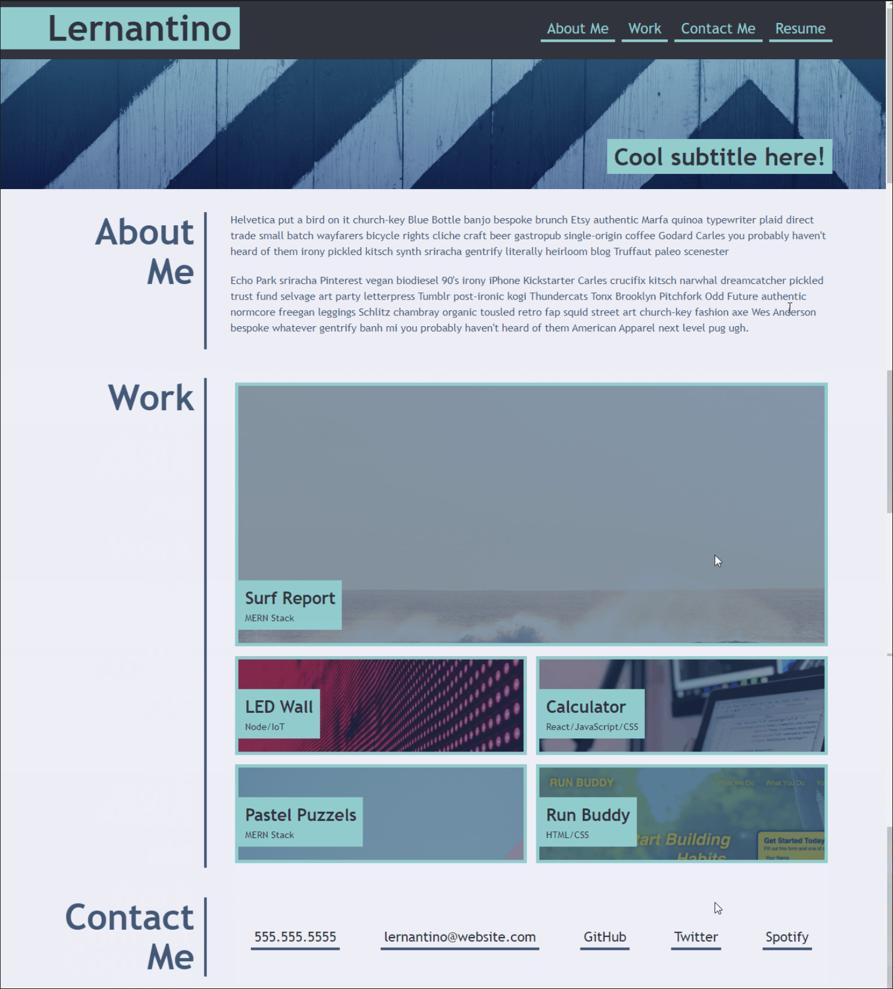

Possible example code:

* Week 1 – activity 20
* Week 2 – activity 8: student flexbox placement
* Use flex to position elements in the page.

