**Test Plan and Result**

**ST1 – Assignment B**

Submitted by: Tenzin Dendup (U3149399)

This is the test plan and test result that I carried out on my Assignment B for ST1 G. The input files used are the ones provided by the teacher. Three tests each has been planned and executed for each option in the program. Screenshots of output from the tests are attached in this document after the test plan.

The following result classifications are to be used:

Category 1 – Show Stopper (the program cannot go live with these)

Category 2 – Severe Error (the program can go live but will need a procedural work around)

Category 3 – Minor Error (the program can go live – its minor)

Category 4 – Test was completely successful

**Test Plan and results**

|  |  |  |  |  |
| --- | --- | --- | --- | --- |
| **Test Id and purpose** | **Details** | **Expected Results** | **Result Category** | **Comment** |
| Option1_test1  Test Order Plan | Select option 1 from menu  Input file: Dec2020.txt | * Order plan has ‘December 2020’ in heading * 4 million insurance for SYH172 * NESA tracking for SYH182 & SYHH19 * 2 Hawk-9 * 1 Hawk Heavy * 3 cylinders of nitrogen * 1360000 kg of LOX * 593450 kg of RP1 | 4 – 4/11/17 | Test screenshot attached at the end of this documement |
| Option1_test2  Test Order Plan | Select option 1 from menu  Input file: Feb2023.txt | * Order plan has ‘February 2023’ in heading * 4 million insurance for SYH192 * 8 million insurance for SYH193 * 16 million insurance for SYH194 * NESA tracking for SYHH54 and SYBFR12 * 3 Hawk-9 * 1 Hawk Heavy * 1 BFR * 1 Drako Spacecraft * 3 cylinders of nitrogen * 5915000 kg of LOX * 713450 kg of RP1 * 1870000 kg of Methane | 4 – 4/11/17 | Test Screenshot attached |
| Option1_test3  Test Order Plan | Select option 1 from menu  Input file: April2025.txt | * Order plan has ‘April 2025’ in heading * 4 million insurance for SYH292 * 4 million insurance for SYH293 * 16 million insurance for SYH294 * 1 million insurance for SYH297 * 96 million insurance for SYHH103 * NESA tracking for SYHH102, SYBFR22, SYBFR44 and SYHH103 * 3 Hawk-9 * 3 Hawk Heavy * 2 BFR * 2 Drako Spacecraft * 6 cylinders of nitrogen * 11815000 kg of LOX * 1420350 kg of RP1 * 3,740,000 kg of Methane | 4 – 4/11/17 | Test screenshot attached |
| Option2_test1  Test Action Plan | Select option 2 from menu  Input file: Dec2020.txt | * Total 3 launches * One morning launch on 3/12/2020 * Two launches on 21/12/2020 using AM and PM timing and seperate launch pads * Display comments if present in input file | 4 – 4/11/17 | Test screenshot attached |
| Option2_test2  Test Action Plan | Select option 2 from menu  Input file: Feb2023.txt | * Total 5 Launches * Two launches on 21/2/23 using AM and PM timing and separate launch pads * Comments displayed * Methane fuel used for SYBFR12 | 4 – 4/11/17 | Test screenshot attached |
| Option2_test3  Test Action Plan | Select option 2 from menu  Input file: April2025.txt | * Total 8 Launches * Two launches on 21/4/25 * Two launches on 22/4/25 * Comments displayed | 4 – 4/11/17 | Test screenshot attached |
| Option3_test1  Test Action plan and write to file | Select option 3 from menu  Input file: Dec2020.txt | * Asks the user for output file name to write to * Rest same as Option2_test1 | 4 – 4/11/17 | Screen shot attached |
| Option3_test2  Test Action plan and write to file | Select option 3 from menu  Input file: Feb2023.txt | * Asks the user for output file name to write to * Rest same as Option2_test2 | 4 – 4/11/17 |  |
| Option 3_test3  Test Action plan and write to file | Select option 3 from menu  Input file:April2025.txt | * Asks the user for output file name to write to * Rest same as Option2_test3 | 4 – 4/11/17 |  |
| General_test1  Test wrong user input at menu | User inputs an invalid option | * Program should say the input is invalid and should ask the user to input again | 4 – 4/11/17 | Screenshot attached |
| General_test2  Test non-existing input file | User specifies and input file that does not exist | * Program should say the input file does not exist and should ask again for input filename | 2 – 4/11/17 | Program says “error in reading file” and exits.  Screenshot attached |

**Evidence of test runs – Screenshots**

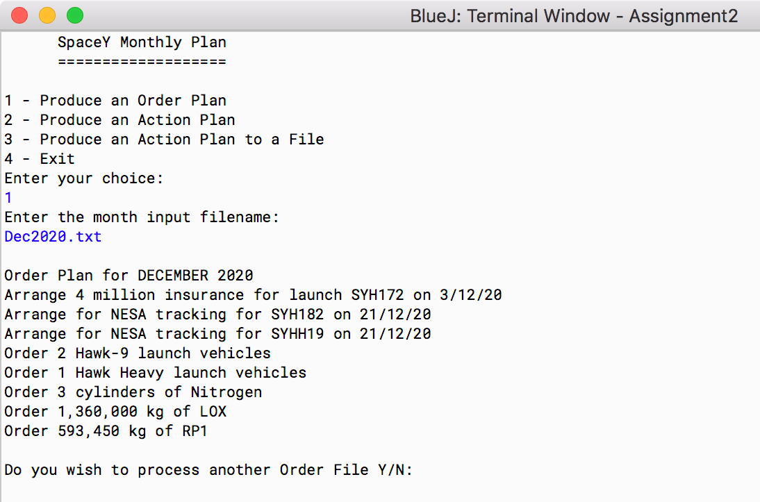

Screenshot 1: Test result of Option1_test1

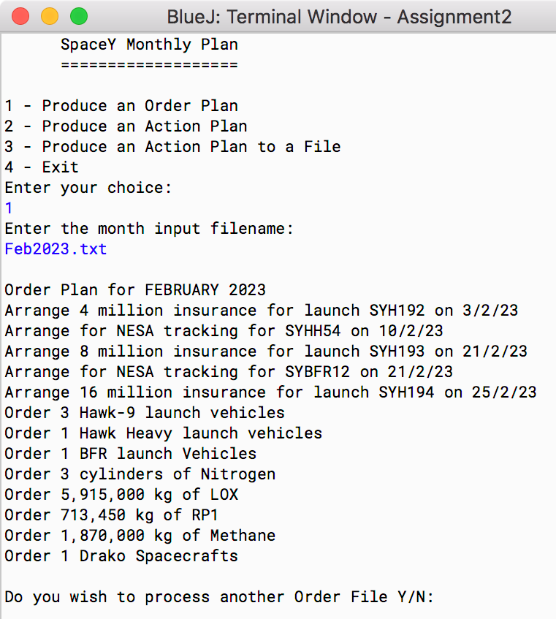

Screenshot 2: Test result of Option1_test2

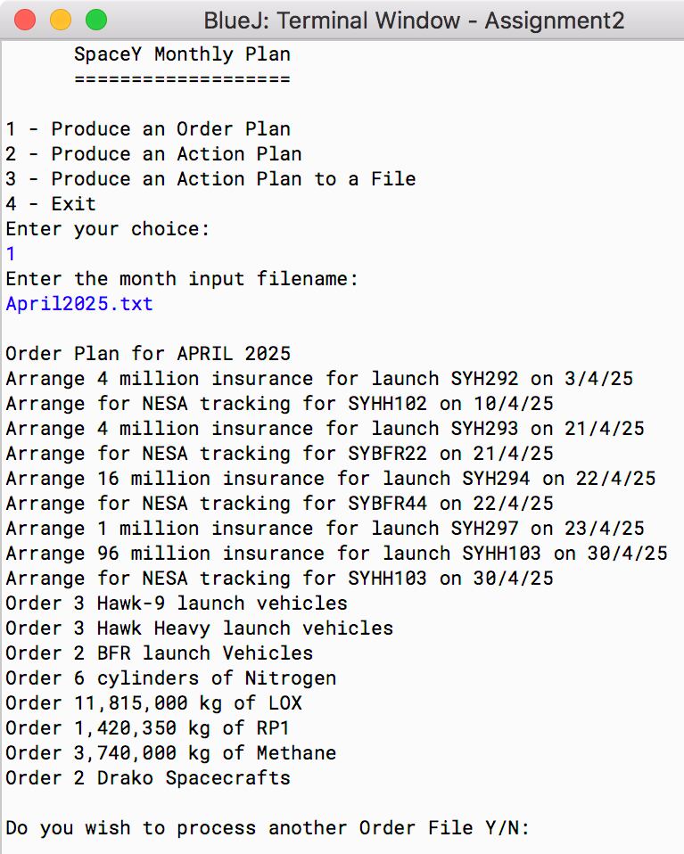

Screenshot 3: Test result of Option1_test3

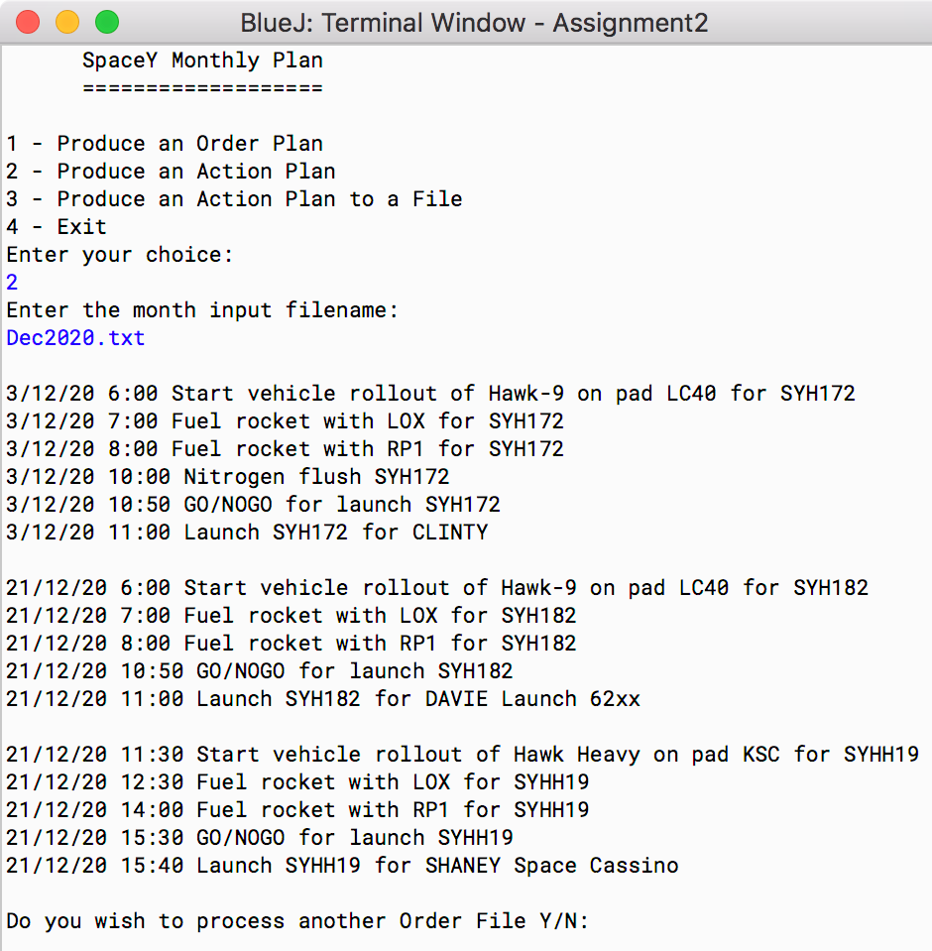

Screenshot 4: Test result for Option2_test1

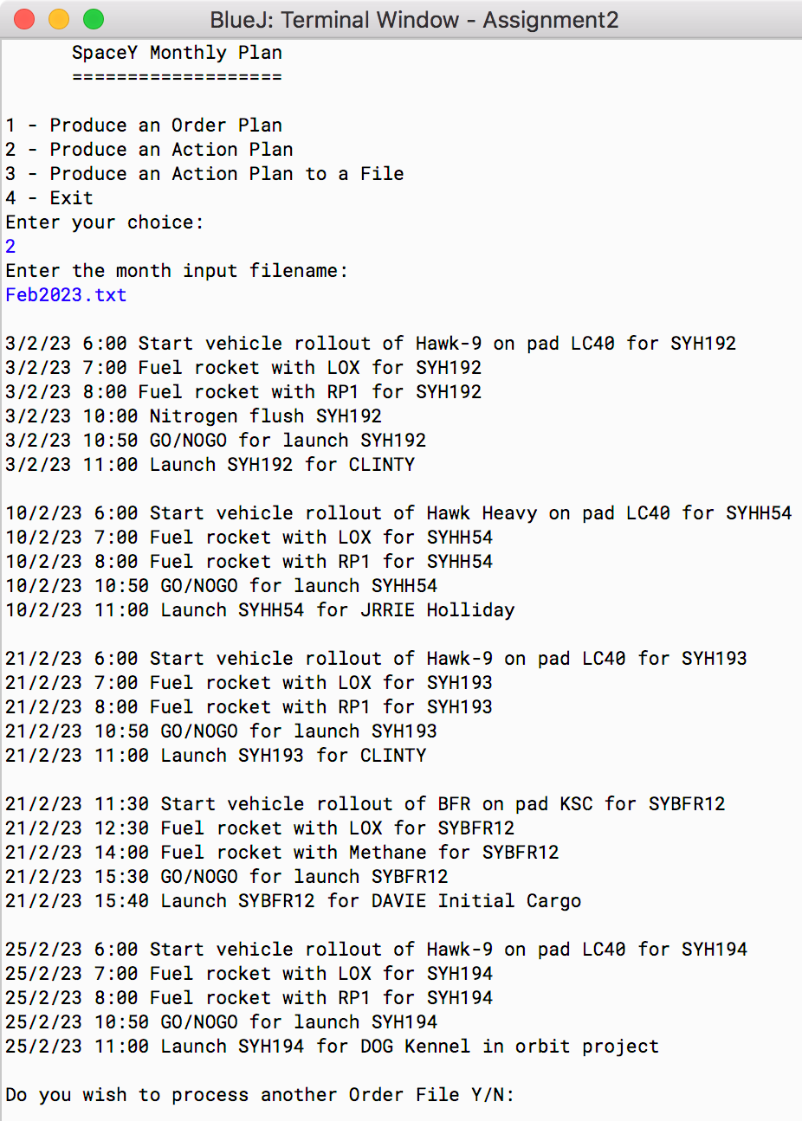

Screenshot 5: Test result for Option2_test2

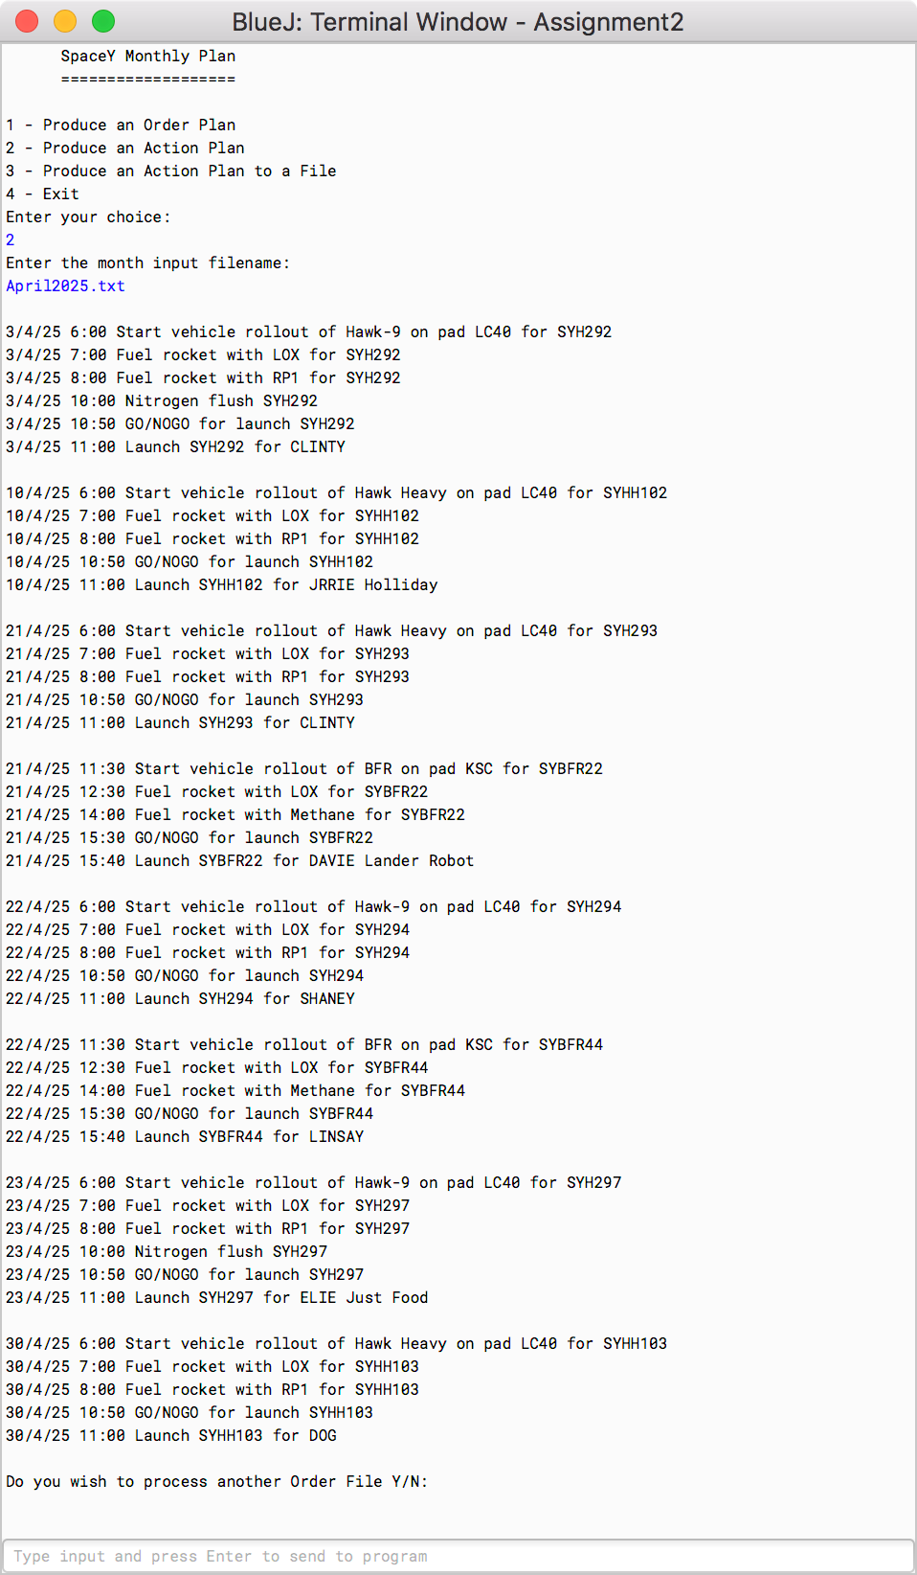

Screenshot 6: Test result for Option2_test3

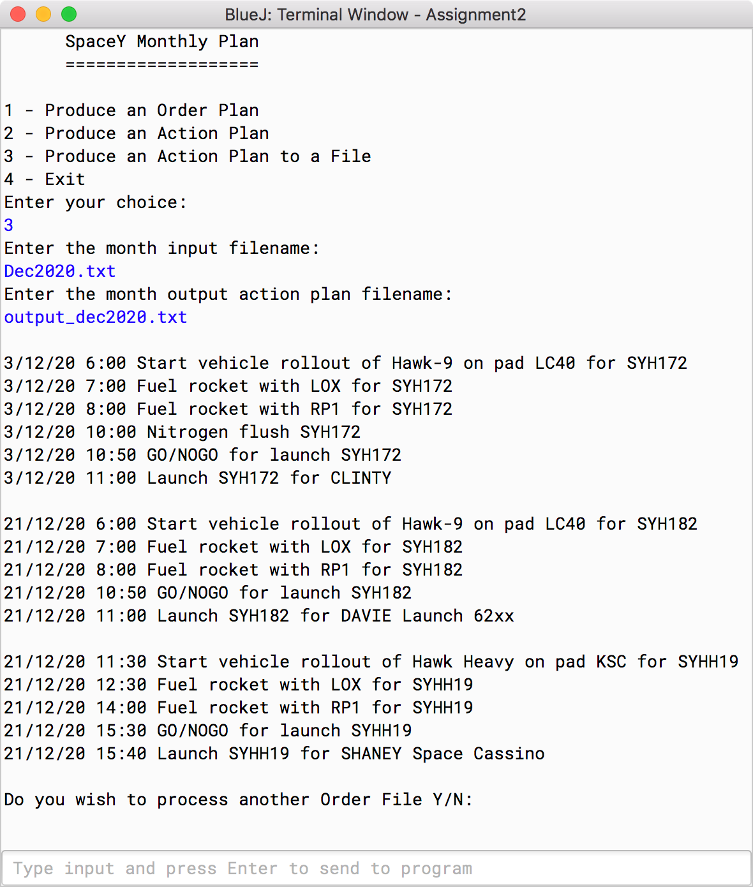

Screenshot 7: Test output of Option3_test1

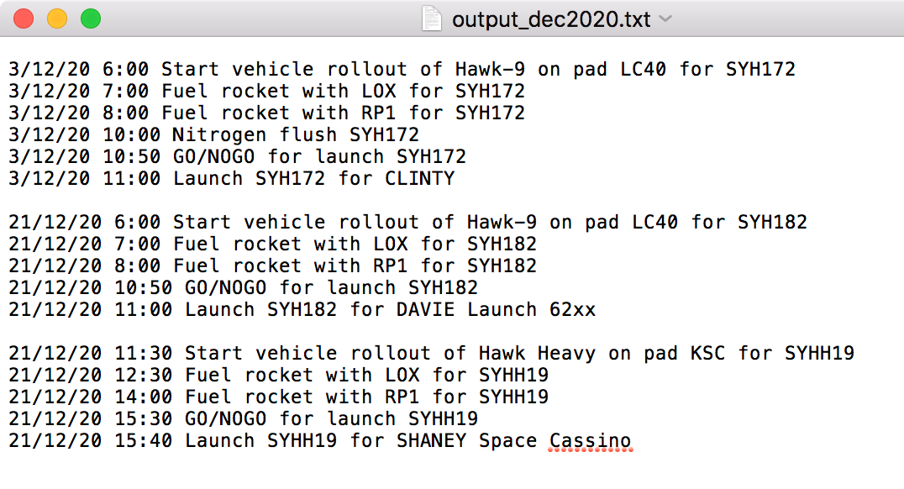

Screenshot 8: Output file for Option3_test1

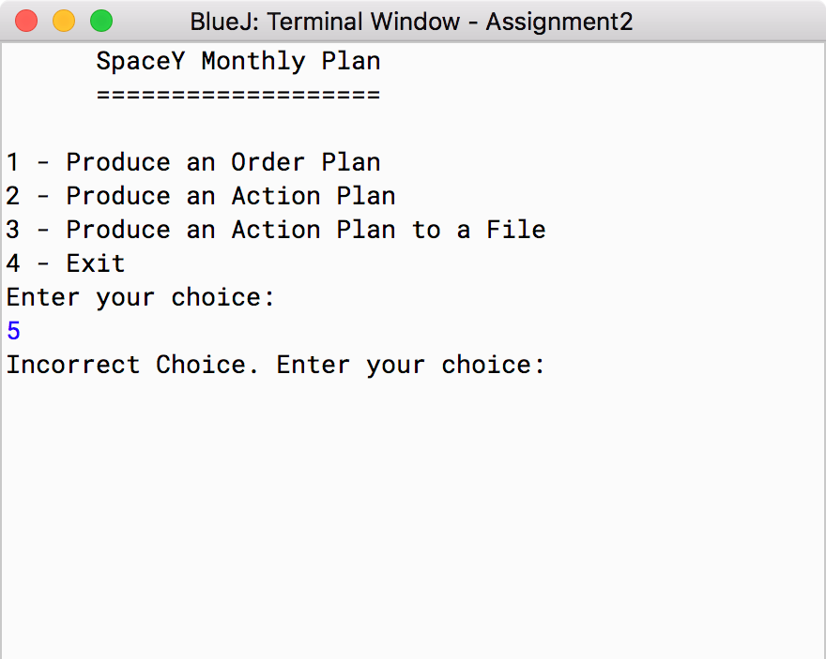

Screenshot 9: Test result for General_test1

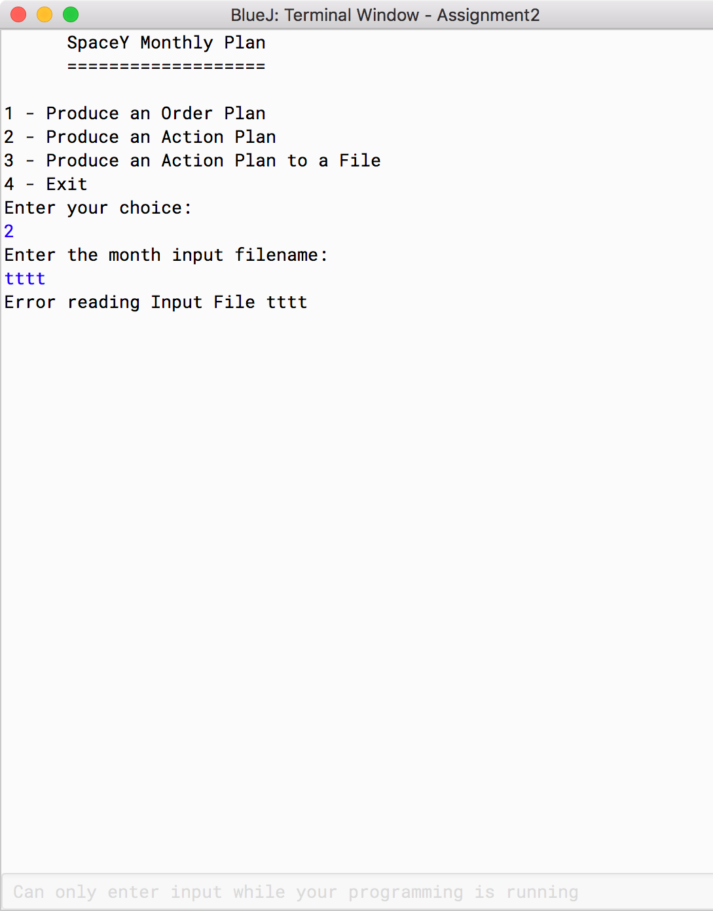

Screenshot 10: Test result of General_test2