U3149399 | Tenzin Dendup

University of Canberra

Database Design

Canberra Health Insurance

Table of Contents

Introduction 3

Entities & Attributes 4

Entity-Relationship Diagram 6

Assumptions 7

# Introduction

This document presents the database design for Canberra Health Insurance. It contains:

1. Entities & Attributes
2. Entity-Relationship Diagram and
3. Assumptions

It is part of Database Design (6672) course assignment for year 2017 (first semester).

# Entities & Attributes

1. **Client** (ClientID, FirstName, LastName, EmailAddress, Gender, DateOfBirth)
2. **ClientAddress** (ClientAddressID, AddressType, StreetNumber, StreetName, Suburb, PostCode, State, *ClientID*)
3. **Insurance** (InsuranceID, *InsuranceTypeID*, *ClientID*)
4. **InsuranceType** (InsuranceTypeID, InsuranceType, Cost)
5. **Payment** (PaymentID, PaymentDate, *ClientID, InsuranceID, StaffID*)
6. **Appointment** (AppointmentID, AppointmentDate, AppointmentTime, *ClientID*, *StaffID*)
7. **Branch** (BranchID, BranchName, StreetNumber, StreetName, Suburb, PostCode, State)
8. **Telephone** (TelephoneID, TelephoneNo, *BranchID*)
9. **Section** (SectionID, SectionName, StreetNumber, StreetName, Suburb, PostCode, State, EmailAddress, TelephonNumber, FaxNumber, *BranchID*)
10. **Staff** (StaffID, FirstName, LastName, Position, Gender, DateOfBirth, EmailAddress, InternalTelephoneNumber, *BranchID*)
11. **StaffTimeTable** (StaffTimeTableID, *StaffID*, Date, StartTime, EndTime)
12. **NextOfKin** (NextOfKinID, FirstName, LastName, TelephoneNumber, StreetNumber, StreetName, Suburb, PostCode, City, State, *ClientID*)
13. **Gym** (GymID, StreetNumber, StreetName, Suburb, PostCode, City, State)
14. **GymClass** (GymClassID, *GymClassTypeID*, *GymID*, *GymInstructorID*, Date, Time)
15. **GymClassType** (GymClassTypeID, ClassName, *GymInstructorID*)
16. **GymClassBooking** (GymClassBookingID, *GymClassID*, *ClientID*)
17. **GymInstructor** (GymInstructorID, FirstName, LastName, Position, Gender, DateOfBirth, InternalTelephoneNumber, *GymID*)
18. **GymEquipment** (GymEquipmentID, EquipmentDetails, *GymID*, *EquipmentSupplierID*)
19. **ServiceHistory** (ServiceHistoryID, *EquipmentID*, DateOfMaintenance, Description)
20. **EquipmentFault** (EquipmentFaultID, *EquipmentID*, CommentsAboutFault, *ClientID*, *GymInstructorID*, Date, Time)
21. **EquipmentSupplier** (EquipmentSupplierID, SupplierName, StreetNumber, StreetName, Suburb, PostCode, State, TelephoneNumber)
22. **SeminarRoom** (SeminarRoomID, RoomDetails)
23. **SeminarRoomBooking** (SeminarRoomBookingID, *StaffID*, Seminar*RoomID*, Date, Time)

# Entity-Relationship Diagram

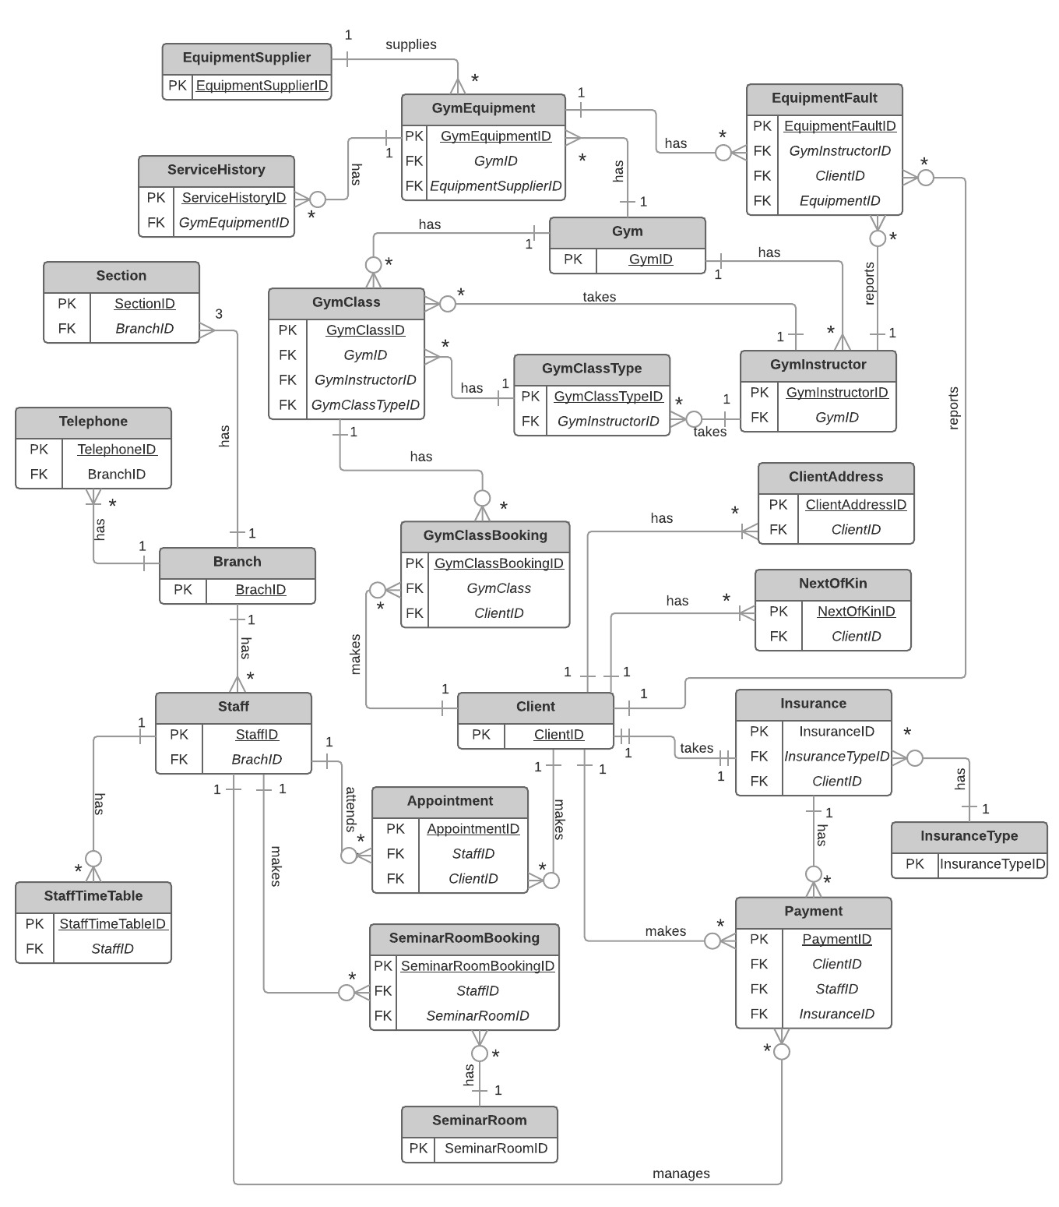

*Figure1: Entity Relationship Diagram for Canberra Health Insurance*

# Assumptions

1. A client can have one or more next of kin
2. A client can make multiple payments for his/her insurance
3. A client can have one address (when Home Address is same as Postal Address) or two addresses (when Home Address and Postal Address are different. *ClientAddress* table is used to store these addresses. *ClientAddress* has an attribute *AddressType*, which has acceptable values of “*Home*” for home address, “*Postal*” for postal address and “*Both*” which indicates home address and postal address are one and same
4. Details of all clients, irrespective of whether they took a health insurance or not, is recorded in the client Table. Once a client takes a health insurance, the insurance details are created in the *Insurance* table.
5. One payment will be handled by just one staff
6. StaffID (Primary key in Staff table) is the staff number.
7. A branch and its sections can have different addresses.
8. All branch telephone numbers are unique
9. A section has only one telephone number
10. CHI has more than one Gym
11. Gym equipment fault can be reported by a client or instructor or both