HTML Assignment for IIT (8936)

# Hierarchy of webpages

Since this is a static website targeted at providing information on various tourist destinations in Bhutan, there is no need for complicated hierarchies. A two level hierarchy with all the pages accessible from the home page and vice versa is the optimal choice.

Figure 1: Figure showing the hierarchy of webpages (2 level hierarchy)

# Navigation

Navigation to other pages from the home page is primarily accomplished through the navigation menu provided on the left hand side of the page. This navigation menu is present on all html pages.

Navigation from other pages back to Home Page is provided through “breadcrumb” link which appears on each page on top of the main content.

The navigation menu also provides links to important external websites related to Bhutan. These will be helpful for visitors to look up information on travel arrangements, tour operators and visa requirements. The various navigation features are illustrated below.

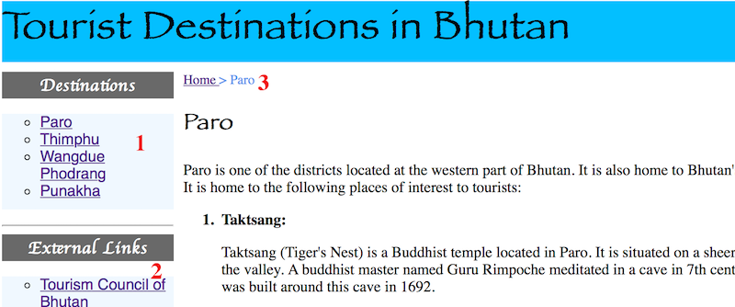

Figure 2: Figure showing various navigation features. 1 - Main Navigation Menu. 2 - Navigation to related external websites. 3 - Breadcrumb navigation