Tenzin Choeying

ITMD 411

LAB 3

DOCUMENT

**CONSOLE SCREENSHOT**

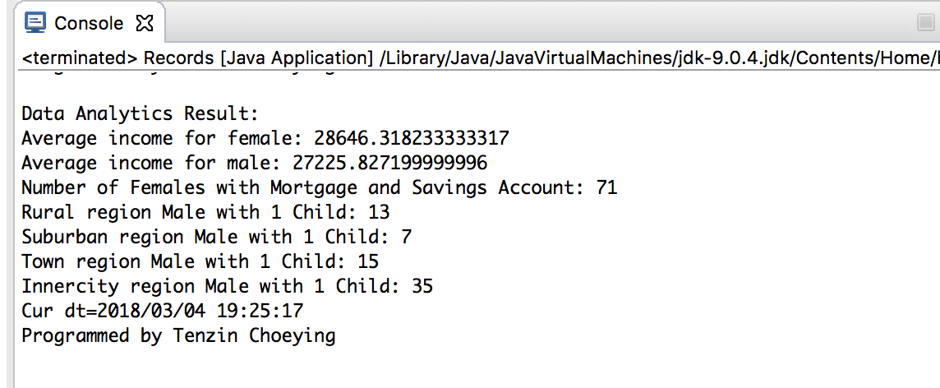

**bankrecords.txt SCREENSHOT**

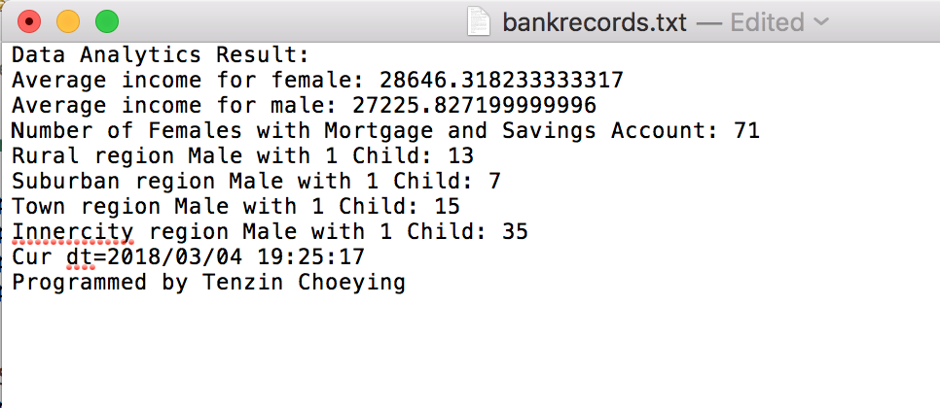

**Records.java Source Code**

**package** Lab02;

**import** java.io.FileWriter;

**import** java.io.IOException;

**import** java.text.SimpleDateFormat;

**import** java.util.Arrays;

**import** java.util.Calendar;

**public** **class** Records **extends** BankRecords {

//create formatted object to write output directly

//to the console and to a file

**static** FileWriter *fw* = **null**;

**public** Records() {

**try** {

*fw* = **new** FileWriter("bankrecords.txt");

} **catch** (IOException e) {

e.printStackTrace();

}

}

**public** **static** **void** main(String[] args) {

Records br = **new** Records();

br.readData();

//call functions to perform analytics

*AverageComp*(); //analyze average income

*femsComp*(); //analyze females w. mortgage/savings account

*malesComp*(); //analyze male count with 1 child

// *** close out file object ***//

**try** {

*fw*.close();

}**catch** (IOException e) {

//**TODO** Auto-generated catch block

e.printStackTrace();

}

}

**private** **static** **void** AverageComp() {

Arrays.*sort*(*robjs*,**new** GenderComparator());

**double** fsum = 0, msum = 0, fCt = 0, mCt = 0;

**for** (**int** i = 0; i < *robjs*.length; i++)

**if** (*robjs*[i].getSex().equals("FEMALE")) {

fsum += *robjs*[i].getIncome();

++fCt;

}**else** {

**if**(*robjs*[i].getSex().equals("MALE")) {

msum += *robjs*[i].getIncome();

++mCt;

}

}

//print resulting averages to console and file

**double** femAvg = fsum/(fCt);

**double** maleAvg = msum/(mCt);

System.***out***.println("Data Analytics Result: ");

System.***out***.println("Average income for female: " + femAvg);

System.***out***.println("Average income for male: " + maleAvg);

**try** {

*fw*.write("Data Analytics Result: ");

*fw*.write("Average income for female: " + femAvg);

*fw*.write("Average income for male: " + maleAvg);

}**catch** (IOException e) {

e.printStackTrace();

}

}

**private** **static** **void** femsComp() {

Arrays.*sort*(*robjs*,**new** GenderComparator());

//store female count

**int** fCt = 0;

**for** (**int** i = 0; i < *robjs*.length; i++)

**if** (*robjs*[i].getSex().equals("FEMALE") && *robjs*[i].getMortgage().equals("YES") && *robjs*[i].getSave_act().equals("YES")) {

fCt += 1;

}

System.***out***.println("Number of Females with Mortgage and Savings Account: " + fCt);

**try** {

*fw*.write("Number of Females with Mortgage and Savings Account: " + fCt);

} **catch** (IOException e) {

e.printStackTrace();

}

}

**public** **static** **void** malesComp() {

Arrays.*sort*(*robjs*, **new** ChildrenComparator());

//store male count

**int** mCt_rural = 0, mCt_suburban = 0, mCt_town = 0, mCt_inner = 0;

**for** (**int** i=0; i < *robjs*.length; i++)

**if** (*robjs*[i].getSex().equals("MALE") && *robjs*[i].getRegion().equals("RURAL")

&& *robjs*[i].getChildren()==1) {

mCt_rural += 1;

} **else** **if** (*robjs*[i].getSex().equals("MALE") && *robjs*[i].getRegion().equals("SUBURBAN")

&& *robjs*[i].getChildren()==1){

mCt_suburban += 1;

} **else** **if** (*robjs*[i].getSex().equals("MALE") && *robjs*[i].getRegion().equals("TOWN")

&& *robjs*[i].getChildren()==1){

mCt_town += 1;

} **else** **if** (*robjs*[i].getSex().equals("MALE") && *robjs*[i].getRegion().equals("INNER_CITY")

&& *robjs*[i].getChildren()==1){

mCt_inner += 1;

}

//printing results

System.***out***.println("Rural region Male with 1 Child: " + mCt_rural);

System.***out***.println("Suburban region Male with 1 Child: " + mCt_suburban);

System.***out***.println("Town region Male with 1 Child: " + mCt_town);

System.***out***.println("Innercity region Male with 1 Child: " + mCt_inner);

//mandatory timestamp for every project

String timeStamp = **new** SimpleDateFormat("yyyy/MM/dd HH:mm:ss").format(Calendar.*getInstance*().getTime());

System.***out***.println("Cur dt=" + timeStamp + "\nProgrammed by Tenzin Choeying\n");

**try** {

*fw*.write("Rural region Male with 1 Child: " + mCt_rural);

*fw*.write("Suburban region Male with 1 Child: " + mCt_suburban);

*fw*.write("Town region Male with 1 Child: " + mCt_town);

*fw*.write("Innercity region Male with 1 Child: " + mCt_inner);

//mandatory timestamp for every project

*fw*.write("Cur dt=" + timeStamp + "\nProgrammed by Tenzin Choeying\n");

}**catch** (IOException e) {

e.printStackTrace();

}

}

}

**GenderComparator.java Source Code**

**package** Lab02;

**import** java.util.Comparator;

**public** **class** GenderComparator **implements** Comparator<BankRecords>{

@Override

**public** **int** compare(BankRecords o1, BankRecords o2) {

// use compareTo to compare strings

//primary sort

**int** result = o1.getSex().compareTo(o2.getSex());

**if**(result != 0) **return** result;

//secondary sort

**return** o1.getRegion().compareTo(o2.getRegion());

}

}

**ChildrenComparator.java Source Code**

**package** Lab02;

**import** java.util.Comparator;

**public** **class** ChildrenComparator **implements** Comparator<BankRecords>{

@Override

**public** **int** compare(BankRecords o1, BankRecords o2) {

// use compareTo to compare strings

**return** (**int**)o1.getChildren() - o2.getChildren();

}

}