* **Initial class diagram**

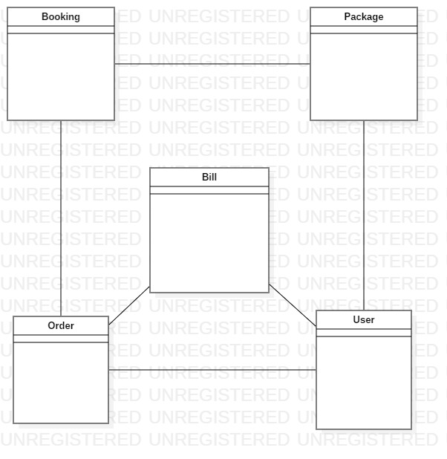

Figure 1 Initial Class Diagram

* **Final Class Diagram**

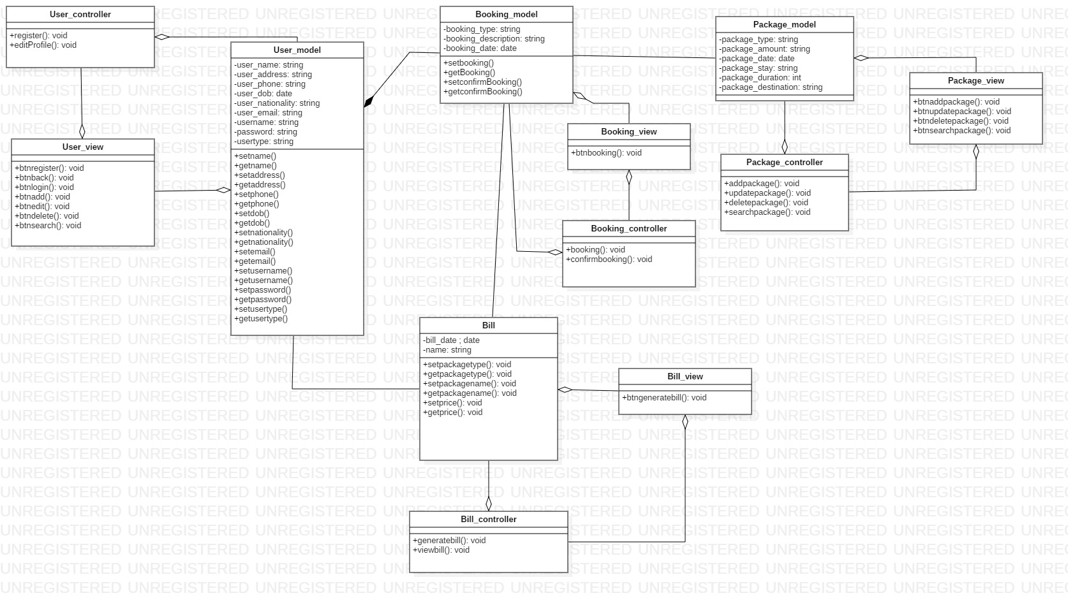

Figure 2:Class diagram

* **UI Design**

1. **Registration**

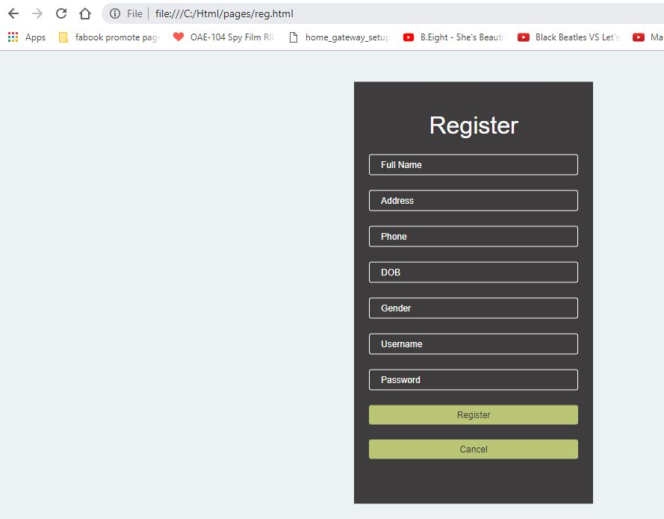

Figure 3:Registration

1. **Login Form**

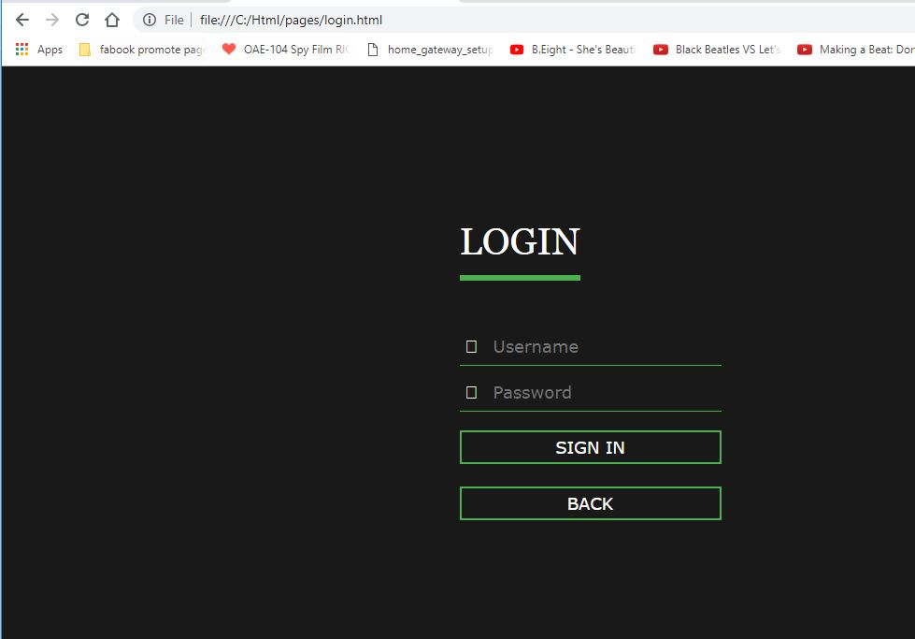

Figure 4:Login

1. **Home Page**

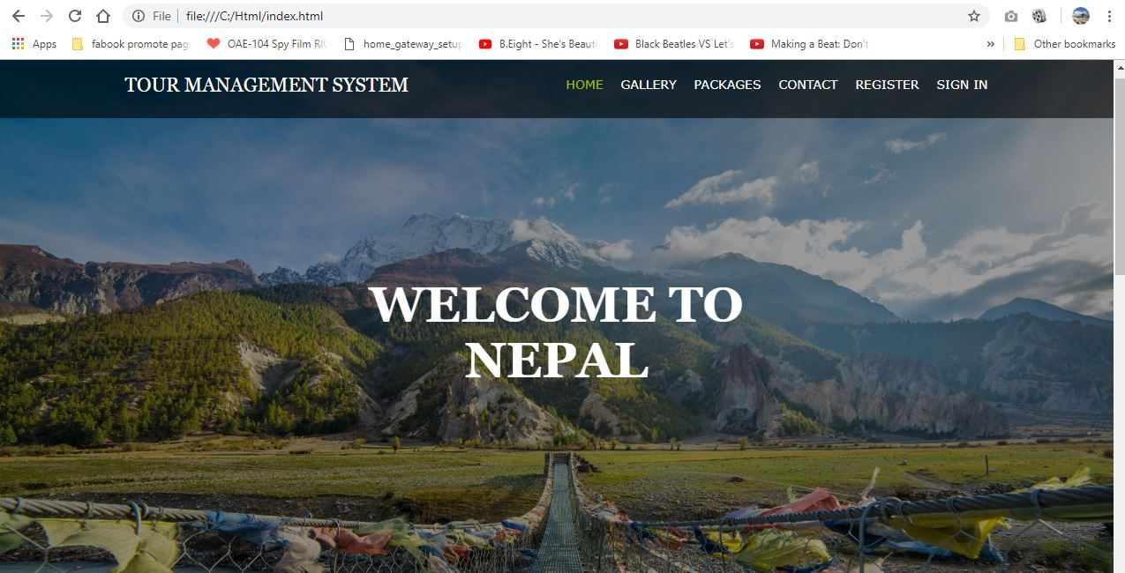

Figure 5:Home Page

1. **Gallery**

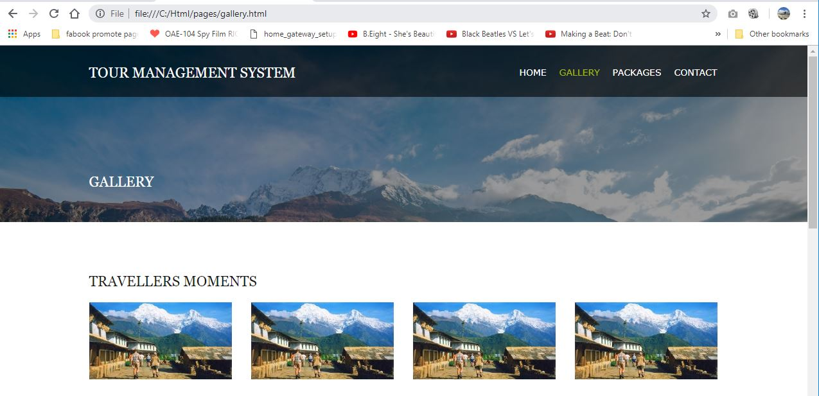

Figure 6:Gallery

1. **Package**

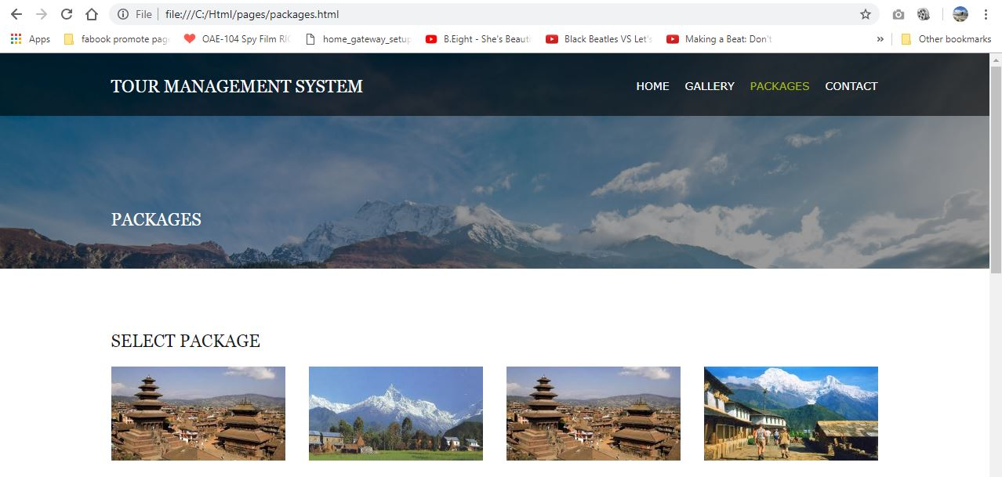

Figure 7:Packages

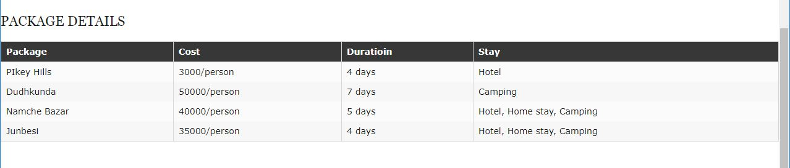

Figure 8:Packages details

1. **Booking**

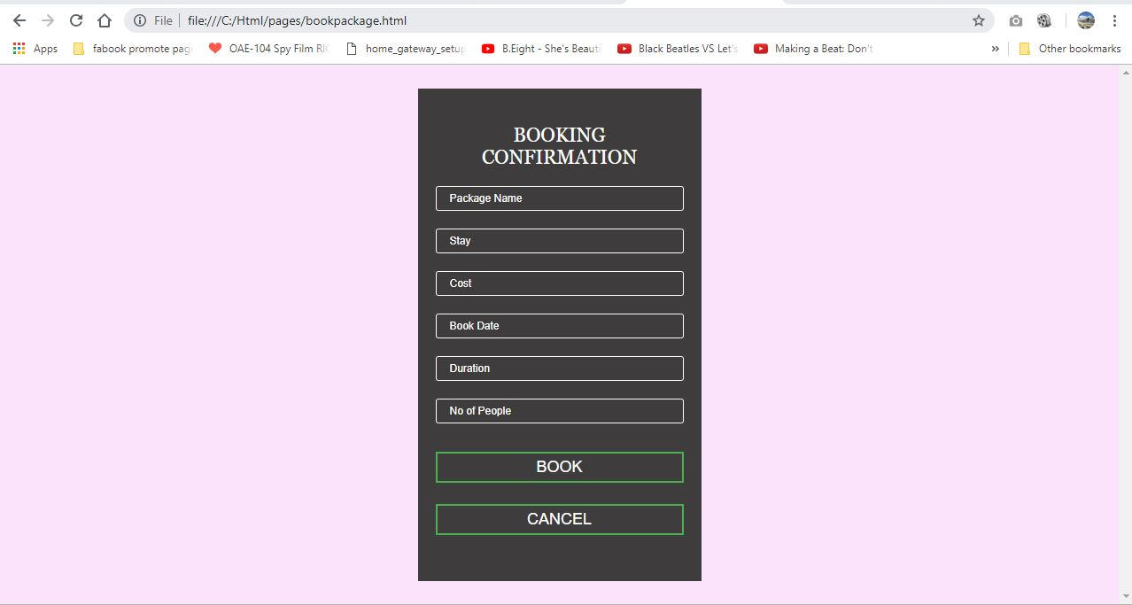

Figure 9:Booking package

1. **Contact**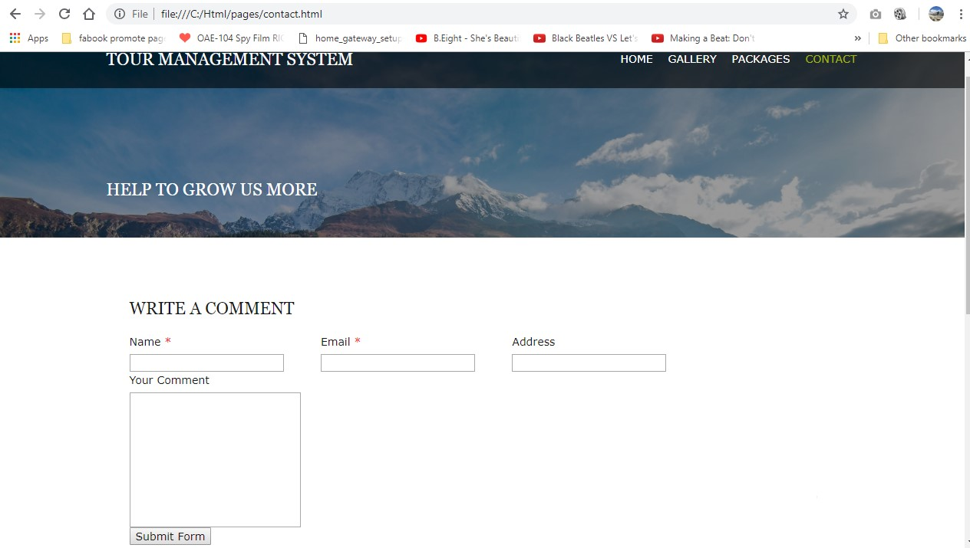

Figure 10:Comment box

1. **Admin page**

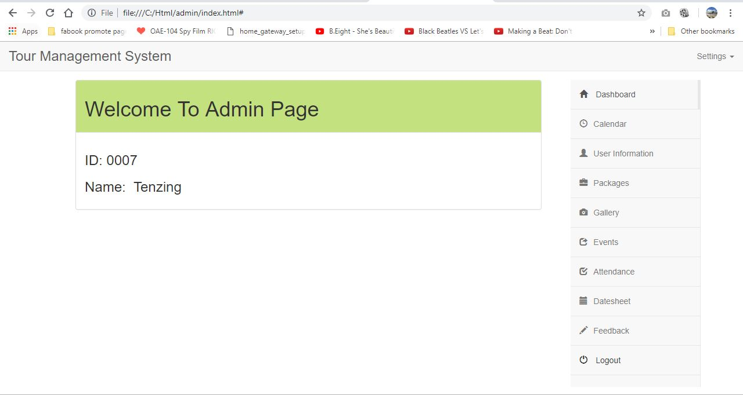

Figure 11:Admin page

1. **Admin package**

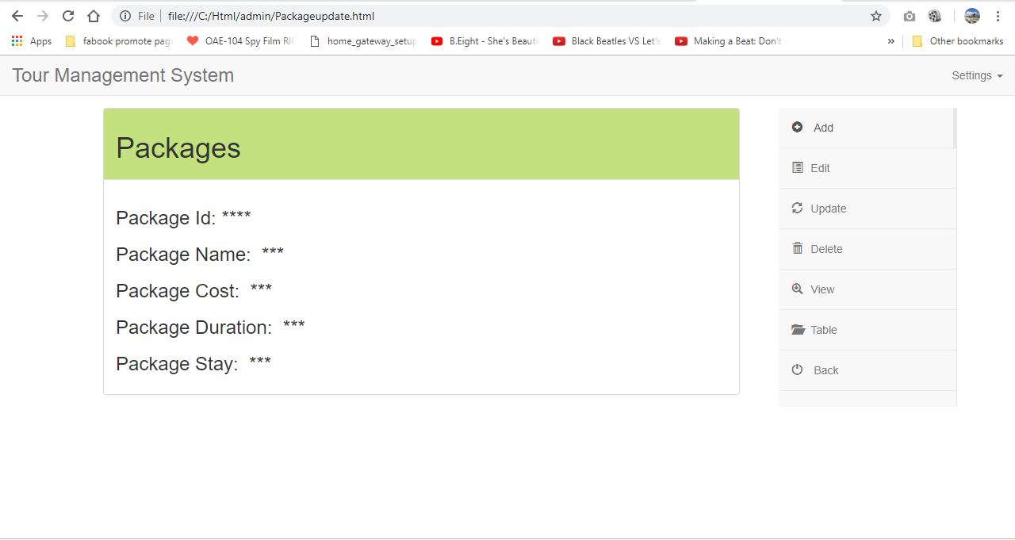

Figure 12:Admin packages

* **ER Diagram**

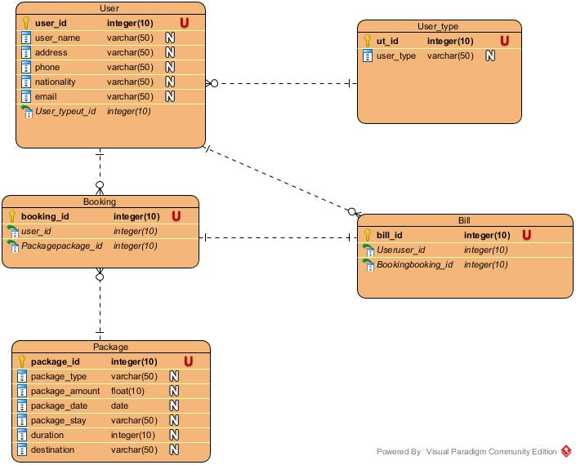

Figure 13: ER Diagram

* **Activity Diagram**

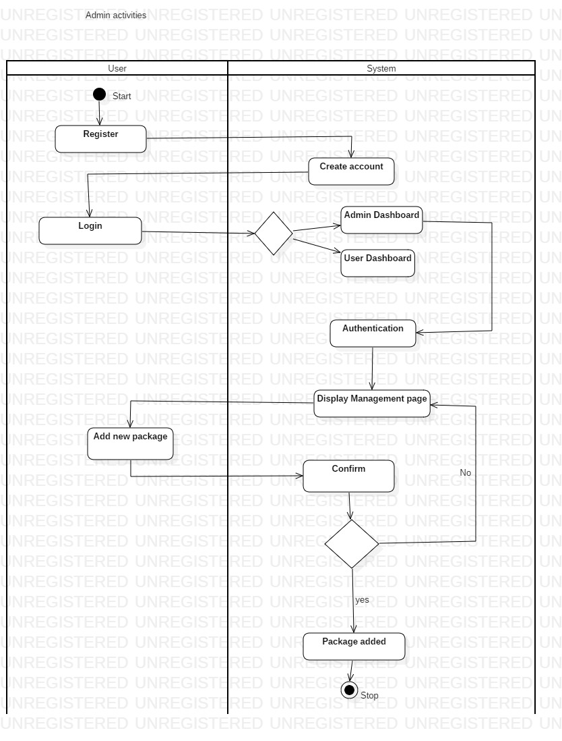

Figure 14:Admin activities

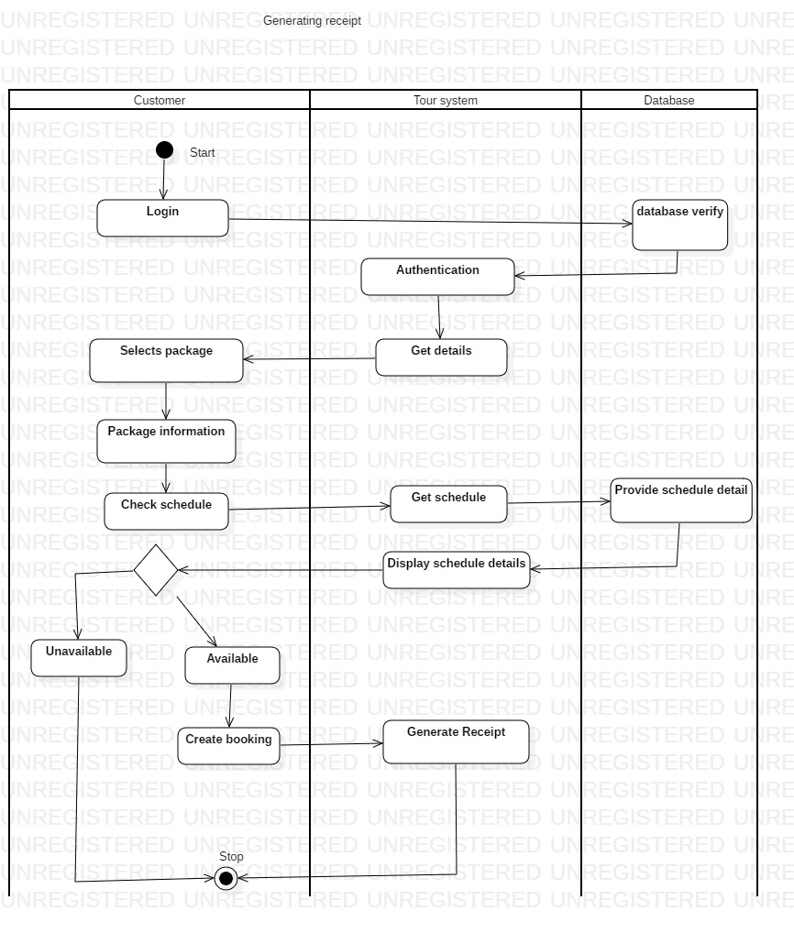

Figure 15:Generating receipt

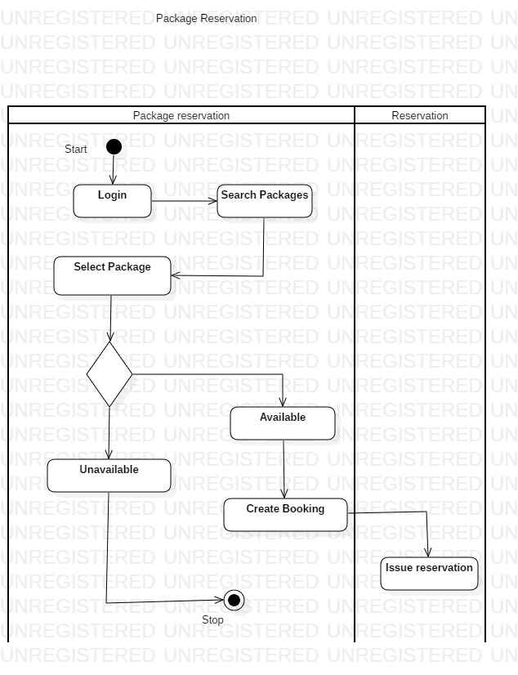

Figure 16:Package reservation