## **User Manual**

1. **REGISTER.**

* Click on “REGISTER” in the navigation bar shown below to open the register form.

Figure 36Navigation bar

* The registration form is displayed below.
* 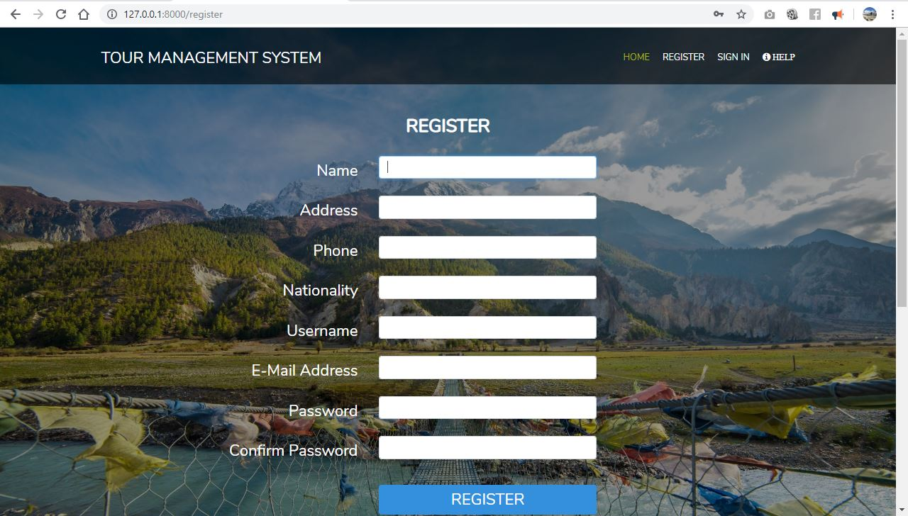Fill all the details in order to get registered in the database.

Figure 37Register form

1. **SIGN IN.**

* After successfully registering the system, click on “SIGN IN” button from the navigation bar shown below to open login form.
* The Sign in form has been displayed below.
* Fill the details properly in order to enter the page.

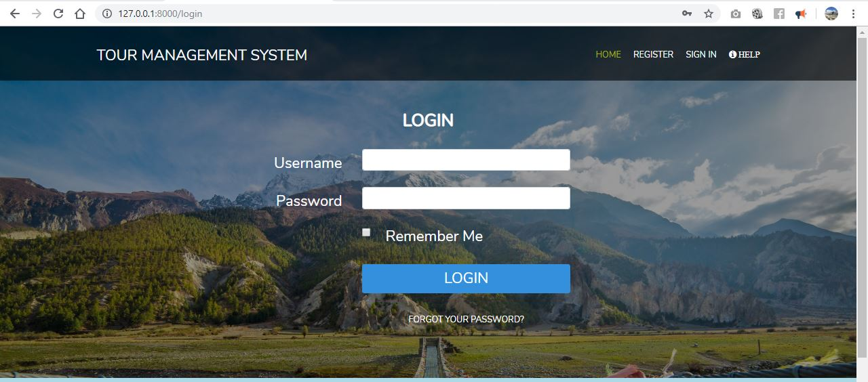

Figure 38Login form

1. **HOMEPAGE**

* After signing the page, the home page will be displayed shown below.
* Clicking on different buttons available in the navigation bar after successful login such as “GALLERY”, “PACKAGE”,” CONTACT”,” EDIT” as displayed below will open different pages accordingly.

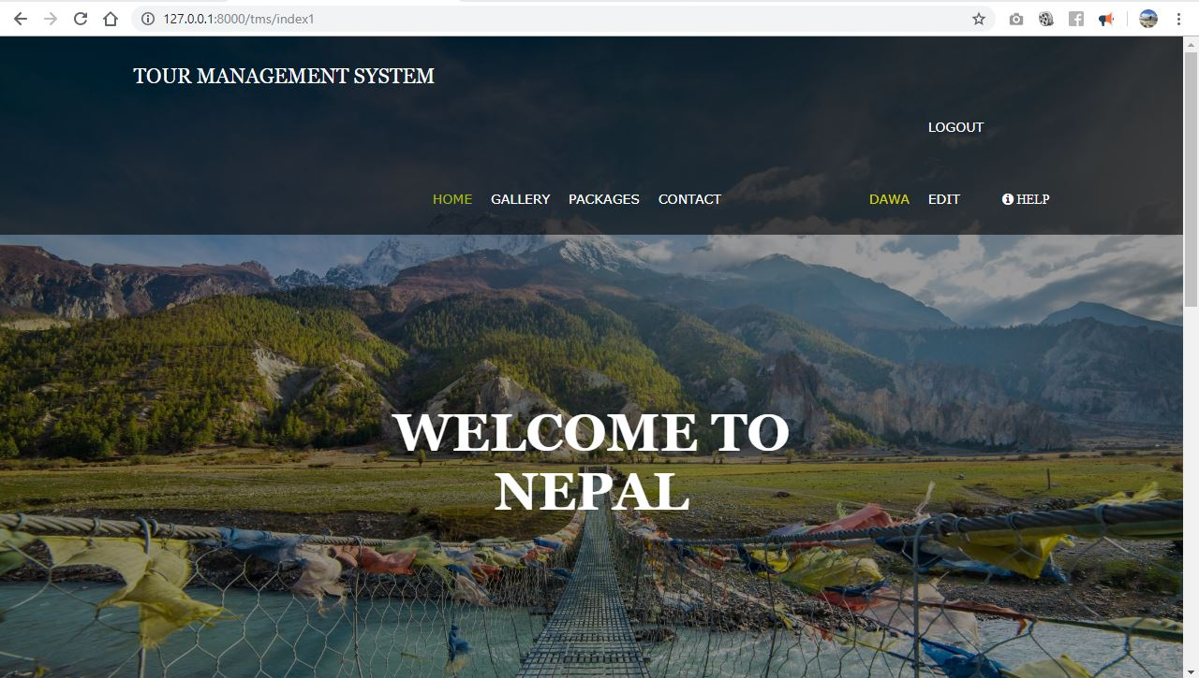

Figure 39homepage

1. **GALLERY**

* To view the gallery page, click on “GALLERY” button, shown below.

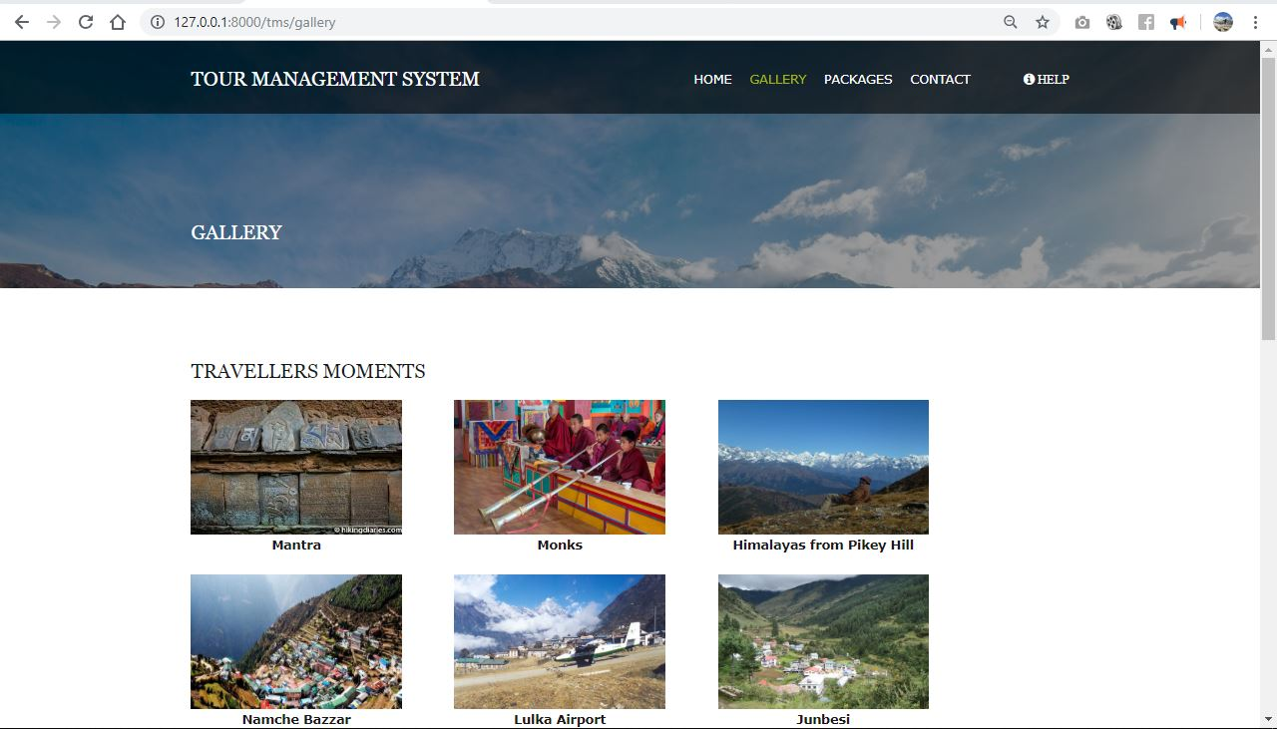

Figure 40gallery page

1. **CONTACT**

* To view the contact page, click on “CONTACT” button, displayed below.
* Fill up the details to contact the webpage.

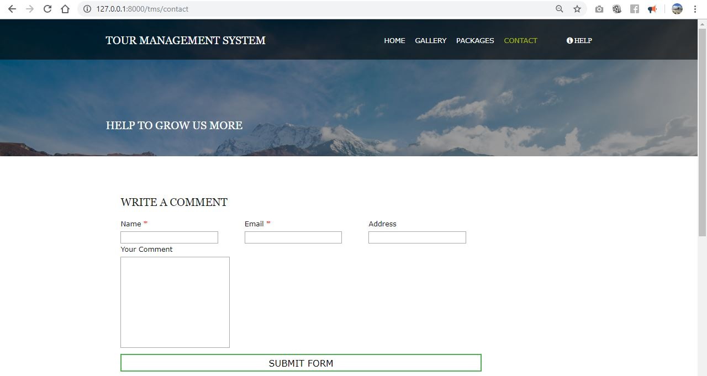

Figure 41Contact page

1. **PACKAGE**

* To book the package, click on “PACKAGE” button to open the package form shown below.
* User can also search the available package, by typing the package name and clicking on the “SEARCH” button, shown below to search the package.
* If the search package in found, it will display the package, if not it will display the message “No data found”.

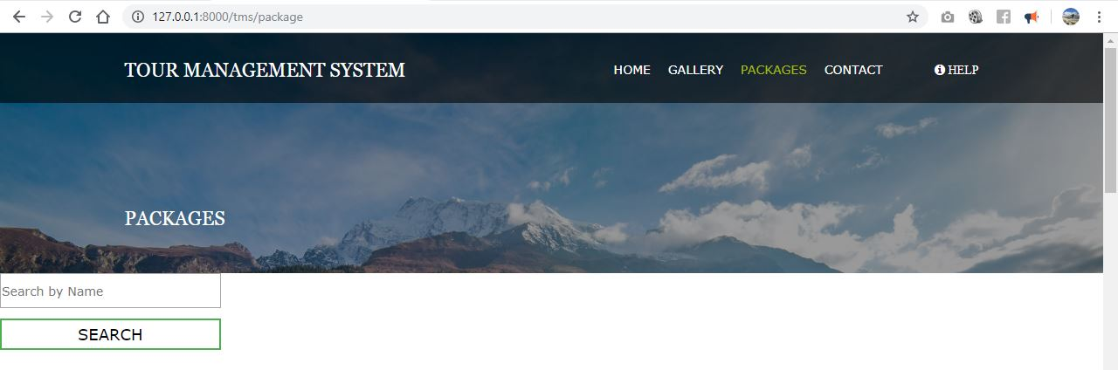

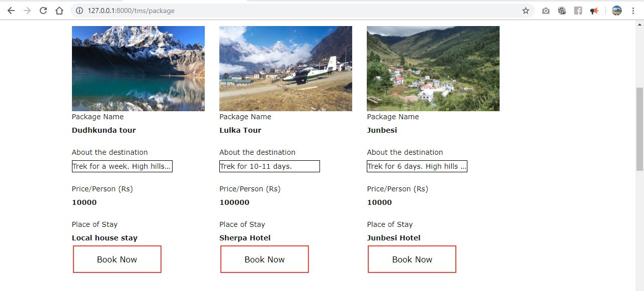

Figure 42package page

* The package details are displayed above.
* To book the available package, click on “Book Now” button to open booking page displayed below.
* Select the appropriate date and number of people travelling. Click on “Book” button to book the package.

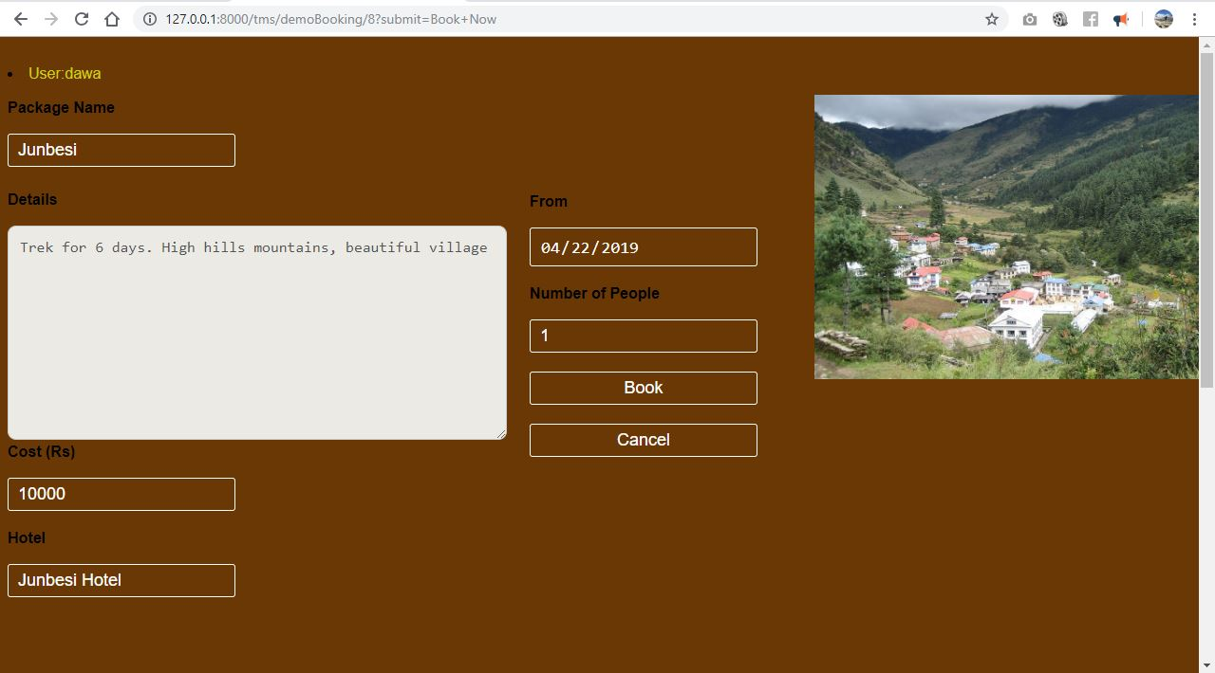

Figure 43booking page

* After booking the package, popup page will be displayed shown below.

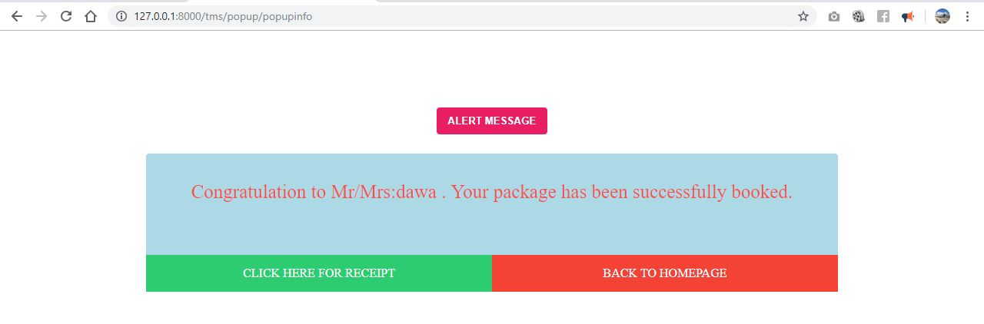

Figure 44info page

* Click on “BACK TO HOMEPAGE” button to go back to homepage.
* Click on “CLICK HERE FOR RECEIPT” to get the receipt shown below.

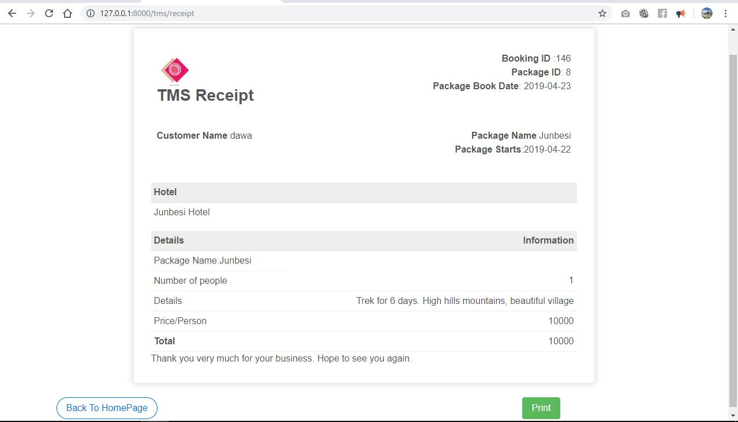

Figure 45receipt

* Click on “Back To HomePage” button on the down-left side of the receipt page to go back to home page.
* Click on “Print” on the down-right side of the receipt page to print the receipt displayed below.

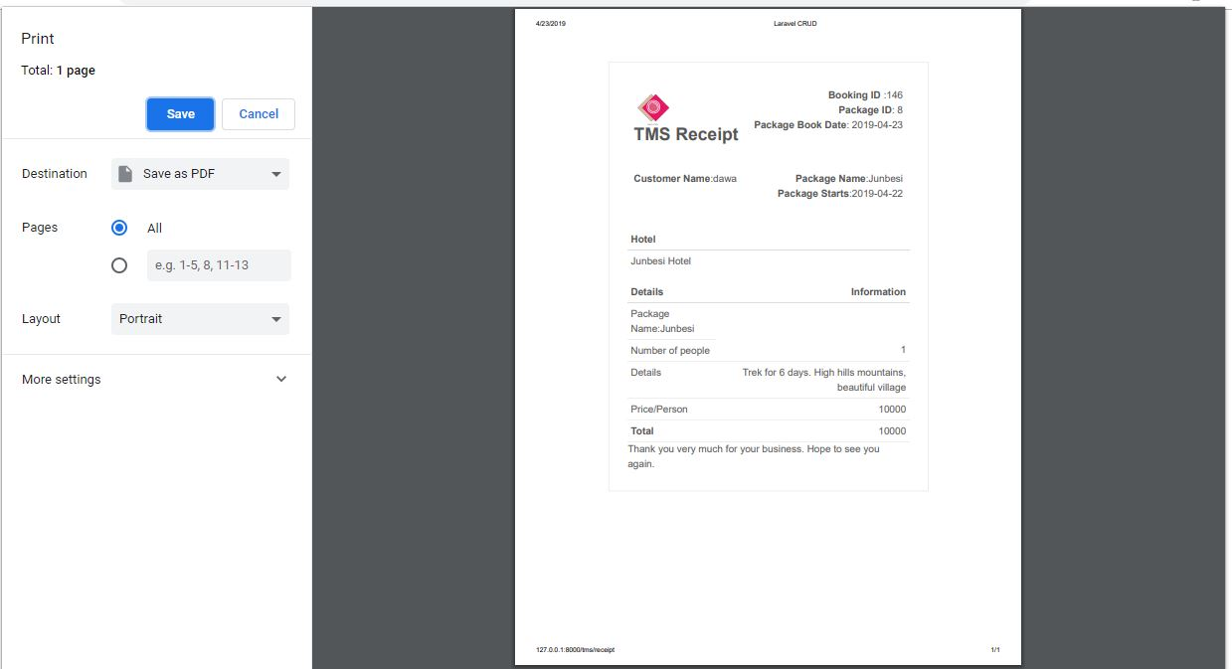

Figure 46 print format