

Android project proposal
On
Travel and Tour Management System


Submitted by : Dawa Tenzing Lama
Batch: Sep 2019 Section (C)
Module Leader : Kiran Rana
Table of Contents
1. Introduction 3
a) Project Introduction 3
b) Justification of the project 4
i) Background of the Project 4
4
ii. Problem statement 4
c) Description of the Project 5
i) Features of the Project 5
2. Aims and Objective of the project 6
3. Development methodology 7
a) Description of methodology 7
b) Design pattern 9
The Model: It is the data layer, which is responsible for managing the business logic and handling network or database API. 11
The View: It is the User Interface (UI) layer. It is a way of representation of the data from the model. 11
The Controller: It is the logic layer. It gets notify the user’s behavior and updates to the Model as required. 11
4. Configuration Management 11
5. Prototyping 12
6. Conclusion 19
7. References 20

1. Introduction

a) Project Introduction

The Travel and Tour Management System is an effective online solution for users to plan, manage and schedule their tour according to their requirements and demands. It is an application designed in Android Studio Software System to automate the travel process to the customers through online facilities for traveling, easy access to the relevant information and necessary travel booking and arrangement. First of all, they hardly know places where they can spend a good time. Further there comes money constraint. This system solves all problems of the client by providing them different packages and facility to personalize their tour. Users may choose the destination and package as and when needed.
This application will have various features for fulfilling the user requirement such as login function, searching packages, package information etc. The application is user friendly and will help the users to find the appropriate route including other necessary information, date and time of booking with fair price while traveling to the destination.

b) Justification of the project

i) Background of the Project

Touring is a part of a life as which can sometimes lead to uncertain situation. In order to overcome that problem, this project will help users to get all the required information about the package, schedule and so on.
Solving this problem can uplift the range of tourism to go higher and increase the revenue too. Through this, customers can utilize various benefits and resources such as online booking, destination information, reviews about the places, etc.
The project will be developed using Object Oriented Java programming in Android Studio. Different techniques and procedures will be implemented that will enhance the quality of application.

ii. Problem statement

The current system is very ancient, having limitations and need to be replace in the time of globalization. One of the biggest disadvantages of the current system is that lacking of online booking system each time an agent need to call in office to check the available packages and then can booked it. Even the user booked the packages, he the confirmation process and payment system is very difficult.
All existing system is traditional and lack of use of technology, therefore the process is very consuming and lengthy as too much of paper work which make the data record time consuming, inefficient, unreliable, risky etc.

c) Description of the Project

i) Features of the Project

User Registration and login
User has to first create an account in the system by registering themselves and then can login into the system for accessing the services.

Tour View
The system contains a list of all the tours and places so that users can explore and get an idea of various places to visit.

Tour Package selection
It has three packages for all tours that include stay, food and traveling and user may select any one of them according to the kind of facility they want.

Tour Cancellation
Users may even cancel their tour if they wish.

Credit Card Payment
They can make payment online via credit card.

Receipt Emailing
Every user gets an instant email notification regarding the payment being made.

Feedback
Users can even provide feedback into the system by filling up feedback form.

2. Aims and Objective of the project

Aims

- To build a proper system to record the traveling information.
- To provide proper information of the traveling routes, destination, locals etc.
- To make online application to create communication and sharing of information.
- To develop database system to store the information of the travelers, places etc.

Objectives

- To collect the exact number of data of the travelers of different parts of the world.
- To give a brief information of the different places.
- To make user friendly GUI system which can also be used by non-technical users (finding user experiences).

3. Development methodology

a) Description of methodology
Waterfall framework which is used for planning, structure and control the process of developing an information system. For my project development, I will use waterfall methodology. Since it is easy to manage because of the rigidity of model and sequential design approach.
For developing, organizing and maintaining the information system, few steps can be taken to lead the development process efficiently.

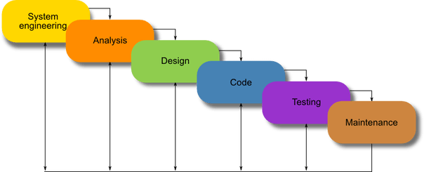Figure 1: Waterfall model

It is a very simple methodology of software development. There are few sequential steps which are advanced after the accomplishment of one due to which there is no overlapping during the process. The steps involved in this methodology are:

- Requirement gathering and analysis
The first phase contains gathering and analyzing requirements, its functions, design, purpose etc.
- System Design
The requirements gathered form the first phase is viewed in brief to design the system.
- Implementation
After getting the inputs form the second phase, the system is first established in units to integrate in the next phase.
- Testing
Testing is must to remove the system problems. Only after the testing of each and every unit, that are developed in the implementation phase are integrated into the system
- Deployment of System
The product will be delivered to the customer, once the functional and non-functional testing is performed.
- Maintenance
It involves modifications in the system to improve the performance. It can occur when requested by the customer. The developed software is provided maintenance service accordingly.

b) Design pattern

It is a detailed document that provides full information about a going to be developed product of process. Its main aims are to ensure that the development product must meet the users’ requirements. For this project, I have chosen the MVC (Model View Controller) pattern.
It is an architectural pattern widely adopted to develop user – interface which splits an application into three different interconnected parts. This pattern is used to detached application’s concerns.
The model is known as the central component of the pattern which directly manages the data, logic and rules the application. A view can represent the information of chart diagram, bar chart etc. and the Controller accept the input that convert it to command for view and mode. Following are the reasons to select this pattern:

- Fast development process.
- Changes/updates will not affect the entire model system.
- Asynchronous practice is supported.
- Multiple views are supported.

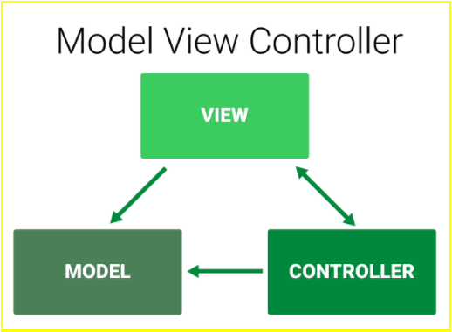

The Model: It is the data layer, which is responsible for managing the business logic and handling network or database API.

The View: It is the User Interface (UI) layer. It is a way of representation of the data from the model.

The Controller: It is the logic layer. It gets notify the user’s behavior and updates to the Model as required.

4. Configuration Management

It is the process of developing and maintaining reliability of the performance, functions as well as the physical attributes of any product with its necessities, enterprise and functioning information during its entire life. It helps to track and keep the detail of the data systematically so that it can be accessed easily when required.
The given figure shows the configuration management of my project.

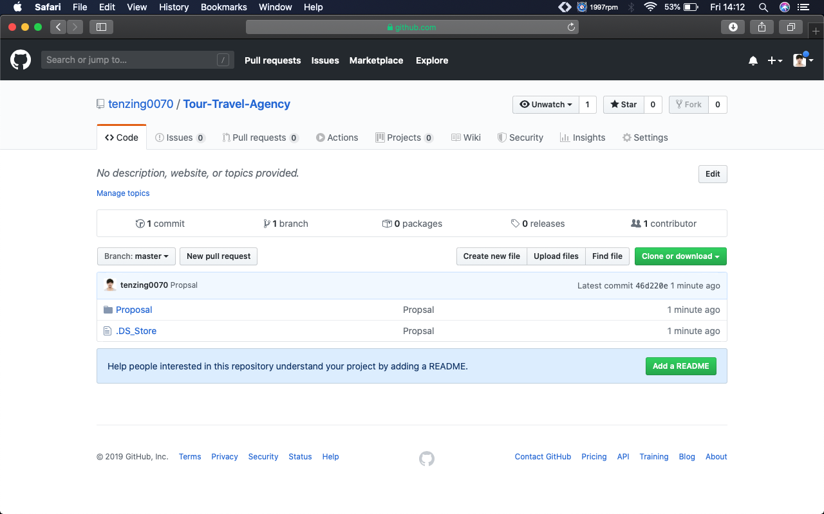
https://github.com/tenzing0070/Tour-Travel-Agency.git

5. Prototyping

- Login

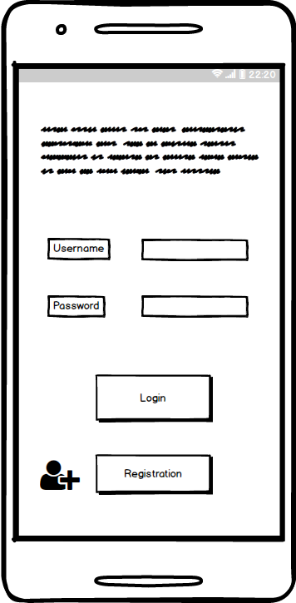

- Registration

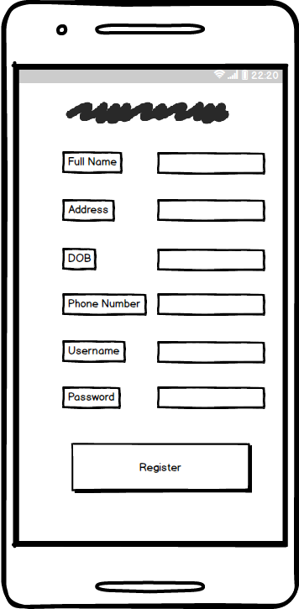

- Dashboard

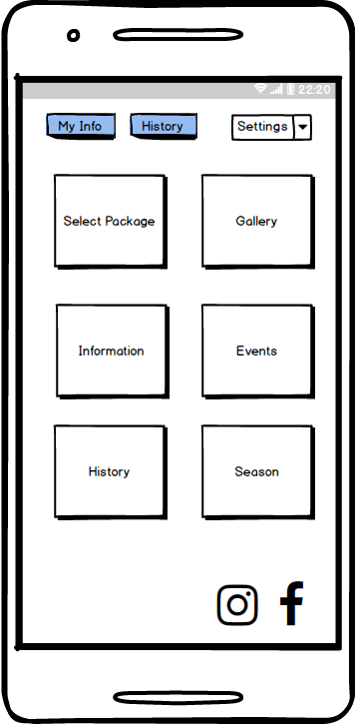

- Package

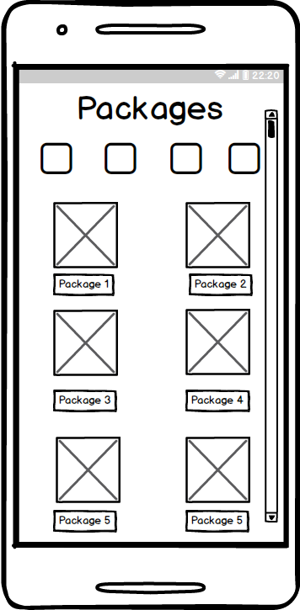

- Package Details

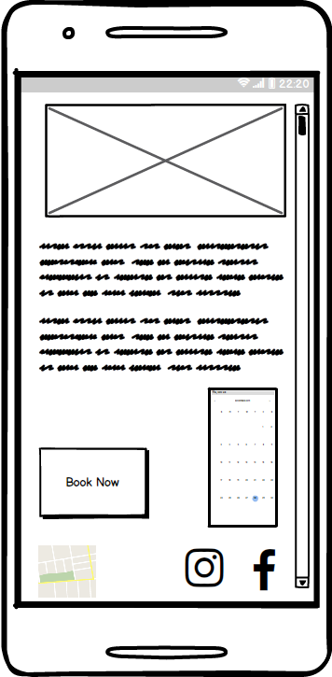

- Checkout

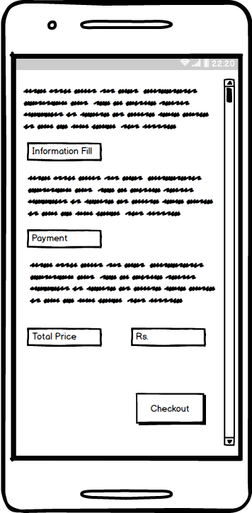

6. Conclusion

Finally, I have successfully accomplished the proposal for this project. Overall background of the proposal, has been planned and discussed. Brief discussion about the project, its features, pros and cons are defined. The prototype design has been made using with an external tool. Rather than paper prototyping, the prototypes are the mockups of the actual interface built in this tool.

7. References

- Waterfall Model. (n.d.). Retrieved from Toolsqa: http://toolsqa.com/software-testing/waterfall-model/

- https://www.geeksforgeeks.org/mvc-design-pattern/

