DNP1 Re-Exam, February 2025
VIA University College
Software Technology Engineering
Written individual examination in DNP1
(4 hours)
The Danish version is found later in the document, after the English version.
Den danske udgave findes længere nede, efter den engelske udgave.
You are allowed to use any IDE (Visual Studio, VS Code, JetBrains Rider, etc) and to browse the Internet for information (however, no live communication, e.g. chats, or contact with any other people, no uploading to public git repository, no use of ChatGPT, or similar AI).
This is an individual exam!
When finished, upload your entire solution folder in a .zip file to WiseFlow.
In general, you must remember to follow the conventions, theory, and best practices taught in class, such as (but not limited to) asynchronous programming, dependency injection, at least minimal error handling, RESTful endpoints, efficient data access. Read the exercise description thoroughly.

Point evaluation
The exam set is split into 3 separate, unrelated assignments. You can do the assignments in any order you want. Various parts (component/project, package, class, method, etc.) are worth a number of points. You can score a total maximum of 100 points.
It is not “all or nothing”, so if part of something works, but not entirely, you may still get a reduced number of points for that.
The points are awarded per assignment roughly as follows:
- Blazor: 35%
- Web API: 35%
- Entity Framework: 30%

Setup solution
First, you need to create a new solution.
Your study number must be included in the solution name, for example:
”DnpExam123456”
You will create a total of three projects: Blazor, WebApi, EFC.
Do not create any extra projects, if not specifically stated.

Assignment 1 – Blazor
In this assignment you will create a stand-alone Blazor app. The idea is that a boardgame hobby club shares boardgames. Members can lend their own boardgames to the club, and they can play other’s games at the club. So, if a member has a game, they wish to make available, they can register it in this app.
Asynchronous programming is optional in this exercise.
Below is a simplified, incomplete class-diagram, which must be followed. You will add more to your system than is shown in the diagram.
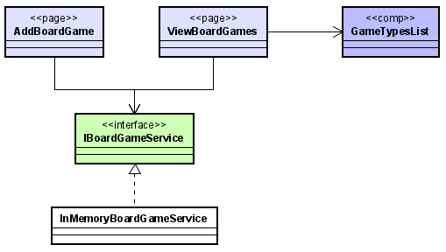

1.1 Create Blazor Project

Create a new "Blazor Web App" or "Blazor WebAssembly Standalone App" project, name it Blazor.

Choose "Include sample pages" as we will use the NavMenu.razor Layout later
(or you can create your own Navigation Menu)

1.2 Entity
Create the following data model class, name it BoardGame. It must have the following properties:
- Owner: The name of the person who owns the board game.
- Genre: The genre of the game, for example: Strategy, Deduction, Escape, Puzzle, etc.
- Title: The title of the board game.
- Play time: The time it roughly takes to play the game, in minutes.
- Front image: A link to the image of the front of the board game box.

Use appropriate types. Place the class somewhere reasonable in your Blazor project.

1.3 InMemoryBoardGameService with dummy data
Create an interface, IBoardGameService.
Then create an implementation, InMemoryBoardGameService.
Place both somewhere reasonable.
The constructor of the InMemoryBoardGameService must initially create at least 5 entries (dummy data) with varying details and keep the entities in a list.
The service must be registered to be injected into various pages.

1.4 Add Board Game
Create a new page, name it AddBoardGame.
This page must contain input fields for the properties on the BoardGame entity.
Use appropriate input field types.
Add a button to the page. When you click the button, a new instance of BoardGame must be created and passed to the IBoardGameService. Define an appropriate method on the interface.
The implementation of this method in InMemoryBoardGameService must then add the board game to the list of entries in the class.
Provide feedback to the user on success or failure.
This new page must be added to the navigation menu.

1.5 Show all games
Create a new page, name it ViewBoardGames.
This page must show a list of the board game entries, ordered by title.
The view must display the following details for the entries:
- Title
- Genre
- The front image
and should look something like the below image:
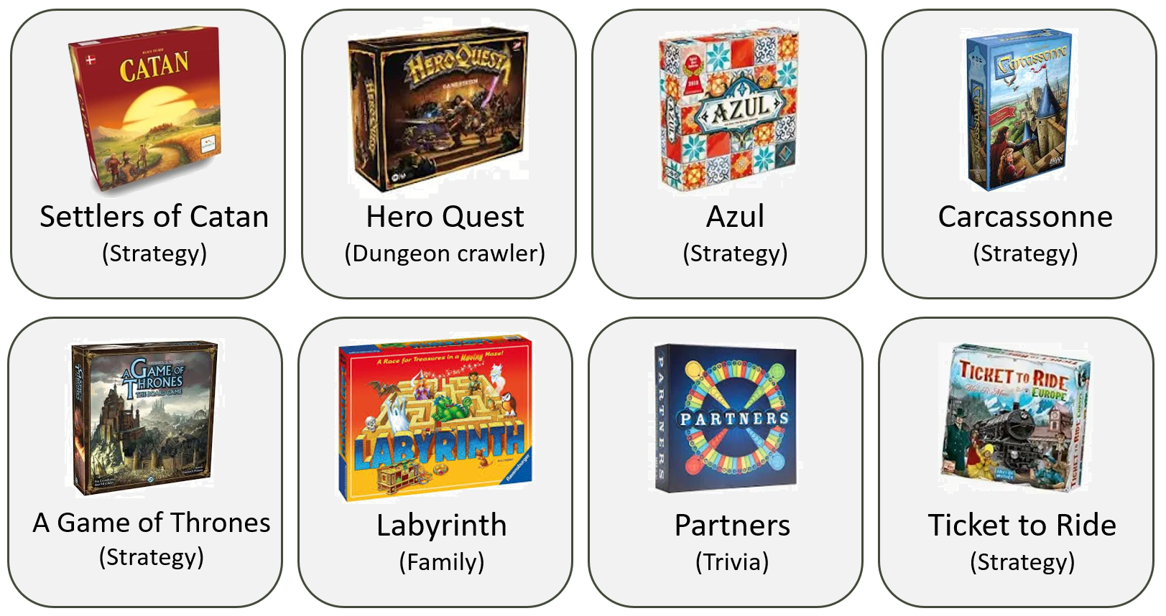
It must be possible to click on a “card”, and then see the owner and the play time.
This page must be added to the navigation menu.

1.6 Component
Create a new component, name it GenreList.
This component will output a list of all genres, and how many games there are per genre.
For example, given the above 8 game boards, the component would output the following information:
- Strategy: 5
- Dungeon Crawler: 1
- Family: 1
- Trivia: 1
Insert the component in your existing page, ViewBoardGames from 1.5.

Assignment 2 – Web API
In this assignment you will create a Web API for a Magic the Gathering deck building app.
Each Deck consists of multiple Cards.
You may use controllers or minimal API for the Web API.
Asynchronous programming is optional in this exercise.
You must include error handling, where relevant.
You must return proper http responses.
You must follow rest-like URI conventions.
Below is a simplified, incomplete, class diagram of the most relevant classes:
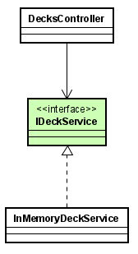

2.1 Create Web API project
Create a new “Web API” project, name it WebApi.

2.2 Entities
Create entities Army and Unit. The entities must contain the following properties:
The Deck has the following properties:
- Id
- PlayerName, name of the person who plays the deck.
- Format, the intended format for the deck, such as “Commander”, “Standard”, or “Vintage”.
- A collection of cards.
The Card has the following properties:
- Id
- CardName, the name of the card.
- ManaCost, how much mana it costs to play the card.
- IsCreature. Some cards are creatures, other cards have other effects.
Choose reasonable types for each property.
Place the classes somewhere reasonable.

2.3 DeckService with dummy data
Create an interface, IDeckService
Then create an implementation, InMemoryDeckService
Place both somewhere reasonable.
The InMemoryDeckService must:
- Contain a list of Decks.
- Initialize the list with dummy data in the constructor
(i.e. it populates the list of Decks with a few Decks, each having some Cards).
The service implementation and interface must be set up for dependency injection, so that it can be used by your controllers/endpoints.

2.4 - Endpoints
Below is a list of endpoints that you must implement.
Either put them in a controller or use the minimal API approach.

2.4.1 Create Deck
Create an endpoint which receives a Deck.
The InMemoryDeckService class must be responsible for setting the Id and adding the Deck to the list of Decks.

2.4.2 Add Card to Deck
Create an endpoint responsible for adding a Card to an existing Deck.
Ensure that the deck exists or return an appropriate response.

2.4.3 View all decks
Create an endpoint responsible for returning decks, where it must be possible to filter the list of decks with optional criteria.
The possible filters are CommanderName and Faction. It must be possible to either apply all filters at the same time, only some of them, or none.

2.4.4 Get cards
Create an endpoint which is responsible for returning the collection of Cards of a specific deck.
Ensure you handle potential errors accordingly.

Assignment 3 – Entity Framework
In this assignment you will create a database and write some sample methods to exemplify the usage of the database.

The database will contain information of characters and their items (e.g. sword, shield, staff, potion, etc.).
You must use Entity Framework Core (EFC) and SQLite.
You must use asynchronous programming in this exercise, where possible.
Below is a simplified, incomplete, diagram of what the exercise will contain:
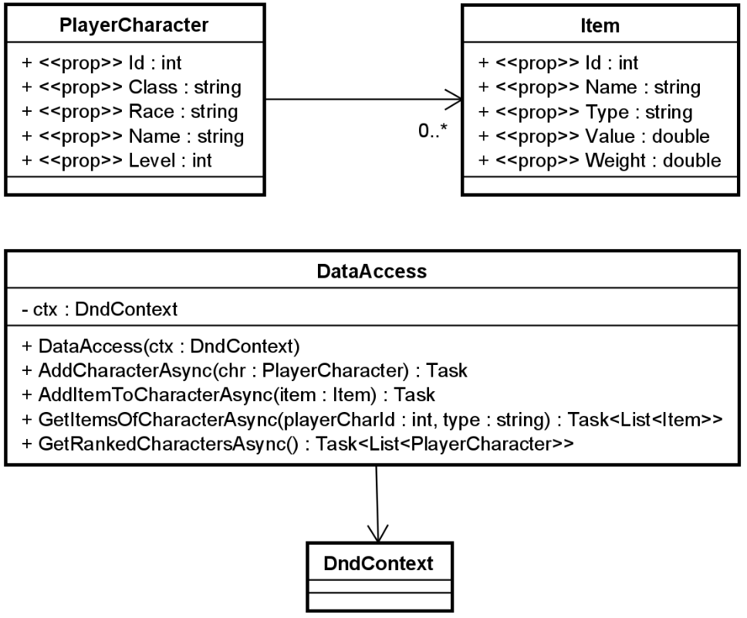

3.1 Create console project
Create a new “Console” project, name it EFC.

3.2 Entities
Create the PlayerCharacter and Item entities in an appropriate directory.
You must define a good primary key for both entities.
The PlayerCharacter has the following properties:
- Class: The class of the character, e.g. monk, warrior, paladin, warlock, etc..
- Race: The race of the character, e.g. elf, human, dragonkin, etc.
- Name: The name of the character.
- Level: The level of the character, a numeric value between 0 and 100.

The Item entity has the following properties:
- Name: The name of the item, e.g. “Rusty broad sword”, “Broken bow”, “Minor healing potion”, ...
- Type: The type of the item, e.g. “Edible”, “Weapon”, “Potion”, “Junk”, etc.
- Value: How much does this item sell for?
- Weight: The weight of the item.
You may add additional properties to both entities, if you need it.

3.3 DbContext
Add relevant EFC NuGet packages to the project.
Create the DndContext class. It must define relevant DbSet properties.
You must use SQLite.
Then create migrations.
Then create the database.

3.4 Data access class
Create the DataAccess class, for now only with its constructor.

3.5 Add character
Implement the AddCharacterAsync(..) method on the DataAccess class.
It takes a PlayerCharacter as a parameter and inserts it into the database.
In the Program.cs file, demonstrate how this method is used. Create at least three characters and add them.

3.6 Add item to character
Implement the AddItemToCharacterAsync(..) method on the DataAccess class.
It must add a new Item to an existing PlayerCharacter.
In the Program.cs file, demonstrate how this method is used. Create and add at least two items to each team.

3.7 Get items for character
Implement the GetItemsOfCharacterAsync(..) method.
It must receive two arguments:
- The playerCharId argument is required.
- The type argument is optional.
The method will find the Items belonging to the PlayerCharacter with the provided ID. If the type argument is provided, the resulting list of items is filtered to only include items of that specific type.

3.8 Get characters ranked
This method will return the list of PlayerCharacters, ordered as follows:
- First, order the PlayerCharacters by their level.
- Then order the list by the characters’ value to weight ratio. This is given by the sum of the values divided by the sum of the weight. But! You must ignore “Junk” items.

In the Program.cs file, demonstrate how this method is used.

This is the end of the exam-set.

