Le Teo Website Development Process
This project focused on building a minimal European luxury interior design website called 'Le Teo'. During the process, I collaborated with AI tools to discuss layout direction, navigation systems, interaction design, and overall website structure. Instead of pretending that I fully knew every part of the coding process from the beginning, I used AI as a creative and technical assistant while learning how HTML, CSS, and JavaScript work together to create a complete interactive website.

1. Initial Website Concept
At the beginning of the project, I focused on establishing the visual identity and emotional tone of the website. I wanted the design to feel modern, architectural, quiet, and editorial rather than looking like a typical ecommerce site. I discussed ideas such as Scandinavian minimalism, modern European interiors, luxury typography, and soft neutral tones with AI to shape the direction of the website.
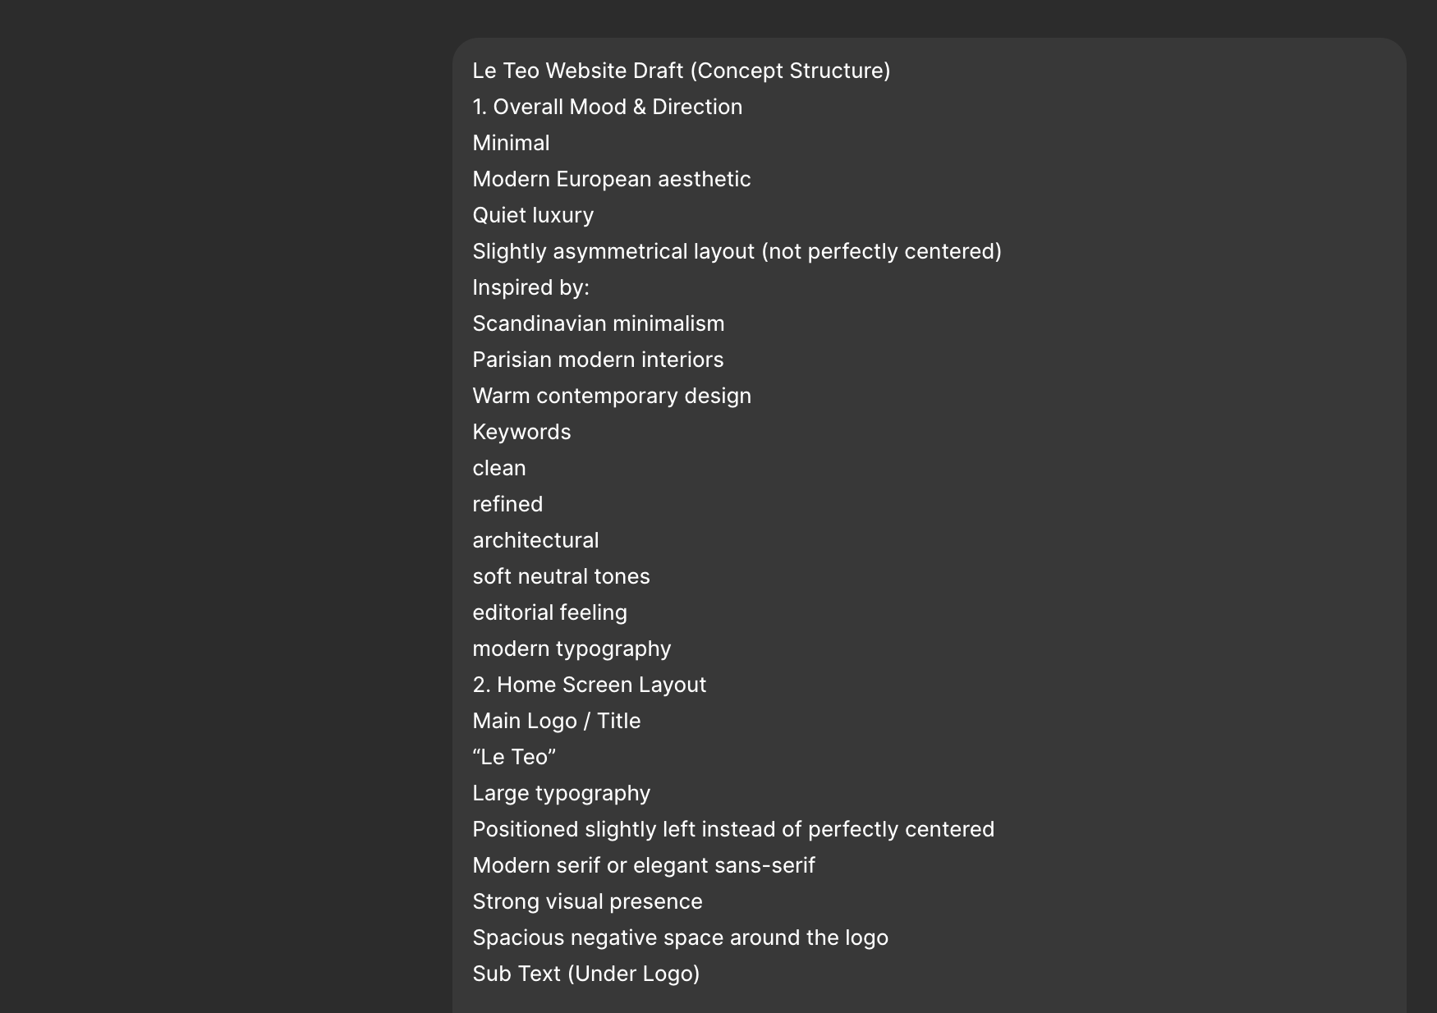
Figure 1. AI discussion and website iteration process.
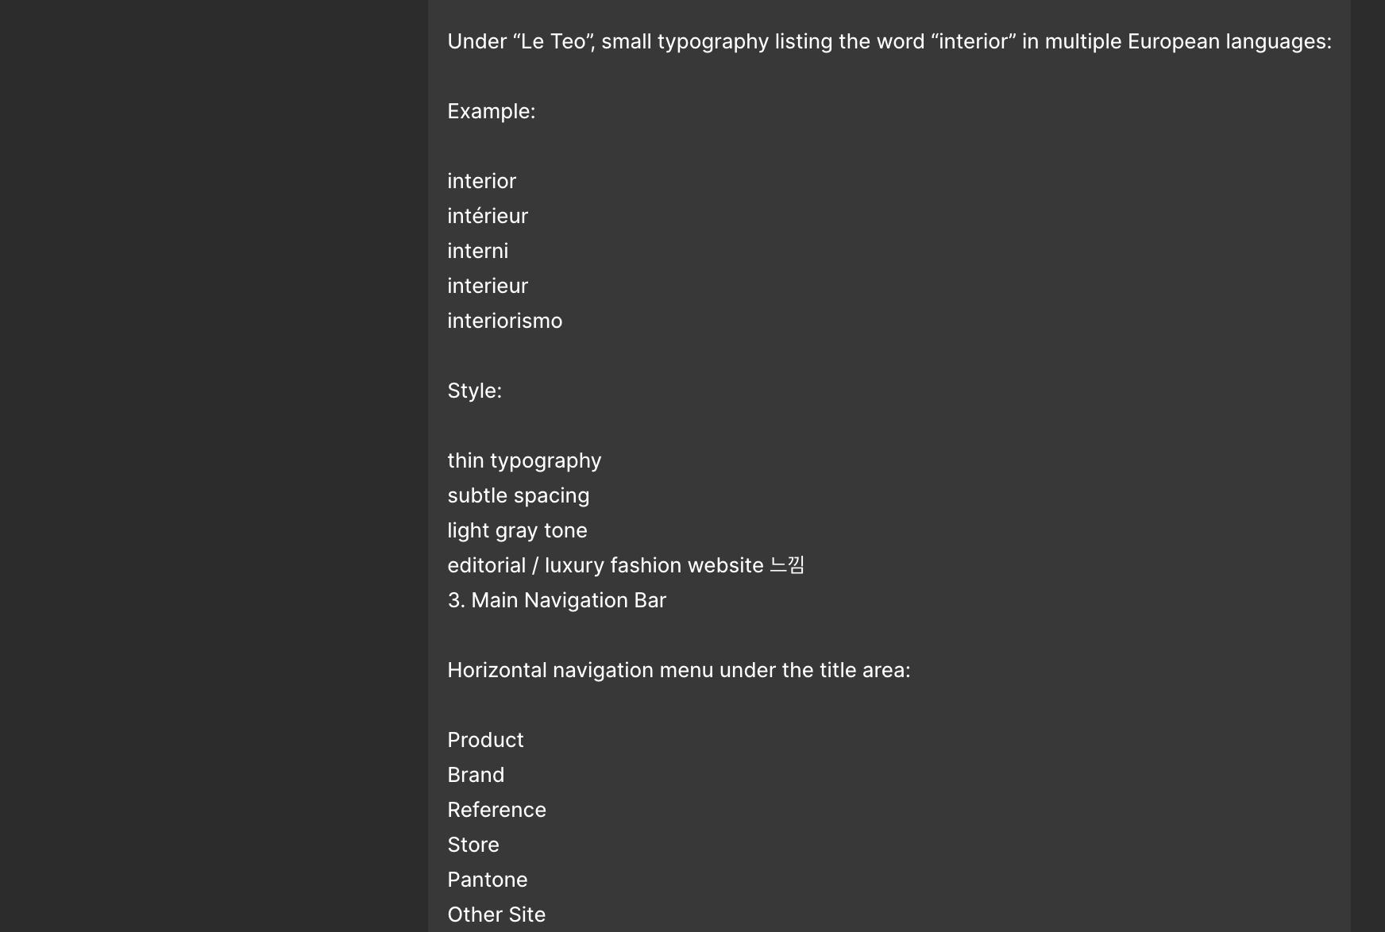
Figure 2. AI discussion and website iteration process.

2. Navigation & Interaction Design
One of the biggest challenges was building the navigation system. The website includes dropdown menus for Product, Brand, and Reference sections. While testing the website, I noticed problems such as menus disappearing too quickly or navigation items breaking on internal pages. Through debugging and discussion with AI, I learned more about hover interactions, page states, and how JavaScript controls dynamic behavior.
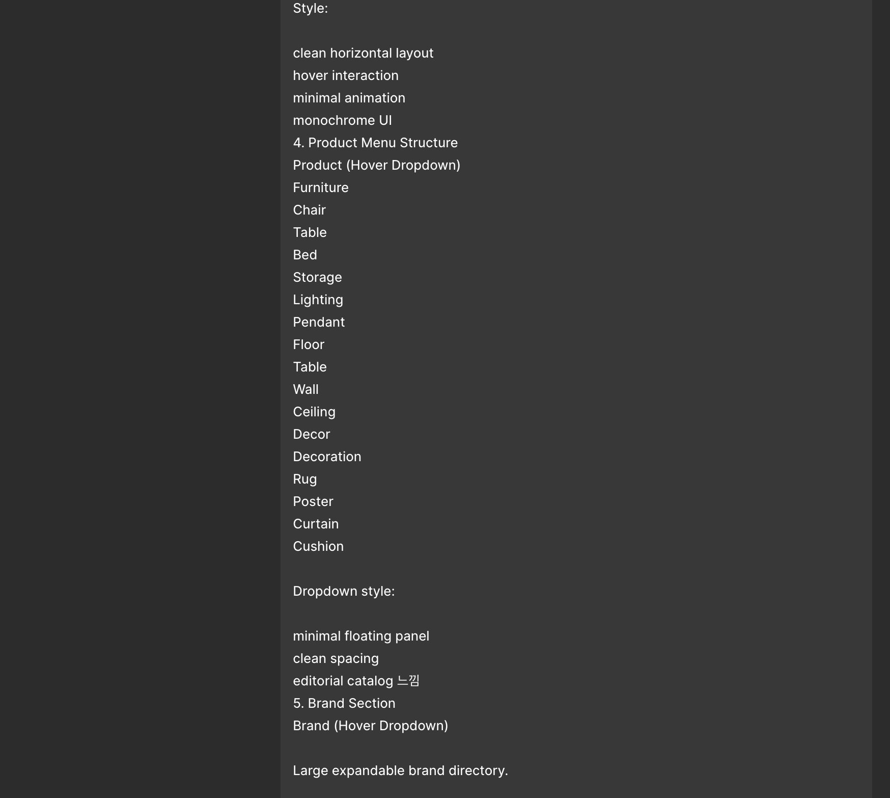
Figure 3. AI discussion and website iteration process.
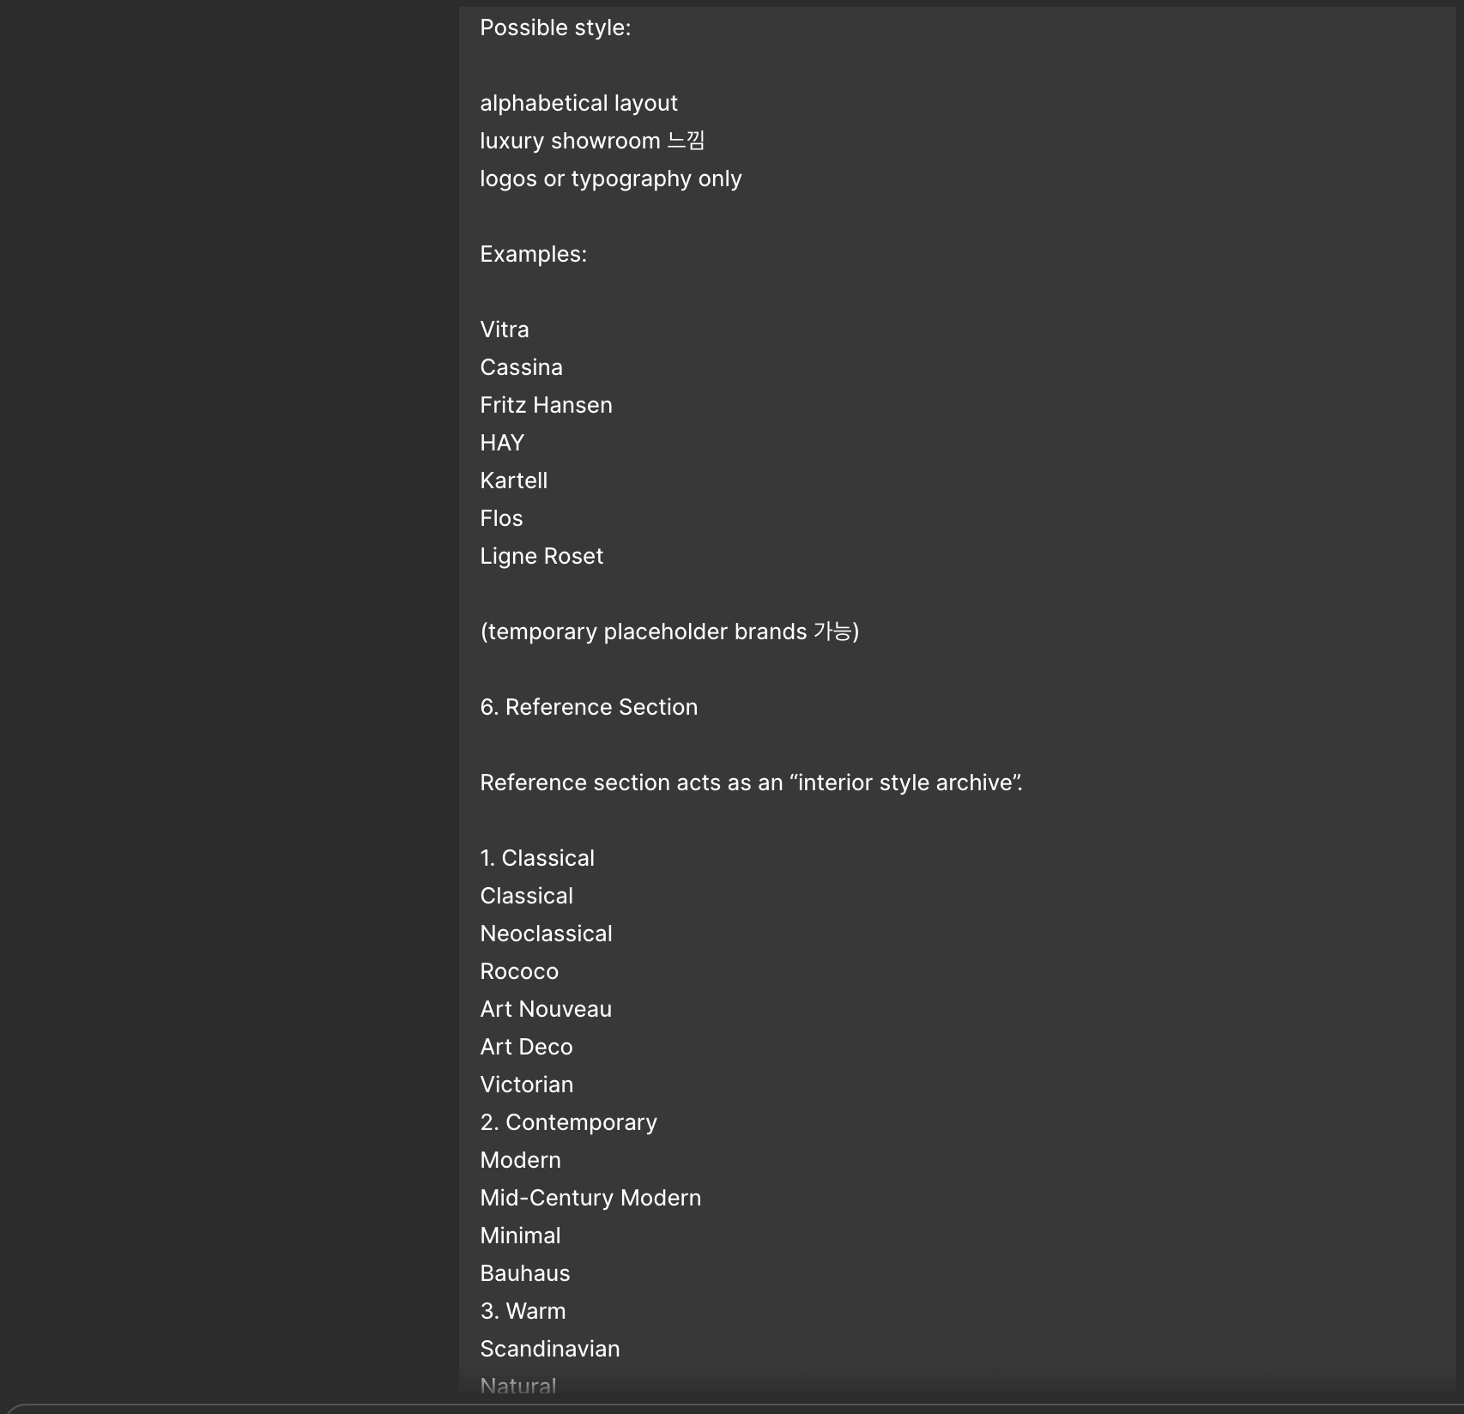
Figure 4. AI discussion and website iteration process.

3. Product Page System
The product pages were designed as editorial-style browsing pages instead of heavy marketplace layouts. The system included product grids, search functionality, category filtering, hover animations, and responsive layouts. This process helped me better understand CSS grid systems, layout organization, and user experience design.
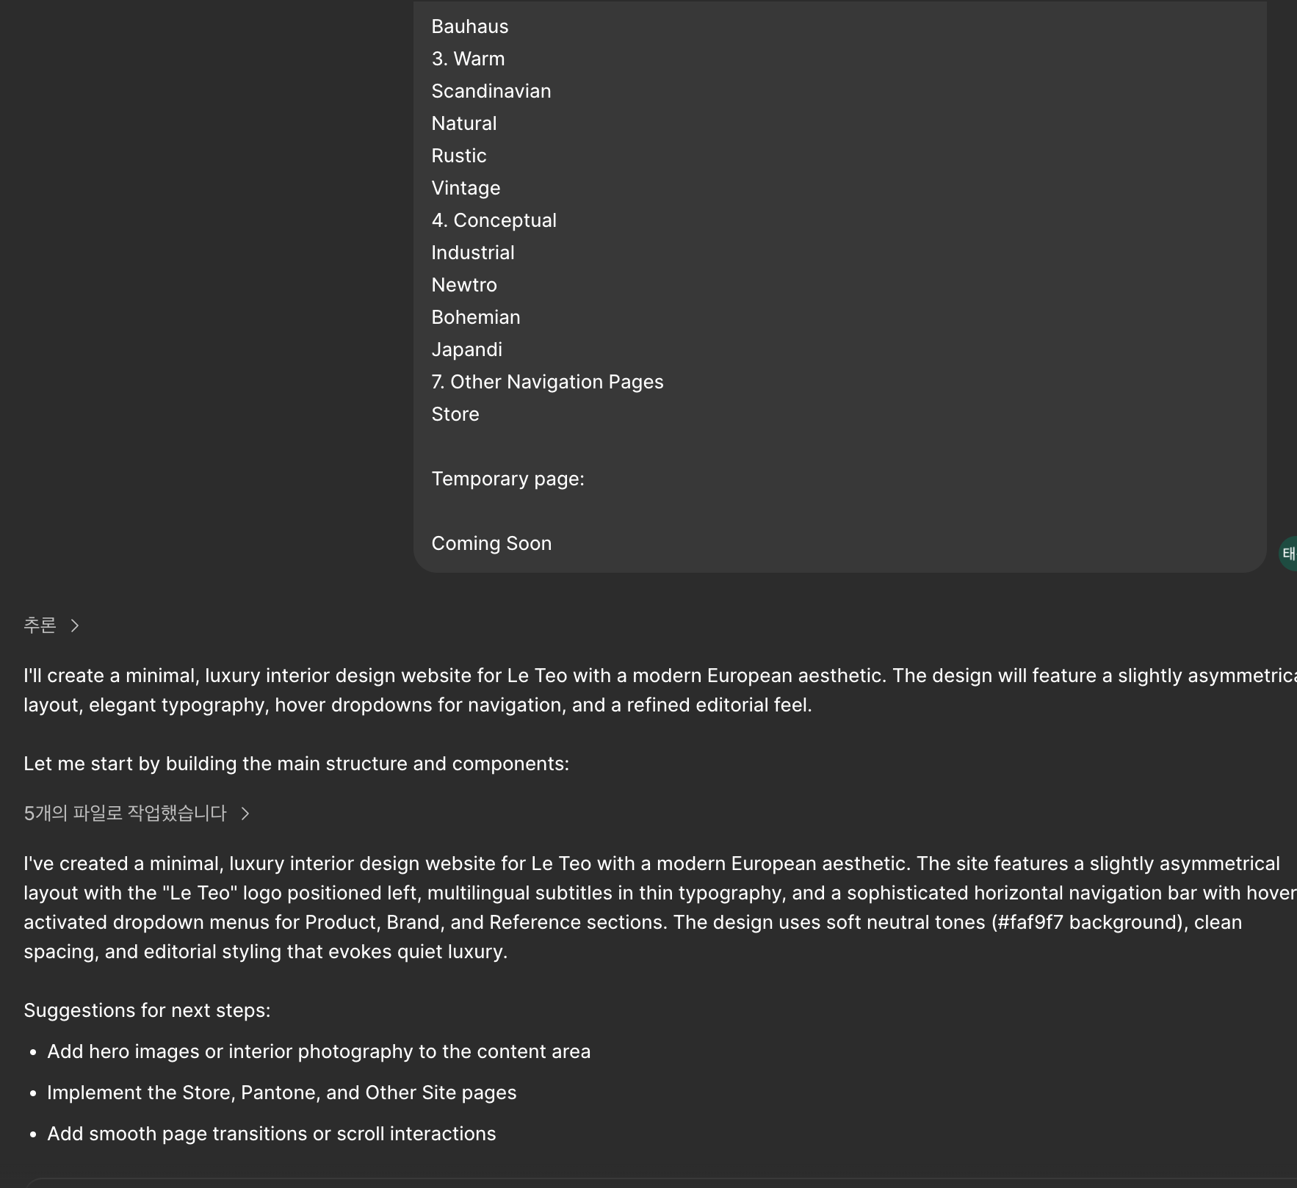
Figure 5. AI discussion and website iteration process.
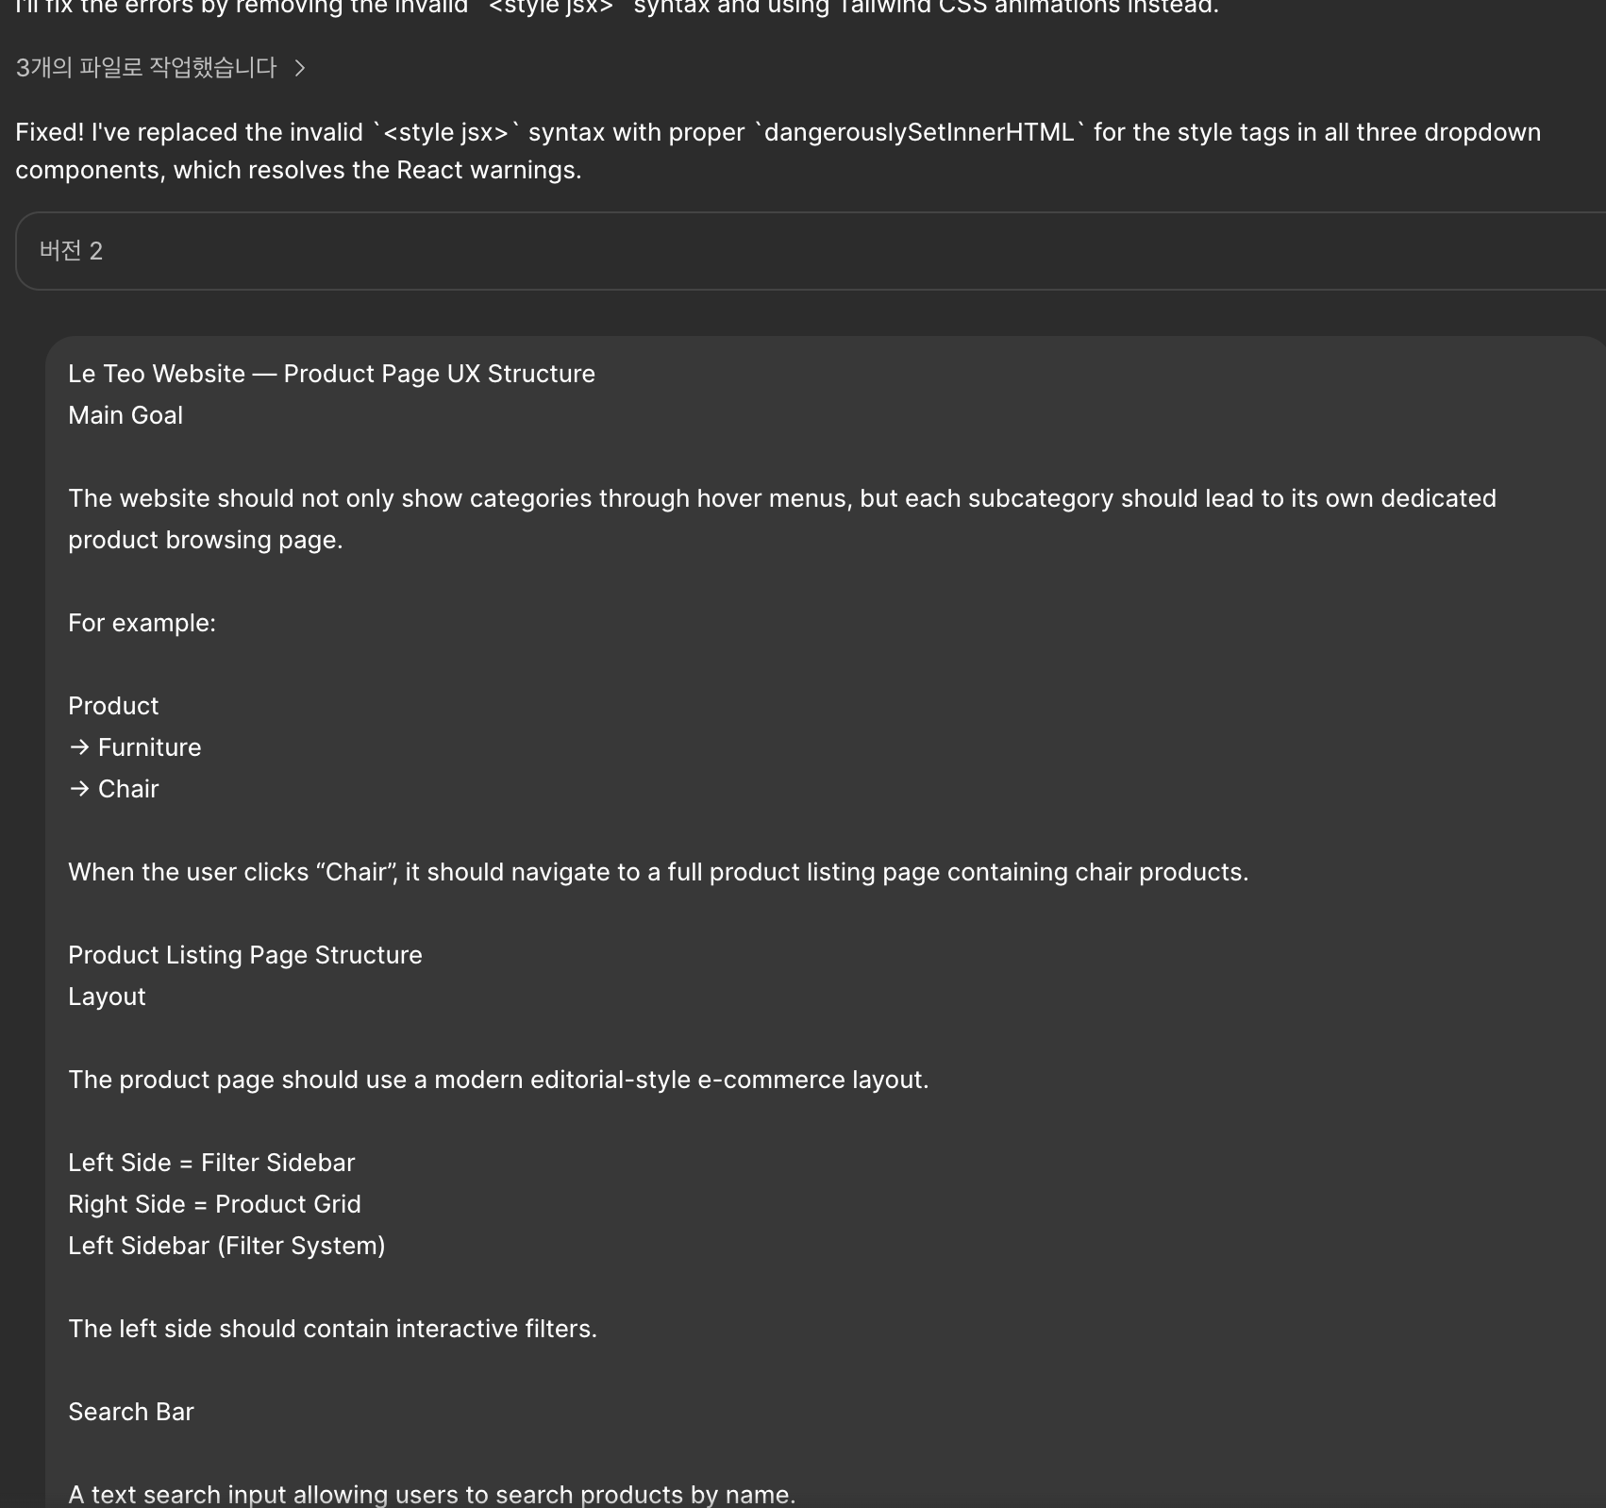
Figure 6. AI discussion and website iteration process.

4. Brand & Reference Pages
Another important part of the project was creating immersive Brand and Reference pages. Each reference style such as Scandinavian, Bauhaus, Industrial, and Japandi was intended to have a different visual atmosphere while still maintaining the core Le Teo identity. This helped me understand how typography, imagery, spacing, and color palettes influence the mood of a webpage.
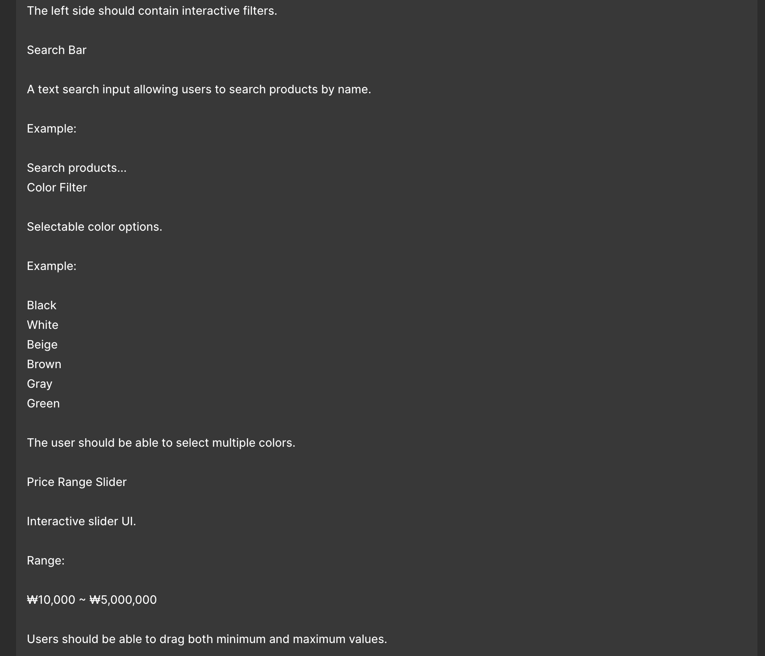
Figure 7. AI discussion and website iteration process.
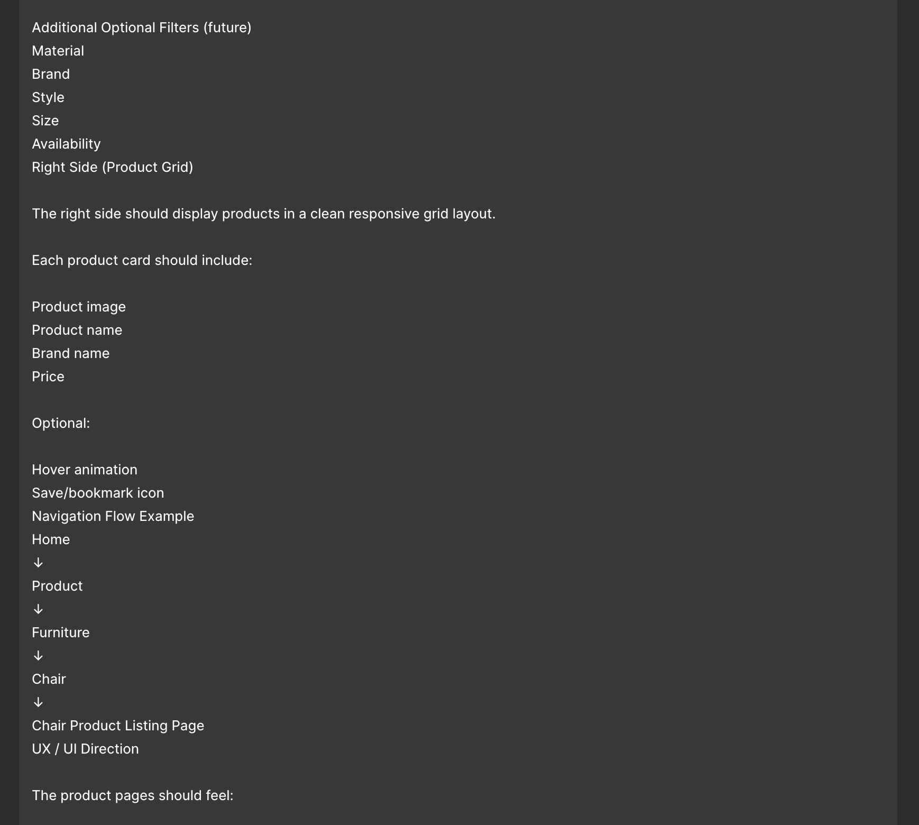
Figure 8. AI discussion and website iteration process.

5. Technical Learning
The project mainly used HTML for structure, CSS for visual styling, and JavaScript for interactions and navigation logic. Even though AI helped generate and improve parts of the code, I still needed to understand the structure enough to modify problems, replace images, fix interactions, and organize the system. I especially learned about dropdown behavior, responsive layouts, DOM interaction, and reusable structures.
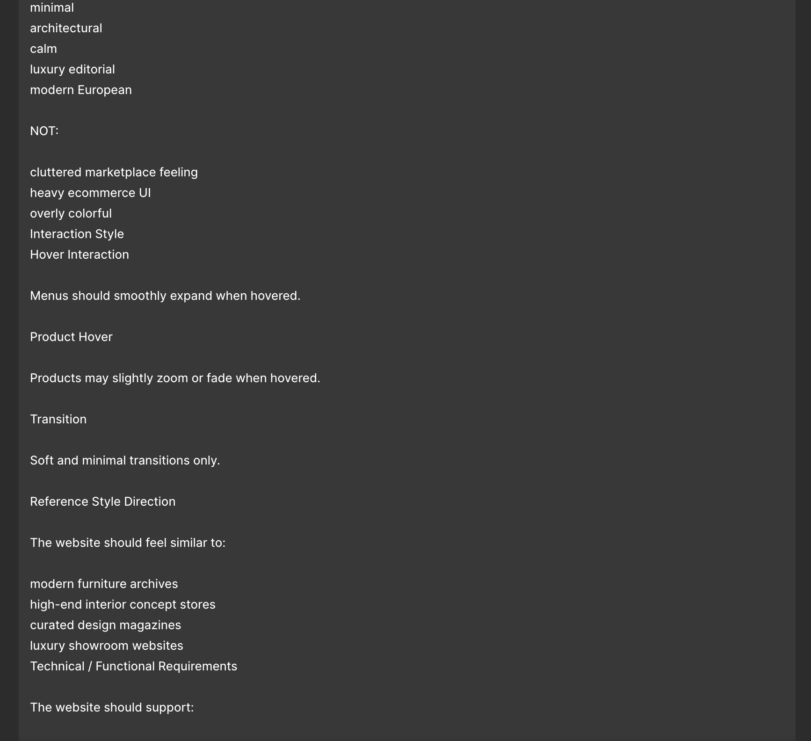
Figure 9. AI discussion and website iteration process.
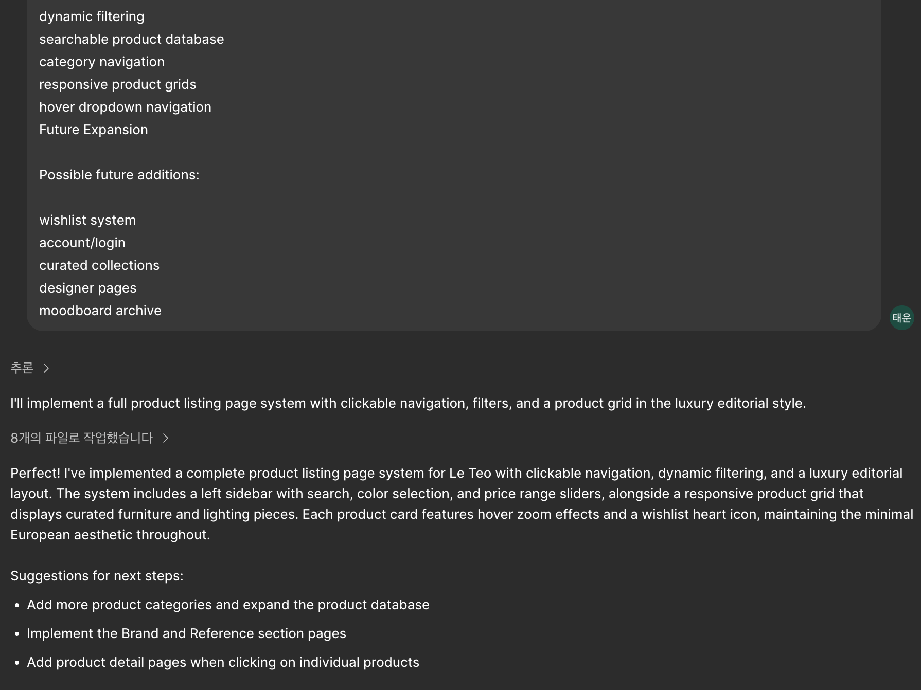
Figure 10. AI discussion and website iteration process.

6. Reflection
Overall, this project helped me realize that frontend design is not only about making things look visually attractive. User flow, interaction design, organization, and responsiveness are equally important. Working together with AI also taught me how AI can be used as a collaborative creative tool during design and coding workflows.
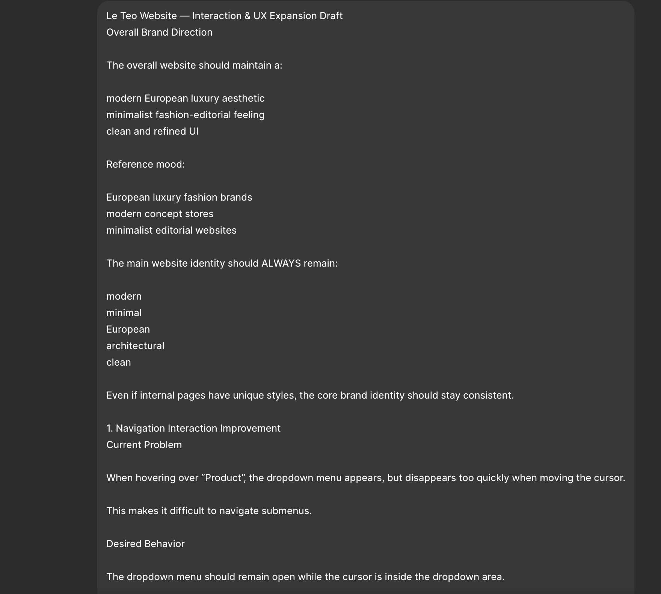
Figure 11. AI discussion and website iteration process.
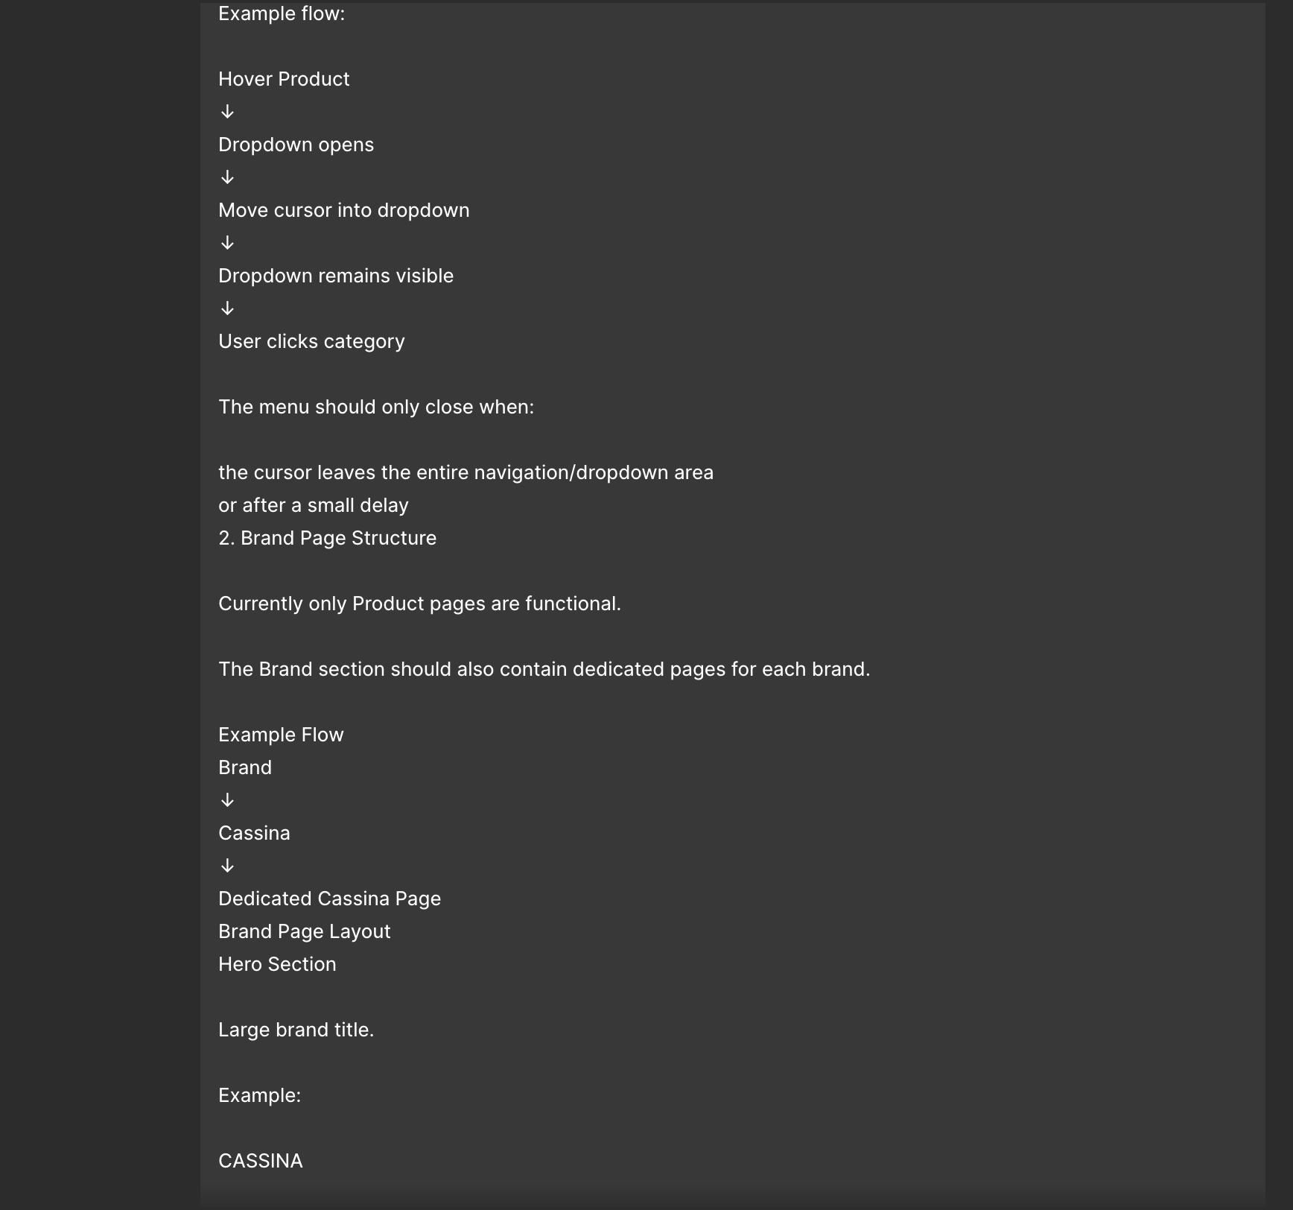
Figure 12. AI discussion and website iteration process.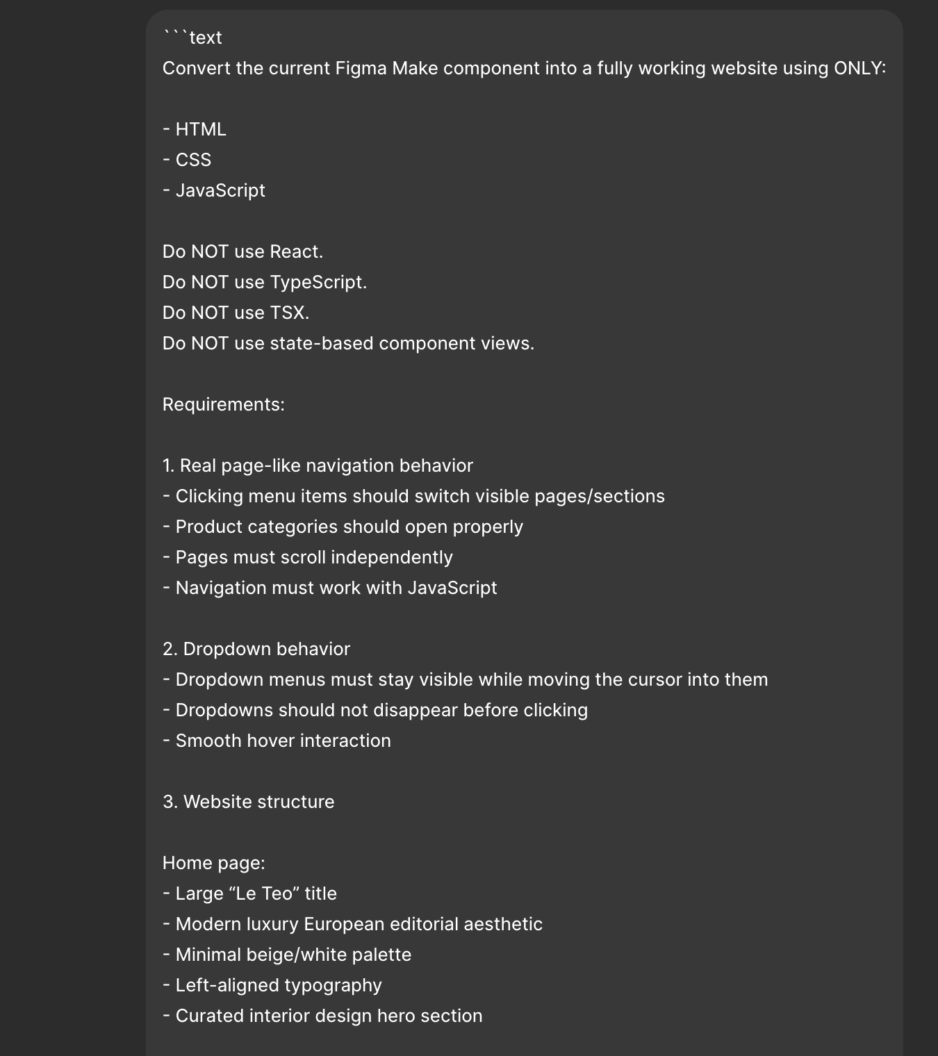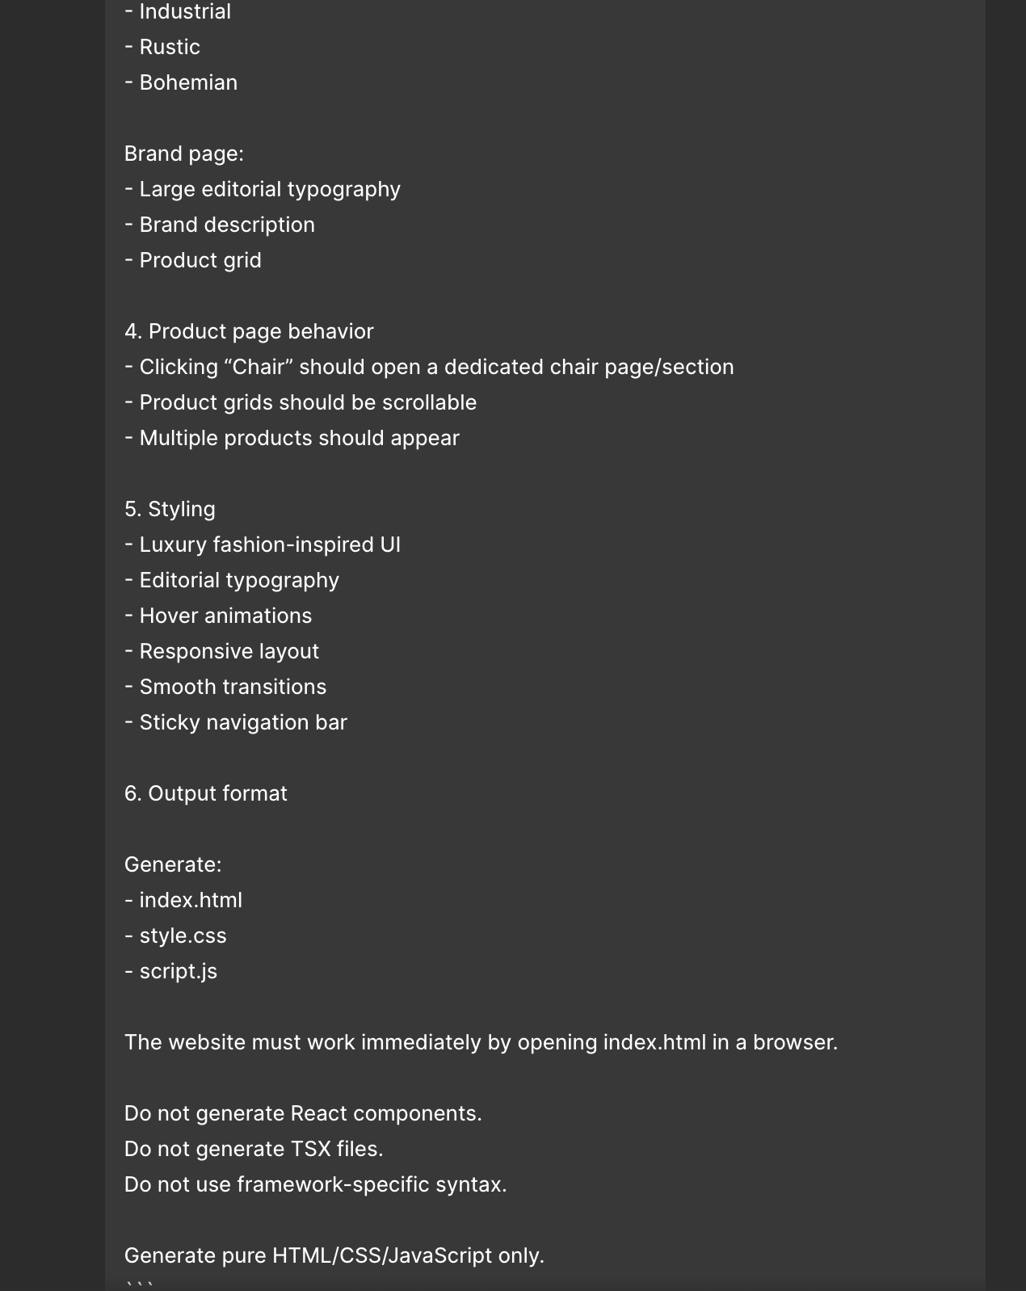
I asked AI to generate the website using HTML, CSS, and JavaScript, and then I studied the code step by step afterward. Beyond simply completing the assignment, breaking down and analyzing already functioning code helped me learn much faster than starting completely from scratch. Through this process, I was able to better understand how the structure, styling, and interactions were built together. I think this experience will help me create more of the system on my own in future projects.

