# Eclesiar's Pulse

Report generated: 2025-08-27 14:27

Source data fetched: 2025-08-27 14:06

**Congratulations to the Top Warrior: Karlos-I (Spain)!**

# ⚔️ Battlefield Pulse: Key War Statistics

Damage attributed to a country is the sum of damage dealt by players of that country across all battles in the last 24 hours (regardless of whether the country was a party to the conflict).

## 🗺️ Military Activity: ongoing and finished wars

Ongoing battles:

* Argentina vs Serbia (war #12773) — region Comodoro Rivadavia (score 0:0)
* Saudi Arabia vs Iran (war #12772) — region Mashhad (score 1:0)
* India vs Bulgaria (war #12771) — region Ahmedabad (score 0:1)
* Romania vs Poland (war #12770) — region Constanta (score 0:3)
* Black vs White (war #12769) — region Stadium (score 4:0)
* North Macedonia vs Croatia (war #12768) — region Strumica (score 1:3)
* Argentina vs Sweden (war #12767) — region Posadas (score 1:4)
* Croatia vs North Macedonia (war #12766) — region Kocani (score 4:3)
* Hungary vs Slovenia (war #12765) — region Murska Sobota (score 1:7)
* Israel vs Slovenia (war #12764) — region Be'er Sheva (score 3:5)

No finished battles to display.

### 🗺️ Wars: Changes vs Yesterday

Ongoing wars: ▼ -2 (10 vs 12)

In the last 24 hours, military activity was recorded in 10 countries.

Slovenia: 3,683,739

Spain: 1,841,366

Bulgaria: 1,457,660

Hungary: 1,167,939

Saudi Arabia: 1,094,658

Sweden: 1,036,658

Croatia: 949,494

## 📊 Executive Summary: Key Changes

⚔️ Total military activity: ▼ -21.1% (13,223,587 vs 16,763,488)

💰 Currency markets: Stable (no significant changes)

See detailed comparisons below for specific metrics.

## ⚖️ Military: Compared to yesterday

Top changes in military activity:

• Bulgaria: -2,418,355 (▼ decrease)

• Hungary: -1,963,226 (▼ decrease)

• Spain: +1,841,366 (▲ increase)

• Slovenia: +1,744,331 (▲ increase)

• United States of America: -1,224,155 (▼ decrease)

## 💰 Economic: Compared to yesterday

### Currency Rate Changes

No currency rate data available for comparison.

### Price Changes for Key Items

Item 14: ▼ -99.10% (0.000067 → 0.007481 GOLD)

Item 11: ▼ -97.39% (0.000563 → 0.021538 GOLD)

Item 5: ▼ -96.86% (0.001520 → 0.048414 GOLD)

Item 15: ▼ -96.78% (0.001126 → 0.035000 GOLD)

Item 18: ▼ -95.35% (0.010005 → 0.215378 GOLD)

Item 20: ▼ -95.24% (0.000890 → 0.018703 GOLD)

Item 16: ▼ -95.18% (0.003378 → 0.070120 GOLD)

Item 19: ▼ -94.83% (0.000345 → 0.006667 GOLD)

# 🏆 Best of the Best: Heroes Ranking

Here's the list of the most powerful warriors from the last 24 hours:

1. Karlos-I (Spain): 1,841,366 damage
2. Colon3lBruce (Slovenia): 1,524,601 damage
3. THANОS (Bulgaria): 1,457,660 damage
4. maher (Slovenia): 1,100,827 damage
5. 1hell (Saudi Arabia): 1,094,658 damage
6. Swedski Lincon (Sweden): 1,036,658 damage
7. Aexil (North Macedonia): 932,338 damage
8. Ashborn (Hungary): 719,383 damage
9. Cameltoe (Poland): 636,937 damage
10. Zoki (Slovenia): 567,674 damage

## 🏆 Top Warriors: Changes vs Yesterday

Warriors who maintained top positions:

• 1Hell: ▼ -20.2% (1,094,658 vs 1,371,436)

• Colon3Lbruce: ▲ +20.6% (1,524,601 vs 1,263,878)

• Thanоs: ▼ -23.7% (1,457,660 vs 1,909,965)

New warriors in top list:

• Maher (Slovenia): 1,100,827 damage

• Cameltoe (Poland): 636,937 damage

• Zoki (Slovenia): 567,674 damage

# 💰 Economic Pulse

## 💼 Top 5 Best Job Offers Worldwide

Best paid job offers across all countries (salary in GOLD):

|  |  |  |  |
| --- | --- | --- | --- |
| Country | Company | Company ID | Salary (GOLD) |
| Slovenia | — | 2974 | 1.533333 |
| Poland | — | 8103 | 1.262136 |
| Chile | — | 2142 | 1.250000 |
| Croatia | — | 3216 | 1.210000 |
| United States of America | — | 200 | 1.133333 |

* flagged as potentially anomalous (re-check conversion)

## Currency rates vs GOLD

|  |  |  |  |
| --- | --- | --- | --- |
| Currency | Rate (GOLD per 1) | Yesterday Rate | Change % |
| -1 | 1.000000 | 1.000000 | → +0.00% |
| ALL | 0.003082 | 0.010000 | ▼ -69.18% |
| ARS | 0.012987 | 0.028571 | ▼ -54.55% |
| AUD | 0.100000 | 0.190694 | ▼ -47.56% |
| BAM | 0.020619 | 0.125000 | ▼ -83.51% |
| BGN | 0.012658 | 0.066765 | ▼ -81.04% |
| BRL | 0.052632 | 0.083333 | ▼ -36.84% |
| CLP | 0.050000 | 0.059175 | ▼ -15.50% |
| CNY | 0.104221 | 0.175346 | ▼ -40.56% |
| COP | 0.010050 | 0.020000 | ▼ -49.75% |
| DEM | 0.100000 | 0.188715 | ▼ -47.01% |
| EGP | 0.020408 | 0.052632 | ▼ -61.22% |
| ESP | 0.200000 | 0.346380 | ▼ -42.26% |
| FRF | 0.027027 | 0.095630 | ▼ -71.74% |
| GBP | 0.055556 | 0.093493 | ▼ -40.58% |
| GEL | 0.066667 | 0.188679 | ▼ -64.67% |
| GRD | 0.027027 | 0.095247 | ▼ -71.62% |
| HRK | 0.100000 | 0.137363 | ▼ -27.20% |
| HUF | 0.027778 | 0.107689 | ▼ -74.21% |
| IDR | 0.010000 | 0.041667 | ▼ -76.00% |
| IEP | 0.033338 | 0.034486 | ▼ -3.33% |
| INR | 0.050000 | 0.100000 | ▼ -50.00% |
| IQD | 0.083333 | 0.120715 | ▼ -30.97% |
| IRR | 0.001001 | 0.011111 | ▼ -90.99% |
| ITL | 0.030303 | 0.073212 | ▼ -58.61% |
| JPY | 0.020408 | 0.029499 | ▼ -30.82% |
| KRW | 0.055556 | 0.103114 | ▼ -46.12% |
| LTL | 0.003333 | 0.020000 | ▼ -83.33% |
| MKD | 0.001126 | 0.077519 | ▼ -98.55% |
| MXN | 0.010124 | 0.012658 | ▼ -20.02% |
| NIS | 0.303490 | 0.411523 | ▼ -26.25% |
| PEN | 0.020000 | 0.040035 | ▼ -50.04% |
| PHP | 0.010000 | 0.125000 | ▼ -92.00% |
| PKR | 0.003448 | 0.066667 | ▼ -94.83% |
| PLN | 0.242718 | 0.249377 | ▼ -2.67% |
| PTE | 0.050000 | 0.099800 | ▼ -49.90% |
| RON | 0.001001 | 0.045459 | ▼ -97.80% |
| RSD | 0.057143 | 0.121036 | ▼ -52.79% |
| RUB | 0.010105 | 0.066667 | ▼ -84.84% |
| SAR | 0.010000 | 0.025647 | ▼ -61.01% |
| SEK | 0.050025 | 0.095429 | ▼ -47.58% |
| SIT | 0.066667 | 0.099020 | ▼ -32.67% |
| TRY | 0.100000 | 0.263227 | ▼ -62.01% |
| UAH | 0.050845 | 0.100000 | ▼ -49.15% |
| USD | 0.066667 | 0.095356 | ▼ -30.09% |
| ZAR | 0.003636 | 0.034483 | ▼ -89.45% |

## Goods — cheapest offers

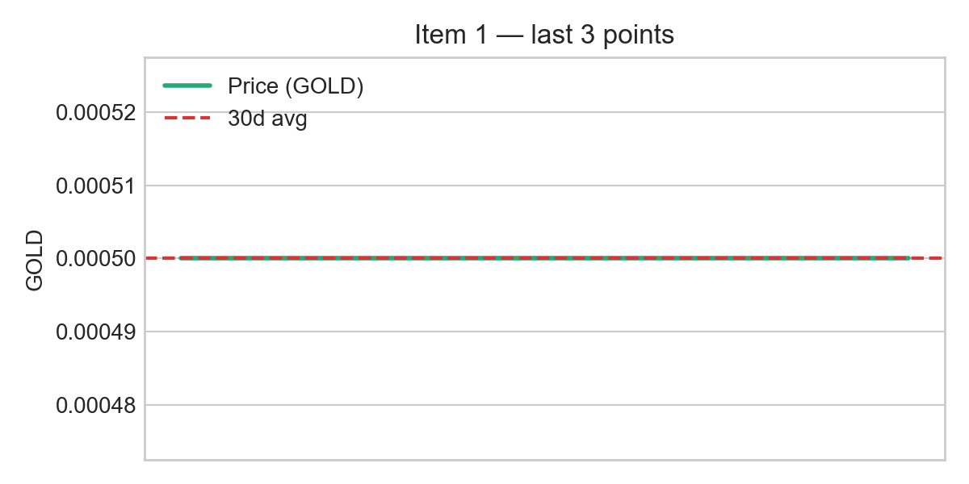

**30d average: 0.000500 GOLD**

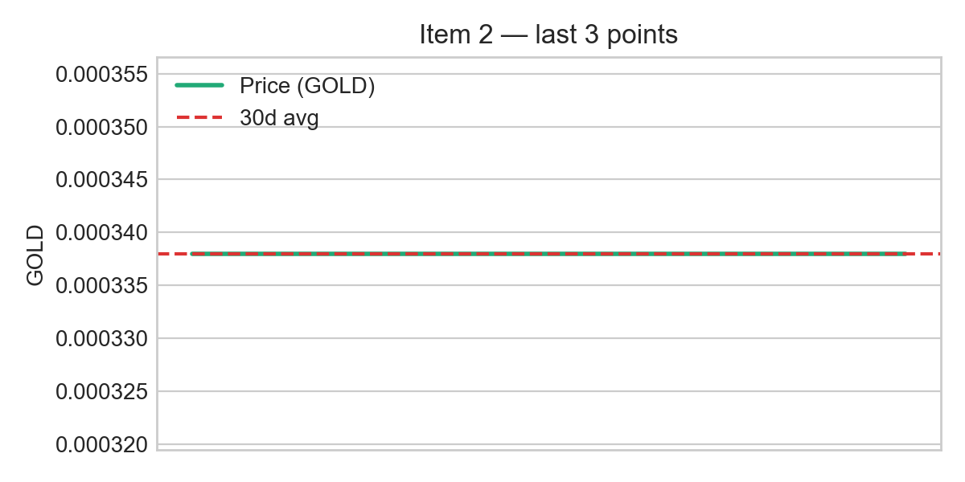

**30d average: 0.000338 GOLD**

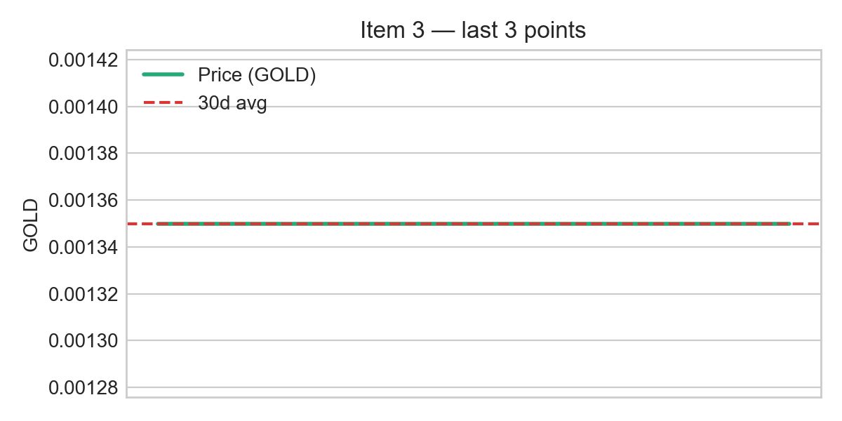

**30d average: 0.001350 GOLD**

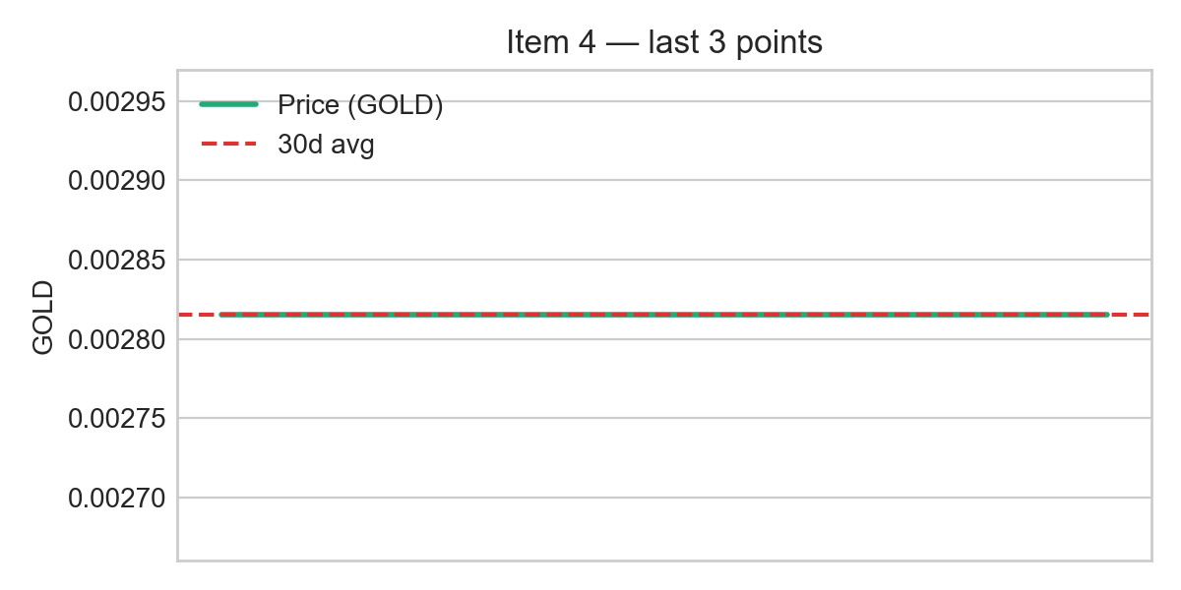

**30d average: 0.002815 GOLD**

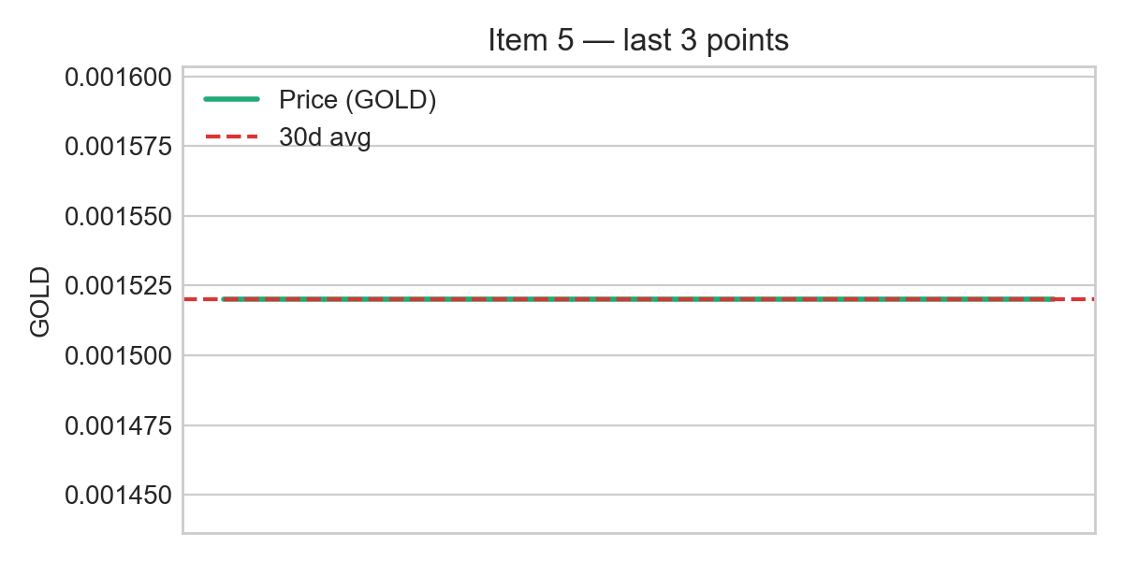

**30d average: 0.001520 GOLD**

## 🌍 Cheapest Items from All Countries

Cheapest items of each type across all countries:

### Raw Materials

|  |  |  |  |
| --- | --- | --- | --- |
| Item | Country | Price (currency) | Price (GOLD) |
| titanium | Pakistan | 0.1 PKR | 0.000345 |
| grain | Romania | 0.5 RON | 0.000500 |
| iron | South Africa | 0.2 ZAR | 0.000727 |
| fuel | Romania | 0.96 RON | 0.000960 |

### Food

|  |  |  |  |
| --- | --- | --- | --- |
| Item | Country | Price (currency) | Price (GOLD) |
| food q1 | North Macedonia | 0.3 MKD | 0.000338 |
| food q2 | North Macedonia | 1.199 MKD | 0.001350 |
| food q4 | North Macedonia | 1.35 MKD | 0.001520 |
| food q3 | North Macedonia | 2.5 MKD | 0.002815 |
| food q5 | North Macedonia | 3.0 MKD | 0.003378 |

### Weapons

|  |  |  |  |
| --- | --- | --- | --- |
| Item | Country | Price (currency) | Price (GOLD) |
| weapon q1 | South Africa | 0.059 ZAR | 0.000215 |
| weapon q4 | North Macedonia | 0.5 MKD | 0.000563 |
| weapon q5 | South Africa | 0.399 ZAR | 0.001451 |
| weapon q2 | Hungary | 0.09 HUF | 0.002500 |
| weapon q3 | Hungary | 0.127 HUF | 0.003528 |

### Tickets

|  |  |  |  |
| --- | --- | --- | --- |
| Item | Country | Price (currency) | Price (GOLD) |
| airplane ticket q1 | Georgia | 0.001 GEL | 0.000067 |
| airplane ticket q2 | North Macedonia | 1.0 MKD | 0.001126 |
| airplane ticket q3 | North Macedonia | 3.0 MKD | 0.003378 |
| airplane ticket q4 | Romania | 10.0 RON | 0.010005 |
| airplane ticket q5 | Romania | 10.0 RON | 0.010005 |

### Aircraft

|  |  |  |  |
| --- | --- | --- | --- |
| Item | Country | Price (currency) | Price (GOLD) |
| aircraft q1 | North Macedonia | 0.79 MKD | 0.000890 |
| aircraft q2 | North Macedonia | 1.5 MKD | 0.001689 |
| aircraft q3 | Romania | 3.33 RON | 0.003332 |
| aircraft q4 | Romania | 7.0 RON | 0.007004 |
| aircraft q5 | Romania | 8.0 RON | 0.008004 |