SNICC Installation

Prerequisites

1. docker
Install docker on your system : [https://docs.docker.com/get-started/get-docker/]

2. git
Install git : [https://git-scm.com/downloads]

3. source code
Open a terminal and clone the source code
$ git clone https://github.com/laurent-braud/snicc.git
Clonage dans 'snicc'...
remote: Enumerating objects: 2157, done.
remote: Counting objects: 100% (12/12), done.
remote: Compressing objects: 100% (11/11), done.
remote: Total 2157 (delta 0), reused 2 (delta 0), pack-reused 2145 (from 1)
Réception d'objets: 100% (2157/2157), 13.93 Mio | 14.89 Mio/s, fait.
Résolution des deltas: 100% (1353/1353), fait.

Run docker image

4. Enter the directory.
$ cd snicc

5. Edit .env
Copy dot.env to .env. Edit .env, setting the host port to suit your needs.
- HOST_PORT : port of the server
- EMAIL_HOST, EMAIL_PORT, EMAIL_HOST_USER, EMAIL_HOST_PASSWORD : authentification to the smtp mail server. If EMAIL_HOST is not set, the server will not output email, so user login is not possible (admin login is still available).

6. Run the containers
This might take some time while docker is downloading and building containers.
$ docker compose up -d
✔ Network snicc_snicc Created
✔ Container snicc-django-1 Started
✔ Container snicc-nginx-1 Started

7. Enter the main container.
$ docker compose exec django bash

8. Build static files
# python manage.py collectstatic
258 static files copied to '/code/static'.

9. Make migrations
# python manage.py makemigrations
Migrations for 'measure':
measure/migrations/0001_initial.py
+ Create model CacheResponse
+ Create model Label
+ Create model Line
+ Create model LineCategory
+ Create model MeasureField
+ Create model Meta_0
+ Create model Pilar
+ Create model Action
+ Add field category to line
+ Create model Meta_1
+ Create model Meta_2
+ Create model Measure
Migrations for 'main':
main/migrations/0001_initial.py
+ Create model Language
+ Create model Post
+ Create model PostCategory
+ Create model Profile
+ Create model Provincia
+ Create model Tag
+ Create model Media
+ Add field category to post
+ Create model PostCategoryVersion
+ Create model PostProfile
+ Create model PostVersion
main/migrations/0002_initial.py
+ Add field user to postversion
+ Add field profile to postprofile
+ Add field tags to post
~ Alter unique_together for postprofile (1 constraint(s))
Migrations for 'user':
user/migrations/0001_initial.py
+ Create model User
+ Create model EditorAccess

10. Apply migrations in the database.
# python manage.py migrate
Operations to perform:
Apply all migrations: admin, auth, contenttypes, main, measure, sessions, user
Running migrations:
Applying main.0001_initial... OK
Applying contenttypes.0001_initial... OK
Applying contenttypes.0002_remove_content_type_name... OK
Applying auth.0001_initial... OK
Applying auth.0002_alter_permission_name_max_length... OK
Applying auth.0003_alter_user_email_max_length... OK
Applying auth.0004_alter_user_username_opts... OK
Applying auth.0005_alter_user_last_login_null... OK
Applying auth.0006_require_contenttypes_0002... OK
Applying auth.0007_alter_validators_add_error_messages... OK
Applying auth.0008_alter_user_username_max_length... OK
Applying auth.0009_alter_user_last_name_max_length... OK
Applying auth.0010_alter_group_name_max_length... OK
Applying auth.0011_update_proxy_permissions... OK
Applying auth.0012_alter_user_first_name_max_length... OK
Applying user.0001_initial... OK
Applying admin.0001_initial... OK
Applying admin.0002_logentry_remove_auto_add... OK
Applying admin.0003_logentry_add_action_flag_choices... OK
Applying main.0002_initial... OK
Applying measure.0001_initial... OK
Applying sessions.0001_initial... OK

11. Create a superuser
# python manage.py createsuperuser
Nombre de usuario: admin
Dirección de email: admin@example.com
Password:
Password (again):
Superuser created successfully.

12. Load initial metadata
The superuser (or any user with id 1) must exist to allow the loading of data.
# python manage.py loaddata main_medidas

13. Superuser access
Navigate to <SITE>/admin/user/user/1/change/ and give the superuser full editor access (“Todos los idiomas”, etc). Save the changes (guardar).
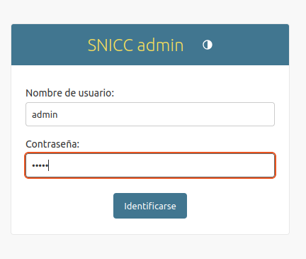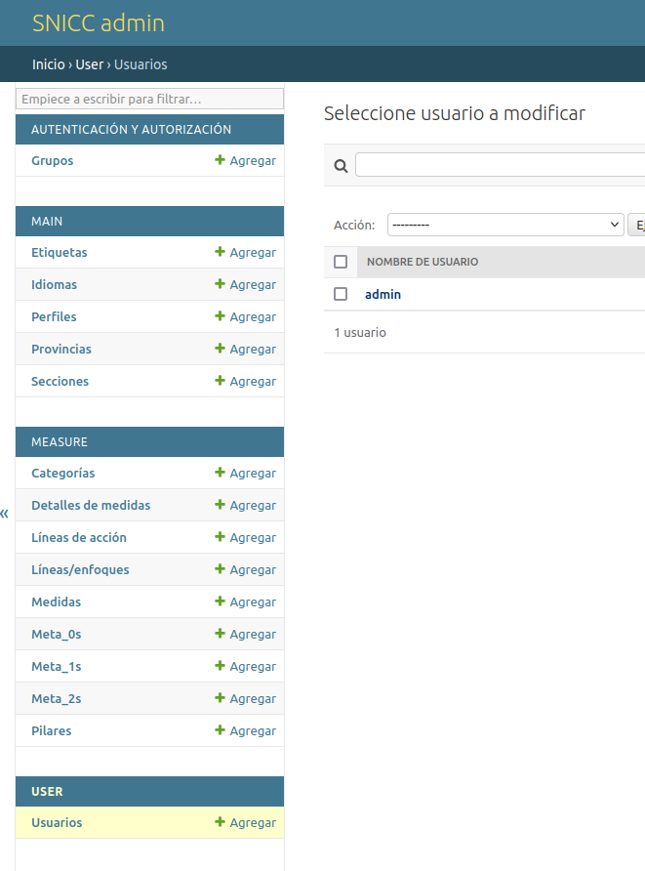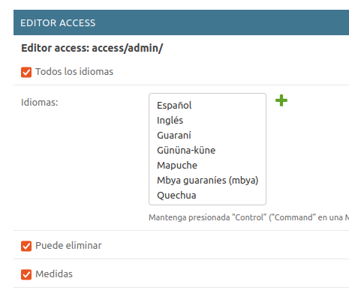

14. Setup users
Create a user via the admin or let him/her registrate through the regular user process.
- For the user to be a editor, go to Editor Access below. Configure the editing access as needed. The user will be able to edit post and/or measures at the /editor/post/list url.
  - Idiomas means the user will only be able to edit specific languages, or all if Todos los idiomas is checked
  - Puede eliminar means the user is able to delete unprotected posts
  - Medidas means the user can also edit measures (but not create new ones).
- For the user to be an administrator, check the is_superuser box. The user will be able to login to the /admin/ interface and edit anything there. You might want to also give editor access to this user.

