CALCULATOR
Author: Ilie Teodora
- Theme Requirements
The project is a simple calculator of basic additions and substractions. This calculator is thought to be used by children, in kindergarten for example, in order to help the children learn the basics of mathematics from a young age.
- Chosen Solutions
I am going to present the functioning principles which make the implementation possible.
A key point to make refers to importing functions, such as “printf”, “scanf” and “exit”. The first one assures displaying the output, at the moment it is called. The second makes possible user intervention. The user is able to insert integers, for example, using “%d”. The type of inserted data is established in “.data” field. The last function marks the end of the program, when called.
Example of declaring the functions to be imported:
extern printf: proc
extern scanf: proc
extern exit: proc

The “start” symbol is compulsory to declare, in preparation for launching the execution. Afterwards, declaring data is needed when there are messages to be displayed and fields required from users. For this to happen, “.data” is noted. In “.data” section, variables, memory locations, are declared, which means that to symbolic names are attached physical addresses of the variables and space is reserved in the memory.
For example, I have the following message:
m_expresie db "Introduce an expression: ", 0

Here, the variable name is “m_expresie”, a symbolic name, chosen to denote an interpretation key to the reader, about what is supposed to mark. “DB” comes from “Data Byte” and its size is of 8 bit. “0” exists because “printf” requires NULL terminated.
The “start:” label in the “.code” section marks the beginning of execution phase. “PUSH” is used to add operands on the stack. “CALL” assures saving the return address on the stack and the jump to the specified address in the instruction. “CMP” is used to compare the two operands by performing subtraction. The result is not stored, but the flags are modified. It is usually followed by a conditional jump instruction.
The jump instruction, “JMP”, produces changes in the execution sequence of others’. There are unconditional jump instructions, which execute in any condition and conditional jumps, which execute when a specific condition is fulfilled (such as a flag or combination of flags). “JE” which executes if and only if the comparison determines equal operands. The tested flags for it is ZF = 1. An example may be:
cmp operator2, 61
je afisare_rezultat
EAX, EBX, ECX, EDX are the registers mostly used in arithmetic and logic operations (responsible with keeping the values of the operands). They are addressed both on half size (16 bit) and 8 bit. Therefore, the 16 bit registers are AX, BX, CX, DX. The first 8 bits of register EAX is considered to be inferior, the “low” part. They are to be initialized before making use of them.
“EAX” is the register which usually keeps one operand and afterwards the result. Considering multiplication and division instructions, it is used as default for the first operand and result. “EBX” is also used for calculating the base address when needed.
“ECX’s” arithmetic function is doubled by the one of a counter, as default in loop instructions. “EDX” is employed “in/out” instructions for ports. It may be implicated as an extension of register EAX, when it comes to multiplying and division operations. “ESP” is a register which addresses the stack of the currently running program. As an example for initializing ax and bx with integers, making use of MOV instruction:
mov EBP, ESP

“MOV” instruction transfers data between two registers, one register and a memory location or an immediate value is stored in a register or variable. Memory-to-memory transfers are not allowed and both parameters must have the same size. It copies the data item referred to by its second operand into the location referred to by its first operand. It has 2 parameters.
The ret instruction transfers control to the return address located on the stack. This address is usually placed on the stack by a call instruction. Issue the ret instruction within the called procedure to resume execution flow at the instruction following the call .
In order to understand better, here is an example: “mov ax, dx”. The data stored in “dx” register would be copied in “ax”.
The arithmetic instructions used in the application are: “ADD”, “SUB”, “CMP”.“ADD” performs the addition of two operands. The result is stored in the first operand.
“SUB” subtracts the second operand from the first and stores the result in the first parameter. The result is stored in the first operand.
In Assembly, users are able to make their own functions, using the syntax:
<function_name> proc
[main_body_of_the_function]
<function_name> endp

Labels are symbolic names or identifiers. They are given in front of instructions. They may contain letters, numbers or special characters. Comments are additional pieces of information, meant to explain the lines of code or to give an interpretation key considering the approached methods. They are inserted after “;”. With or without them, the code would be compiled and executed.

- Obtained Results
The first part of the application consists in including libraries (msvcrt.lib), alongside declaring printf, scanf and exist as functions to be imported. In this phase, I mention the start symbol (in order to prepare the execution) and data declaring. Here are declared the variables. Some of them are marked under the “DB” type (Data Byte), 8 bit size and some of them are “DD” type (define double word) .
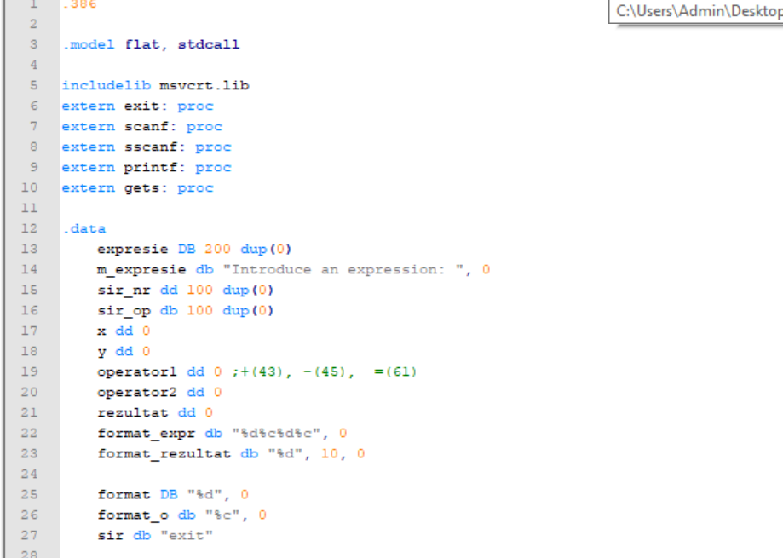
‘Suma’ and ‘diferenta’ procedures are calculating the addition, respectively the substraction of the 2 numbers entered by the user.
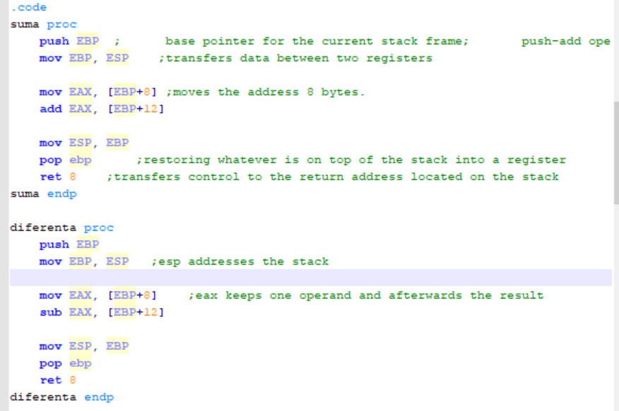
In ‘operatii’, we establish if the sign entered is ‘+’ or ‘-’
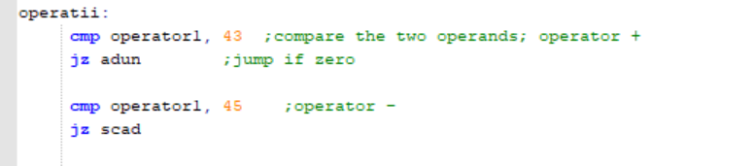
afisare_rezultat is used to print the result and after the result was printed, the application jumps to the end, where it is finished.

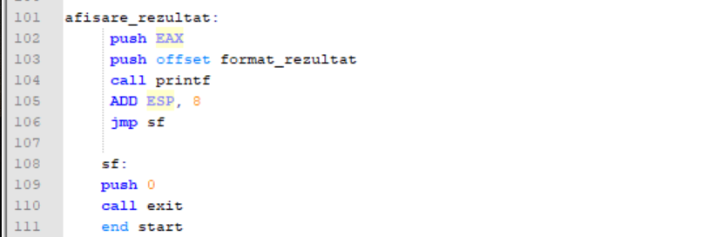

- Tests and Inspection
The application is very easy to be used. The user has to write an equation looking like: ‘a+b=’ or ‘a-b=’ and the application will give the answer.
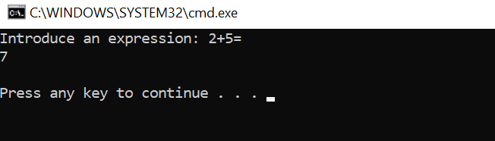

Date:
21.05.2021

