ASSIGMENT NUMBER 4
-Programming Techniques-
Food Delivery Management System

STUDENT NAME: Tat Teodora
GROUP: 30423

CONTENT

- Assignment Objectives
- Problem analysis, modelling, scenarios, use cases
- Design
- Implementation
- Results and testing
- Conclusions
- Bibliography

- Assigment Objects
It is required to create an application for a catering company, having a role based access control system and a way to process information from files. The roles consist of customer, employee and administrator, with the employee having a notification system for when a customer places an order. The administrator can also generate reports and modify the products in the files
This application is very complex, needing the following secondary objectives to achieve it:
Objective | Description | Chapter in which is detailed
Problem analysis | In order to translate the problem into code, one must first extract from the statement relevant information about the functionalities and use cases. | 2
Design | Once the necessary information is extracted, one can start mapping it into the programming paradigm provided. | 3
Implementation | In this step, the code is written to solve the required problem, based on the previously made mapping. | 4
Testing | In order to ensure that the final product or even partial results required for a next stage work correctly, the implemented code must in turn be subjected to tests that simulate usage scenarios identified in the analysis stage. | 5

- Problem analysis, modelling, scenarios, use cases

Functional requests

File operations. The main way to populate the application with products is by reading from a .csv file. A receipt can also be additionally created in a .txt file
Graphic interface. This type of application is more natural to use in the form of a graphical interface, especially for a product order window or data editing
Persistence of information after closing the application. Despite the fact that this is relegated to non-functional requirements, it is crucial in such a context. Here, however, they opt for serialization rather than databases
Role-based access control. The application requires not only account-based operations, but also role-based permissions, which are administrator, employee, and client.

Admin | Employee | Client
- - Can operate on products and menus (add, delete, modify)  - - Can create menus containing several basic products  - - Can import a list of initial products from a .csv file  - - Can generate various reports related to statistics | - Receive notifications when a customer orders something | - He can create an account on the platform  - See products from a menu  - Search for products based on several criteria simultaneously  - To order more products and download the receipt in .txt format

Generating reports for the administrator. As mentioned, the administrator can generate certain reports such as:
- List of orders from a time interval
- List of products that have been ordered more than a certain number of times
- List of customers who have ordered more than a given value, having orders with a total greater than a given value
- All products ordered on a given day and how many times they were ordered.
In order to generate them, Lambda expressions and streams must be used.
Non-functional requirements
Notification system. Every time a customer places an order, an employee should be notified so they know to prepare their food for the order
Design by Contract. For easier code maintenance, it is better to know about the preconditions, postconditions and data axioms used in the class
Use-case scenarios
Even though there is a commonality in app login, each role has totally unique use cases.
Use case: Editing a product
Main actor: the admin
Main use case:
1. The admin logs into the application
2. A window opens for the admin where boxes with existing products appear
3. The admin clicks on the edit button, which turns the window into an editable one
4. Save the changes to the serialization file
Alternate scenario: Admin gets the password or username wrong
- An error message will be displayed and the admin will re-enter their credentials
Alternative scenario: The admin changes his mind and doesn't want to edit anymore.
- The admin will exit the edit mode of the window

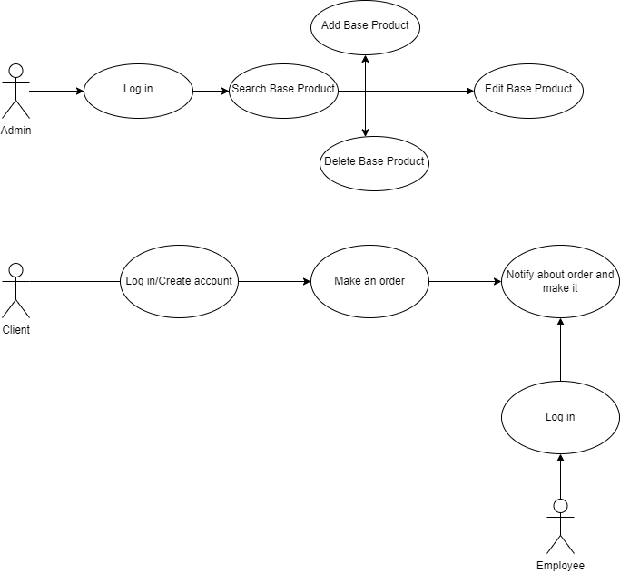

- Design(design decisions, UML diagrams, data structures, class design, interfaces, relationships, packages, algorithms, user interfaces) and Implementation
Observer Pattern
It is an architectural pattern that contains an Observable (resources that can change) and one or more Observers that are notified of changes made to the Observable. In this case, catering employees must be notified when a customer orders something, so they know to prepare the food for the order.
Composite Pattern
It is an architectural pattern that allows a group of objects to be treated as a single instance. It is based on subclasses that inherit a base class that is either an abstract class or an interface. They can be divided into the following categories:
- Component: the root class from which all subclasses will start. In this case it is represented by the MenuItem abstract class.
- Leaf: Implements the functionality of the Component class, without having references to other objects among its instance variables (BaseProduct in this case)
- Composite: Contains leaves as instance variables. For example, CompositeProduct and OrderItems each contain a list of references to objects of type BaseProduct
By treating a list of objects as a unit, one can easily calculate the total of a command or menu.
Data structures used
Sets
Sets are collections that do not accept equal objects (which equality is defined by the .equals() or compareTo() method). In this project, the uniqueness of the name of the products in stock and of an order had to be ensured, as well as the name of the users in order not to create confusion when logging in.
Hashing and Mapping
This project required the use of scatter tables and mapping of certain objects. A prime example would be even keeping orders in memory that, instead of having a list of products as an instance variable, were mapped to an object of type Order.
Mapping also helped to match products and their number of occurrences across orders.
Class Designs and Packages
I used these main packages: BusinessLogic, DataAccess, Service, GUI and controller.
I used Composite Design Pattern for modelling the classes MenuItem, BaseProduct and CompositeProduct because it is meant to allow treating individual objects and composite objects in the same way. I also used the Observer Design Pattern to notify the employees each time an order was performed because it is a behavioral design pattern and specifies communication between objects: observable (an object which notifies) and observer (an object which is notified about the changes made in the observable’s state).
I made the packages based on a layered architecture:
- Presentation layer – UI takes the action made by the user and sends it to the controller and at the end the result is taken from the controller and send to the UI;
- Business logic – handles the application logic; it takes information from the user and sends it to the Data layer and vice versa.
- Data layer – it is the layer which handles the storing of data, for example the products or the users’ data in this case; it contains the FileManager and the Serializator class
The packages and classes are organized in the following form:
- The main class is the CateringApplication class, where I create the object controller of the class Controller and I call the start() method from the Controller
- Business Logic: this package is presented below with the given classes. Here we have an inheritance relationship between the MenuItem Class and the BaseProduct and ComposedProduct classes (MenuItem is the parent class of the 2).
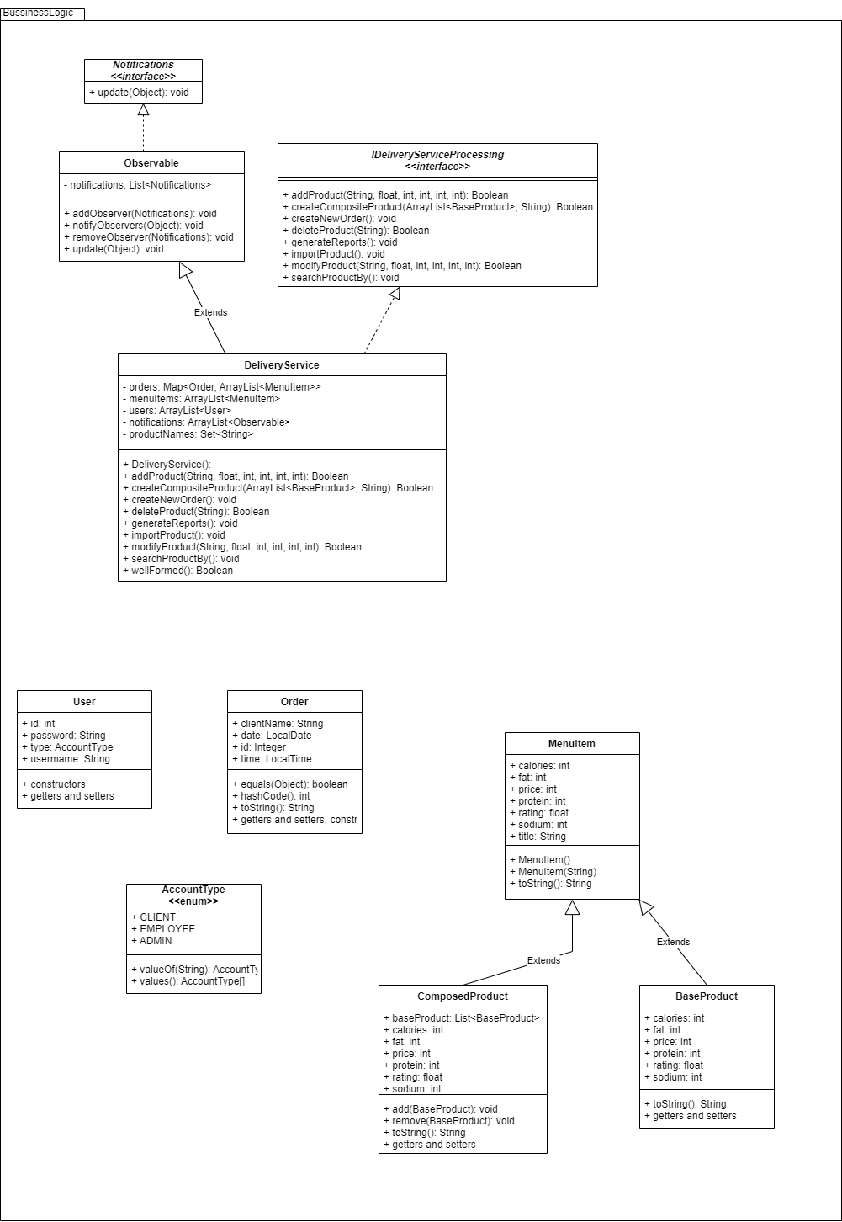

- DataAcces: this package contains the Serializer class, in which I take the information from a file, transform it into a series of bits with the serialize() function and then help reconstructing the read line from the given line and show it or save it in another given file with the help of the deserialize() function method.
public class Serializer<T> {
public void serialize(T genericObject, String filePath) throws IOException {
FileOutputStream fileOutputStream = new FileOutputStream(filePath);
ObjectOutputStream objectOutputStream = new ObjectOutputStream(fileOutputStream);
objectOutputStream.writeObject(genericObject);
objectOutputStream.flush();
objectOutputStream.close();
}
public T deserialize(String filePath) throws IOException, ClassNotFoundException {
FileInputStream fileInputStream = new FileInputStream(filePath);
ObjectInputStream objectInputStream = new ObjectInputStream(fileInputStream);
T genericObject = (T) objectInputStream.readObject();
objectInputStream.close();
return genericObject;
}
}

- Service Package: here I have another package, called Filter in which I have implemented some methods which I used further to help my client and my admin windows to search different products based on some key words or range (for example: price range), I then of course implemented and used these methods in the controllers with the help of lambda expressions.
Here are some filters I made:

public class KeyWordsFilter implements Predicate<MenuItem> {
private String[] keyWords;
public KeyWordsFilter(String[] keyWords){
this.keyWords = keyWords;
}
@Override
public boolean test(MenuItem menuItem) {
String lowerTitle = menuItem.getTitle().toLowerCase(Locale.ROOT);
for(String word: keyWords){
String lowerWord = word.toLowerCase(Locale.ROOT);
if(lowerTitle.contains(lowerWord)) {
return true;
}
}
return false;
}
@Override
public String toString() {
StringBuilder stringBuilder = new StringBuilder("KeyWordsFilter(");
for(String s:keyWords){
stringBuilder.append(s);
stringBuilder.append(", ");
}
if(keyWords.length > 0){
stringBuilder.deleteCharAt(stringBuilder.length() - 1);
}
stringBuilder.append(") ");
return stringBuilder.toString();
}
}

public class SodiumFilter implements Predicate<MenuItem> {
private int min, max;
public SodiumFilter(int min, int max) {
this.min = min;
this.max = max;
}
@Override
public boolean test(MenuItem menuItem) {
return min <= menuItem.getSodium() && menuItem.getSodium() <= max;
}
@Override
public String toString() {
return "SodiumFilter(" + min + ", " + max + ") ";
}
}

public class PriceFilter implements Predicate<MenuItem> {
private int min, max;
public PriceFilter(int min, int max) {
this.min = min;
this.max = max;
}
@Override
public boolean test(MenuItem menuItem) {
return min <= menuItem.getPrice() && menuItem.getPrice() <= max;
}
@Override
public String toString() {
return "PriceFilter(" + min + ", " + max + ") ";
}
}

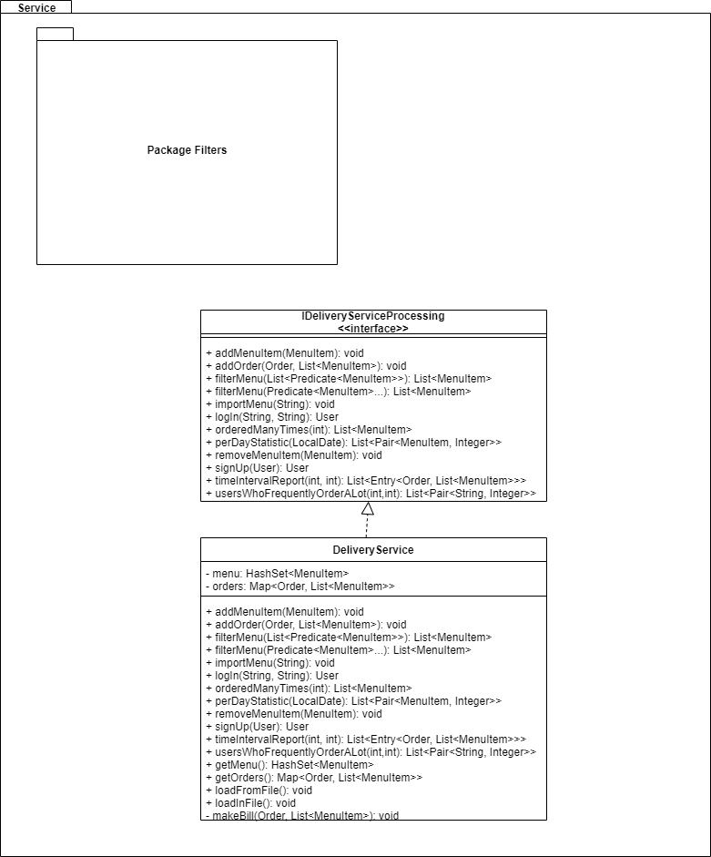

- Controller package: this is the package where I have all the controllers for my interfaces in which I used JavaFX to make them. Some of the windows are described below:
This is the LogIn window, in which the user must write the name and the password. There are 4 possible windows that can be open after that: an admin window, an employee window, or a client window. In case the sign up button is pressed, a new similar window for creating a client account will appear.

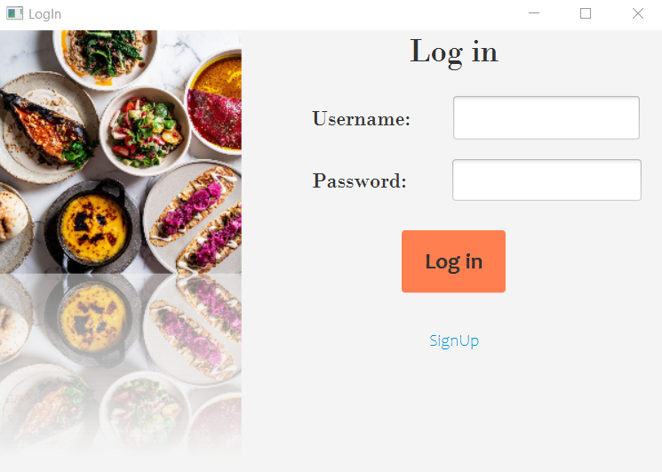

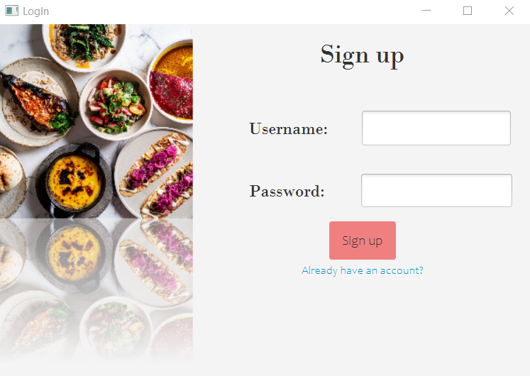
The admin window will appear once logged in, which has all the requested requirements: add/modify/delete/search products and view reports. Once the Reports button is pressed, a new window for the reports will open and the admin will can read all the reports wanted.
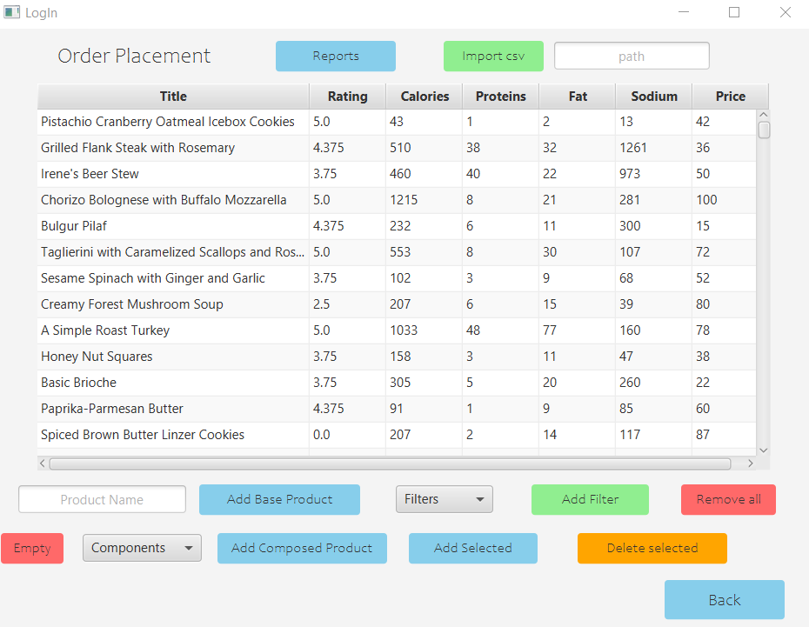
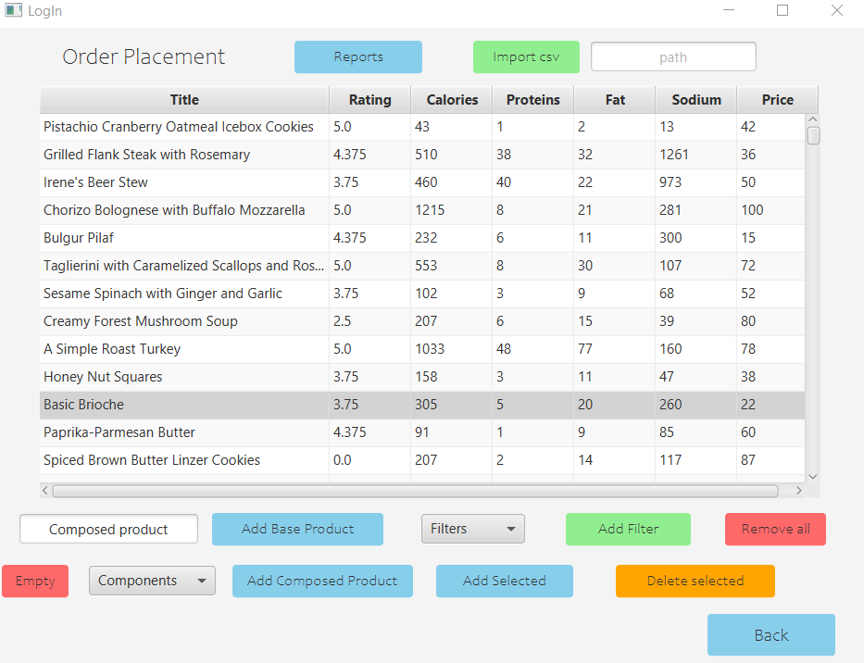
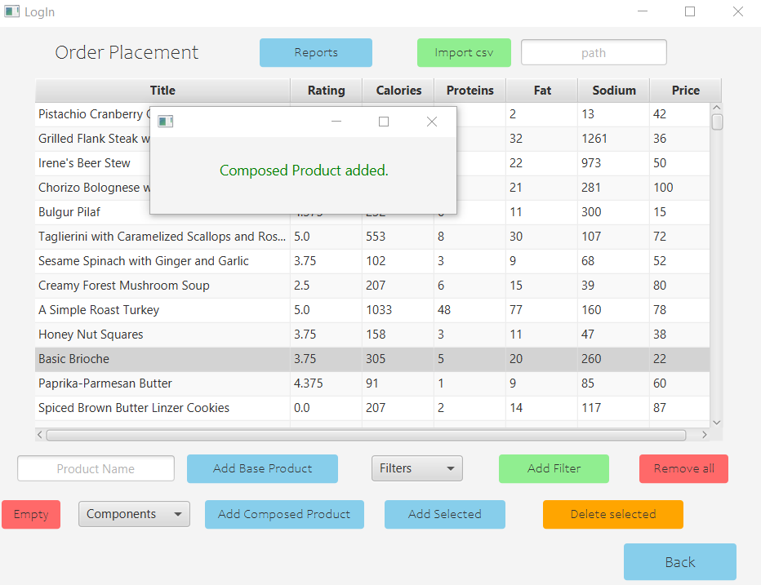
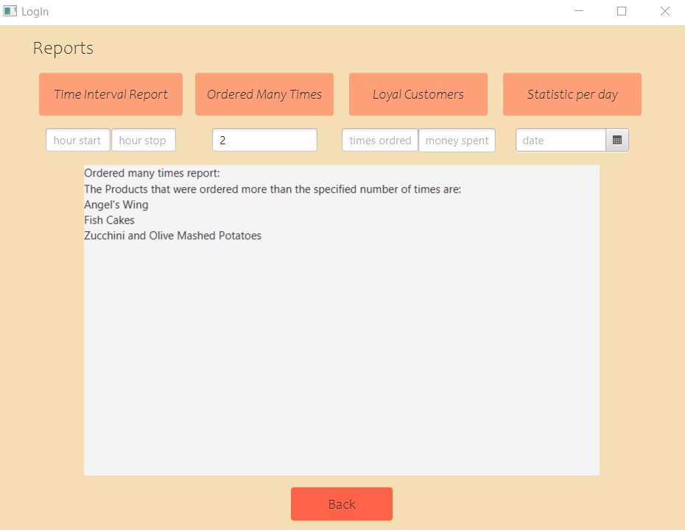
Once a client loggs in, the window for client will appear, where it can search a wanted product by the requested criterias and place an order. Certain messages appear on the screen as the client attempts to do these actions. These actions I will show in the following pictures:
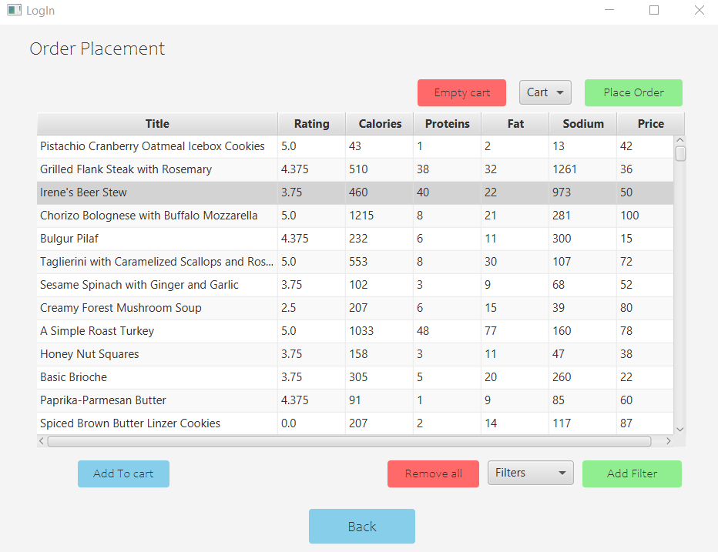
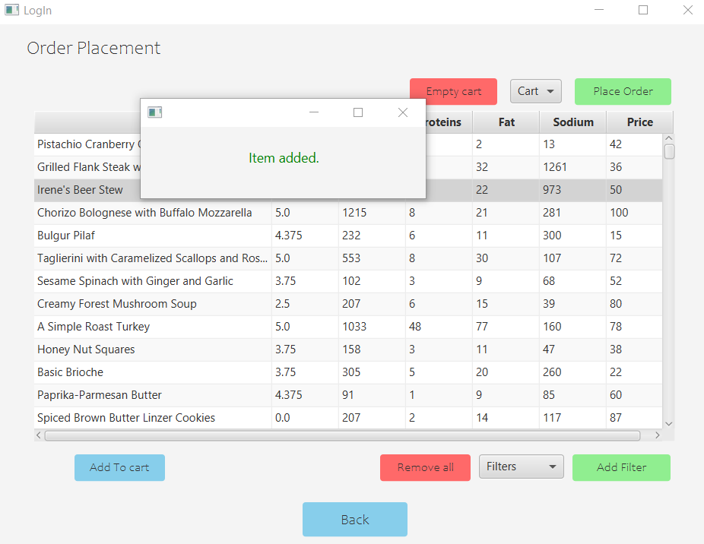
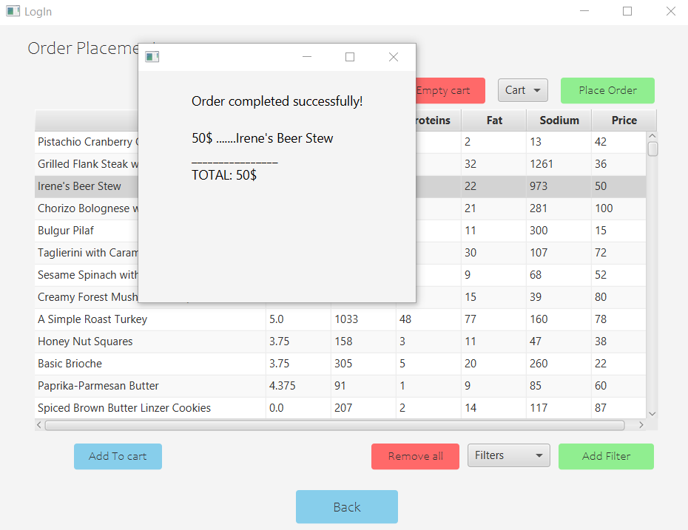

Also, when an ordered is placed by any client, in the meantime a bill.txt is generated with a random id:
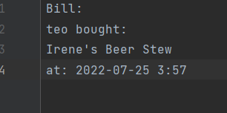
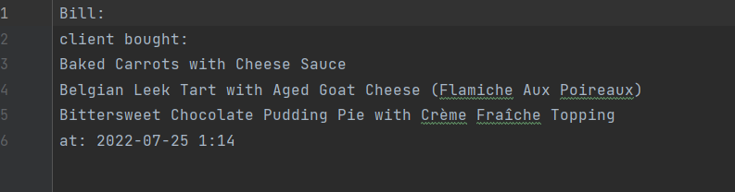
When the employee window is opened, the employee can see what orders were made and what products were placed by every customer, like in the following image:
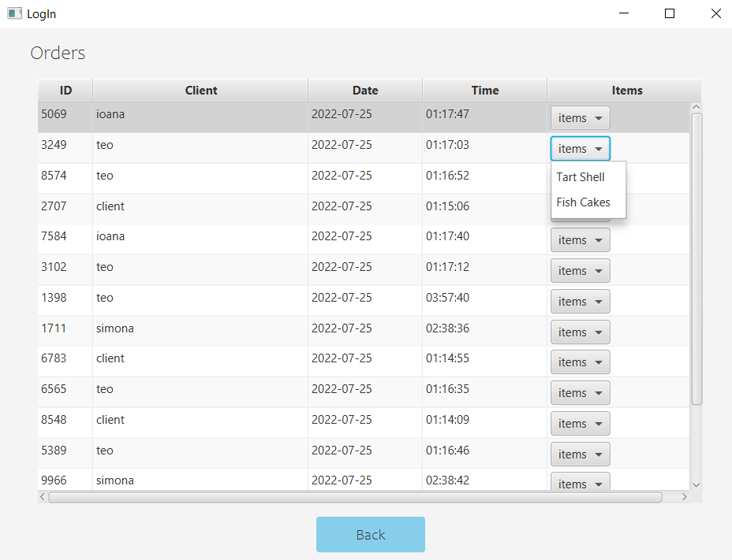
- Results
The modifications made on the data are not lost but applied to the content of each file representing a byte stream. These files are managed through serialization and deserialization. Each time the content of such a file is needed, it is deserialized and when the modifications are made, the updated data is serialized, so it is written back into the file by replacing the old content. If a product is added, deleted or modified, the updated data is write into the file. If an order is made, and is serialized as well, a bill is generated and the employees are notified.

- Conclusions
In conclusion, this application provides the user with an intelligible way to manage the products from the menu or to generate some reports if he is an admin, to make an order if he is a client and to see the made orders in case the user is an employee.
- Possible Updates
Personal data page and more attributes for employee, admin, customer. As in applications that already exist on the market, it would be nice to have a window for viewing this data. There might even be profile pictures.
Operation on personal data for admin. In general, an admin is someone who has a lot of control over the maintenance of the computer system. There are also cases where personal data changes are desired. That's why it would be good for the admin to have an operation page on users and their personal data.
Better employee notification interface. Due to limited time, we implemented the admin interface only to observe the Observer pattern. In the future it would be better for notifications to be panels that last a bit longer, not just dialog windows that close immediately.
View orders. It would be very useful for customers to see their active orders (which have not been delivered yet). If I were making a command interface box, I could also complete the previous point.
Development of a more complex notification system. This involves receiving notifications for multiple events and implementing the observer pattern for clients as well. It would be very useful for the employee to be able to change the status of an order and for the customer to be notified of this.
Developing the interface for the form. The customer creation, product and product search form and even login are just made to be functional, but they could be even better if they had an option to reset all inputs. Also, their code would be much easier to write with reflection.
GUI threads. It's a real Nightmare to load the entire GUI
Using the Employee class as the observer, instead of the employee window. This would prevent notifications from being lost when the window is closed, and the employee would be able to receive notifications even when offline.

- Bibliography
- https://docs.oracle.com/javase/tutorial/java/javaOO/lambdaexpressions.htm
- https://docs.oracle.com/javase/tutorial/java/javaOO/methodreferences.html
- https://www.oracle.com/technical-resources/articles/java/ma14-java-se-8- streams.html
- https://winterbe.com/posts/2014/07/31/java8-stream-tutorial-examples/
- https://howtodoinjava.com/java8/java-stream-distinct-examples/
- http://www.tutorialspoint.com/java/java_serialization.htm
- https://www.baeldung.com/java-https://www.geeksforgeeks.org/serialization-in-java/
- https://docs.oracle.com/javase/8/docs/api/java/io/Serializable.html
- http://javarevisited.blogspot.ro/2011/02/how-hashmap-works-in-java.htm
- http://docs.oracle.com/javase/8/docs/technotes/guides/language/assert.html
- http://javarevisited.blogspot.ro/2012/01/what-is-assertion-in-java-java.html
- http://stackoverflow.com/questions/11415160/how-to-enable-the-java-keywordassert-in-eclipse-program-wise
- https://intellij-support.jetbrains.com/hc/en-us/community/posts/207014815-How-toenable-assert
- https://docs.oracle.com/javase/7/docs/technotes/tools/windows/javadoc.html#tag

