Rectangle Problem

Objectives:
- Given some points in cartesian coordinate, (X, Y) find the number of rectangles that can be created by those points.
- Take into consideration only the rectangles that are parallel with the X, Y axes.

Sample Inputs:

(1,1), (1,3), (2,1), (2,3), (3,1), (3,3)

(1,1), (1,3), (2,1), (3,1), (3,3)

Sample Outputs:
- 3 – for the first input
- 1 – for the second input

Algorithm:
- I implemented in Java the application with 4 classes: Main, Count, Point and Array.
- In the Main class, I used the Scanner class to get the inputs from the keyboard. I stored the inputs in a matrix that always has 2 columns because we are talking about 2D points. Finally, I used the GetRectangles method found in the Count class to get the output.
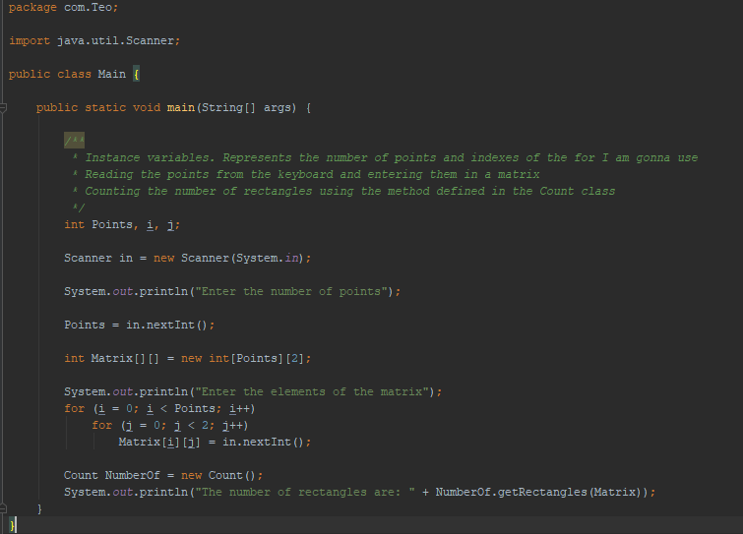
- In the Count class, resides the GetRectangles method. In this method, I calculated the number of rectangles in the given points. After sorting the points, I parsed the vector. First with two for loops. My goal was to get 2 points on the same X axis so that they can form a line and then to search for the other 2 points. I searched for the third point with a for loop and then I checked if this point was on the same Y axis as the first point. If this was true, I calculed where the fourth point should be. Finally, I checked if this fourth point exists.
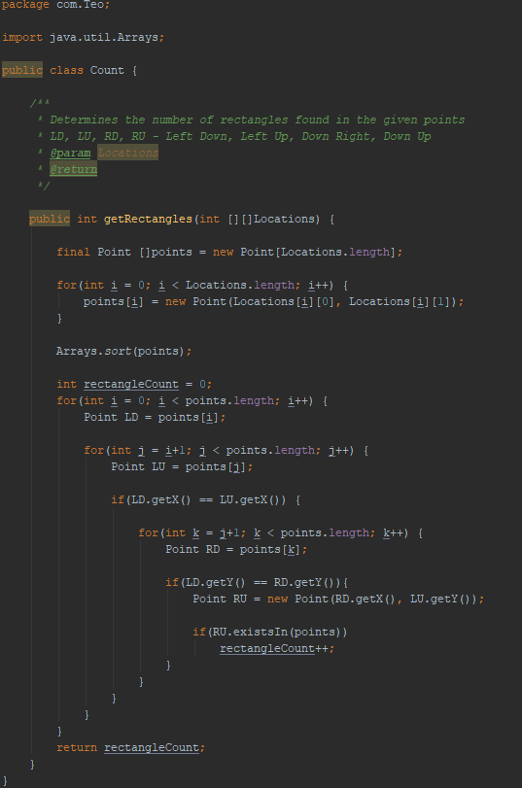
- In the point class, I have two instance variables, X and Y that are the coordinates of a given point in plane. I also implemented the constructor so I can initialize the point and also the getters for each X and Y for a proper encapsulation. The method existsIn calls for the contains method that is found in the Array class.
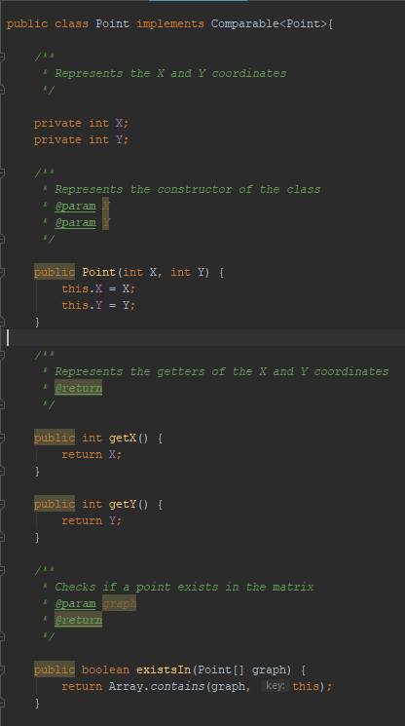
- In the Array class, the validation for some methods is done. Firstly, the method named contains searches for a point if he exists in the given matrix. Then, I made a overloaded method that takes as parameters objects and then return the contains method mentioned before. I also made a method that converts from object to String Array.
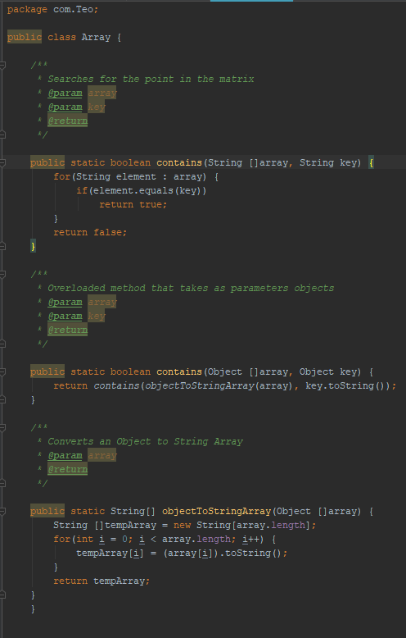

Results:
Below, there are 2 figures with the results of the 2 inputs.
In the first one, the sample input is used and the sample output is correct.
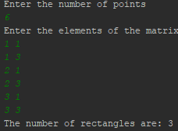
In the second figure, I tried the program with the second input, which was the first input without the (2,1) point. The output was 1 which is correct.
