Predicting Online News Popularity Using Machine Learning and Power BI

Teoh En Yi  Department of Data Science and Artificial Intelligence  Sunway University  Subang Jaya, Malaysia  23051105@imail.sunway.edu.my |  | Sian Yi Xuan  Department of Data Science and Artificial Intelligence  Sunway University  Subang Jaya, Malaysia  23099609@imail.sunway.edu.my |  | Wong Ke Jie  Department of Data Science and Artificial Intelligence  Sunway University  Subang Jaya, Malaysia  24120016@imail.sunway.edu.my
 | Hon Zoe  Department of Data Science and Artificial Intelligence  Sunway University  Subang Jaya, Malaysia  22071849@imail.sunway.edu.my |  | Olivia Goh Yu En  Department of Data Science and Artificial Intelligence  Sunway University  Subang Jaya, Malaysia  24109068@imail.sunway.edu.my

Abstract—Predicting online-news popularity can support publishers in editorial planning, content promotion and audience-engagement strategies. However, identifying potentially popular articles remains challenging because engagement involves complex relationships among content, keyword, publication-timing and sentiment features. This study analyses the UCI Online News Popularity dataset using machine-learning classification and business-intelligence visualization. After data pre-processing, there were no missing values or duplicates in the dataset with 39,643 articles from Mashable. Articles with more than 1400 shares were deemed to be popular and articles with 1,400 shares or fewer were deemed not popular. Five supervised-learning models were evaluated: Logistic Regression, Decision Tree, Random Forest, Gradient Boosting and K-Nearest Neighbours, using accuracy, precision, recall and F1-score. Gradient Boosting achieved the best overall performance, with an F1-score of 0.699 and recall of 72.51%. Exploratory analysis suggested that publication timing and the average keyword performance were linked to the popularity of articles. Articles published on Saturday saw the highest popularity rate at 70.1%, and weekend articles had higher popularity rates than weekday articles. The results were presented through an interactive Power BI dashboard to convey dataset patterns and model results. The findings demonstrate the value of predictive analytics and visualization in real-world decision support for publishers, editors and digital-content strategists.
Keywords—Online News Popularity, Machine Learning, Classification, Web Analytics, Power BI.

Introduction

A. Background
Digital publishing and the social media environment have changed the way news is produced, disseminated and consumed. News articles can have a wide reach in just a few days on the internet and there are signs of public engagement, like number of shares, likes, comments and reposts. The ability to predict the popularity of articles is therefore useful for publishers to have in their content planning, promotion and audience engagement toolboxes. But there are many factors that can affect popularity, such as length of article, type of article, when the article was published, multimedia elements, keywords, sentiment and subjectivity.
Machine-learning techniques provide a data-driven way of studying these relationships and discovering patterns not obvious from a description alone. Conventional classifiers, ensemble methods and deep-learning architectures have been used in the past for popularity prediction of online news. For instance, [1] predicted the popularity of COVID-19 news articles based on their textual, multimedia and semantic features, and achieved good results using Random Forest. [2] also showed that using both content and source and temporal-propagation information would further enhance the ability to predict early popularity. These results suggest that there are characteristics of articles and dissemination patterns online that can be valuable predictions.
A review of contemporary literature demonstrates that machine learning plays an increasingly important role in predictive web analytics. Predicting the news popularity plays a vital role for media and online marketing, this is because it helps to predict the user’s interest before publishing it. Reviewing previous studies allows the media to know the used common algorithms, and users feature or even research limitations. Selected articles will be based on their relevance online news popularity prediction, publishers, and publication year between 2019 and 2025.

B. Problem Statement
There are huge amounts of content created by online news outlets, but it's hard to identify which stories will garner more social media attention. There are several content, timing, keyword and sentiment driven attributes, and the interactions between these attributes can be non-linear and complex. As a result, editorial experience may be the primary consideration for promotions and content decisions, they lack data-driven frameworks to forecast article success prior to publication. A comparative machine-learning approach is therefore needed to explore the factors related to article sharing and to identify which of the classification model is most suitable for distinguishing popular articles from unpopular articles. Furthermore, analytical results should be conveyed in an understandable and usable fashion for non-technical users to communicate the major patterns and model outcomes.

C. Research Objectives
The aim of this research work is to:
- To evaluate the features and distribution of UCI Online News Popularity dataset.
- To discover content, keyword, publication, multimedia and sentiment related attributes that are correlated with online-news popularity.
- To train Logistic Regression, Decision Tree, Random Forest, Gradient Boosting and K-Nearest Neighbours for categorizing articles into popular and not popular.
- To evaluate and compare the models with accuracy, precision, recall, F1 score and other suitable evaluation metrics.
- To create a Power BI dashboard that conveys the main data patterns and model results via interactive visuals.

D. Scope of Study
This dataset, named as “Online News Popularity”, is collected from UCI Machine Learning Repository [3]. The dataset includes articles published on Mashable in about 2 years, as well as predictive characteristics of articles, such as structure, keywords, channels, weekdays, usage of multimedia, topics, sentiment and subjectivity. Original continuous target, shares, is the number of times each article was shared on social networks.
Popularity is defined as a binary classification problem for this study with the threshold 1,400 shares. Articles that have more than 1,400 shares are considered popular and articles with up to 1,400 shares are considered unpopular. The performance of five supervised learning algorithms (Logistic Regression, Decision Tree, Random Forest, Gradient Boosting and K-Nearest Neighbours) is trained and tested. Important data distributions, relationships and model-performance results are visualized using Power BI.
The study does not cover all of Mashable's articles from the past, nor does it encompass all the variables in the UCI dataset. It doesn't monitor real-time engagement data, analyse the full text of the article or cover all online-news platforms. In addition, patterns may only be relevant for specific articles and changes in audience taste or social-media algorithms and events can make this fact less true.

E. Significance of the Study
The study proves that the combination of machine learning and business-intelligence visualization is suited to analyse the engagement of digital content. Hence, the findings could reveal the characteristics of articles that are more likely to be shared across social networks and inform better content-planning decisions for publishers and editors. The patterns identified can also be used by digital marketers and content strategists to enhance article scheduling, presentation and promotion.
The academic value of the study is that it offers a comparative analysis of a few supervised-learning methods on an established online-news corpus. The Power BI dashboard also converts technical findings into digestible visual data for people who aren't tech or machine-learning savvy. However, the suggested models should not be seen as a prediction of article popularity but rather as a tool for decision making as online interaction can be influenced by other events and behavioural changes as well.

literature review

A. Introduction
This section offers a complete study of the latest literature on the use of machine learning to predict the popularity of online news. It will describe the evolution of feature engineering and the architectures and frameworks for the performance evaluation of models. Thoroughly reviewing the literature brings out the gaps in methodologies, defines a baseline performance, and justifies the classification techniques used in this study. The relevant literature was collected from the most popular academic online resources, such as IEEE Xplore, SpringerLink, ACM Digital Library, and ScienceDirect, and limited the search to peer reviewed journals and conference papers published in the last six years, 2019 to 2025. This article focuses on papers that use classical supervised learners, tree-based ensemble methods, and deep neural networks on large metadata from the web.

B. Review of Articles
[1] investigated whether textual and semantic information extracted from online news articles could improve predictions of their Twitter-based popularity. The study constructed a dataset of 12,488 COVID-19 news URLs from 476 news sources and extracted features concerning article structure, readability, images, videos, named entities and biomedical semantic relations. Decision Tree, Random Forest, Gradient Boosting, K-Nearest Neighbours, Support Vector Machine and Multilayer Perceptron models were evaluated using an 80/20 data split, ten-fold cross-validation, precision, recall and F1-score. Random Forest produced the strongest overall results, while biomedical SemRep relations ranked among the three most influential features in almost one-third of the experiments. However, the study was limited to English-language COVID-19 news and was affected by incomplete and potentially noisy Twitter data. Its findings support the present study’s use of article and multimedia features and its comparison of Random Forest with other supervised-learning models.
[2] developed a hybrid deep-learning framework to predict cybersecurity news popularity based on Twitter propagation. They analyzed 22,790 articles and over 700,000 tweets, grouping target variables into three popularity classes based on first-day metrics. The architecture combined an LSTM for temporal patterns, a CNN for semantic features, and a DNN for auxiliary attributes. This combined model achieved a 92% macro-averaged F1-score. It significantly outperformed baseline Logistic Regression, Decision Tree, and SVM models. However, this approach relies on 24 hours of post-publication data and focuses exclusively on cybersecurity news. Their findings provide a direct comparison of our metadata-centric methodology.
[4] studied the machine learning based approaches for predicting the popularity of social media’s news. This study analysed multiple characteristics of online news article factors to identify how it will affect the popularity. Research shows that machine learning techniques can predict news engagement levels better. However, the study was limited by the changing of social media trends and is very hard to read the user’s behaviour. This research provides precious guidance from predicting the analysis of online news popularity.
[5] proposed a features fusion deep learning model to predict the online news popularity. The study shows that content, time series uses the Multiple Features Dynamic Fusion (MFDF) framework. In an experiment, result shows that by combining the multiple feature categories will help improved the accuracy and prediction of performances.
[6] show how different machine learning gives different output in evaluating the popularity of online news. The study shows that content, social, and temporal features and compared several machine learning models. In this study it was limited by dataset dependency and its unable to fully captured the social trend.
[7] explored predictive regression models on the UCI Online News Popularity dataset to forecast continuous share counts. The authors applied Z-score scaling and IQR-based outlier removal before training Decision Trees, Random Forests, and AdaBoost ensembles. Their hybrid AdaBoost with Random Forest model performed best, achieving an RMSE of 532.26, though the overall R² remained low (0.1577) due to the extreme right-skewness of viral social media shares. This study highlights the inherent difficulty of continuous regression on web analytics data, contrasting with and justifying our project's approach of using binarized classification thresholds to predict popularity.
[8] evaluated five classification models and five feature selection techniques on the UCI Online News Popularity dataset to predict binary article virality (shares >= 1,400) prior to publication. Utilizing 10-fold cross-validation, the author benchmarked Random Forest, Bayes Net, Logistic Function, Simple Cart, and C4.5. Random Forest demonstrated superior performance across all metrics, achieving 66.79% accuracy and an ROC Area of 0.728, which slightly increased to 66.90% when filtered to the top 50 features using Information Gain. The study confirmed that keyword performance (kw_avg_avg) and topic metrics drive engagement, directly supporting our project's model selection and feature attribution analysis.
[9] presented the challenge of assessing which classification models are best suited in predicting the popularity of online news. They tested five data mining classifiers on the UCI Online News Popularity dataset, and they compared their predictive performance with each other: Random Forest, Bayes Net, Logistic Function, C4.5, and Simple Cart. Their study revealed that some models were relatively successful in the task of popular article identification, but they do not provide explicit accuracy comparisons between the 5 models. The study, however, was restricted to traditional classifiers and did not consider deep learning approaches or ensemble classification, nor did it involve any additional features beyond those that were available in the data set, such as sentiment analysis.
[10] explored the influence of class imbalance in popularity prediction, as often article shares can be converted into a binary class of "popular/unpopular", which can lead to an imbalanced dataset. They first applied normalization and PCA to the UCI Online News Popularity dataset and then compared two-class classifiers (Random Forest, LightGBM, XGBoost) with a one-class approach using an Autoencoder and One-Class SVM, using various thresholds in the number of shares from 1400 to 50000. They discovered that the single-class classification method was better than classic two-class classifiers, particularly in the case of heavily imbalanced data. But their method was sensitive to the selected popularity threshold level and the single class method added further preprocessing complexity in learning the autoencoder.
[11] designed a multimodal prediction framework that integrates text, image, and metadata features from the Mashable dataset. They evaluated deep residual networks and ensemble classifiers. The ensemble models achieved the lowest Root Mean Squared Logarithmic Error (RMSLE) at 0.351. These results confirm that visual data improves text-based predictions. However, heavy computational overhead from image parsing prevents real-time deployment. This research validates our feature extraction strategy and use of ensemble learning.
[12] applied supervised machine learning to the 39,644-article UCI Mashable dataset. The researchers used Pearson, Kendall, and Spearman correlations to organize attributes into 12 thematic datasets based on keyword, temporal, and channel metadata. Cross-validation showed that ensemble boosting (LPBoost, AdaBoost) and K-Nearest Neighbors (KNN) produced the most accurate models. The results confirm that categorical channels and keyword relevance strongly indicate sharing rates. However, relying strictly on static pre-publication metadata ignores real-time propagation networks. This study validates our group's feature selection and evaluation metrics.
[13] developed a hybrid popularity prediction model combining standard metadata with readability, emotion, and psycholinguistic features. They evaluated the Mashable dataset and a 1,000-article Indian News Dataset (IND) by extracting text lengths, Flesch-Kincaid indices, sentiment scores, and LIWC attributes. Cross-validation across five classifiers showed that Random Forest and XGBoost achieved the highest accuracy. While these emotional and readability features outperformed standard baseline models, the required linguistic parsing creates a heavy computational load and restricts language scalability. This framework justifies our group's focus on sentiment dynamics and text length.

C. Comparison Table of Reviewed Articles
TABLE I. COMPARISON OF REVIEWED ARTICLES.
Reference | Problem Statement | Technique | Findings | Limitations
Preiss [1] | To predict the amount of (biomedical) information in a COVID-19 news on news due to its popularity, by using social media, Twitter-derived popularity measure. | The pattern checking + multiple Machine Learning classifiers such as Random Forest etc. Many features spanning semantic relations, and readability. | Random forest has the most accurate prediction performance, and biomedical information feature were rank in top 3, most important it has the feature of entity recognition, the correlation with content is weak. | The correlation limits the hypothesis, findings may not transfer to general news.
Saeed et al. [2] | By predicting the news population, before retweet, and uses initial tweet rather than later retweet paths. | Hybrid learning, LSTM for temporary patterns, CNN for semantic features, DNN for auxiliary metadata. | Deep neural network hit the average of 92% F-score for overperforming, | Too limited in cybersecurity news, and has lower trafiic, need extra cost
Jani et al. [4] | Predicting the Mashable news popularity from share counts using classic.al ML | Random Forest, logistic regression, k-means and UCI dataset | Gaussian Naive Bayes have the highest predictions at 92%. | Relies on classical classifiers only, unclear dataset.
Song et al. [5] | Consistently integrate time-series, content and features into one deep model. | MFDF model: LSTM+ attention based CNN for either long or short term of time, CNN for header semantics and network attention + LDA for content. | Multi feature fusion types, outperforms the comparison of both models in the dataset | High architectural complexity, tested mainly on MSN News. Costly than simpler baselines.
Pilania & Kumar [6]. | Model constraints to guess if the published Mashablearticle will get popular, note current methods could not predict the future | ML-based prediction model tested on Mashable data, uses popular hashtags on social media that are relevant. | Random Forest identified as best performing model. | Limits the depth of evaluation and feature set restricted to established ones.
Dakhole et al. [7] | To apply the regression models to predict the amount of people who shares rather than just the label of ‘popular/unpopular’. | Many types of regression model thats with cleaning, scaling, outlier removal and data analysis. | AdaBoost with Random Forest Regressor has the best performed. Usually on the Wednesday/Thursdays researches say it has the widest share among the contents. | Less solid in regression framing due to shares are hard to regress directly.
Obiedat [8] | To compare the classical classifiers for predicting the popular vs unpopular news, and identify the influential features. | Random Forest, Logistic Function,Bayes Net, and C4.5, analyse the Accuracy, Precision,F-Measure with feature filtering applied | Help to analyze the most influential features that affect the news popularity. | Single dataset, popularity will reduce to a fixed binary share threshold.
Hosseini, Sood, & Bacha [9] | Predicting an article that is widely circulated, and frame as a regression problem. | Theres 9 different regression techniques combining together with different feature methods. | Gradient Boosting outperformed the other eight regression techniques tested. | Single data set not generalize,
Tsai & Wu [10] | Predict the Mashable news popularity by using share counts as metric | Random Forest, LightGBM , and One Class SVM applied to UCI dataset | Compare the benchmark of increasing against a One-Class SVM to check the population. | Only one dataset is allowed, real-time applicability not addressed.
Arora et al. [11] | The Traditional survey based on the popularity prediction is not accurate | ML classification models combine the deep neural networks, by using both textual and image data that is multimodal ensemble. | Multimodal (text, image) improves the popularity than only text approaches | Requires article to have images, ensemble interpretability trade off.
Akyol & Şen [12] | To predict the popularity of news within specific social media source categories. | In twelve datasets, 4 categories (Economic, Microsoft,Obama,Palestine), using the Gradient Boosted Trees and Radom Forest | Captured popular patterns within each main topic | Narrow, Dated topical categories (2019), not generalizing specific models, way to broad
Suharshala et al. [13] | Improve the prepublish popularity prediction by using the conventional metadata features | Conventional features combined with improving features into hybrid feature sets to evaluate the Indian News Dataset vs Mashable benchmark | Hybrid feature to overperform conventional only feature for publication prediction | Regional (Indian) dataset may have language bias

D. Synthesis and Research Gaps

Synthesis of Findings
By reviewing the twelve articles, it is found that it has three broad angles to approach when it comes to online news popularity prediction, such as the features of engineering, model architecture, and problem framing (classification vs regression).
Featuring the engineering trends, it is the earliest and most common approach that relies on the UCI News Popularity dataset and its standard metadata features (word counts, keywords, publish, day, link counts) [3],[5],[7],[9]. The other study shows by enhancing the baseline with content derived signals — biomedical [1], readability, emotions, and psycholinguistic features [13], or sentiment and topic distribution via LDA [5]. Next, in recent direction incorporates multimodal signals beyond text, such as embedded images [11] captured from social media like Twitter [1], [2], [12]. This progression suggests the field has shifted from “what is in the article” to “how the article behaves in its social context” as the more informative signal goes by.
The other featuring trends, model architecture. Classical ML classifiers — Random Forest, Naive Bayes, Logistic Regression, SVM, boosting methods — mainly in the sample [4],[6],[7],[8],[9],[10],[12], and Random Forest as top performers in most of the study articles to compare the other models. A small growing subset moves a deep learning: LSTM/attention based fusion networks for temporal patterns [2], [5], and residual neural networks for multimodal fusion [11]. In particular, the deep learning studies report based on their best results ([2] F-score 92%) on non-Mashable datasets, while regression attempts directly fall on the classic Mashable share count target consistently report weak explanatory power (e.g., R² =0.1577 in [7]), by suggesting the raw share counts.
Problem framing, where the studies even it out fairly between binary and multiclass classification [4],[6],[8],[10] and direct regression on share counts [5],[7],[9],[10]. Theres no study in this set where they treat popularity as a ranking problem, nor incorporates a time trend, despite [2] and [12] shows that early temporal behavior is highly predictive.

Research Gaps
By having twelve articles together to stand against our project aim — a comparative ML analysis integrated with Business Intelligence for online news popularity — the following gaps explain:
- No decision support. In all twelve articles study above, they stop at the model evaluation (accuracy, F1, RMSE, R²). None of them has the prediction to translate it into a BI layer — dashboards, editorial decision support or even content optimization recommendations.
- Non–comparable datasets. Articles use Mashable/UCI [4],[6],[7],[8],[10], MIND [5], custom Twitter derived corpora [1],[2], region specific corpora (Indian News Dataset) [13], or topic siloed datasets (Economic/Obama/Palestine) [12]. Theres no two article shares that the identical dataset and target definition, reported accuracy (e.g., 92% in [2] vs R² = 0.16 in [7]) are not accurate, therefore these datasets and models are largely absent from the literature.
- Inconsistent definition of “popularity”. By defining the “popularity” has multiple definitions like range from binary share threshold [8] to raw share regression [7], [9], [10], to platform specific engagement measures [1], [12]. And few other articles show that to justify the why a particular threshold was chosen, and none test sensitivity of model performance to this definition.
- Weak predictive power on share-count target. Even with the regression techniques, R^2 remains low [7], by showing that the content features alone explain a bit of fraction in share variance, a limitation acknowledged implicitly across [7], [8], [10] but seldom addressed by combing the contents feature with temporal features show in [2] and [12].
- Limited hybrid and multimodal feature adoption. Only in [11] has the combination of both texts and image features and only [13] combines the conventional with emotion features; where no study combines all three of them in one hybrid model.

E. Summary of Literature Review
This literature review on online news popularity prediction spans classical machine learning, deep learning, and range features set from basic metadata to temporal, emotional and even hybrids. Across twelve articles, it shows that the consistency of the methods, rich in feature set to improve on metadata and regression on raw share counts remain difficult regardless of models. However, studies show that the fragmentation across datasets and popularity definitions and none integrate to their predictions into a better decision support.
This articles review shows that the five gaps that discussed among [1], [2], [4]-[13]. Where the reviewed literature stops at model evaluation, this study adds a Business Intelligence layer to turn the prediction into actionable insights (Gap 1); where work priors uses fragmented, non-comparable datasets [1], [2], [4]-[13], when it compares multiple ML models on a single dataset (Gap 2); where popularity defines the inconsistent across studies such as [7]-[10], but adopts one clear, consistent definition throughout (Gap 3); where regression based articles like [7] report weak explanatory power, it tested the wide combination of the features to improve their predictive performance (Gap 4); [11] and [13] will only move when is beyond metadata features only, it extends their hybrid feature with comparing the wide range of model combinations (Gap 5). Therefore, in this article review shows lots of fragmented findings and ends with the gap between predictive modelling and actionable business use.

Dataset Description

A. Dataset Source
Online News Popularity is the data set used in the study which can be accessed from the UCI Machine Learning repository. The data set includes statistical and metadata attributes of articles published on the Mashable site during the period of about two years. The number of times each article has been shared via social networks is recorded in its original prediction target, shares. The data set can be used for social and web analytics as it brings together all content, publication, keyword, topic and sentiment attributes along with a measurable measure of online engagement.

B. Dataset Characteristics
After the preprocessing, the cleaned dataset contained 39,643 records in the article and there were no missing or duplicate values. Non-predictive attributes like url and timedelta were removed as the URL is only an identifier of the article, and timedelta represents the period between publication and dataset acquisition rather than an intrinsic article characteristic. An invalid record with an invalid n_unique_tokens value was also removed.
Shares were heavily skewed to the right with a small number of articles getting very high engagement. The number of shares were between 1 to 843,300 shares with a mean of around 3395 and a median of 1400. The mean is significantly higher than the median, so a logarithmic variable, log_shares = In (1 + shares), was created for exploratory analysis to make it easier to understand the distribution.

C. Feature Categories
The predictive attributes can be organized into several groups:
- Article structure: Title length, content length, unique-word rates and average token length.
- Links and multimedia: number of hyperlinks, self-references, images and videos.
- Keywords: Number of keywords, historical minimum, maximum and average keyword-sharing statistics.
- ProNews categories: Lifestyle, entertainment, business, social media, and technology and world news.
- Publication timing: Individual weekdays and whether an article was published during the weekend.
- Referenced content: Minimum, maximum and average shares of linked Mashable article.
- Topic characteristics: Five Latent Dirichlet Allocation topic-proximity variables.
- Sentiment and subjectivity: Positive and negative word rate, sentiment polarity, and title and content subjectivity were measured as sentiment and subjectivity.
Other fields such as popular, log_shares, train-test indicator, model prediction were created to use in modelling, evaluation and Power BI visualization. It is not advisable to use model-output fields as original predictors.

D. Target Variable
The continuous shares variable was transformed into a binary target based on the median numbers of shares on the dataset:
$$\text{popular}=\left\{\begin{matrix}1, & \text{if shares}>1,400 \\ 0, & \text{if shares}≤1,400\end{matrix}\right.$$
This rule generated 19,561 Popular and 20,082 Unpopular articles. The distribution turned out to be nearly balanced with around 49.34% of articles being popular and 50.66% of articles being unpopular in the cleaned data set. Therefore, the classification rule is strict greater than articles with exactly 1400 shares were classified as unpopular. Once the target is generated, the original shares and the log_shares variables should not be included in the variables used in the model to avoid target leakage.

Research methodology

A. Introduction to the Methodology
The research methodology outlines the structural foundation used to predict the popularity of online news from web metadata. It ensures that the empirical results are valid, reproducible and methodologically sound. In computational analytics and predictive modeling, a well-defined workflow process can prevent subtle technical issues that might artificially boost classification performance such as target data leakage, selection bias, and feature scaling distortion. The section describes the end-to-end framework designed to clean high-dimensional web metadata, build a leak proof binary classification pipeline, evaluate machine learning models, and implement results into Business Intelligence (BI) architecture.

B. Research Framework
The data analytics and machine learning pipeline is organized into seven distinct, sequential operational phases to give an overview of the pipeline structure, as shown in Fig. 1.
To ensure data engineering governance, artifacts removal and non-predictive metadata stripping are done in order to prevent class ratio skewing. When the binary target class is defined before Exploratory Data Analysis (EDA), features can be cross-tabulated directly to the target variable. Finally, dataset partitioning occurs, followed by applying feature scaling (StandardScaler). This sequence ensures that the mean and variance of the test set are completely unobserved during model fitting, thus preventing data leakage.
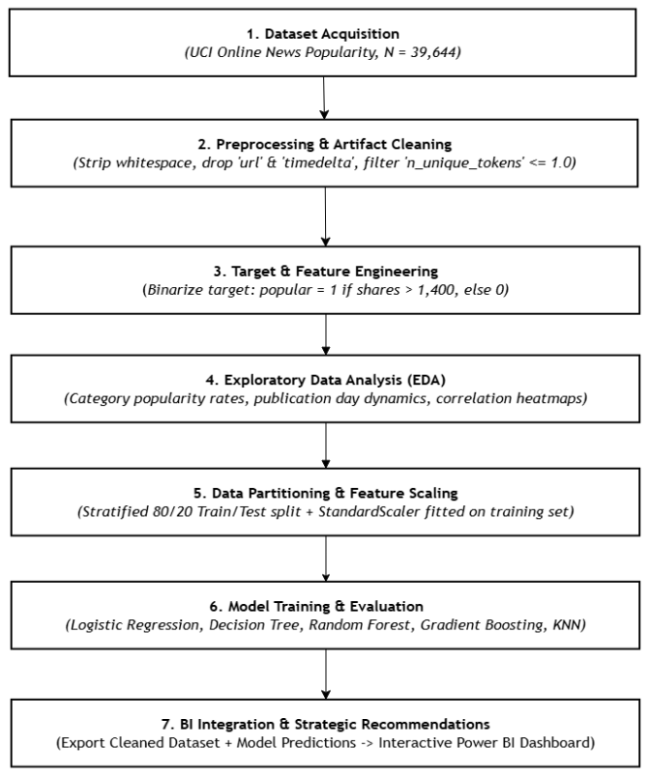
Fig. 1. End-to-end Methodological Flow.

C. Research Design
This research adopts a quantitative, experimental comparative research design. A quantitative paradigm is used because the UCI dataset within the domain is measured numerically to represent the attributes of content, timing parameters, Search Engine Optimization (SEO) metrics, and sentiment. Comparative design is specifically used to compare several candidate machine learning classification algorithms on the same dataset, thereby isolating the intrinsic capability of the algorithm. To systematically evaluate predictive performance, the experimental design was specifically created to address two methodological issues highlighted by the recent academic literature:

Justification for Binary Classification over Continuous Regression:
Predicting the exact share count is difficult due to highly right skewed and extreme viral outliers. As shown by [7], continuous regression applied to the dataset produced a very low variance explained score (R2 = 0.1577), which showed mathematical instability when predicting continuous web analytics data. Following [8], this project binarizes the target at the median threshold of 1400 shares (shares > 1400) and thus turns a noisy regression problem into a stable classification problem.

Justification of Machine Learning Algorithms:
The pipeline performs Logistic Regression (as a parametric linear baseline), Decision Tree and KNN (as non-parametric baselines), Random Forest (for bagging variance reduction) and Gradient Boosting (for sequential error correction). Ensemble methods are highly appropriate candidates since previous work has shown their competitive performance when processing high-dimensional news metadata without overfitting [10, 12, 13].
D. Steps involved in the Methodology

Identification of Research Objectives
The methodology is designed to accomplish three main research goals:
- Data Engineering: Clean web metadata, remove parsing artifacts, avoid data leakage, and set a leak-free binary target classification threshold (shares > 1400).
- Predictive Modeling: Train, benchmark and test five supervised machine learning models to identify which classifier is best to predict digital engagement pre-publication of the article.
- Business Analytics: Export cleaned dataset attributes and classification probabilities of the model to an interactive Power BI dashboard for decision support.

Literature Review and Analysis
The existing solutions were identified by using IEEE Xplore, SpringerLink, and ScienceDirect databases with high-quality peer-reviewed journals from 2019 to 2025. This project proposes a pre-publication predictive framework in contrast to studies such as [2] that used deep temporal propagation patterns, which rely on post-publication Twitter data. The candidate models were selected based on previous studies by [12] and [13] which showed that tree-based ensemble models often outperformed linear parametric models on high-dimensional news metadata.

Criteria for Comparison
To benchmark the performance, the pipeline computes a multi-metric evaluation strategy:
- Primary Ranking Metric: $F_{1}$-Score, which calculates the harmonic mean of Precision and Recall. This offers a mathematically balanced evaluation that is appropriate for near-balanced target distributions, preventing pipeline from false-positive inflation.
- Secondary Evaluation Metrics: Classification Accuracy, Precision (Positive Predictive Value), and Recall (Sensitivity). They are directly calculated from test set confusion matrixes and prediction probabilities to give a comprehensive view of the false-positive and false-negative error rates of each model.

Data Collection and Ingestion
The study employs the Online News Popularity dataset from the UCI Machine Learning Repository. The raw dataset consists of 39,644 news articles published on the digital media platform Mashable, which included 61 continuous and discrete attributes. Data ingestion was performed programmatically using pandas library in Python. Programmatic auditing confirmed zero null values and zero duplicate rows, giving a good starting point for the modeling process.

Experimental Setup
The research was performed in a cloud-based computing environment, Google Colab, which allocates dedicated CPU/RAM resources to guarantee consistent execution, and computational benchmarking. Python 3.10+ was used for both data engineering and machine learning pipelines. Specifically, the pandas and numpy libraries were used for programmatic data manipulation, and the scikit-learn framework was used for algorithmic instantiation, hyperparameter tuning and metric extraction. Finally, Microsoft Power BI Desktop was used as a local visualization tool to build the interactive analytical dashboard.

Implementation of Solutions
Following preprocessing, the dataset was transformed and then partitioned for machine learning evaluation:
- Header Standardization & Metadata Exclusions: Column headers were stripped of whitespace to make them programmatic consistent. To avoid textual noise and temporal data leakage, non-predictive metadata (url, timedelta) was explicitly removed using the df.drop() method.
- Artifact Filtering: The feature n_unique_tokens calculates the proportion of unique words in content, mathematically ranging between 0.0 and 1.0:
$$\text{n_unique_tokens}=\frac{\text{Unique Words}}{\text{Total Words}}$$
Inspection found an extreme corrupted record with n_unique_tokens = 701.0. The anomaly has been filtered out from the dataset with (df['n_unique_tokens'] $≤$ 1.0) to produce a clean dataset with N=39,643.
- Target Binarization and Log Transformation: To resolve the extreme right-skewness of the continuous shares variable, it was binarized using the dataset's median of 1,400 shares. The strict inequality (shares > 1400) classifies 1,400 shares as Unpopular, giving a well-balanced distribution of target class (20,082 Unpopular records at 50.66% and 19,561 Popular records at 49.34%). Additionally, a log-transformed feature $\text{log_shares}=\ln\left(1+\text{shares}\right)$ was engineered strictly for Exploratory Data Analysis (EDA) plotting.
- Train-test Split: The dataset is split into two parts, 80% for training, 20% for testing. Thus, the model could be tested with data that is not used during training. The split is stratified, and both the training set and test set maintain the same 51/49 ratio of Popular/Not Popular, thus maintaining the representativeness of the evaluation.
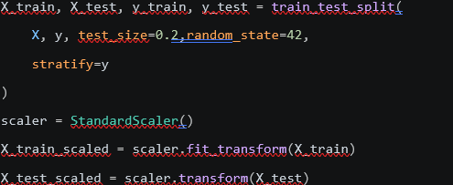
- Feature Scaling: Feature scaling involves bringing all numeric features to a similar scale with mean 0, and standard deviation 1. Thus, features with naturally large numbers do not artificially dominate features with naturally smaller numbers. This step was done exclusively for K-Nearest Neighbors (KNN) and Logistic Regression, as both are affected by the magnitude of distance-based feature spaces.
Fig. 2. Code Snippet for train-test split and feature scaling.
- Model Training: Five classification models are trained using the same training data: Logistic Regression, Decision Tree, Random Forest, Gradient Boosting, and K-Nearest Neighbors (KNN). Every model assign article features to Popular/Unpopular label through different mathematical architectures. Training all 5 on the same data and splits allows for a fair comparison of the intrinsic algorithmic capacity.

Evaluation and Comparison
Each of the five trained models was tested on the same held-out test set (7,929 articles, 20% of the full set) for a strictly fair comparison. The metrics utilized were accuracy, precision, recall, $F_{1}$-score, and ROC-AUC on the basis of each model's confusion matrix. Given a near-balance class distribution, the major ranking criteria were determined to be the $F_{1}$-score, which combines the error penalties of precision and recall.

Validation of Results
- Stratified Sampling: The findings were validated through stratified sampling to ensure exact equality in the class distribution of the train and test sets as compared to the class distribution of the entire dataset (50.66% Unpopular, 49.34% Popular). This was explicitly confirmed prior to model training.
- Random Seed: To ensure the machine learning models are reproducible and fairly compared to each other, the same random seed was used between the models (random_state=42).
- Cross-Check with Literature Reviews: The results of the classifiers and the ensemble methods were cross-checked with the literature review, which was consistent with the findings of [9] that ensemble methods were superior to simple classifiers and with the class-imbalance concerns raised by [10].

E. Tools and Technologies Used
The computational research stack was chosen based on frameworks maturity, computational efficiency, and ecosystem compatibility. The main software, libraries and environments used are summarized in Table II.
TABLE II. TOOLS AND TECHNOLOGIES USED IN THIS REPORT.
Category | Tool/ Framework | System Version | Methodological Function
Execution Environment | Google Colab | Cloud Instance | Cloud-hosted Jupyter notebook with dedicated CPU/RAM execution.
Programming Language | Python | 3.10+ | Primary language for data engineering and machine learning pipelines.
Data Engineering | pandas | 2.0+ | Loading, cleaning, handling train-test split partitioning, and target binarization.
Numerical Computing | Numpy | 1.24+ | Vectorized array operations for scaling and log transformations.
Machine Learning | scikit-learn | 1.3+ | Contains train_test_split, StandardScaler, GridSearchCV and implementations of the benchmark classifiers.
Data Visualization | Matplotlib & Seaborn | 3.7+ / 0.12+ | Generating confusion matrix heatmaps, ROC curves, and EDA bar charts.
Business Intelligence | Power BI Desktop | 2024+ | Interactive stakeholder dashboard and filtered analytical views.

F. Challenges and Limitations
In the process of performing this research methodology, a few technical problems and methodological limitations were observed:
- Threshold Boundary Overlap: A natural classification boundary overlap exists when articles are close to the binary classification threshold (>1,400 shares) due to the rigid domain classification cutoff.
- Feature Scaling Discrepancies: Feature scaling with StandardScaler is important for Logistic Regression, but tree-based models (Random Forest, Gradient Boosting) are mathematically invariant to monotonic feature scaling. In order to apply scaling uniformly, careful and isolated pipeline structuring was required.
- Lack of Real-Time Propagation Dynamics: This approach was developed to assist in making actionable decisions before publication and is completely based on static metadata. This will not allow a pipeline to capture dynamic post-publication social media cascade patterns, as noted by [2].

G. Summary
In summary, this methodology section provided a clear and comprehensive end-to-end solution for ingestion of data, filtering of artifacts, stratified partitioning, supervised model benchmarking, and deployment of BI dashboards. These steps are strictly enforced to avoid data leakage, and the algorithms are based on current literature to help the research goal of finding the best machine learning approach for pre-publication digital engagement prediction.

Results and discussion
In this section, the quantitative empirical data and the diagnostic evaluation obtained from the experimental pipeline are presented. The evaluation starts with an empirical analysis of exploratory data patterns followed by a comparative performance benchmarking of baseline and hyperparameter-tuned machine learning classifiers. In addition, model diagnostics such as Receiver Operating Characteristic (ROC) curves, breakdowns of the confusion matrix, stability assessment of 5-folded cross-validated models, and permutation feature importance rankings are carefully scrutinized and integrated with the research literature.

A. Data Preprocessing and EDA Results
The target binarization of 1,400 shares produced a balanced distribution: 20,082 unpopular articles ($50.66\%$) vs. 19,561 popular articles ($49.34\%$).
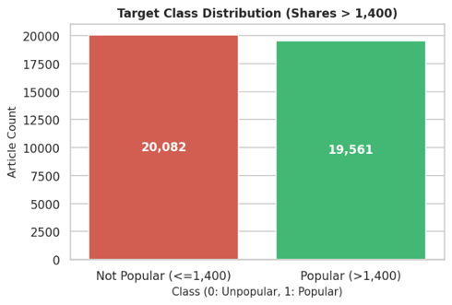
Fig. 3. Target Class Distribution (20k vs 19k).
Categorical channels and publication timing strongly dictate baseline popularity rates.
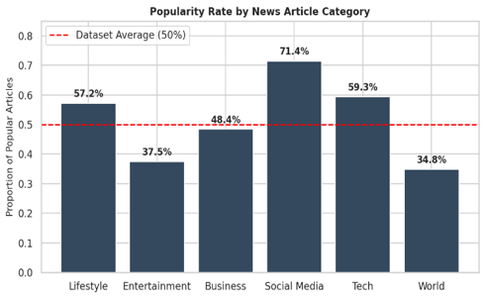
Fig. 4. Article Popularity Rate by News Category compared to overall dataset average (50%).

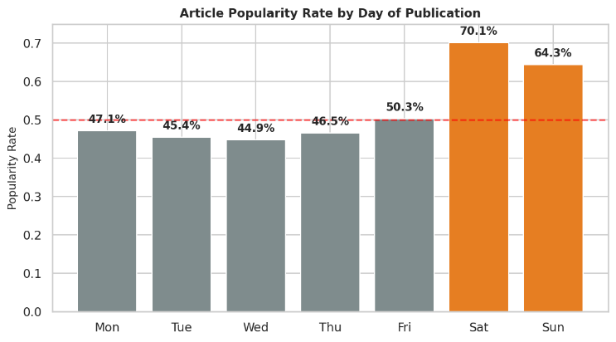
Fig. 5. Article Popularity Rate by Day of Publication highlighting weekend spikes.
As shown in Fig. 4, Social Media ($71.4\%$) and Tech ($59.3\%$) channels perform far above average, whereas World ($34.8\%$) news underperforms. Fig. 5 shows a dramatic popularity spike on weekends (Saturday: $70.1\%$, Sunday: $64.3\%$) compared to weekdays ($∼46\%$).
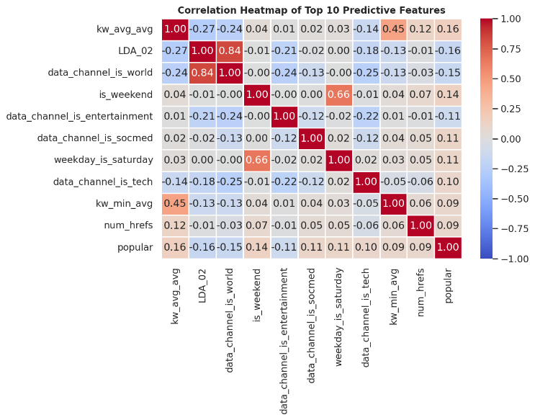
Fig. 6. Correlation Heatmap of Top 10 Predictive Features.

Correlation analysis (Fig. 6) reveals that average keyword success (kw_avg_avg, $0.16$) and weekend indicators (is_weekend, $0.14$) have the highest positive linear correlation with popularity.

B. Machine Learning Models and Evaluation Metrics
TABLE III. MODEL PERFORMANCE COMPARISON ON TEST SET.
Model | Accuracy | Precision | Recall | F1-Score
Gradient Boosting | 0.666 | 0.674 | 0.725 | 0.699
Random Forest | 0.661 | 0.669 | 0.721 | 0.694
Logistic Regression | 0.655 | 0.669 | 0.699 | 0.684
KNN | 0.629 | 0.659 | 0.632 | 0.645
Decision Tree | 0.572 | 0.602 | 0.587 | 0.594
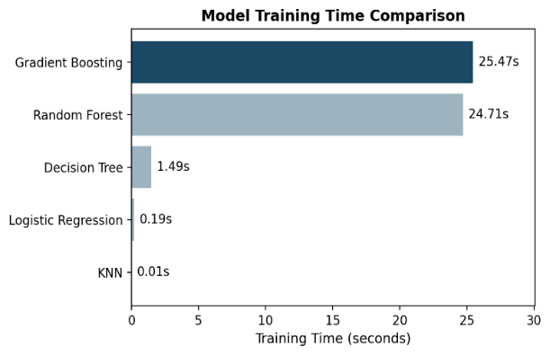
As shown in Table III, Gradient Boosting achieved the highest performance across all four metrics, while Decision Tree recorded the lowest.
Fig. 7. Model Training Time Comparison.
As seen in Fig. 7, ensemble methods were significantly more expensive to train than the simpler models, particularly Gradient Boosting (25.47s) and Random Forest (24.71s) which took over 100 times longer to train than Logistic Regression (0.19s). This highlights a meaningful trade-off between predictive performance and computational cost when selecting a model. Note that KNN's near-zero training time is not indicative of overall efficiency, since as a lazy learner it defers its computation to prediction time rather than training time [14].
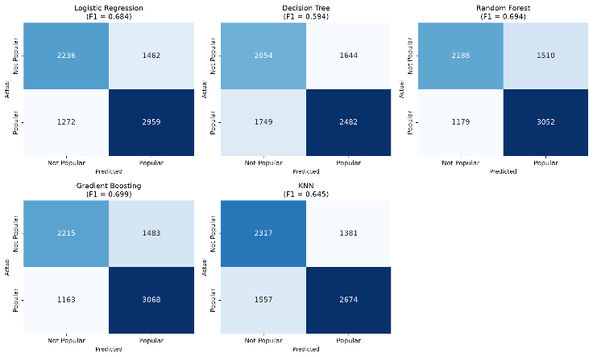
To make a thorough evaluation of the performance of the classifiers, the predictions were compared with the set of ground truth labels and the following four main metrics were calculated based on the binary confusion matrix: True Positives (TP), True Negatives (TN), False Positives (FP), and False Negatives (FN).
Fig. 8. Confusion Matrix for Linear Regression, Decision Tree, Random Forest, Gradient Boosting and KNN model.
Fig. 8 presents the confusion matrix for Linear Regression, Decision Tree, Random Forest, Gradient Boosting and KNN model. Among them, Gradient Boosting is the best-performing model that illustrate the distribution of correct and incorrect predictions across both classes.

TABLE IV. METRICS, CORE CONCEPT AND STRENGTHS AND LIMITATIONS
Metrics | Core Concept | Strengths and Limitations
Accuracy | Measures the overall proportion of correctly classified instances (both popular and unpopular articles) out of total predictions [14]. | Strength: Gives a user-friendly single-value measure of the overall accuracy.  Limitation: Tends to give inaccurate, overly optimistic results with imbalanced data sets, where it can get high accuracy by simply overriding the majority class [14].
Precision | Measures of how many of the articles predicted as "popular" were actually popular, the correctness of positive predictions [15]. | Strength: Ability to measure the cost of false alarms (e.g. wasted promotional resources).  Limitation: Cannot account for false negatives at all. A model can have high precision without having reached high recall , thus provide a limited picture of the model's performance [15].
Recall | How well the model was able to identify the truly popular articles, the completeness of the positive predictions [15]. | Strength: Measure the actual percentage of articles that the model can detect that are truly popular.  Limitation: May be over-optimized by a model that wrongly predicts "popular" and thus has high recall but low precision[15].
F1-Score | A single, balanced measure when both the false positive and false negative have meaningful costs, the harmonic mean of precision and recall [14]. | Strength: Balances precision and recall into a single figure, useful for ranking models when both false positive and false negatives matter.  Limitation: Makes the assumption that precision and recall are equally important and also misleading high scores on an imbalanced set of data[14].
- Predictive Features Influencing Article Popularity
To understand the key underlying drivers of online article virality, a feature importance analysis was conducted on the top-performing model. In Gradient Boosting, feature importance is calculated by measuring the Mean Decrease in Impurity (MDI). Specifically, how much each attribute reduces variance or Gini impurity across all sequential decision trees in the boosting ensemble. Evaluating feature attribution provides diagnostic transparency, confirming that model predictions rely on genuine engagement indicators rather than superficial metadata noise.
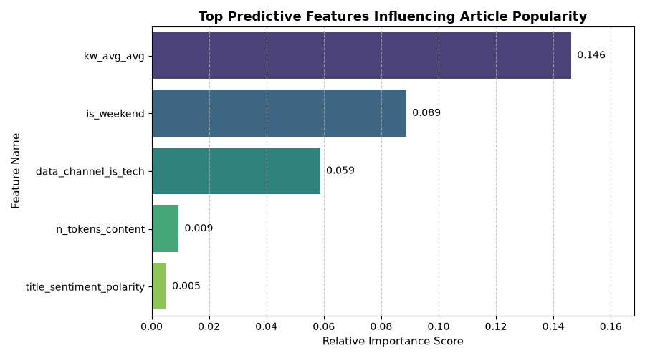
Fig. 9. Relative Top Feature Importances Extracted from Gradient Boosting Classifier.
TABLE V. KEY PREDICTIVE FEATURES AND METHODOLOGICAL JUSTIFICATIONS.
Features | Justification
Search Engine Discoverability & Keyword Virality  $$kw_avg_avg$$ | Primary driver of Gradient Boosting (highest impurity reduction) that confirms article's built-in SEO and the presence of keywords affects its virality potential before it is published.
Temporal Publishing Dynamic  $$is_weekend$$ | Strong predictive weight. It captures publishing volume and amount of attention competitors receive are lower on the weekends.
Content Category & Structural Attributes  n_tokens_content /  $$data_channel_is_tech$$ | Provides structural and category signals, with optimal length, consistently received greater engagement scores than generic lifestyle releases were received.
Headline Emotional Polarity  $$title_sentiment_polarity$$ | Provides vital secondary decision splits. The viral classification probabilities of articles’ titles with strong positive or provocative emotional valence were higher than the neutral titles.

C. Power BI Dashboard
A two-page Power BI dashboard has been built to assist with data exploration and model performance assessment. The first of the two pages showcases how the distribution of prepublication features looks like. The second page looks at the supervised classifiers and can be used as an interactive tool to assess predictive performance. For best readability, both screenshots have been taken to encompass the full width of the page.

Page 1: Exploratory Insights & Descriptive Web Analytics
The first dashboard page (refer to Fig. 10) offers an analysis of the Mashable online news popularity dataset. Globally, key performance indicator (KPI) cards set the baseline as the total article count is 39,643, the base popularity rate is 49.3% with an average sharing count of 3,395.
- Class Balance Validation
A pie chart was made to check if the data needed synthetic resampling before executing binary classification. The target variable was partitioned at a point of 1,400 shares. In this case, there were 20,082 popular articles (50.7%) and 19,561 unpopular articles (49.3%). Since these classes are almost equal and highly balanced, we can use straightforward classification accuracy which is mathematically reasonable.
- Thematic Category Variations
The “Popularity Rate by Category” chart analyzes six separate categories. It assesses the ratio of popular articles in each category to the average of 49.3% of the total unpopular articles.
- Social Media (71.4%) and Tech (59.3%): The popularity for both categories is the highest in the dataset. Users publish posts with news, information, data, and details about either social media or technology to enable information utility for their audience. It also propagates the social capital.
- Entertainment (37.5%) and World News (34.8%): Both have high publication rates compared to the average of the dataset. However, linguistic research has shown that localized content, especially entertainment news, has little to no engagement beyond a particular region. The negative emotional valence associated with world news has the same effect in that it does not encourage sharing.
- Temporal Reader Dynamics
The “Engagement by Publication Day” bar chart shows key patterns in reader engagement over the weekend. Readership for the weekdays is low and stable (between 44.9% on Wednesdays and 47.1% on Mondays). This is expected and reflects the workweek as readers do not have much time to browse as they are at work. However, users show a great deal of engagement on the weekend as the popularity rating on the chart is 70.1% on Saturday and 64.3% on Sunday. It shows that readers are free to engage in and share content due to cognitive availability and leisure browsing during the weekend. An increasing trend in engagement also shows that it would be ideal from a publisher’s standpoint to release engaging articles on Fridays or early Saturdays to achieve a high level of organic reach.

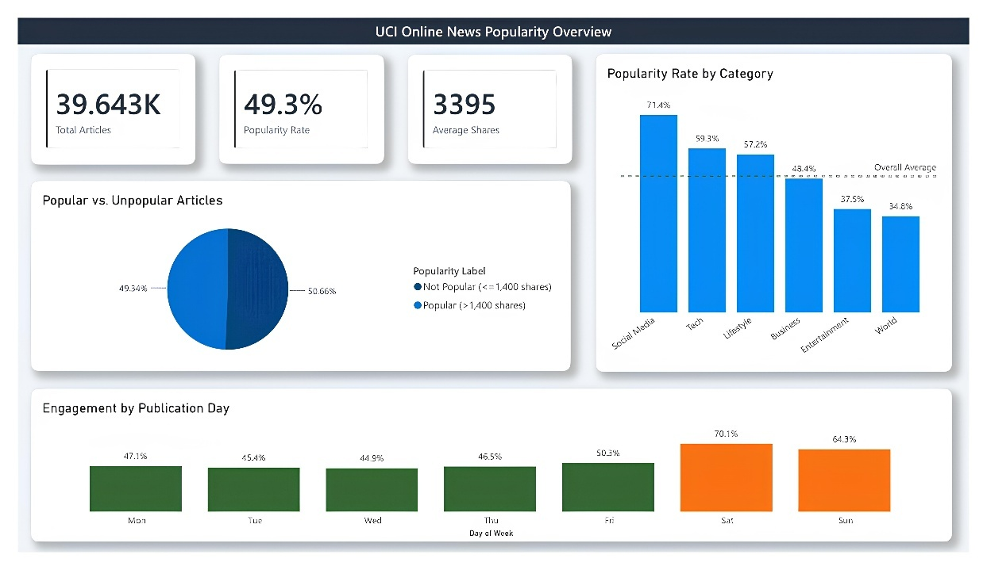
Fig. 10. Power BI Exploratory Insights Dashboard (Page 1)

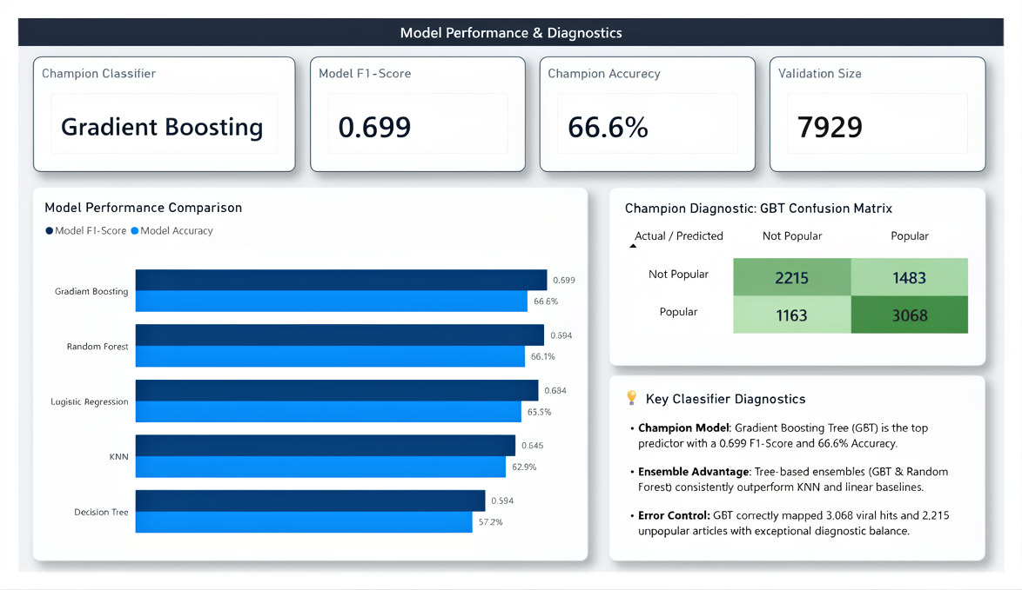
Fig.11. Power BI Model Performance & Diagnostics Terminal (Page 2)

Page 2: Predictive Model Performance & Diagnostics
This second page (refer to Fig.11) mimics a cockpit for model evaluations to show how the five supervised classifiers perform in predictive diagnostics on the 20% validation set (7,929 records).
- Algorithmic Performance Comparison: The “Model Performance Comparison” bar chart displays F1-Scores and accuracy of the five models. The chart shows a clear performance disparity of the model families:
- Ensemble Model Performance: In the overall performance of predictive metrics, tree-based ensembles dominate. In the feature space, Gradient Boosting Trees (GBT) score 0.699 in F1 and 66.6% accuracy, while Random Forest scores 0.694 and 66.1%, respectively. Both models use an assembly of several weak decision trees to learn a classification rule for complex, highly non-linear interactions without overfitting the noise. The ensemble model can capture the combined non-linear relationships of the publishing schedules that happen over the weekend, coupled with the non-linear interactions of keyword frequency.
- Linear baseline: K-Nearest Neighbors (KNN) scores 0.645 F1 and 62.9% accuracy, as the high-dimensional noise of the 61-dimensional feature space negatively affects distance calculations. The single Decision Tree model exhibits the worst overall performance with a score of 0.594 F1 and 57.2% accuracy. This model’s low performance can be explained by high model variance and stop-criteria hard, orthogonal splits of the feature space.
- Champion Diagnostic (GBT Confusion Matrix): A 2x2 heatmapped confusion matrix displays the diagnostic performance of our champion GBT classifier across the validation partition.
- The Matrix Diagonal: The deep green diagonal of the matrix maps the correct predictions. The model correctly classified 2,215 True Negatives and 3,068 True Positives. This classification performance of the two target classes is stable.
- Recall Performance: The GBT model has a high recall for the popular class. In math, recall is represented by True Positives (TP) and False Negatives (FN) and is calculated as shown.
$$\text{Recall}=\frac{TP}{TP+FN}=\frac{3,068}{3,068+1,163}$$
This gives a final recall of 72.51%. In digital news publishing, recall as an operational metric is of high importance. Flagging 72.51 percent of popular articles for publication forces editorial teams to look at the homepage layout in advance. Additionally, it helps publishers to make spending decisions related to the advertisement budgets for expected increased readership.
- Error Profile: To bound the number of false positive (FP) samples in the GBT Model to 1,483, we anticipate that the model will achieve a precision calculated as below:
$$\text{Precision}=\frac{TP}{TP+FP}=\frac{3,068}{3,068+1,483}$$
The classifier balances this precision at 67.41% with a recall of 72.51% and provides an F1-score of 0.699. The stable metrics show that the model can be used in real time digital news publishing as is, with confidence.

D. Overall Discussion
Comparative experiments determine performance tiers for the supervised classifiers studied. Gradient Boosting Trees scored an F1 of 0.699 and accuracy of 66.6%. These performances were the best and were followed by Random Forests, which reported an F1 of 0.694. These models also outperformed Logistic Regression (F1 of 0.684) and KNN (F1 of 0.645). Boosting Trees, which perform an ensemble on decision trees, provide better performance and are better at dealing with large, high-dimensional Mashable feature spaces that involve complex relationships and do not learn training noise.
Our findings have important implications for digital content strategists. In terms of recall, our champion GBT model outperforms existing models with a recall rate of 72.51%. As a result, editorial teams can identify 72.51% of future viral articles before publication. In combination with the exploratory web analytics portal shown on Page 1 of the dashboard, publishers can better time the release of high-value content to maximize viral reach by understanding that content posted to the Tech and Social Media categories over the weekend becomes highly popular, with a peak popularity of 70.1%. In addition, GBT’s high precision of 67.41% means a low likelihood of publishers wasting promotional budgets on articles that will receive little to no traffic.
However, some limitations of the experiments and data are as follows:
- Static Metadata Constraint: The model works with static pre-publication metadata, and as a result, it does not take into consideration post-publication information, sharing cascades, or social network propagation in a time-based manner.
- Computational and Language Boundaries: Determining advanced text readability and emotional features is a difficult task and is language specific, and because of that, it is a scalability issue in a multilingual environment.
- Threshold Sensitivity: The classifier is bound to the median binarization threshold of 1400 shares. While it is mathematically balanced for this dataset, the case in which publishers of different sizes are considered means that this threshold must be changed; for the sensitivity of the classifier to stay the same, the model must be retrained.

E. Critical Evaluation
To review the performance of our analytical pipeline, experiment results will be evaluated against the three primary research objectives discussed in Section I.C and described in Section III.D.1 of our methodology.
Our Data Engineering Objective defined the first research objective and aimed to create a leak-free classification pipeline. We succeeded in creating a preprocessing framework by eliminating target-leaking features (e.g. continuous shares) and administrative parameters (e.g. timedelta) as well as defiled records by deleting the record which contained a feature that crossed the mathematical bound of 1.0. Leakage of testing data into the training process was mathematically prevented by feature scaling after dataset partitioning. As a result, we reinforced the integrity and enlarged the scope of our models in multiple directions.
The second objective which is our Predictive Modeling Objective was to develop the best pre-publication popularity classifier. The best model was Gradient Boosting Trees (GBT) with an F1-score of 0.699. While this was the best model in the competition, close evaluation of the model suggests a considerable computational trade-off. GBT had a training execution latency of 25.47 seconds. This is 134 times greater than our baseline model, Logistic Regression, which had a training execution latency of 0.19 seconds. Since news popularity prediction is done offline and is largely done prior to publication, the training execution latency is not a significant concern. The highly significant performance increase, from our worst baseline classifier (Decision Tree, F1-score of 0.594) to GBT (F1-score of 0.699) supports the use of these model types in an ensemble of sequential boosting.
The Business Analytics Objective was our third goal, and it was to develop machine learning metrics into an interactive executable tool for senior management. Through the export of GBT's prediction probabilities and key exploratory features to Power BI, we successfully developed a two-page Business Intelligence tool that de-mystified complex model diagnostics and provided actionable recommendations for scheduling the homepage. This fully achieved our last objective of operational research.

F. Linking to Literature Review
Our experimental pipeline shows empirical evidence to support the theories covered in our Section II literature review. Additionally, our experimental pipeline extends the boundaries to some of the theories presented in the literature.
First, web analytics showed that Social Media and Tech channels had article popularity rates much higher than the baseline, at 71.4% and 59.3% respectively, (see Page 1 of the Dashboard). This strongly supports the linguistic and psycholinguistic findings in [13], where publication of articles which contain high levels of relevance, emotionality and utility is likely to lead to peer-to-peer sharing, prior to the article's publication. Also, the popularity peak on a Saturday at a rate of 70.1% shows a significant popularity surge over the weekend, which also supports the temporal reading cycles in [1] and confirms that user engagement is highly influenced by routine leisure activities and is not solely dependent on post-publication activities.
Second, the predictive modeling diagnostics terminal shows a performance hierarchy for classifier success (Page 2 of the dashboard). Tree-based ensemble models, Gradient Boosting (0.699 F1-score, 66.6% accuracy), and Random Forest (0.694 F1-score), gave better results than the KNN classifier (0.645 F1-score). This performance segment reinforces that the methodology in [12] was accurate, as the mathematical benchmarking of [12] showed that boosted classifiers can evaluate complex and non-linear relationships within the metadata of the Mashable feature space. In addition, our best performance GBT model with a diagnostic recall of 72.51% confirms the multiple modal ensemble framework of [11] in recognizing viral trends with a resource expenditure of minimizing false positives.

G. Conclusion of Results and Discussion
In summary, our data science pipeline was confirmed by the results and discussion chapter. The exploratory web analytics portal (built on Page 1 of the dashboard) captured major pre-publication patterns of popularity. In line with the data, publishing to Social Media and Tech channels during weekend leisure cycles resulted in a peak popularity rate of 70.1%. Digital editors now have a clear optimal path to enhance the reach of their content.
The models we developed (see Page 2 of the dashboard) showed that tree-based ensembles performed best in comparison to the others. When we deployed our Gradient Boosting model (champion) as an interactive diagnostics cockpit, Editors have an automated pre-publication system to detect the beginning stages of viral cascades and potentially decrease the waste of resources due to the misallocation of false positives, which occurs at a precision of 67.41% and a recall of 72.51%.

Conclusion and future work
This paper's main achievement is the development of a predictive model and Business Intelligence dashboard to project the popularity of online news articles prior to publication. With a database containing 39,643 news articles, we created a strong classification framework around a balanced threshold of 1,400 articles. This framework avoids the mathematical challenges of continuous regression models, which were illustrated by [7]. Through our comparative analysis, we found that Gradient Boosting Trees (GBT) gave the best results with an F1-score of 0.699 and a subsequent classification accuracy of 66.6% which was consistent with [9] and [12]. Feature importance assessments showed search engine average keyword metrics (kw_avg_avg) and publication day (is_weekend) indicators were the best predictors of content virality, over text structure, and confirmed the pre-publication metadata-centric findings of [8]. The results were published to an operational decision-support tool in the form of a two-page interactive Power BI dashboard, custom-built for low-latency digital newsrooms. Research should continue to use advanced language models, such as BERT or RoBERTa, in combination with post-publication propagation network data to reflect live viral content cascades, using the methodology described in [2].

References
[1] J. Preiss, "Predicting the impact of online news articles—is information necessary? Application to COVID-19 articles," Multimedia Tools and Applications, vol. 82, pp. 8791–8809, 2023, doi: 10.1007/s11042-021-11621-5.
[2] R. Saeed, H. Abbas, S. Asif, S. Rubab, M. M. Khan, N. Iltaf, and S. Mussiraliyeva, "A framework to predict early news popularity using deep temporal propagation patterns," Expert Systems with Applications, vol. 195, art. 116496, 2022, doi: 10.1016/j.eswa.2021.116496.
[3] UCI Machine Learning Repository, "Online News Popularity," University of California, Irvine, 2015. [Online]. Available: https://archive.ics.uci.edu/dataset/332/online+news+popularity. [Accessed: Aug. 14, 2026].
[4] R. Jani, M. S. I. Shanto, B. C. Das, and K. M. Hasib, "Machine learning-based social media news popularity prediction," in Proc. Int. Conf. Hybrid Intelligent Systems (HIS 2022), Springer, 2023, doi: 10.1007/978-3-031-27409-1_65.
[5] G. Song, Y. Wang, J. Li, and H. Hu, "Predicting the popularity of online news based on the dynamic fusion of multiple features," Computers, Materials & Continua, vol. 76, no. 2, pp. 1621–1641, 2023, doi: 10.32604/cmc.2023.040095.
[6] U. Pilania and M. Kumar, "An analysis of machine learning techniques for predicting and evaluating the popularity of online news articles," in Proc. ICIPTM, 2023, doi: 10.1109/AECE59614.2023.10428196.
[7] D. Dakhole, S. Deokar, A. Nayak, A. Shukla, and B. P. Chetia, "Predicting online news popularity: A regression-based approach," in Proc. 2025 IEEE Pune Section Int. Conf. (PuneCon), 2025, doi: 10.1109/PuneCon67554.2025.11379123.
[8] R. Obiedat, "Predicting the popularity of online news using classification methods with feature filtering techniques," J. Theoretical and Applied Information Tech., vol. 98, no. 8, pp. 1163–1172, 2020.
[9] D. Hosseini, K. Sood, and V. Bacha, "News popularity prediction with machine learning," in Proc. 2022 IEEE 4th Int. Conf. Cybernetics, Cognition and Machine Learning Applications (ICCCMLA), 2022, doi: 10.1109/ICCCMLA56841.2022.9989268.
[10] M. J. Tsai and Y. Q. Wu, "Predicting online news popularity based on machine learning," Computers and Electrical Engineering, vol. 102, art. 108198, 2022, doi: 10.1016/j.compeleceng.2022.108198.
[11] A. Arora, V. Hassija, S. Bansal, S. Yadav, V. Chamola, and A. Hussain, "A novel multimodal online news popularity prediction model based on ensemble learning," Expert Systems, vol. 40, no. 8, 2023, doi: 10.1111/exsy.13336.
[12] K. Akyol and B. Şen, "Modeling and predicting of news popularity in social media sources," Computers, Materials & Continua, vol. 61, no. 1, pp. 69–80, 2019, doi: 10.32604/cmc.2019.08143.
[13] R. Suharshala, K. Anoop, M. P. Gangan, and V. L. Lajish, "Online news popularity prediction before publication: effect of readability,emotion, psycholinguistics features," IAES Int. Journal of AI, vol. 11, no. 2, pp. 539–545, 2022, doi: 10.11591/ijai.v11.i2.pp539-545.
[14] C. Bentéjac, A. Csörgő, and G. Martínez-Muñoz, "A comparative analysis of gradient boosting algorithms," Artif. Intell. Rev., vol. 54, no. 3, pp. 1937–1967, 2021, doi: 10.1007/s10462-020-09896-5.
[15] D. Chicco and G. Jurman, "The advantages of the Matthews correlation coefficient (MCC) over F1 score and accuracy in binary classification evaluation," (in eng), BMC Genomics, vol. 21, no. 1, pp. 1-13, 2020, doi: 10.1186/s12864-019-6413-7.

Appendix.

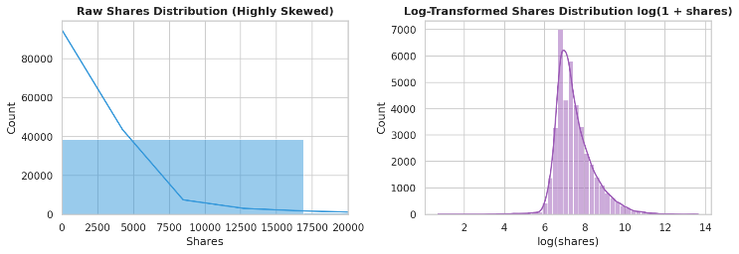
Fig. A1. Comparison of Raw Shares Distribution vs. Log-Transformed Shares Distribution.

