CSCE 5222 Feature Engineering

Project Plan/Report

Group NUMBER

Member: NAMES

1. Problem statement

Clearly state the project you want to work on.

1. Data used

State the data used in this project including ground truth for evaluation

1. Method

Give details of the method and any parameters used.

1. Evaluation

State the evaluation metric and discuss the results

The following are examples of inserting tables and figures. You can duplicate them and make changes for yours.

Table 1 This is an example of a table

|  |  |  |  |  |  |
| --- | --- | --- | --- | --- | --- |
| Name | Size | Type | Class | Accuracy | Precision |
| Image 1 |  |  |  |  |  |
| Image 2 |  |  |  |  |  |

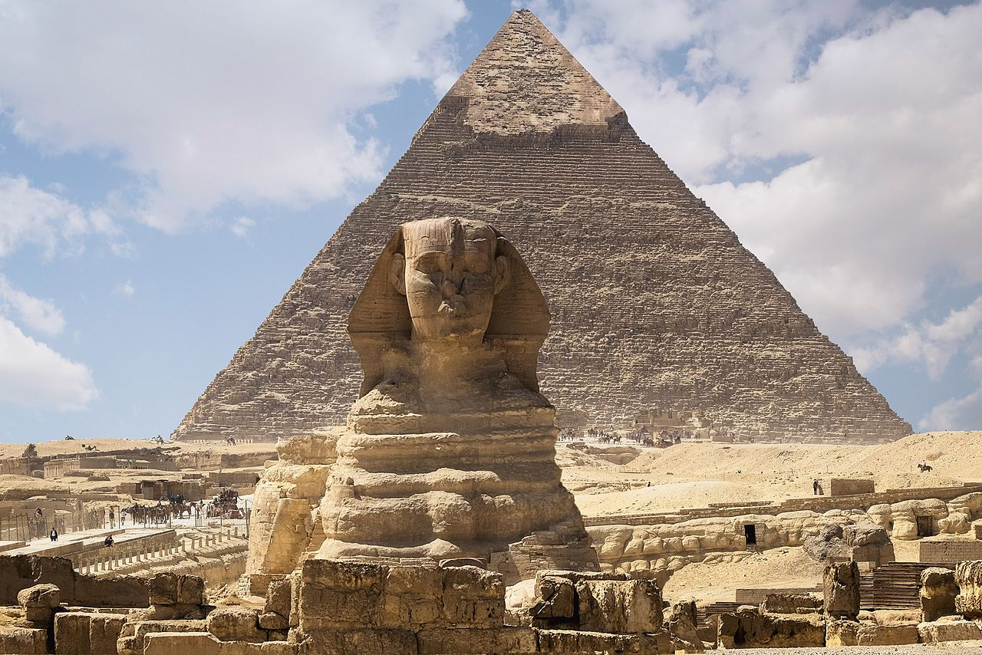

Figure 1. This is an example of a figure. Note, use textbox to enclose both the figure and the figure title.