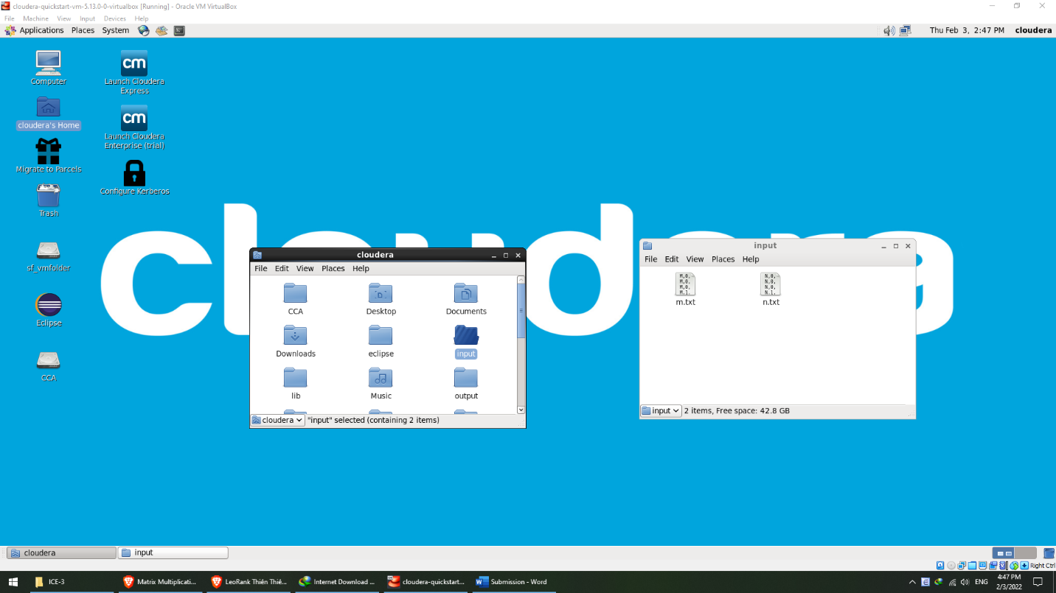

Step1: Put matrices m and n to /home/cloudera

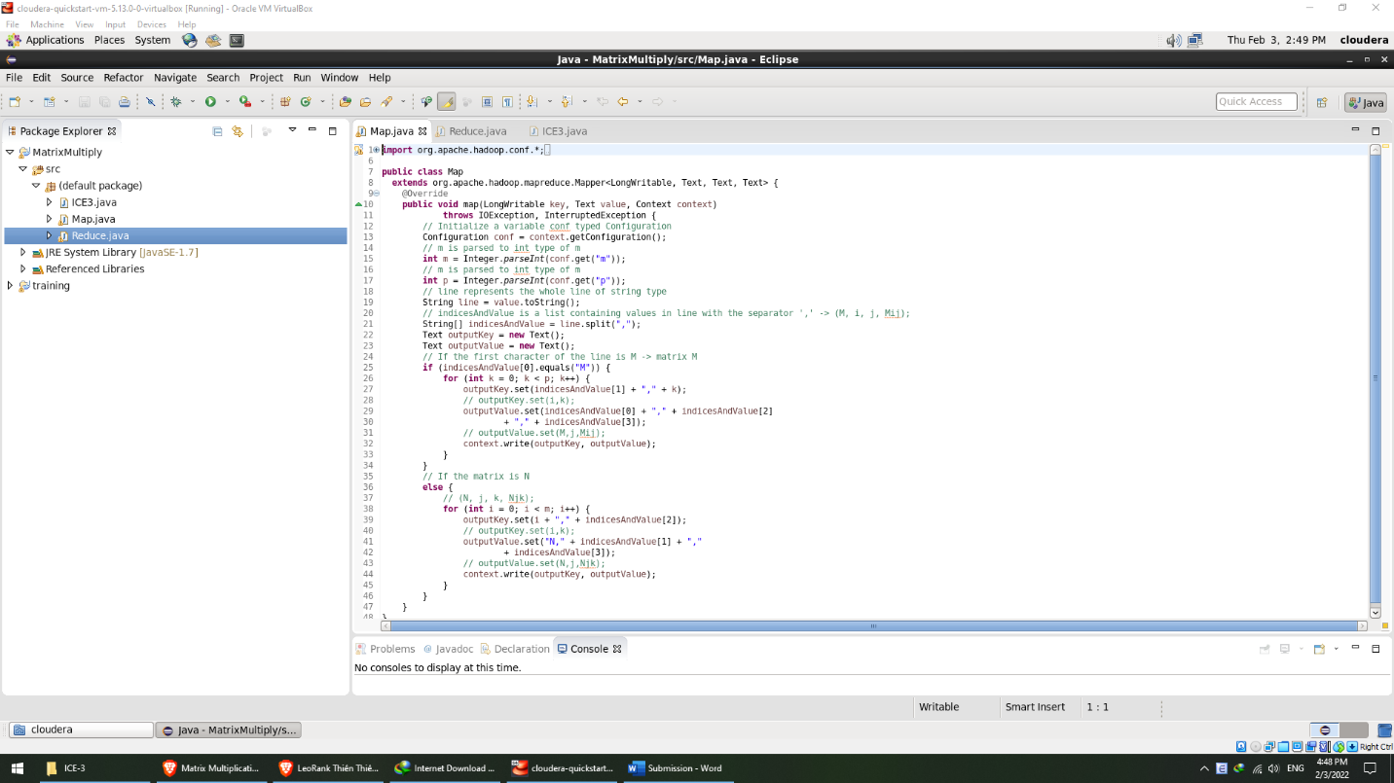

Step 2a: Create class Map.java with comments

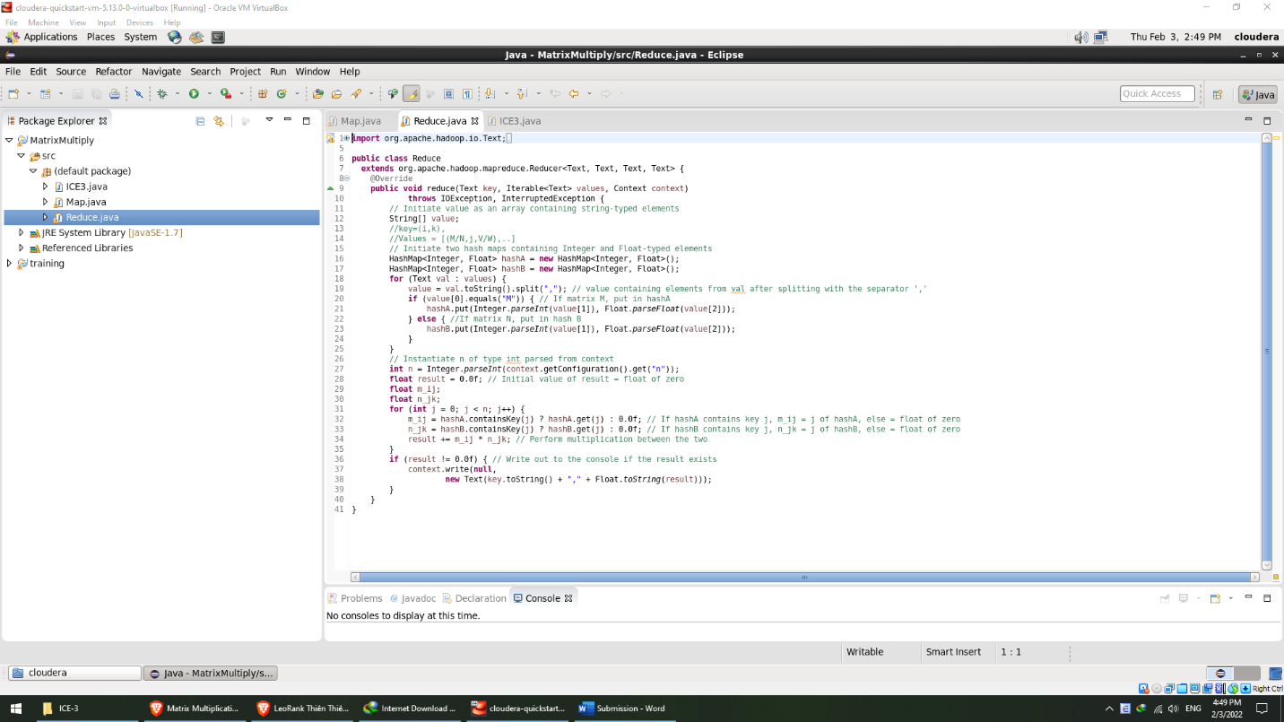

Step 2b: Create class Reduce.java with comments

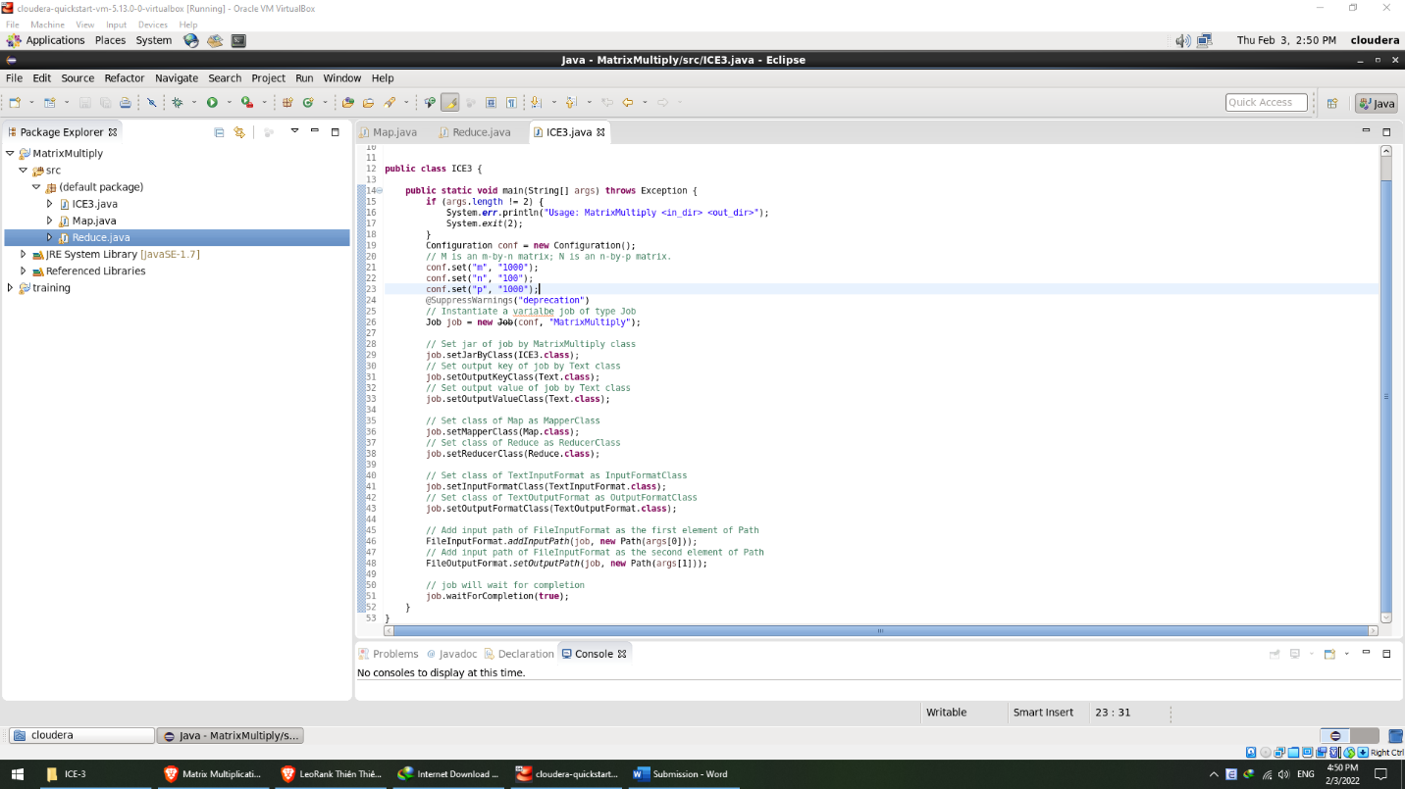

Step 2c: Create class ICE3.java with comments

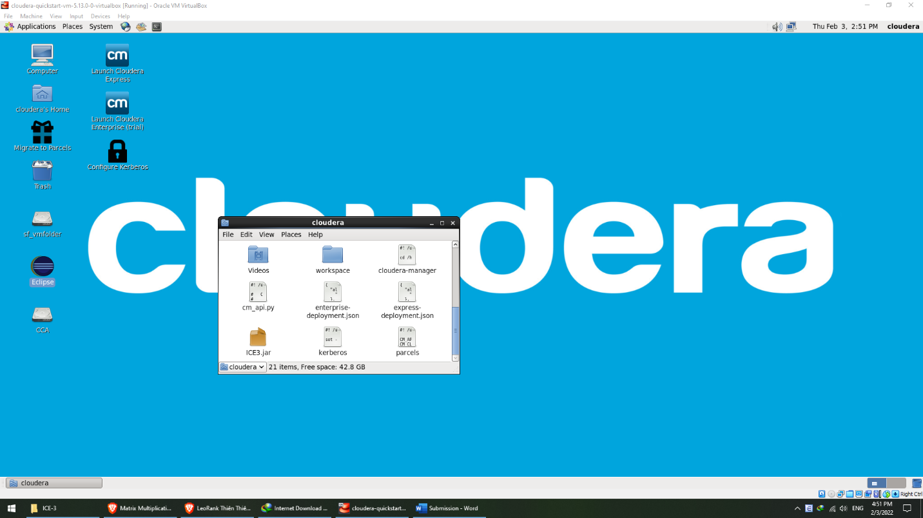

Step 3: After exporting ICE3.jar to /home/cloudera

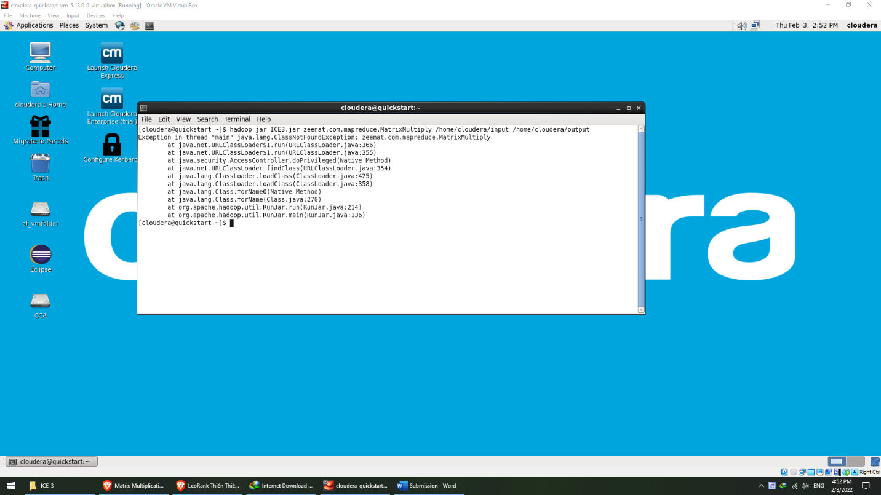

Step 4: Run the command and receive errors

Bonus question: Here is my understanding about the exercise:

* The mapping gets matrices and store their units to the right places

x

* For the above example, the map class is as follows:
  + The input is formatted to be pairs of keys and values (k, v)
  + In matrix N, i is row, j is column
  + In matrix N, j is row, k is column
  + In java file / Map class, M,1,1 represents the position of the unit at row 1, column1 of matrix M; M,1,2 = unit at row 1, column 2 of matrix M and so on
  + These will be stored in memory
* The reduce class is as follows:
  + HashMap A and B store values of matrix M and N respectively
  + For each loop, the multiplication between a unit in matrix M and a unit in matrix N get added till the end of the loop / matrices
  + Then the console prints out
* ICE class:
  + Set the dimensions of matrices to m, n, and p
  + The rest is explained by my comments in the code