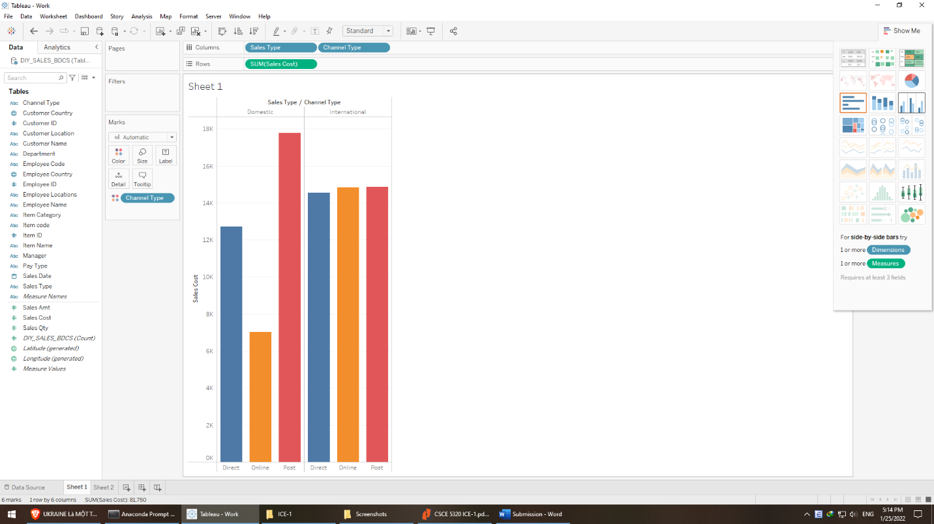

Analysis:

* There are two sales types: domestic and international
* Each of sales types has three channels: direct, online, and post
* The difference among each channel types is drastic in domestic sales type, international types have roughly the same cost (14.8k) in all sales types. Box plot visualization can show the variance of each. The median and mean are mostly the same in both types.
* In domestic sales types, post bears the most cost (17k), nearly three times of online ones (17k), and 1.5 of direct (12.7k)
* Domestic online shopping is a potential channel because of its lowest cost

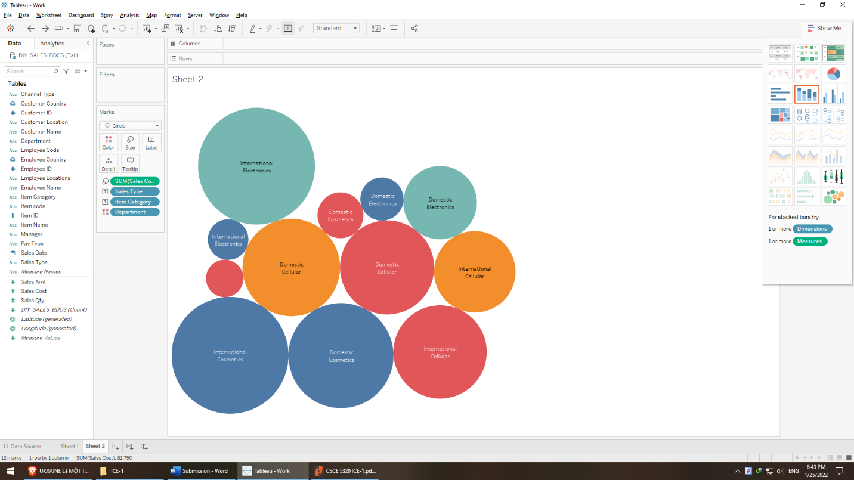

Analysis:

* Sales types unique values: domestic and international
* Item category unique values: cellular, cosmetics, and electronics
* Department unique values: Accounting, Audit, Finance, Sales (not all departments exist in one item category)
* International sales types have slightly higher cost than domestic’s (7426 vs 6897), and the former’s variance is also greater.
* Within domestic:
  + Cosmetic - accounting has the highest cost while electronics – accounting has the lowest cost -> Cost pattern may not depend on department (may be item category)
  + Electronics costs generally are lowest, then cosmetics, then cellular
  + The cost difference between departments is highest in cosmetics, then electronics, then cellular
* Within international:
  + The order of decreasing difference between departments in order of category is cosmetic > electronics > cellular
  + Cosmetics – accounting and Electronics – sales are almost the same, similar to cosmetics – finance vs electronics – accounting
* Between departments:
  + The decreasing cost follows this pattern: accounting, finance, sales, and audit