**Sheet 1:**

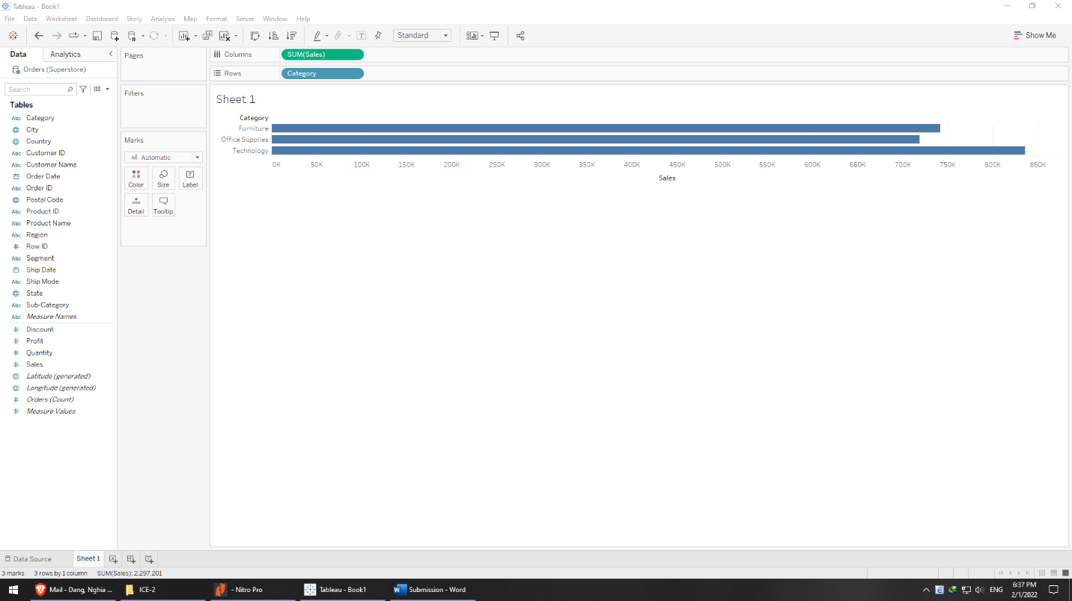

* Category is of nominal typed, 3 unique values: furniture, office supplies, and technology
* In terms of quantity: technology > furniture > office supplies but the difference is insignificant (836, 742, and 719)

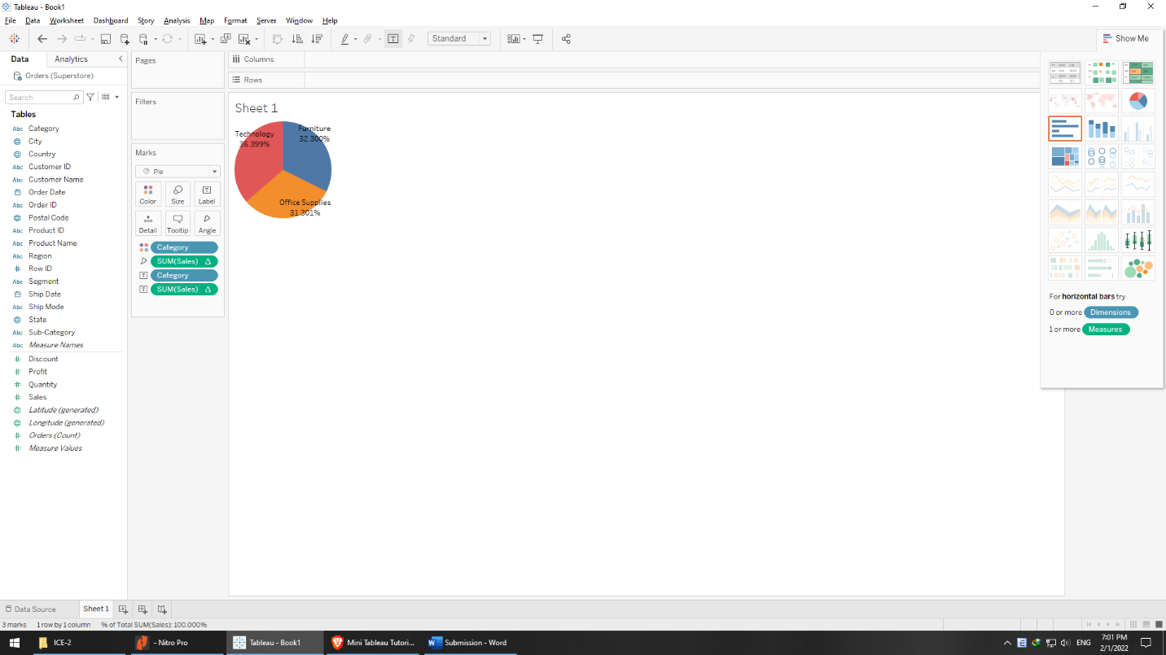

* In percentage, it also shows the same

**Sheet 1, 1-a, and 2 on dashboard:**

* Region 1: Central and Time spike: 2016 – Q3

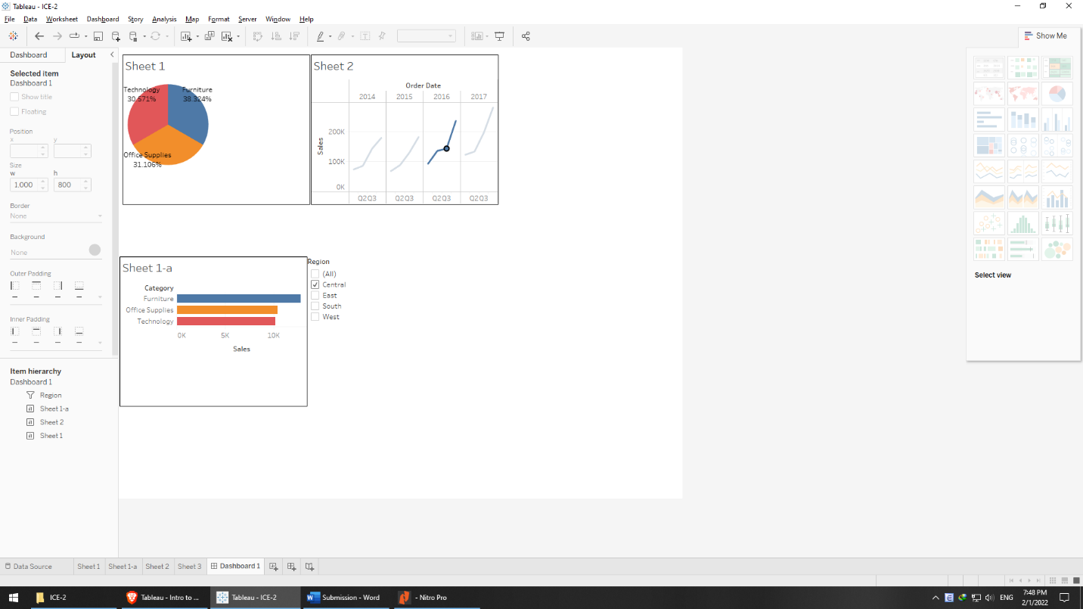

* + Technology (30.6%) < Office supplies (31.1%) < Furniture (38.3%)
  + The difference between the top sales (furniture) is a little substantial to the rest
  + The sales so far are very slightly increasing against the previous quarter (visually from the slope). From the sheet 2, it can be seen that it will skyrocket in the next quarter, in which events, such as Thanks Giving, Black Friday, Christmas, and New Year will happen because manufactures want to get rid of old models / versions and restock new ones. Statistically, the event that is expected to explode the sales is likely Black Friday on technology merchandise due to the fact that model difference neither matters on office supplies nor furniture but does dramatically on technology ones. Hence, technology is generally expected to outperform other two sales types in the last quarter.
* Region 2: East and Time spike: 2016 – Q3

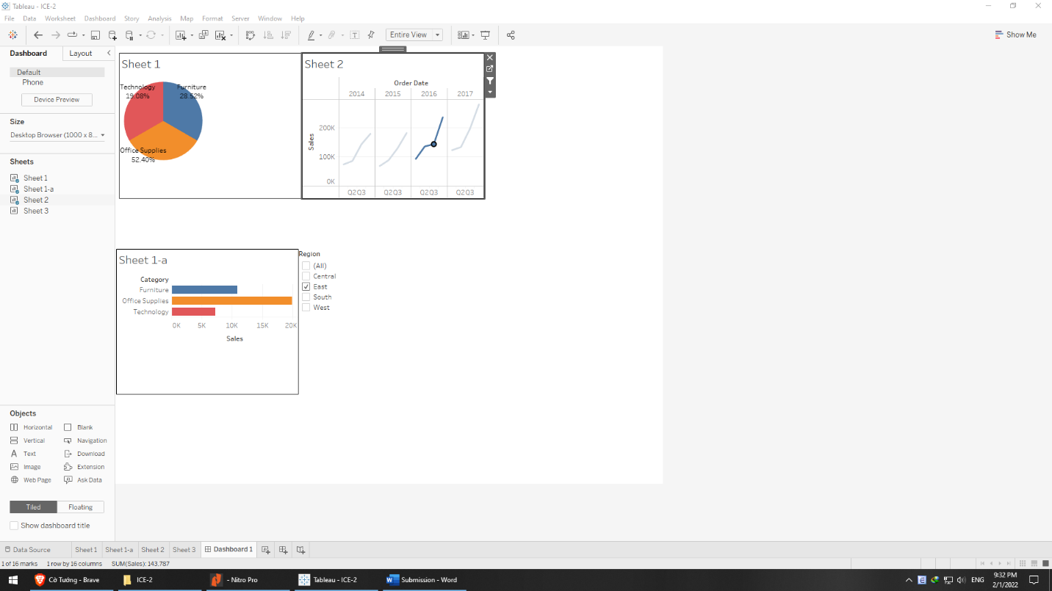

* + Visually, the furniture sales are dominant to other types when taking account for over half of all sales (52% or approximately 20k) in the third quarter of 2016 followed by furniture 28.5% and technology 19%. The difference between the last two is also perceivable.
  + Thus, office supplies should receive extra support from other departments in Q3 if it shows the similarly seasonal pattern in other years.
  + With the similar reasoning, the technology merchandise is expected to outperform the other two types in 2016-Q4.

**Region and States Sales**

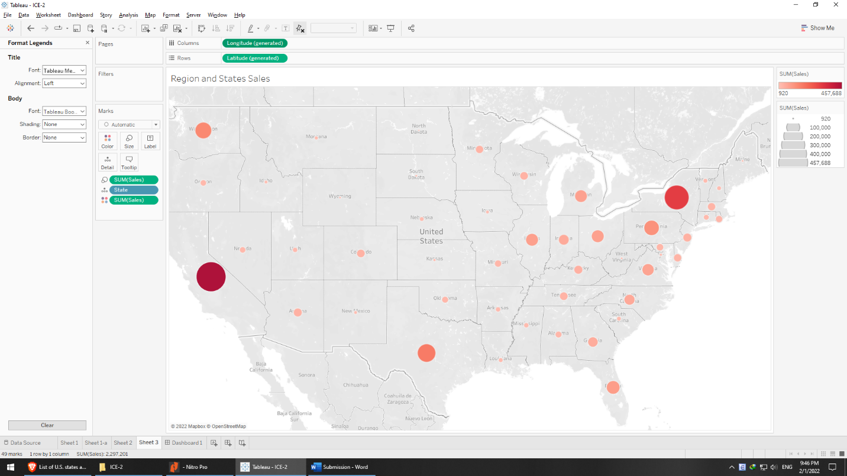

* It’s not surprising that California, Texas, and New York, Florida take the top four positions due to their population. Washington State, yet, came right after them while it is the 13th largest state (number taken from <https://en.wikipedia.org/wiki/List_of_U.S._states_and_territories_by_population> in 2010. For simplicity, I assume it is updated), which should be furthermore scrutinized if it is only a sudden surge or can be a promising channel.
* The top sales spreading from west to east shows that geographic is likely not a factor of sales revenue.
* Similarly, as has been noted, state size plays a trivial role in sales (population, on the other hand, is a different story).
* Except for the Big Three (California, Texas, and Florida), other coastal states don’t show clear relationship with their advantage of being close to sea compared with others surrounded by terrain. This factor should be clarified, too.