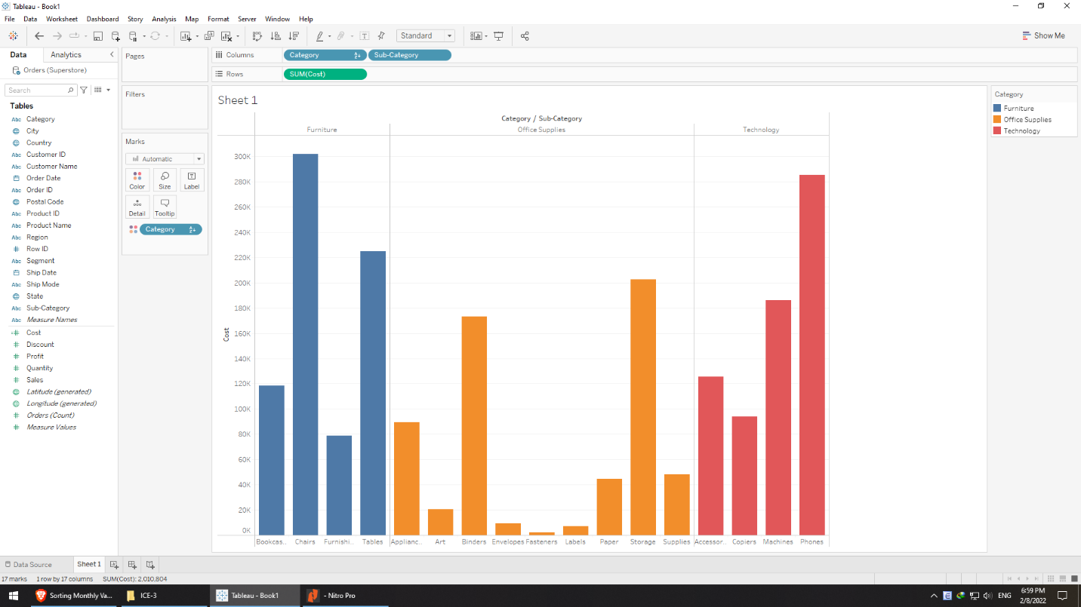

**Create and use the data calculated field**

* Furniture has 4 values: bookcase, chair, furnishing, table
* Office supplies has 8 values
* Technology has 4 values
* The highest cost item is chair, the lowest one is fastener

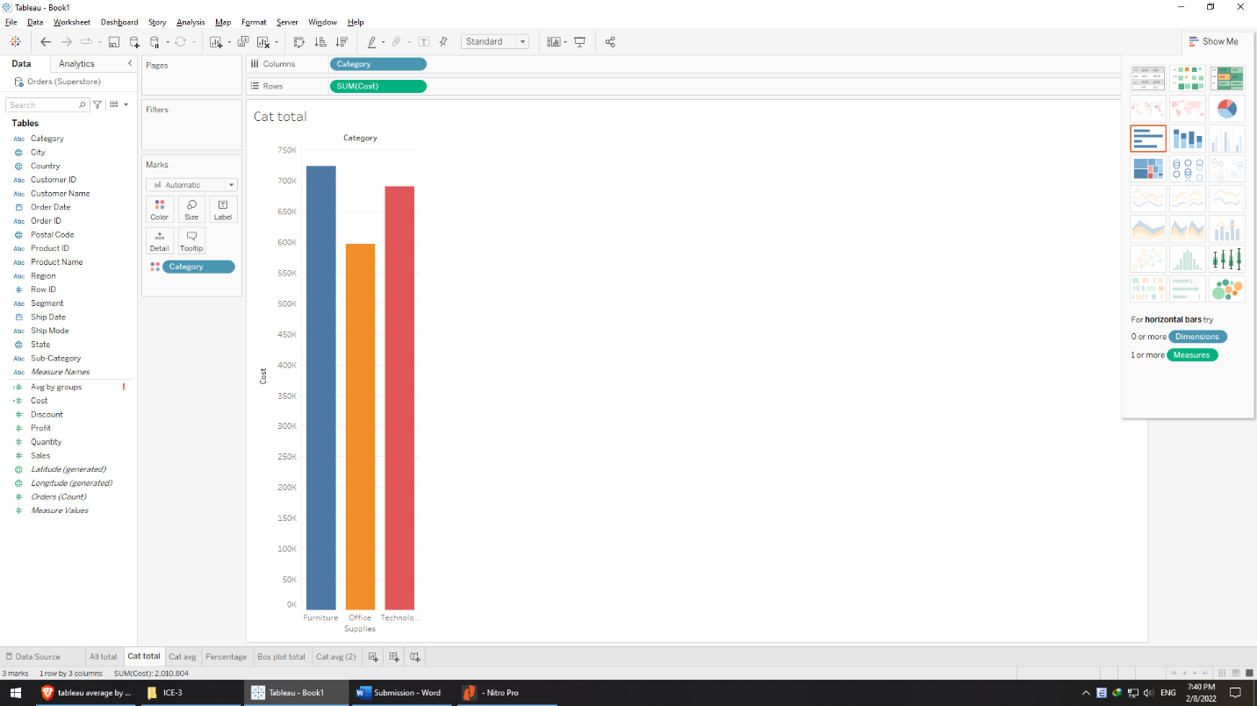

* The sums of costs of categories are not too much different: Furniture ($724) > Technology ($691) > office supplies ($597)

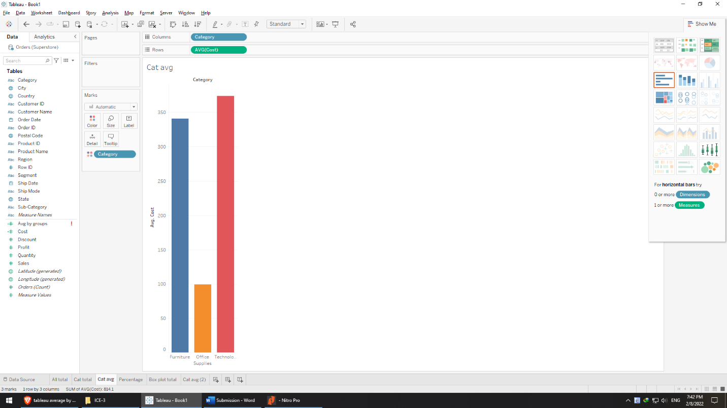

* Average costs are yet significant among categories: Technology ($374) > furniture ($341.1) > office supplies ($99)

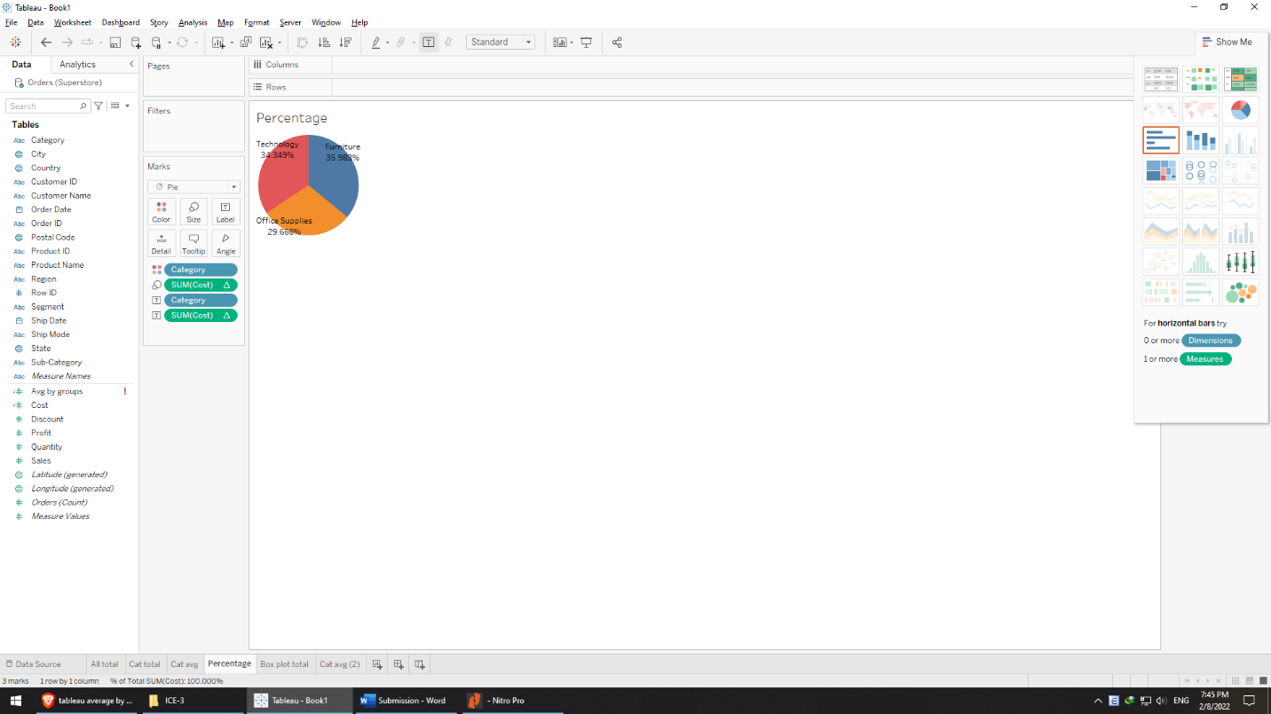

* In percentage, furniture (36%) > technology (34%) > office supplies (30%), the different is insubstantial

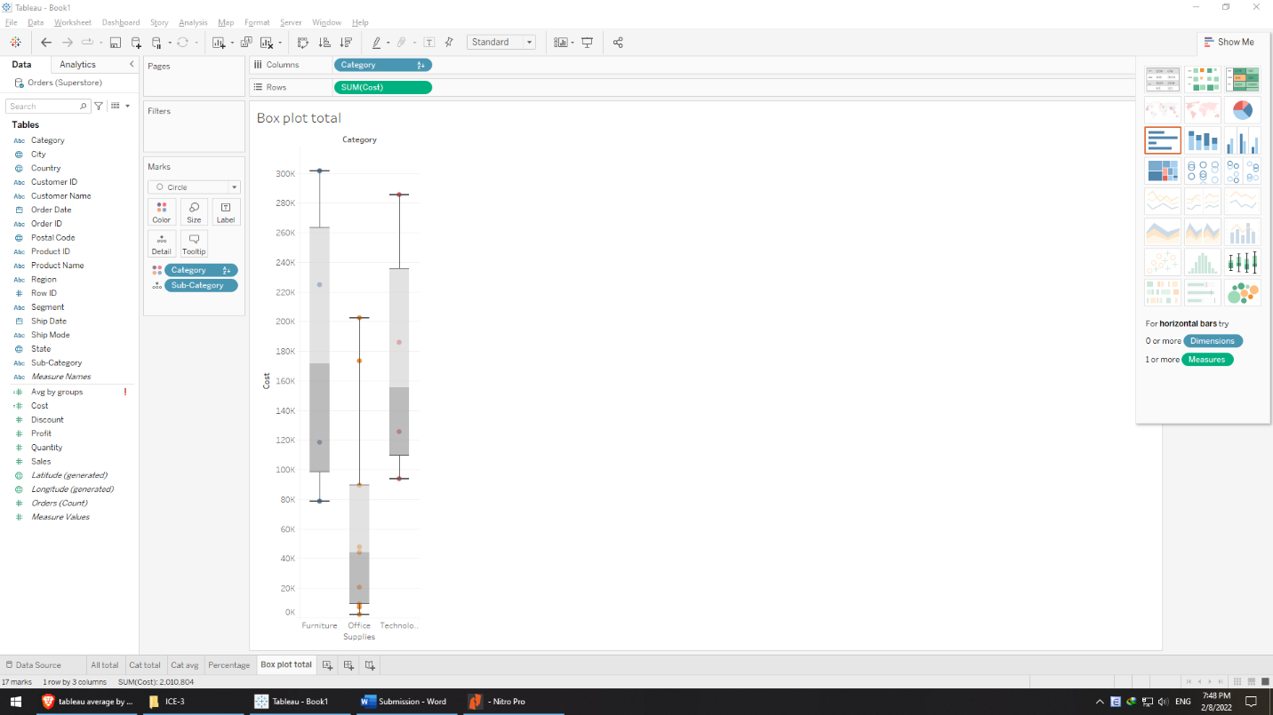

* From the box plot, in order of variance, furniture > technology > office supplies

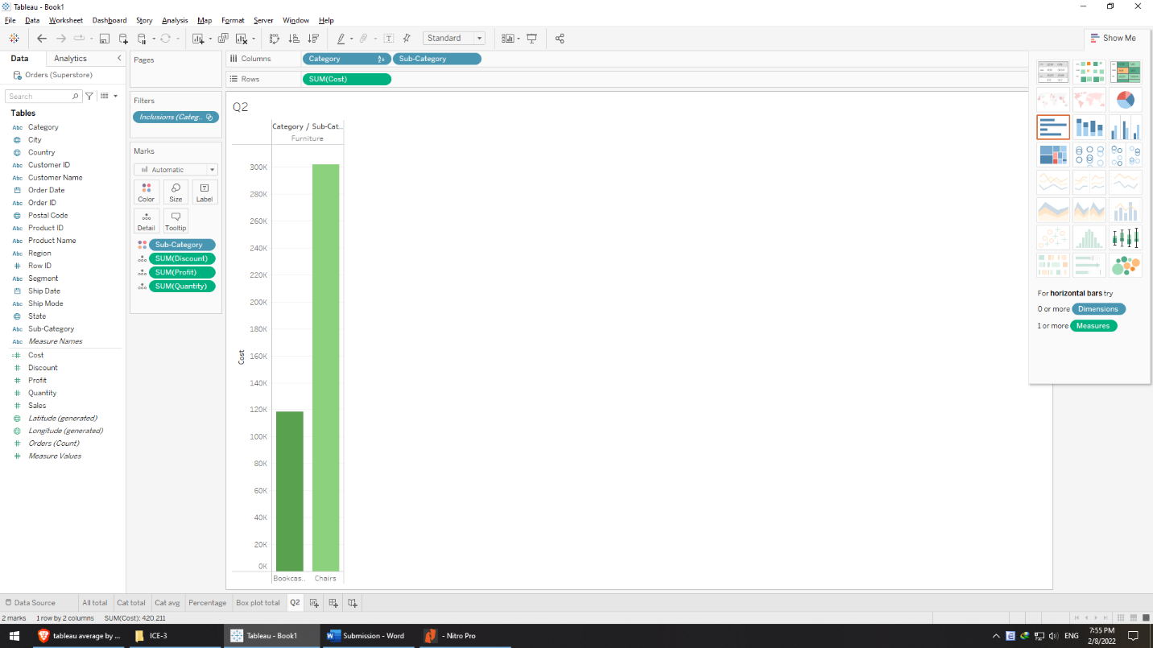

**Interactivity with text and visual tooltip**

* Furniture: bookcase and chair
* Chairs have over 2.5 against bookcases in terms of cost
* The ratio of discount of bookcases is a bit higher than chairs (as their values are 48 and 105 due to the fact that value of chairs is under 2.5 against chairs’)
* Surprisingly, chairs are 26k in profit compared with bookcases (loss of 3.4k)
* Bookcases quantity is 868 while chairs’ is 2,356, which makes sense since the business should focus on selling profitable merchandise.

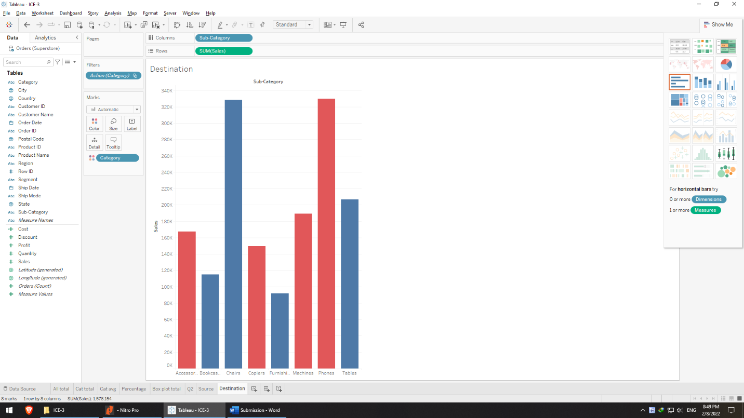

**Step 7**

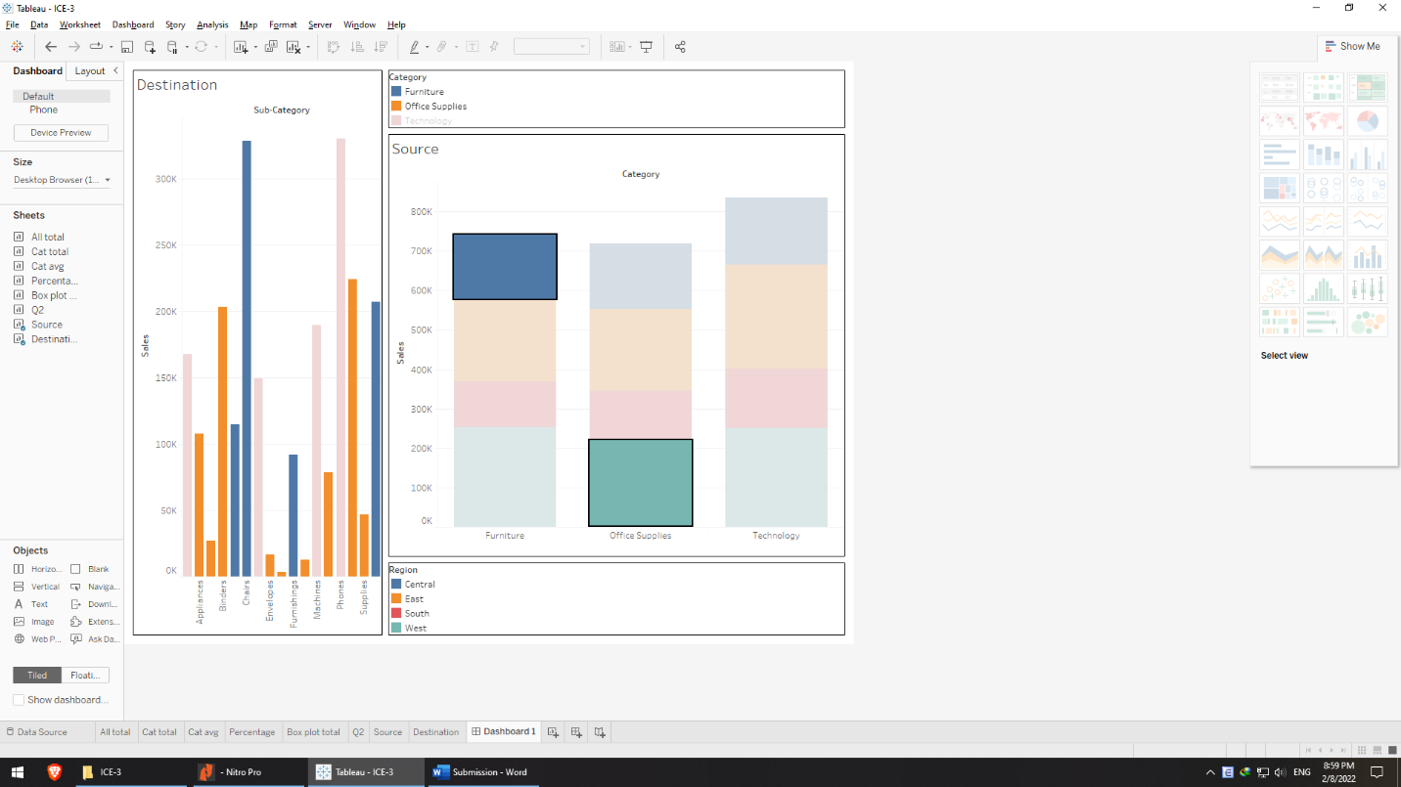

**Step 9**

|  |  |
| --- | --- |
| **Furniture – Central** | **Office supplies - West** |
| On average, higher sales | On average, lower sales |
| Lowest: Furnishings 92 k | Lowest: Fasteners 3k |
| Highest: Chairs 328 k | Highest: Storage 224k |
| 4 sub-categories | 9 sub-categories |

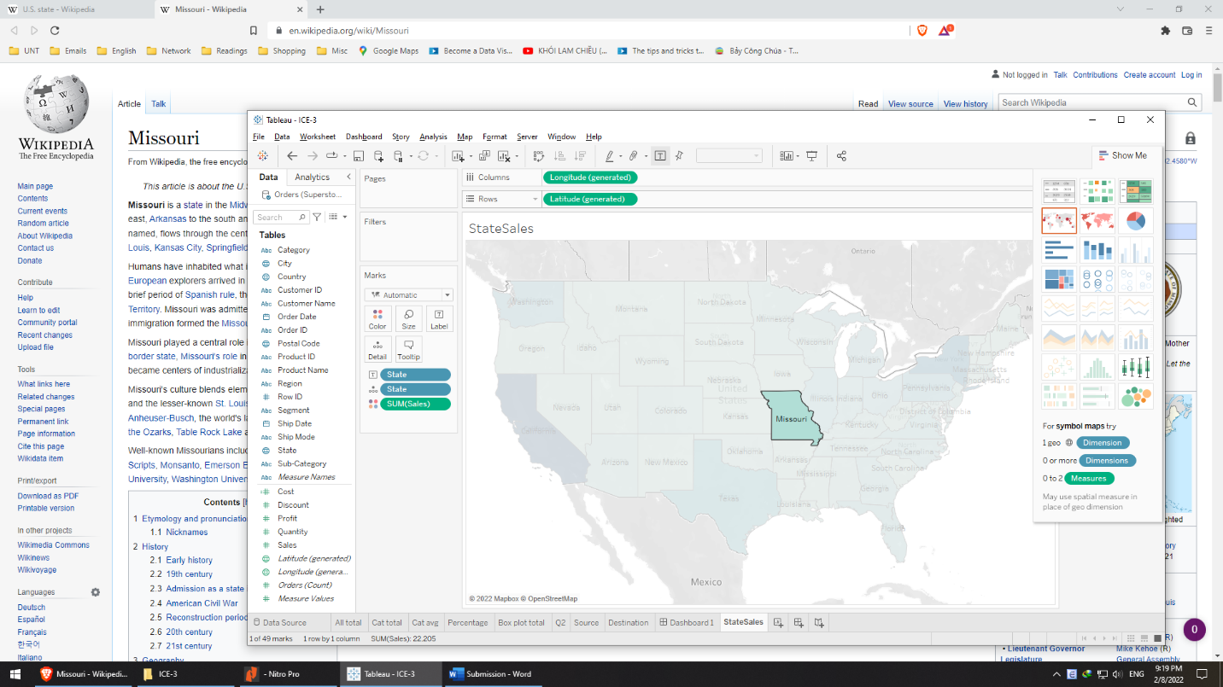

**Step 10**