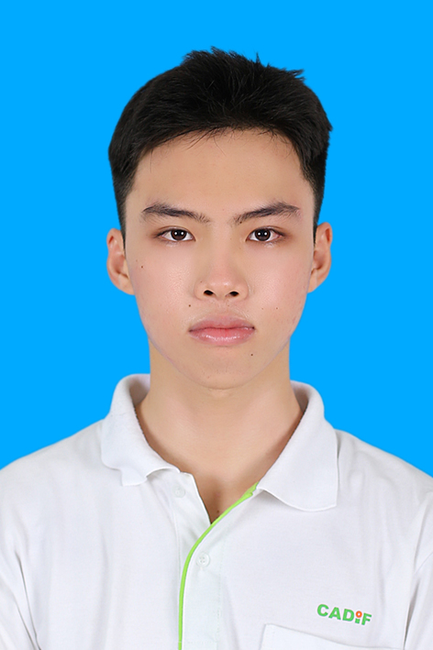

Nguyen Nhat Tai | 0396770544 | tainn.dv@gmail.com

# About me

I am a senior student at Can Tho University (CTU), majoring in Software Engineering. From very early on in my life, I started to fall in love with technology 😍 This love has helped me develop a very good technological mindset, and given me the curiosity to learn more. I firmly believe that no amount of knowledge is sufficient to succeed. 🧠

# Work Experience

**Amigoscode** *2024-2025*Python Developer

# Skills

* Python
* Java
* Marketing
* Management