Team Name: Cloud
Team Members: Teoman Kasarcı – Batuhan Büyüknacar – Başar Haktan Yaman – Ali Emre Sayan
GitHub Repository: https://github.com/teomanksrc/cse311-project

CSE 321 Data Systems · Project Report (Checkpoint 1)
PO Score Management System for Acıbadem University CSE · Presentation: Thursday, 12 November 2026

Section 1 · Introduction
Our system is a web application that manages each student's Program Outcome (PO) scores for Acıbadem University's Computer Engineering department, our pilot customer. Instructors enter assessment grades (midterm, project, ...). The system turns them into Learning Outcome (LO) scores inside each course and then into the department's 11 POs, combining every course a student has taken into one PO profile. Every step uses the same rule: score = Σ(weight × score) ÷ Σ(weights).
Key features at this checkpoint:
- Weighted score chain Assessment → LO → PO, verified against the guideline's worked example (Elif: LO1 86.0, LO2 82.9, PO1 85.0, PO2 82.9) by automated tests.
- One profile per student across many courses: a PO score combines every LO → PO link of every course the student took (LO → PO weights on the department's 1–5 scale).
- Honest handling of missing grades: a missing grade is left out of the average and the score is flagged as incomplete instead of being treated as 0.
- Four roles (Admin, Department Head, Instructor, Student) with permissions enforced on the server; a student can only ever see their own data.
- Grade entry per assessment in a table; the whole table is saved in one transaction or not at all.
- Dashboards: students see their PO profile as a bar chart plus a per-course LO breakdown; the department head sees the average score, number of students and number of incomplete scores per PO.
- Semester-aware curriculum: a Course (CSE 311) is taught as CourseOfferings (CSE 311, 2026-Fall); LOs, assessments and weights belong to the offering, so changing them next term never rewrites history.
- Integrity in the database itself: unique and CHECK constraints (grades 0–100, LO → PO weight 1–5, assessment weight > 0, no duplicate links).
- Always up-to-date scores: any change to a grade or weight recomputes the affected cached scores in the same transaction.
- Continuous integration: every push runs linting, migrations and 47 automated tests on PostgreSQL 16.
Planned for the final demo: syllabus upload that proposes LOs and weights automatically, bulk grade import, AI-generated performance reports, notifications and OBS/LMS integration.

Section 2 · System Design

2.1 System architecture
The system is a server-rendered Django application backed by PostgreSQL (Figure 1). There is no separate front-end application: Django renders HTML templates styled with Bootstrap, and Chart.js draws the PO charts in the browser. Table 1 lists every component and whether it exists today or is planned.
Table 1. Components of the system.
Component | Technology | Responsibility | Status
Web UI | Django templates, Bootstrap 5, Chart.js | Login, grade entry, dashboards | Built
Web application | Django 5.2 on Python 3.12; apps accounts, curriculum, grading, scoring | Business rules, permissions, scoring | Built
Database | PostgreSQL 16 in Docker (named volume, health check) | Single source of truth | Built
Dev fallback | SQLite | Lets developers work without Docker | Built (dev only)
Cache | Redis via Django's cache framework | Cache dashboard aggregates; today the cached score tables play this role | Planned
Notifications | E-mail (Django e-mail backend) | Alert students when a PO drops below a threshold | Planned
3rd-party integrations | OBS / LMS export files (CSV, Excel) | Import enrollments and grades | Planned
CI | GitHub Actions + PostgreSQL service container | Lint, migrate, test on every push | Built

How a grade change flows through the system:
- The instructor submits the grade table for one assessment.
- The view checks that the instructor teaches this offering and that every value is a number between 0 and 100. If any value is invalid, nothing is saved.
- Inside one database transaction the grades are inserted, updated or deleted.
- Each change fires a Django signal that calls scoring/recompute.py for the affected student.
- recompute.py reads the student's grades and weights and passes plain numbers to scoring/services.py, a pure Python module with no database access.
- The results are written to the cached tables StudentLOScore and StudentPOScore, and the transaction commits grades and scores together.

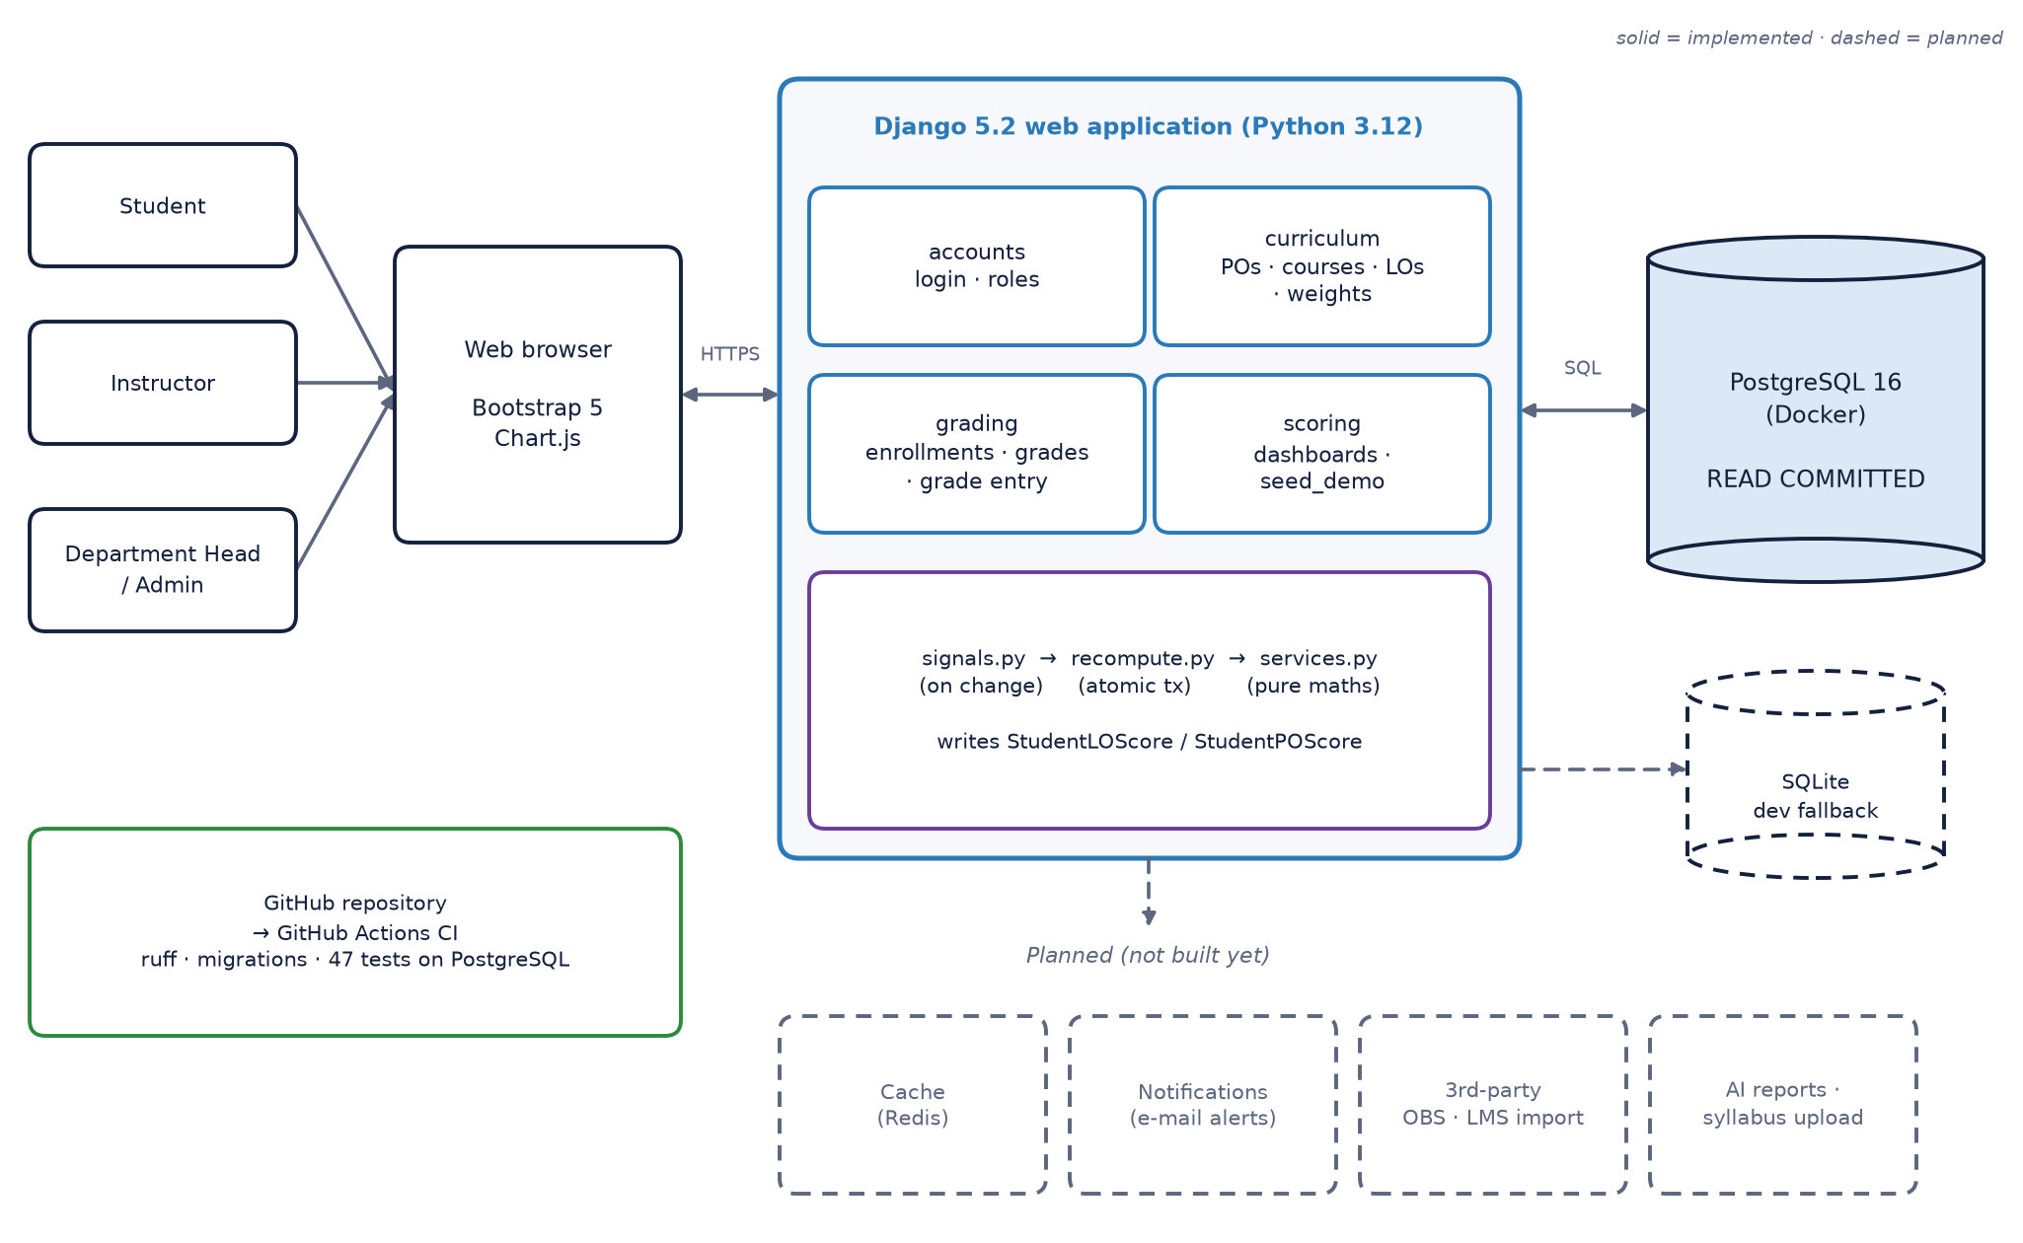
Figure 1. System architecture. Solid boxes are implemented, dashed boxes are planned.

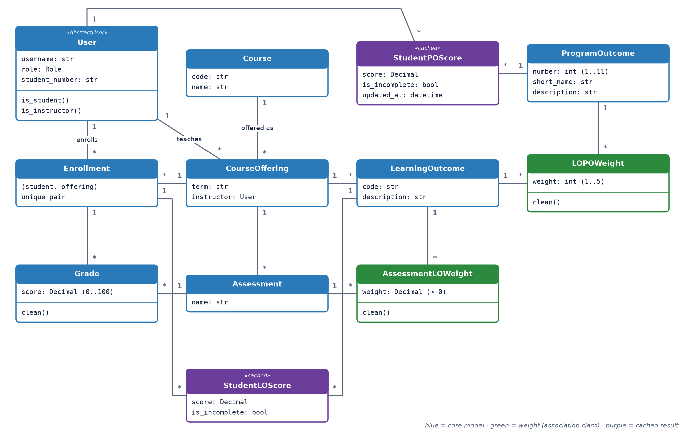
Figure 2. Class diagram of the Django models and their relationships.

2.2 Class / object diagram
Figure 2 shows the twelve model classes. Blue classes are the core domain, green classes are association classes that carry the weights, and purple classes are cached results derived from the others. Table 2 explains each relationship and what happens on delete.
Table 2. Relationships between the classes.
Relationship | Multiplicity | Meaning | On delete
Course → CourseOffering | 1 : * | A course is taught in many terms | Cascade
User → CourseOffering | 1 : * | An instructor teaches offerings | Protect
CourseOffering → LearningOutcome | 1 : * | LOs are defined per offering | Cascade
CourseOffering → Assessment | 1 : * | Midterm, project, ... per offering | Cascade
Assessment ↔ LearningOutcome | * : * via AssessmentLOWeight | Assessment feeds LO with a weight | Cascade
LearningOutcome ↔ ProgramOutcome | * : * via LOPOWeight | LO feeds PO with weight 1–5 | Cascade
User ↔ CourseOffering | * : * via Enrollment | A student takes an offering | Cascade
Enrollment → Grade ← Assessment | 1 : * each | One score per student per assessment | Cascade
Enrollment → StudentLOScore | 1 : * | Cached LO score per enrollment | Cascade
User → StudentPOScore | 1 : * | Cached PO score per student (max 11) | Cascade

Design choices behind the diagram:
- Course vs CourseOffering: weights and LOs change between semesters; attaching them to the offering keeps old terms' scores reproducible.
- Weights as association classes: a many-to-many link with a weight is a class of its own, which lets the database validate every weight with a CHECK constraint.
- Custom User with a role field: one table for all people, extended from Django's AbstractUser on day one.
- Scoring logic outside the models: scoring/services.py contains only pure functions that return a ScoreResult(score, is_incomplete). It is unit-tested without a database (Listing 1).
def weighted_average(sources, available):
"""Combine sources = [(key, weight)] using available = {key: score}."""
numerator = Decimal("0")
denominator = Decimal("0")
missing = False
for key, weight in sources:
weight = check_weight(weight) # raises ValueError if weight <= 0
if key in available:
numerator += weight * to_decimal(available[key])
denominator += weight
else:
missing = True # missing grade: skipped, flagged
if denominator == 0:
return None # nothing feeds this score
return ScoreResult(score=numerator / denominator, is_incomplete=missing)
Listing 1. The single scoring rule (scoring/services.py), used for both LO and PO scores.

Section 3 · Data Model
Figure 3 shows the physical schema in PostgreSQL: twelve application tables, their columns, keys and relationships. Table 3 lists each table's rows, columns and raw size.

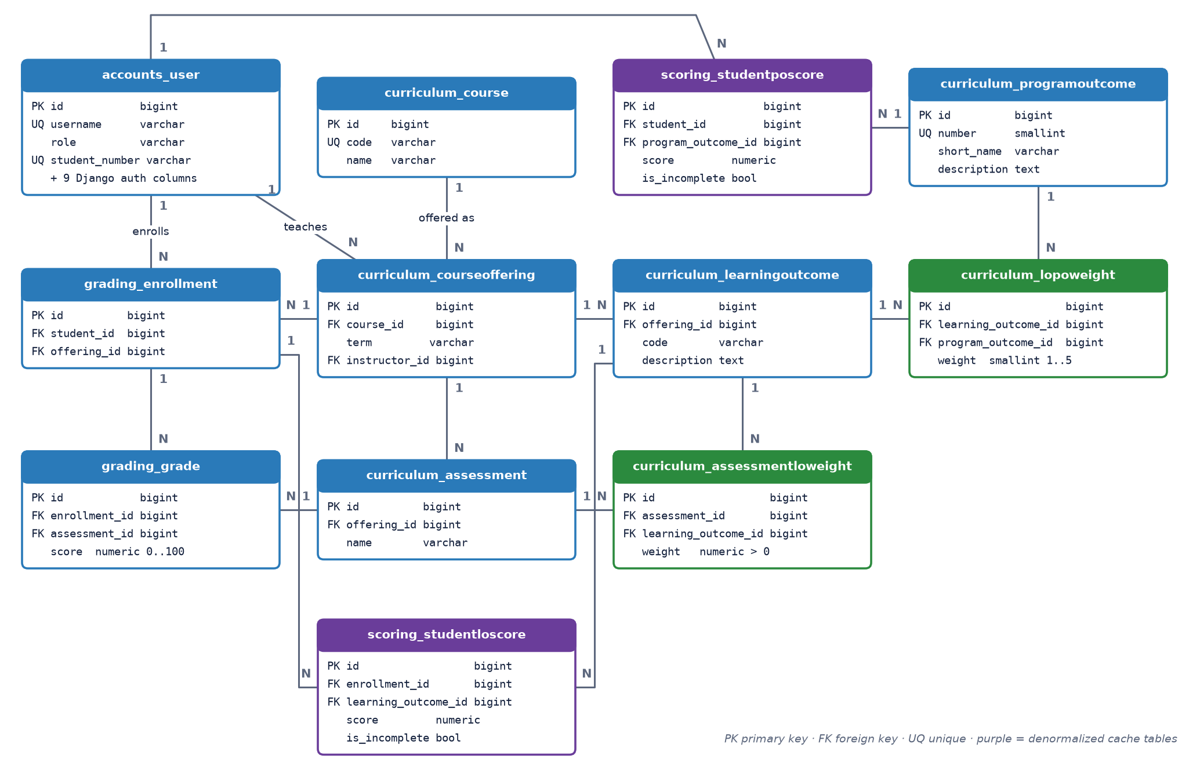
Figure 3. Data model (ER) diagram of the PostgreSQL schema.

3.1 Tables, rows, columns and raw size
Table 3. Rows, columns and raw size of every table (measured on 1 November 2026, PostgreSQL 16.15).
Table | Rows | Columns | Data | Indexes | Total
accounts_user | 5 | 13 | 8 KB | 80 KB | 96 KB
curriculum_programoutcome | 11 | 4 | 8 KB | 32 KB | 48 KB
curriculum_course | 3 | 3 | 8 KB | 48 KB | 56 KB
curriculum_courseoffering | 3 | 4 | 8 KB | 64 KB | 72 KB
curriculum_learningoutcome | 5 | 4 | 8 KB | 48 KB | 64 KB
curriculum_assessment | 6 | 3 | 8 KB | 48 KB | 56 KB
curriculum_assessmentloweight | 10 | 4 | 8 KB | 64 KB | 72 KB
curriculum_lopoweight | 8 | 4 | 8 KB | 64 KB | 72 KB
grading_enrollment | 6 | 3 | 8 KB | 64 KB | 72 KB
grading_grade | 12 | 4 | 8 KB | 64 KB | 72 KB
scoring_studentloscore | 10 | 6 | 8 KB | 64 KB | 72 KB
scoring_studentposcore | 10 | 6 | 8 KB | 64 KB | 72 KB
Total (12 tables) | 89 |  | 96 KB | 704 KB | 824 KB

These numbers come from the demo dataset created by python manage.py seed_demo (11 POs, 3 courses, 5 users, 2 students, 12 grades) and were measured with the query in Listing 2. PostgreSQL stores data in 8 KB pages, so at this size every table occupies exactly one data page and the sizes reflect page granularity rather than data volume; indexes dominate the total. We ran VACUUM FULL before measuring so that old row versions left by repeated re-seeding are not counted. The final report will repeat the measurement on a realistic dataset.
SELECT relname,
n_live_tup,
pg_size_pretty(pg_relation_size(relid)) AS data,
pg_size_pretty(pg_indexes_size(relid)) AS indexes,
pg_size_pretty(pg_total_relation_size(relid)) AS total
FROM pg_stat_user_tables
ORDER BY relname;
Listing 2. Query used to measure table sizes.
Expected volume for the department. We assume about 270 students in total across all four years (the department's approximate size). If each student takes about 45 courses over four years, with about 4 assessments and 4 LOs per course, the largest tables would hold roughly 48,600 grades (270 × 45 × 4), 48,600 cached LO scores, 12,150 enrollments (270 × 45) and 2,970 cached PO scores (270 × 11). Including indexes that is in the order of 10–20 megabytes, so a single PostgreSQL server is more than sufficient. Section 4 describes how we would grow beyond that.

3.2 Schema style: normalized, with two deliberate denormalizations
- Normalized (3NF) operational schema. The tables in accounts, curriculum and grading store each fact exactly once: a course name only in curriculum_course, a weight in exactly one row, a grade in exactly one row. There are no repeating groups and no transitive dependencies. This is the source of truth.
- Denormalized cache tables. scoring_studentloscore and scoring_studentposcore store values that can always be derived from grades and weights. We keep them because every dashboard request would otherwise join grades, assessment weights, LOs and LO → PO weights for every student. The application rewrites them in the same transaction as the change that affects them (Section 5), and they can be rebuilt from scratch at any time.
- Not a star or snowflake schema (yet). This is an OLTP schema for day-to-day data entry, not a data warehouse. For the planned reporting features, scoring_studentposcore is a natural fact table with student, program outcome and term as dimensions, giving a star schema for analytics.

Section 4 · Scalability & Fault Tolerance

4.1 Index types
All indexes are B-tree indexes, PostgreSQL's default, because every query in the system is an equality or range lookup on keys. Table 4 groups them by purpose.
Table 4. Indexes in the schema (all B-tree).
Index kind | Examples | Used for
Primary key (unique B-tree) | id on every table | Row lookup, foreign-key targets
Composite unique B-tree (business keys) | (enrollment_id, assessment_id) on grades; (student_id, program_outcome_id) on PO scores; (learning_outcome_id, program_outcome_id) on LO → PO weights | Prevent duplicates; the leading column also serves 'all grades of an enrollment' and 'a student's PO profile'
Foreign-key B-tree (created by Django) | assessment_id on grades, instructor_id on offerings, offering_id on LOs | Joins, grade-entry page (grades of one assessment), cascades on delete
B-tree with varchar_pattern_ops | username, course code, student_number | Prefix search (LIKE 'CSE%') in the admin site

Hash, GIN and BRIN indexes are not used: there is no full-text or JSON data, and no very large time-ordered table yet.
Index clean-up (found and fixed while preparing this report). A query on PostgreSQL's pg_index catalog showed three redundant indexes: grade_assessment_idx and grade_enrollment_idx on grading_grade, and po_score_po_idx on scoring_studentposcore. Each duplicated a foreign-key index that Django already creates, adding write cost and space with no read benefit. We removed them in two migrations (grading/0002, scoring/0002); the same query now returns no rows. An automated test (test_no_duplicate_indexes) runs this check against PostgreSQL on every CI build, so duplicates cannot come back. Removing them also shrank grading_grade from 104 KB to 72 KB and scoring_studentposcore from 136 KB to 72 KB in total size.

4.2 Materialized views and cubes
- Today: the two cached score tables work as application-maintained materialized views that are refreshed incrementally, one student at a time, whenever a grade or weight changes. Dashboards read precomputed rows. The department dashboard aggregates scoring_studentposcore (AVG and COUNT grouped by PO) at request time, which is cheap because that table has at most 11 rows per student.
- Planned: a PostgreSQL MATERIALIZED VIEW with department averages per PO, term and course, refreshed with REFRESH MATERIALIZED VIEW CONCURRENTLY after grade batches, plus a GROUP BY CUBE (term, course, program_outcome) roll-up for the department head's reports.

4.3 Partitioning and replication
- Partitioning (planned): not needed at today's size. When several years of history accumulate we will partition grading_grade and the score tables by term (LIST or RANGE). Queries for the current term then touch one partition (partition pruning), and old terms can be archived by detaching a partition. This requires copying the term onto the grade row as the partition key, a small and deliberate denormalization.
- Replication (planned): PostgreSQL streaming replication with one primary for writes and one hot-standby replica for read-heavy dashboards and reports, using a Django database router. Grade entry always reads the primary; dashboards tolerate a few seconds of replica lag. The replica can be promoted if the primary fails.

4.4 How the system tolerates failures today
- Atomic transactions: a failure in the middle of a save rolls everything back, so no half-saved grade table or half-updated score profile can exist (Section 5).
- Constraints in the database: invalid grades or weights are rejected by PostgreSQL even if a code path bypasses the forms. Tests check this directly.
- Derived data is rebuildable: the cached score tables can be recomputed from grades and weights at any time (recompute_student, recompute_offering), so losing them is not data loss.
- Container resilience: PostgreSQL runs with a named Docker volume (data survives container restarts), restart: unless-stopped and a pg_isready health check.
- Regression safety: GitHub Actions runs migrations and all 47 tests against a real PostgreSQL 16 on every push, so schema and logic errors are caught before they are merged.
- Reproducible environment: seed_demo is idempotent and rebuilds the demo data in one command.
The SQLite fallback is a development convenience, not a fault-tolerance mechanism: in production a missing database must fail loudly. We will disable the fallback outside development. Planned backups: daily pg_dump plus WAL archiving for point-in-time recovery.

Section 5 · Consistency

5.1 Where and how we use transactions
Table 5. Transactions in the system.
Location | Mechanism | What it guarantees
grading/views.py · enter_grades | transaction.atomic() block | All grades of one assessment table are saved together, or none are. Validation runs before the transaction starts.
scoring/recompute.py · recompute_student | @transaction.atomic + SELECT ... FOR UPDATE | Locks the student's row, then rewrites the student's LO and PO cache rows as one unit. Called from a signal inside an outer transaction it becomes a savepoint, so scores commit with the grade change.
scoring/recompute.py · recompute_offering | @transaction.atomic | A weight change recomputes every student of the offering in one transaction.
Django admin add / change / delete | Django wraps each admin save in transaction.atomic | Signals fire inside it, so the cache is updated together with the admin change.
seed_demo command | @transaction.atomic | The demo dataset is created completely or not at all.

student_of = {row["enrollment"].id: row["enrollment"].student_id for row in rows}
with transaction.atomic():
# save in student-id order: the same lock order as every recompute
ordered = sorted(parsed.items(), key=lambda item: student_of[item[0]])
for enrollment_id, score in ordered:
if score is None:
Grade.objects.filter(
enrollment_id=enrollment_id, assessment=assessment
).delete()
else:
Grade.objects.update_or_create(
enrollment_id=enrollment_id,
assessment=assessment,
defaults={"score": score},
)
# each save/delete fires a signal: recompute_student() runs in the same transaction
Listing 3. Saving a grade table (grading/views.py, slightly reformatted for print).

5.2 Isolation level
We use PostgreSQL's default READ COMMITTED isolation level; Django does not override it. We verified this on the running database: SHOW default_transaction_isolation returns read committed. Under READ COMMITTED no transaction ever reads uncommitted data (no dirty reads), and a reader sees either a student's complete old scores or the complete new ones, because each recompute commits at once. Recomputes for different students touch disjoint rows and do not conflict. Recomputes for the same student are serialized with a row lock, as described next.

5.3 Race condition: found, reproduced and fixed
The problem. While writing this report we found one race condition. If two instructors save grades for the same student in two different courses at the same moment, both transactions recompute that student's scores. Under READ COMMITTED neither can see the other's uncommitted grade, so the transaction that commits last overwrote the cached LO and PO scores with values that ignored the other grade. If the cached rows did not exist yet, one transaction could also fail on the unique constraint.
Reproduced. We ran two concurrent transactions against PostgreSQL 16: the first changed a student's CSE 311 midterm and kept its transaction open for 2 seconds, while the second changed the same student's MAT 241 final. Afterwards we compared the cached rows with a fresh recompute. Without a lock, 4 cached rows were stale. With the fix, 0 rows were stale.
The fix. recompute_student now locks the student's row first (Listing 4). The second transaction waits at that line until the first one commits. Because READ COMMITTED gives every new statement a fresh snapshot, its next queries see the first transaction's committed grades, so no update is lost. To rule out deadlocks, every code path takes these locks in the same order (by student id): recompute_offering iterates students by id and the grade-entry view saves rows by student id. An automated test checks that the lock is the first query of every recompute. We kept READ COMMITTED: SERIALIZABLE would also prevent the anomaly, but it aborts transactions on conflict and needs retry logic around every save, while one row lock is simple and targeted.
@transaction.atomic
def recompute_student(student):
# Serialize concurrent recomputes of this student (no-op on SQLite).
list(get_user_model().objects.select_for_update().filter(pk=student.pk))
enrollments = list(Enrollment.objects.filter(student=student))
...
Listing 4. Row lock at the start of every recompute (scoring/recompute.py).
Constraints that keep the data consistent regardless of the application:
Table 6. Database constraints (excerpt).
Table | Constraint | Rule
grading_grade | grade_score_0_to_100 | CHECK (score >= 0 AND score <= 100)
grading_grade | uniq_grade_enrollment_assessment | One grade per student per assessment
curriculum_lopoweight | lo_po_weight_1_to_5 | CHECK (weight BETWEEN 1 AND 5)
curriculum_assessmentloweight | assessment_lo_weight_positive | CHECK (weight > 0)
curriculum_courseoffering | uniq_offering_course_term | A course is offered once per term
grading_enrollment | uniq_enrollment_student_offering | A student enrolls once per offering
scoring_studentposcore | uniq_po_score | One cached score per student and PO

Section 6 · Teamwork
[To be completed by the team: how the work was divided and which member carried out which task.]

