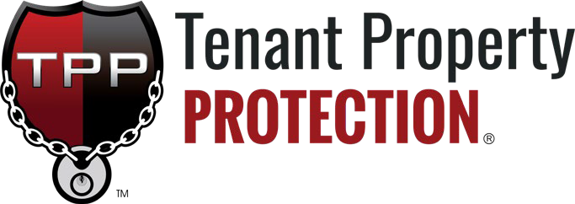

Tenant Property Protection Plan
TENANT RESPONSIBILITY ADDENDUM


I UNDERSTAND THAT THIS SELF STORAGE FACILITY REQUIRES THAT I PROVIDE PROTECTION FOR MY PROPERTY BECAUSE THE FACILITY DOES NOT EXTEND INSURANCE TO MY STORED
COVERED LOSSES
1.

INITIAL HERE
BURGLARY¹
WATER DAMAGE² FIRE, WINDSTORM
BUILDING COLLAPSE EXPLOSION
HAIL
SMOKE VANDALISM
RODENT

2.

INDICATE
YOUR CHOICE AT THE RIGHT AND INITIAL HERE

1-Burglary losses must show visible signs of forced entry and be reported to the police and facility management. Disc or cylinder locks required to waive burglary deductible.

2-Does not include loss due to surface waters or flooding. Flood insurance is available through the U.S. Government and the National Flood Program.

It is the Tenants responsibility to maintain and provide a list of inventory records and documentation. This will establish a base line of Tenant inventory records and in the event of a loss, will provide the most accurate information for claims adjudication services. To simplify the process for Tenants, we created a web application tool called BirdsEyeProtection (https://birdseyeprotection.com). All uploaded documentation added will be stored in a cloud-based repository at the time of submission.

3.
INITIAL HERE

PROPERTY. The Addendum will be retained by this facility as part of your lease or Rental
Agreement.

I understand that this self storage facility and/or its management:
- Is not responsible for loss or damage to my property
- Is a commercial business renting space and is not a bailee or warehouseman

TENANT PROTECTION PLAN (TPP PLAN) IS IMMEDIATELY EFFECTIVE UPON RECEIPT OF PAYMENT

YES, I WANT TO PARTICIPATE IN THE TPP PLAN:
Select One | Protection Limit | Monthly Fee
 | $2,000 | $12.00
 | $3,000 | $15.00
 | $5,000 | $25.00

In consideration of payment selected in the box shown at right, in addition to monthly rent, the (TPP Plan) will cover loss or damage to Tenant’s property stored within the storage units identified in the Rental Agreement you signed, up to the protection plan limit selected on the Tenant Responsibility Addendum for losses caused by the following:

Loss or damage may be caused by, but not necessarily limited to:
- Fire, explosion, smoke, or hail
- Burglary, vandalism, or malicious mischief. See Terms & Conditions for specific provisions applying to burglary claims
- Roof leak or water damage. PLEASE NOTE: Flood, surface water, underground water or water that backs up through or overflows from a sewer, drain or sump or accidental discharge of substances from within plumbing, heating, air conditioning or fire protection system is NOT covered
- Windstorm that first causes damage to the building
- Collapse of the building where your property is stored
- Impact of aircraft, missile, or vehicle
- Rodent damage (covered up to $500)

YOUR SIGNATURE ON THIS LEASE ADDENDUM IS REQUIRED AS PROOF THE TENANT PROPERTY PROTECTION (TPP PLAN) WAS MADE AVAILABLE TO YOU AND YOU EITHER ACCEPTED OR PROVIDED PROPER PROOF OF COVERAGE:

I acknowledge that I have read the above information which explains the TPP Plan that is available to me.

Customer Signature:

Customer Name:

Date: Unit Number: _
CLAIM CONTACT
I have provided my approved declaration page or certificate of insurance as proof of coverage. Therefore, I do not need the coverage at this time.
www.TPPClaims.com

All required claim documentation must be completed and received by TPP within 30 days of discovery to finalize your claim quickly. Please refer to http://tpptermsandconditions.com/
for the latest TPP Terms & Conditions.

IMPORTANT: This facility and its ownership require in your Rental Agreement under the Insurance Obligation and Responsibility clause; you must provide proof of coverage via a Homeowners or Renters Insurance Declaration Page or Certificate of Insurance for your stored property. Failure to provide proof of insurance within ten (10) days of signing your Rental Agreement, or prior to expiration or cancellation of your insurance policy, will result in your automatic enrollment in the $9 per month Basic Plan, which will be added to your next monthly rent payment. PROTECTION PLAN TYPE REQUIREMENT - The protection plan selected by Tenant must correspond to the type of space rented under this Rental Agreement, whether an enclosed storage unit, outdoor/indoor vehicle or RV parking space, or Flex Space unit. In the event Tenant selects a protection plan that does not match the space type, Management may, without further notice or consent from Tenant, adjust enrollment to the correct protection plan applicable to the space type rented in accordance with the terms of this Rental Agreement and the applicable plan requirements. Tenants shall be responsible for any resulting change in fees, protection limits, or coverage terms.
TPPSECURE 7.1.23

