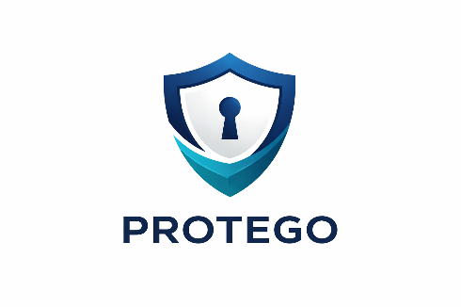

Protego Protection Plan
Customer Responsibility Addendum


I UNDERSTAND THAT THIS SELF STORAGE FACILITY REQUIRES THAT I PROVIDE PROTECTION FOR MY PROPERTY BECAUSE THE FACILITY DOES NOT EXTEND INSURANCE TO MY STORED
1.
COVERED LOSSES
COVERED LOSSES

BURGLARY¹ WATER DAMAGE² FIRE WINDSTORM
BUILDING COLLAPSE EXPLOSION
HAIL
SMOKE VANDALISM

2.

- Burglary losses must show
visible signs of forced entry and be reported to the police and facility management. See Claim Contact section below

- Does not include loss due to surface waters or flooding.
Flood insurance is available through the U.S. Government and the National Flood Program
Per The Lease Agreement
PROPERTY. This facility will retain the Addendum as part of your lease or rental agreement.

I understand that this self storage facility and/or its management:
- Is not responsible for loss or damage to my property
- Is a commercial business renting space and is not a bailee or warehouseman

PROTEGO PROTECTION PLAN IS IMMEDIATELY EFFECTIVE UPON RECEIPT OF PAYMENT
Select One | Protection Limit | Monthly Fee
 | $2,000 | $12.00
 | $3,000 | $15.00
 | $5,000 | $21.00

I select the Protego Plan in consideration of the payment chosen in the box shown at the right, and in addition to the monthly rent. The PLAN will cover loss or damage to the Customer’s property stored within the storage units identified in the rental agreement you signed, up to the protection limit selected on the Customer Responsibility Addendum for losses caused by the following:

Loss or damage may be caused by, but is not necessarily limited to:
- Fire, explosion, smoke, or hail
- Burglary, vandalism, or malicious mischief. (Burglary is covered, provided there is a visible sign of forced entry)
- Roof leak or water damage. PLEASE NOTE: Flood, surface water, underground water, or water that backs up through or overflows from a sewer, drain, or sump, or accidental discharge of substances from within plumbing, heating, air conditioning, or fire protection systems is NOT covered
- Windstorm that first causes damage to the building
- Collapse of the building where your property is stored
- Impact of aircraft, missile, or vehicle
- Rodent damage is covered up to $500

3.

YOUR SIGNATURE ON THIS LEASE ADDENDUM IS REQUIRED AS PROOF THE PROTEGO PROTECTION PLAN HAS BEEN ACCEPTED.
I acknowledge that I have read the above information which explains the
Protego Protection Plan that is available to me.

Customer Signature:

Customer Name:

Date: Unit Number: _
CLAIM CONTACT
No, I decline to participate in the Protego Protection program. I acknowledge that I have proper proof of coverage under the terms per section 11 of the rental agreement. I will submit my homeowners/renters insurance declaration page to opt-out: https://myownpolicy.com for review/approval. The Protego Protection plan will automatically be added to my account until I receive notification that I was approved to opt-out. I assume all risks for loss of, or damage to my stored property. I also agree to insure my stored property and understand that I have released the Owner/Operator from liability for loss or damage to my property, however caused, including negligence of the Owner/Operator.
www.ProtegoClaims.com
All required claim documentation must be completed and received by Protegoclaims.com as soon as possible, to finalize your claim quickly. Please refer to
www.protegotermsconditions.com for the latest Terms & Conditions

Customer Signature: __________________________________________ Date: ______________

PROTEGO 4.17.26

