Bloinx: Community Savings Circles on the Blockchain

Low-income communities across Latin America and beyond have long relied on informal savings and lending circles. Known as tandas in Mexico, and as Rotating Saving and Credit Associations (ROSCAs) globally, these community-run pools allow members to contribute money regularly and take turns receiving lump-sum payouts. Despite their popularity, traditional tandas face many challenges and require a burdensome manual process where one organizer must manage a ledger, remind everyone to pay on time, hold cash securely, and if trust erodes, the entire circle collapses! No matter how many successful savings cycles they complete, it doesn’t translate into a credit score or bank relationship! In other words, while ROSCAs solve a community need, they operate as isolated financial islands.
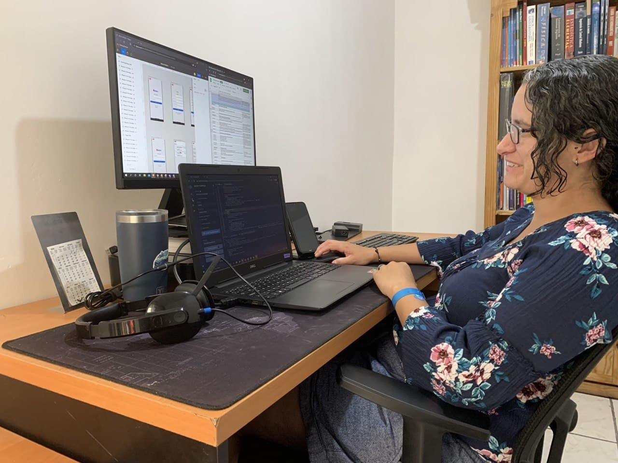
During the COVID-19 pandemic, these vulnerabilities were stark. Gabriela Guerra, a mother in Mexico and co-founder of BX Smart Labs, experienced how hard it was to access credit or financial support when her family needed it; her own experience prompted her to do something about it. The problem was not the concept of community saving – that was thriving – but rather the lack of a decentralized, scalable system to elevate and augment it. This is the issue Bloinx (by BX Smart Labs) set out to tackle while leveraging blockchain technology as a foundational infrastructure for trust and governance in community finance.
A Trust Layer and Toolkit for Savings Circles
With seed funding from the UNICEF Venture Fund, BX Smart Labs developed Bloinx – a decentralized application (dApp) built on Ethereum-compatible infrastructure (initially on Celo) that encodes the rules of a ROSCA in an immutable program. Each savings circle becomes a smart contract that automates contributions and disburses the pot to the right member on schedule. Instead of a paper ledger, the contract records every action on‑chain.

To shield users from volatility, Bloinx initially used Celo Dollars (cUSD), a USD‑pegged stablecoin, and integrated the Valora mobile wallet so people could join with a phone number and PIN – no seed phrases, no MetaMask, and certainly no crypto jargon. Creating a circle is as simple as starting a group in the app and sharing an invite code; the contract enforces the agreed rules and shows everyone, in real time, who has paid and who is due next.

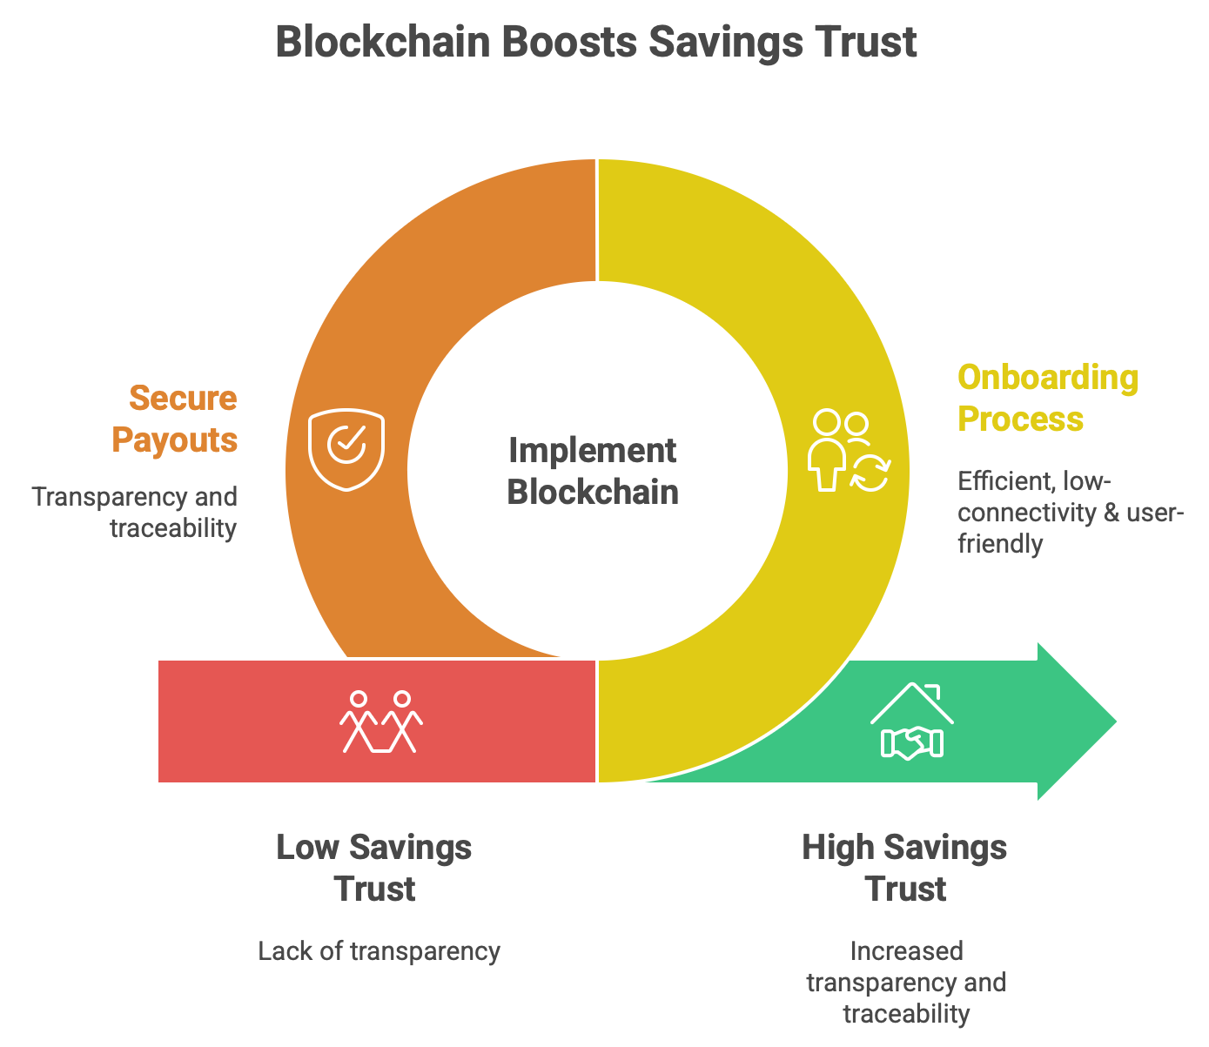
Transparency was built‑in from the start. Every contribution and payout is an immutable transaction visible to the group, so no single “trustee” can misreport or mishandle funds. Because trust is anchored in code, circles can include members who don’t already know one another – even across borders. Pilots linked women in Mexico and Venezuela in the same rounds, something difficult with traditional tandas. This blockchain-based platform made saving circles more secure, remote-friendly and transparent.

Learning by Doing

As an early‑stage innovation, Bloinx prioritized iterative learning. The team adopted a human-centered design approach, involving real users in multiple rounds of testing and improvement. “We ran 3 usability tests to define the best UI approach,” the founders reported, and then two live pilot rounds with actual communities to verify the app’s interactions with the blockchain.

- Every payment and payout triggers a blockchain event. A lightweight dashboard (using The Graph indexing) lets implementers track activity – contributions per week, group balances and contract state. This gave the implementing partners (including NGOs) a bird’s-eye view of circle performance, rather than having to collect ledgers from the field.
- Most early users were women with limited tech exposure. Their input shaped design choices; more flexible contract parameters (group size, frequency), clearer flows, simpler copy. In one instance, the team realized that requiring every user to have their own crypto wallet and internet access would exclude many, so they added a shared‑device mode: one facilitator’s phone records each contribution as members confirm with a personal PIN, no individual smartphones or connectivity required.

Given pilot scale, formal outcomes like changes in long‑term savings behavior were not measured rigorously yet. The focus was feasibility, usability and trust: could communities run authentic ROSCAs digitally, and would they choose to do so again?

Results and Early Impacts

In late 2021, the team launched a beta in Latin America where they ran a few tandas in Mexico and Venezuela over several months. Even at a small scale, the impact on individuals was tangible. One early participant was a Venezuelan community group (the “Ubikalo” community) learning about blockchain; their involvement in the pilot not only helped them build crypto literacy, but also proved the concept worked in a real community setting. In live token pilots, users completed contributions and payouts under real conditions; where issues emerged, fixes were added and re‑tested. Users not familiar with crypto need support for the first steps, once they’ve done the process once, it becomes easy and they do it very confidently.
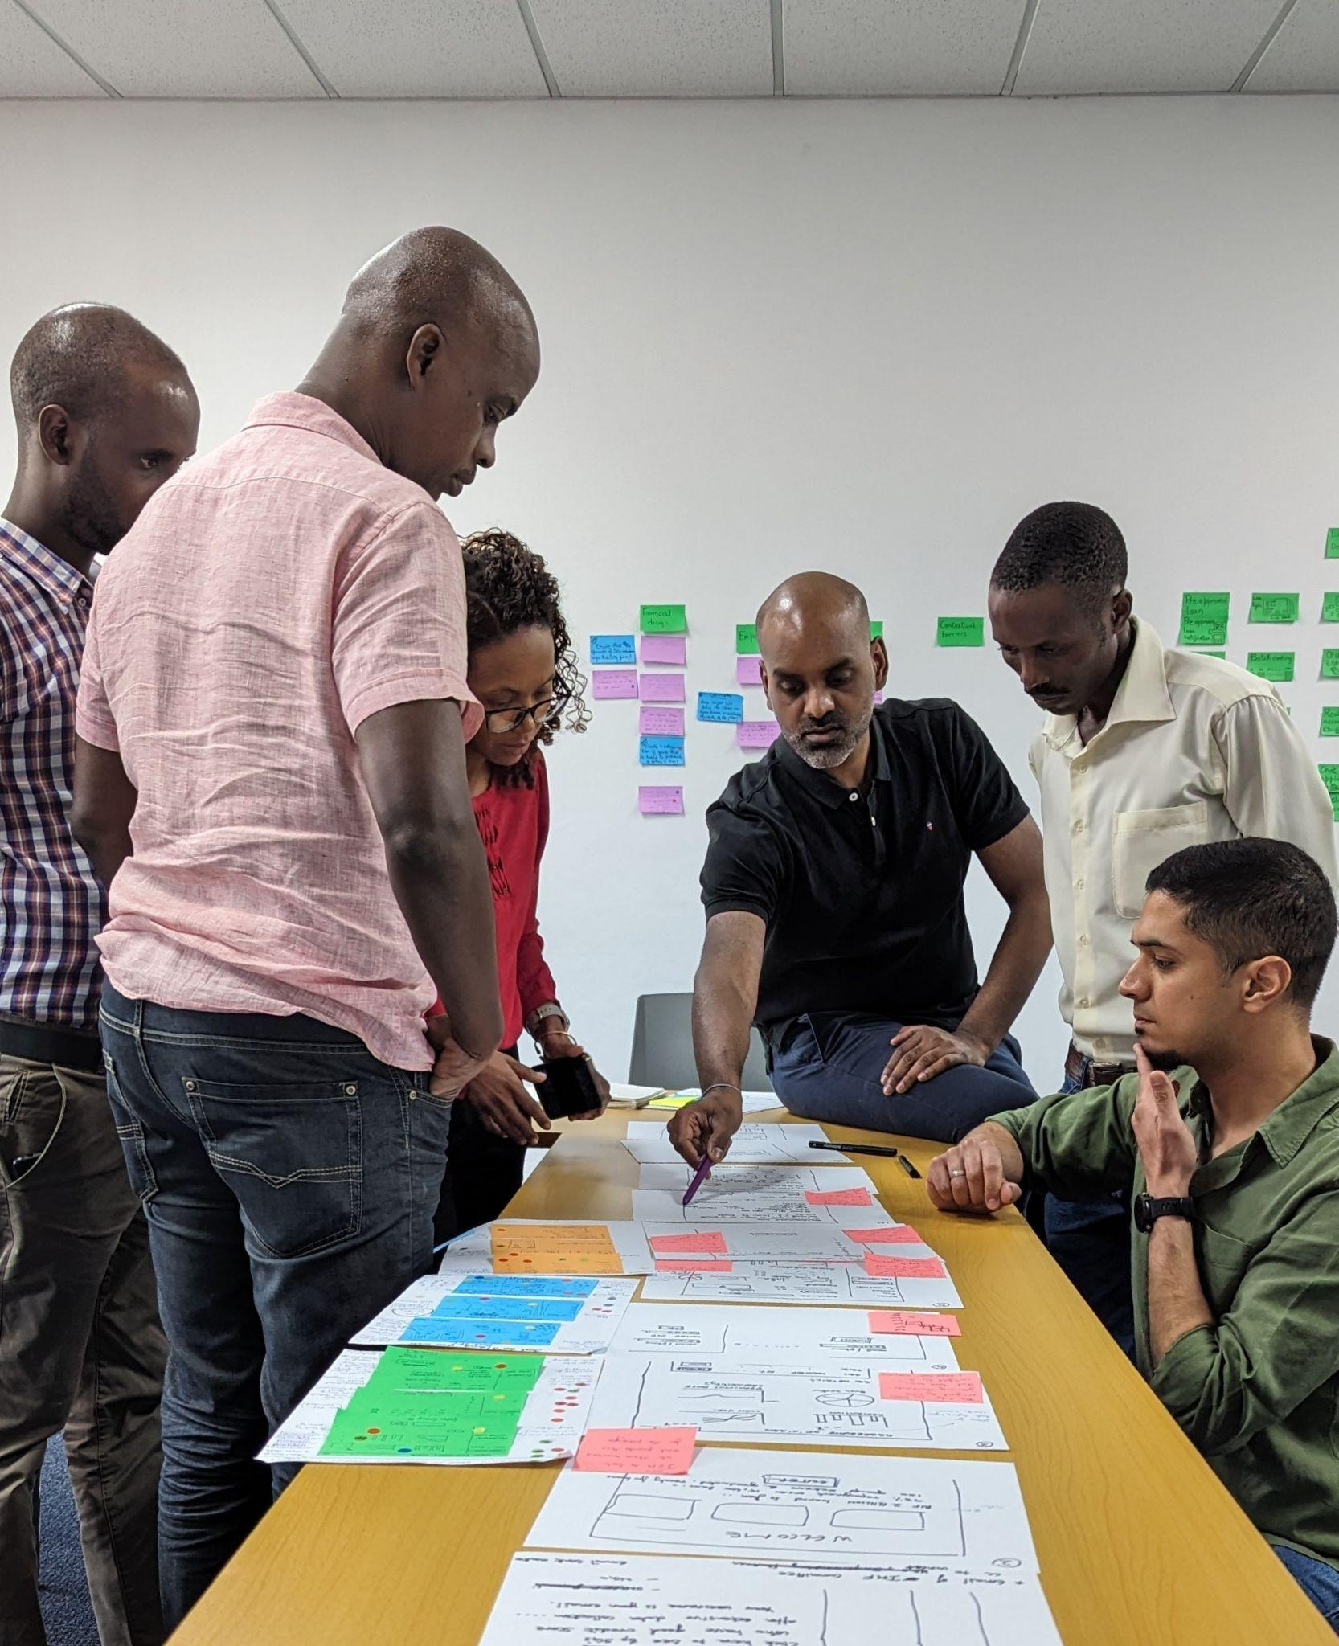
Beyond user satisfaction, Bloinx’s results include technical achievements that set the stage for broader impact. The platform processed dozens of transactions with near-instant finality and negligible fees on the Celo network. The immutable record even began to form a rudimentary credit history for participants. Although the pilot was too short to leverage this with a bank, the data is there. UNICEF’s country office in Burundi found this especially intriguing; seeing Bloinx’s success in Latin America, they partnered with the team to adapt it for rural youth savings groups in Burundi in 2023.

In that second pilot, Bloinx shifted to a hybrid model and about 50 savings groups around Bujumbura were selected to try it. The pilot is still ongoing, and for now, those contributions still happen in cash, but each is recorded as a tokenized event on the backend. A local microfinance institution will have access to these records to explore future credit scoring, and although that formal linkage is pending, the pilot succeeded in its core aim and proved that the technology could adapt to a low-connectivity, low-literacy environment and still preserve the benefits seen in the Latin American trial.

The project graduated from the UNICEF Venture Fund in 2022, gaining visibility in the global Ethereum community. The solution’s open-source code has been forked by at least two other teams to build similar blockchain-based savings tools. The Bloinx team themselves launched an ERC-20 token called $BLX as a rewards mechanism in later iterations – minted to users who finish a saving round, with extra tokens for those who waited longer in the rotation. While exploratory, it reframed patience and reliability as on‑chain reputation – an idea that could reinforce savings behavior at scale.

Challenges and Lessons Learned

Implementing a cutting-edge blockchain tool in underserved communities surfaced hurdles on three fronts:

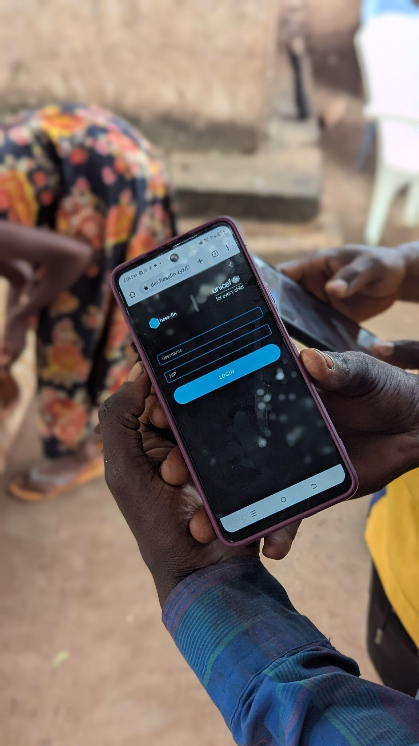
- People! The steepest curve was adoption and literacy. Many participants were new not only to crypto but to mobile finance itself, and some feared “money-wise technology” because of misinformation. Trust was built through patient, hands-on onboarding with community partners. In Burundi, where digital literacy was lower, a shared-device model proved pivotal. Equally important was hiding complexity. As Gabriela summarized, “they don’t have to know anything about blockchain”; the chain runs under the hood. The broader lesson is that UX and trust-building outrank technical purity. Custodial wallets, centralized elements and even paper backups were acceptable on-ramps when inclusion was the goal.

- Partners! Technology alone could not unlock credit. Bloinx’s endgame is to turn ROSCA histories into bankable records, but forging microfinance partnerships within pilot timeframes was hard. In Burundi, the absence of a ready lending partner meant on-chain logs could not immediately translate into loans. Early “merchant coupon” experiments also stalled without sufficient user scale. Lesson learned: grow a stable user base first; bring lenders and merchants in once network effects and clear value are visible.

- Plumbing! Bloinx evolved across different networks; each move driven by mission fit and usability. Hiccups were inevitable, and an open-source code shortened recovery. In rural settings, unreliable power and connectivity required an offline mode with local caching so meetings could proceed and sync later, a crucial design choice for worst-case environments.

Perhaps the most profound lesson was about trust and transparency. When participants could see every transaction confirmed on their screens and knew that no one could alter the records, their confidence in the system rose. However, that trust also depended on the human trust in those introducing the technology. Bloinx’s community engagement – working with local UNICEF staff or community leaders – was indispensable. Technology did not replace the human element; it augmented it.

Outlook: Scaling Impact and Fostering Inclusion

Having proven its concept in two continents, Bloinx is poised for the next phase of growth. Next up is “Caja de Oro” in Mexico, where about 200 participants will test seamless peso on-/off-ramps so users can cash in and out without touching crypto rails. Technically, the team is planning to deploy Bloinx on an Avalanche subnet or a similar Ethereum Layer-2 network dedicated to social impact applications, where gas is pre-funded so transactions feel free at the edge and vetted NGOs can onboard communities without cost frictions.

Scaling will still hinge on education, trust-building and partnerships, especially with microfinance. If, for example, the Burundi pilot secures a lending partner, youth entrepreneurs could translate Bloinx histories into real loans, closing the inclusion loop. In the meantime, Bloinx is changing mindsets. Transparent, tamper-resistant records strengthen the social contract of saving together. As the founders put it, the goal is to “create saving communities across states, countries and continents” – a vision that is steadily coming into focus.

