Reletório do AR

R

March 5, 2017

## R Markdown

This is an R Markdown document. Markdown is a simple formatting syntax for authoring HTML, PDF, and MS Word documents. For more details on using R Markdown see <http://rmarkdown.rstudio.com>.

When you click the **Knit** button a document will be generated that includes both content as well as the output of any embedded R code chunks within the document. You can embed an R code chunk like this:

## speed dist   
## Min. : 4.0 Min. : 2.00   
## 1st Qu.:12.0 1st Qu.: 26.00   
## Median :15.0 Median : 36.00   
## Mean :15.4 Mean : 42.98   
## 3rd Qu.:19.0 3rd Qu.: 56.00   
## Max. :25.0 Max. :120.00

## Including Plots

You can also embed plots, for example:

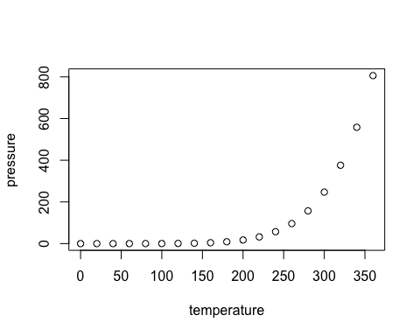

Note that the echo = FALSE parameter was added to the code chunk to prevent printing of the R code that generated the plot.