

Table of Contents

1.0 Introduction 4

2.0 Hardware Requirements 5

2.1 Smart Door Lock 5

2.2 Smart Bulb 5

2.3 Dimmer Switch 6

2.4 Smart Curtain 6

2.5 Temperature Sensor 7

2.6 Raspberry Pi 8

2.7 Door Alarm 9

2.8 433 MHz RF Transmitter and Receiver module 10

3.0 System Design 11

3.1 Client Flowchart 11

3.2 Server Flowchart 12

4.0 Protocol Design 13

4.1 Selection of Protocol 13

4.2 TCP Functions 13

4.2.1 TCP Open Connection 13

4.2.2 TCP Write 14

4.2.3 TCP Close Connection 15

4.2.4 TCP Listen.vi 16

4.2.5 TCP Read 17

5.0 Appendix 19

5.1 User Manual 19

5.1.1 Login Panel 19

19

5.1.2 Light 21

5.1.3 Brightness 22

5.1.4 Curtain 23

6.0 System Review 26

6.1 System Limitations 26

6.2 Future Enhancements 26

7.0 Conclusion 28

References 29

1.0 Introduction

In this assignment, the developer was proposed a project to build a smart home control system for a new housing developer.

The deliverable system is expected to have various house devices-controlling functionalities, including functionalities to control the lights, curtains, television and doors with controls like buttons. In addition, the smart home control system is expected to have a central control keypad, which allows user(s) to key in verification PIN to process the authorization of their access to the control system.

Furthermore, the system has automation functionalities – for example, when it reaches a certain point in time of a day, curtains will automatically open / close, television volume will be toned down, etc..

To develop the system, the NI LabVIEW software is used to produce the system prototype.

The main objective of this project is to create a system that simplify the performing of actions such as opening / closing curtains, opening / closing doors, switching lights on / off by having controls of these devices in a centralized in a location. The system enables house owners to perform everyday actions with ease by the press of a button. The automation functionalities also omits the extra work for actions such as having to open the curtain manually when the sun rises.

The smart home control system fits the description of internet of things (IoT). The internet of things is a system formed by interrelated computing devices, objects, people, digital and mechanical machines which are assigned with unique identifiers. Entities in an IoT are able to transfer data over a network without human-to-computer or human-to-human interaction (Gillis, 2020).

2.0 Hardware Requirements

# 2.1 Smart Door Lock

Figure 2.0: Smart Door Locks (Null, 2021)

In order to build the smart home control system, a smart door lock which provides PIN entry functionality is required. Smart door locks enable the ability to build a keyless door lock to the main entrance of the house, replacing the traditional key-and-lock mechanism with a verification system that requires the entry of valid PIN combinations to enter the house. The “login panel” of the system requires this component.

# 2.2 Smart Bulb

Figure 2.: Smart Bulb (Colon & Moscaritolo, 2021)

Smart bulbs are internet-capable LED bulbs which lighting can be customized, scheduled and controlled (Anon., n.d.). In order to control the lighting in the house via a IoT system, smart bulbs are chosen to handle the lighting. It is also required that the chosen smart bulbs are able to change color to implement the color change in lighting according to temperature.

# 2.3 Dimmer Switch

Figure .2: LED Dimmer

Dimmer switches are used to control the level of brightness of light. Basic dimmer switches work by controlling the amount of electricity that flows through the circuit. Modern dimmers are more complicated: they divert electricity from the light bulb by taking the electricity that is flowing through the light’s circuit and turn them on and off (FowlerElectric, n.d.).

# 2.4 Smart Curtain

Figure 2.3: Remote-controlled Smart Curtain

Smart curtains are curtains that can be remotely controlled. These devices can be integrated into the smart home control system to implement the functionality to open/close curtains (Kong, 2020).

# 2.5 Temperature Sensor

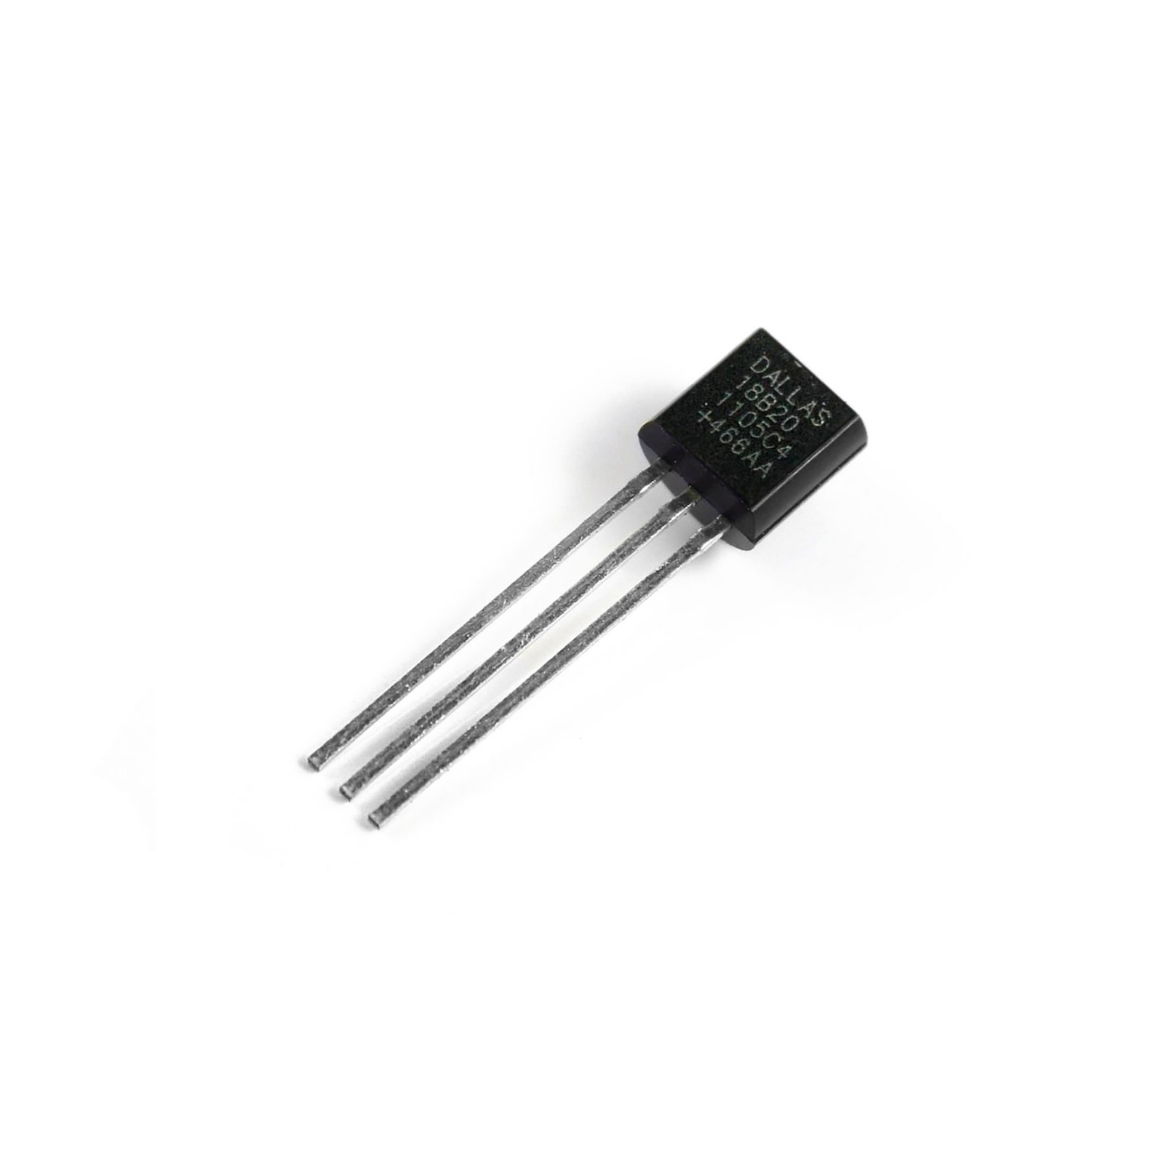

Figure 2.4: DS1820 Temperature Sensor

A temperature sensor measures the temperature of its environment and convert this input data into electronic data to monitor, record or signal temperature changes (Jost, 2019). These devices are used to detect the temperature of the house, which the colour of the lighting changes accordingly.

# 2.6 Raspberry Pi

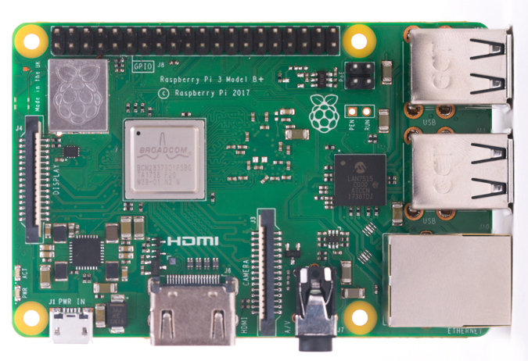

Figure 2.5: Raspberry Pi 3

Raspberry Pi are cheap single-board computers that run Linux, commonly used to do home automation. These devices provide a set of general purpose input/output (GPIO) pins, which allow the controlling of components for physical computing. They also enable the exploration of IoT (Anon., n.d.). With that said, Raspberry Pi is a very important component in this project.

# 2.7 Door Alarm

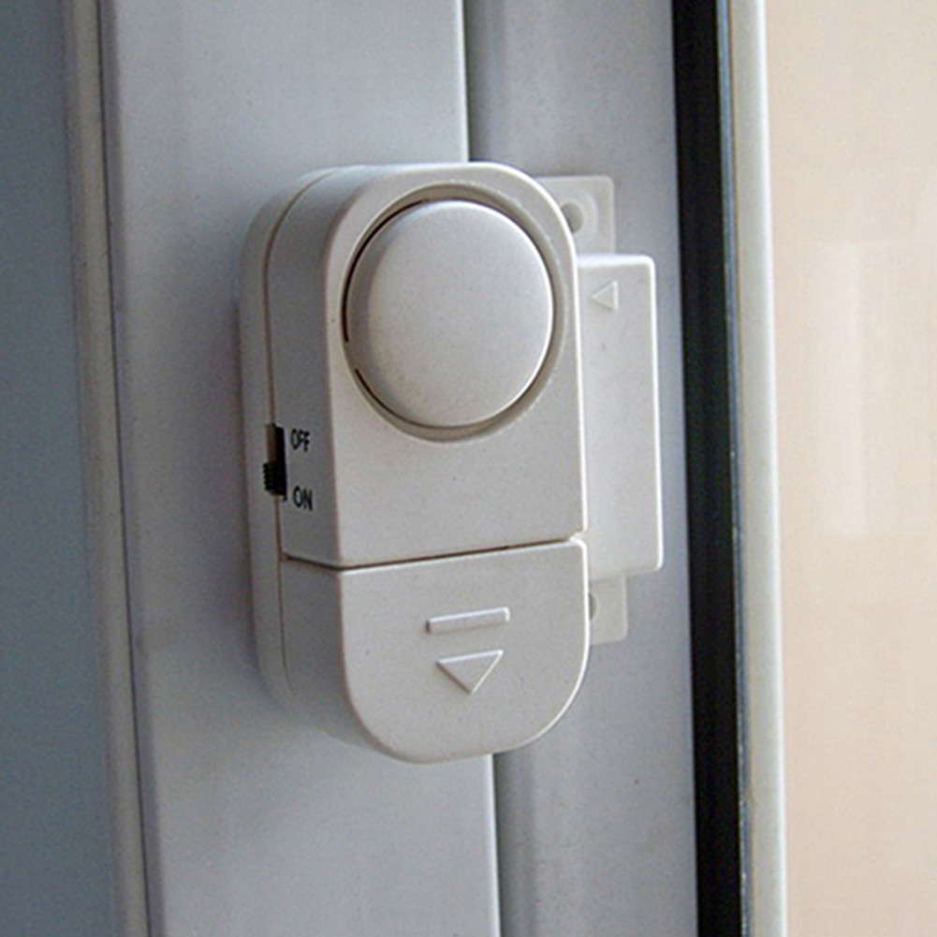Figure 2.6: Door Alarm

Alarms are required to notify the house occupants, should the locked doors are being tampered with.

# 2.8 433 MHz RF Transmitter and Receiver module

Figure 2.7: 433 MHz RF Transmitter and Receiver Module

The 433 MHz RF transmitter and receiver module is a pair of small radio-frequency (RF) electronic modules which transmit and receive radio signals between two devices. The data is sent from the transmitter’s end and received at the receiver’s end (Anon., n.d.). These are used to transmit and send signals between devices in the smart home control system.

3.0 System Design

# 3.1 Client Flowchart



Figure .0: Client Flowchart

# 3.2 Server Flowchart



Figure 3.1: Server Flowchart

4.0 Protocol Design

# 4.1 Selection of Protocol

The transport layer is the fourth layer in the Internet model. It is also the core of the Internet model. The functions of the transport layer include packetizing, connection control, addressing and providing reliability. In this assignment, both Transmission Control Protocol / Internet Protocol (TCP/IP) and User Datagram Protocol (UDP) are considered as choices of the main protocol for the transmission of data between the client and the server. TCP/IP protocol is chosen after considering its suitability to the system over the other.

While speed-wise, UDP has the advantage over TCP/IP, there are other factors to be considered while picking the protocol. TCP is a connection-oriented transport-layer protocol, which means the packets can only be sent through an established connection; whereas UDP is a connectionless protocol, which means no connection establishment or release are required for the transmission of data. TCP checks for errors and guarantees the delivery of data in the same order it was sent, while with UDP, there are no error-checking and recovery services (Cook, 2017). UDP does only basic checking for errors, does not sequence data, and does not guarantee delivery of data to the destination, making TCP a better choice for the system, as a smart home control system requires integrity and accuracy within the transmission of data.

The following are the TCP-based functions in LabVIEW utilised in this assignment: TCP Open Connection, TCP Write, TCP Close Connection, TCP Listen and TCP Read.

# 4.2 TCP Functions

## 4.2.1 TCP Open Connection

Figure 4.0: TCP Open Connection

This function opens a TCP network connection with the address and remote port or service name.

Components of TCP Open Connection:

* address: the address with which the TCP connection is established.
* remote port or service name: port or name of the service with which the TCP connection is established.
* timeout ms: time in milliseconds which the function waits to complete and return an error.
* error in / out: error information.
* local port: local connection port
* connection ID: a network connection refnum that uniquely identifies the TCP connection.

Figure 4.1: Application of TCP Open Connection

The above image shows an example usage of TCP Open Connection in the client vi. The function opens up a TCP connection with the local computer on port number 50000, with a timeout of 60000 milliseconds.

## 4.2.2 TCP Write

Figure 4.2: TCP Write

This function writes data to a TCP network connection.

Components of TCP Write:

* connection ID: a network connection refnum that uniquely identifies the TCP connection.
* data in: data written to the connection.
* timeout ms: time in milliseconds which the function waits to complete and return an error.
* error in / out: error information.
* connection ID out: returns the same value as connection ID.
* bytes written: the number of bytes written to the connection.

Figure 4.3: Application of TCP Write

The above image is an example usage of TCP Write in the client vi. The first TCP Write node writes the string representation of the number of bytes written to the connection, while the second TCP Write node writes the string representation of the actual data written to the connection.

## 4.2.3 TCP Close Connection

Figure 4.4: TCP Close Connection

This function closes a TCP network connection.

Components of TCP Close Connection:

* connection ID: a network connection refnum that uniquely identifies the TCP connection.
* error in / out: error information.
* connection ID out: returns the same value as connection ID.



The image above is an example usage of TCP Close Connection in the client vi. In this example, TCP Close Connection is used to close the connection opened by the TCP Open Connection node.

## 4.2.4 TCP Listen.vi

Figure 4.5: TCP Listen.vi

This function creates a listener and waits for an accepted TCP network connection at the specified port.

Components of TCP Listen.vi:

* net address: network address to listen.
* service name: reference for the port number.
* port: port number to listen for connection.
* timeout ms: time in milliseconds which the function waits to complete and return an error.
* error in / out: error information.
* resolve remote address: whether to convert the remote IP address to string.
* listener ID: a network connection refnum that uniquely identifies the listener.
* connection ID: a network connection refnum that uniquely identifies the TCP connection.
* remote address: the address of the remote machine associated with the connection.
* remote port: the port of the remote system used for the connection.

Figure 4.6: Application of TCP Listen.vi

The above image shows an example usage of TCP Listen.vi. In this example, the TCP Listen.vi node creates a listener which waits for an accepted TCP network connection with the local computer at port number 50000 with no timeout (wait forever until a TCP connection is found).

## 4.2.5 TCP Read

Figure 4.7: TCP Read

TCP Read reads a number of bytes from a TCP network connection, then returns the results in **data out**.

Components of TCP Read:

* mode: indicates the behaviour of read operation
* connection ID: a network connection refnum that uniquely identifies the TCP connection.
* bytes to read: number of bytes to be read.
* timeout ms: time in milliseconds which the function waits to complete and return an error.
* error in / out: error information.
* connection ID out: returns the same value as connection ID.
* data out: data read from the TCP connection.

Figure 4.8: Application of TCP Read

The example above shows an example usage of TCP Read in server vi. In this example, the TCP Read node is carrying the data to the server side, and is instructed to read 6 bytes of data.

5.0 Appendix

# 5.1 User Manual

The menu of the client side is split according to their functionalities: Login, Light, Brightness, Curtain, Door, TV.

## 5.1.1 Login Panel

Green light indicates valid PIN; red light indicates invalid PIN

Shows time/date

Figure 5.0: User Manual: Login Panel

If you mistyped, press “Reset” to retype

After entering a 4-digit PIN, press “Enter”

Enter the PIN with the number keys

Once logged in, all menu tabs become accessible.

You can access other control panels here

Figure 5.2: Accessing Tabs

## 5.1.2 Light

Figure 5.3: User Manual: Light

Figure 5.4: Turning On Lights

Turn on/off individual lights

Rotation of lights in all rooms

Turn on/off all the lights

## 5.1.3 Brightness

Controls the brightness of the lights. 0 indicates lowest brightness, 255 indicates highest brightness

Figure 5.5: User Manual: Brightness

Figure 5.6: Variations in Light Brightness

## 5.1.4 Curtain

Figure 5.8: Open Curtain

Figure 5.9: Close Curtain

Open / close individual curtain

Open / close all curtains

Figure 5.7: User Manual: Curtain

Automate the opening of doors upon arrival

Open / close all the doors

Figure 5.10: User Manual: Door

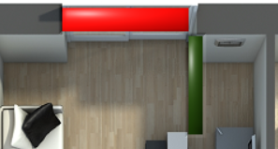

Figure 5.12: Opened Door

Figure 5.11: Closed Door

Open / close individual doors

Figure 5.13: User Manual: TV

Figure 5.14: TV Playing a Video

Mute sound

Turn up sound volume

Turn down sound volume

Reverse

Fast-forward

Stop playing

Pause playing

Start playing

Switch broadcasting channel

Power on / off the television

6.0 System Review

# 6.1 System Limitations

There are certain limits within the designed system. While being able to control basic house devices such as lights, curtains and doors, the system lack the capabilities to control other appliances like washing machine, coffee maker, boiler and alike which are excluded due to the complex nature of the controls for said appliances. For the alarm system, only occupants inside the house will be able to hear the sound alarm and be notified of attempted crime activities. Should there be no one inside the house, no one will be aware of the triggering of the alarm system, as there are no means of the alarm system notifying house residents away from home. Besides, the smart home control system is rendered useless during power outages.

# 6.2 Future Enhancements

In the future, the login panel should be enhanced with fingerprint or face recognition functionality as a safer authorization method over PIN entry. For automation of lighting controls, ambient light sensors can be implemented into the system to automate the brightness of lights according to the brightness of the room. The same input data can be used to control the opening / closing of curtains.

Furthermore, the security system can be enhanced by installing security cameras around the entrances. The footages of the security cameras can be viewed in real-time from an application specifically designed for the system through the house owners’ smartphone. The house owners may also communicate with the visitor through said application. The security system can also be further enhanced by having log files which record the activities performed with the smart home control system, which may help in investigation of crime activities that happened within the household. Besides that, the automation of controls for various house appliances as mentioned above are also desirable.

The entire system can be further enhanced by implementing a sound recognition system, which enables users to send input data to the system with their voice instead of pressing buttons or turning knobs. It further conveniences the users by having them not need to get up and walk to the control panel.

7.0 Conclusion

In conclusion, a smart home control system is successfully built for the project. The system meets the project requirements such as having controls for lights, curtains, doors and television. Furthermore, it automates the control for the colour of lights according to the room temperature and curtains according to time. It also features a security system which sounds an alarm when a locked house entrance door is being tampered with, and also automatically rotates the switching on and off of lights in different rooms when the house is not occupied for a long duration. Not only does the smart home control system brings convenience to the residents of the house by simplifying and automating the process of controlling simple house devices, saving time and energy, it is also expected to provide security to them that they do not have to be wary of thefts or other malicious activities done to the house.

As technology evolves to be more and more advanced, home automation is sure to grow to be more popular in the future. It is hoped that the created smart home control system will not only be utilised by house owners to maximize efficiency, but also serve as a foundation to a more advanced system which will require more in-depth research and resources to develop.

References

Anon., n.d. *433 MHz RF Transmitter and Receiver module pinout, features & working.* [Online]   
Available at: https://www.etechnophiles.com/433-mhz-rf-transmitter-and-receiver-module-pinout-features-working/  
[Accessed 10 June 2021].

Anon., n.d. *smart bulb (smart light bulb).* [Online]   
Available at: https://internetofthingsagenda.techtarget.com/definition/smart-bulb-smart-light-bulb  
[Accessed 10 June 2021].

Anon., n.d. *What is a Raspberry Pi?.* [Online]   
Available at: https://opensource.com/resources/raspberry-pi  
[Accessed 10 June 2021].

Colon, A. & Moscaritolo, A., 2021. *The Best Smart Light Bulbs for 2021.* [Online]   
Available at: https://www.pcmag.com/picks/the-best-smart-light-bulbs  
[Accessed 10 June 2021].

Cook, M., 2017. *TCP vs. UDP: What’s the Difference?.* [Online]   
Available at: https://www.lifesize.com/en/blog/tcp-vs-udp/  
[Accessed 11 June 2021].

FowlerElectric, n.d. *How Dimmer Switches Work and the Advantages they Provide for Your Home.* [Online]   
Available at: http://fowlerelectricnv.com/dimmer-switches/  
[Accessed 10 June 2021].

Gillis, A. S., 2020. *internet of things (IoT).* [Online]   
Available at: https://internetofthingsagenda.techtarget.com/definition/Internet-of-Things-IoT  
[Accessed 10 June 2021].

Jost, D., 2019. *What is a temperature sensor?.* [Online]   
Available at: https://www.fierceelectronics.com/sensors/what-a-temperature-sensor  
[Accessed 10 June 2021].

Kong, S. H., 2020. *What are smart curtains and just how smart are they?.* [Online]   
Available at: https://www.localiiz.com/post/tech-smart-home-technology-curtains-somfy  
[Accessed 10 June 2021].

Null, C., 2021. *The best smart lock for a keyless home.* [Online]   
Available at: https://www.techhive.com/article/3212828/best-smart-lock.html  
[Accessed 10 June 2021].