S m i t h s o n i a n A s t r o p h y s i c a l O b s e r v a t o r y & S t e w a r d O b s e r v a t o r y , T h e U n i v e r s i t y o f A r i z o n a

Quarterly Summary



**April - June 2017**

MMT Observatory Activities

Our Quarterly Summary Reports are organized using the same work breakdown structure (WBS) as used in the annual Program Plan. This WBS includes a major category with several subcategories listed under it. In general, many specific activities might fall a tier or two below that. The WBS will be modified as needed in future reports.

**Administrative**

**Program Management**

**Staffing**

**Scheduling**

**Quarterly Reports**

**Strategic Planning**

**Reports and Publications**

**Presentations and Conferences**

Safety

**Training**

**Safety Inspections**

**Procedures and Protocols**

**Personal Protective Equipment**

**Interlock System**

Primary Mirror

**Coating & Aluminization**

**Ventilation and Thermal Systems**

**Hardpoints**

**Actuators**

**Secondary Mirrors**

**f/9**

**f/5**

**f/15**

**Baffling**

**Hexapods**

**f/5 hexapod**

**f/9 and f/15 hexapod**

**Optics Support Structure**

**Truss**

**Secondary Hub**

**Spider Arms**

**Neutral Members**

**Pointing and Tracking**

**Azimuth**

**Elevation**

**Rotator**

**Science Instruments**

**f/9 Instrumentation**

**f/5 Instrumentation**

**f/15 Instrumentation**

**Instrument Handling**

**Topboxes and Wavefront Sensors (WFS)**

**f/5 WFS**

**f/9 Topbox**

The camera for the f/9 wavefront sensor was replaced in April and commissioned on-sky in May. Details on the camera and its new host computer implementation are given in the report for the previous quarter. The new camera is well-aligned with the optical axis of the system, though slightly rotated with respect to the lenslet array as seen in Figure 1. This rotation calibrates out and does not affect the analysis of the WFS images.

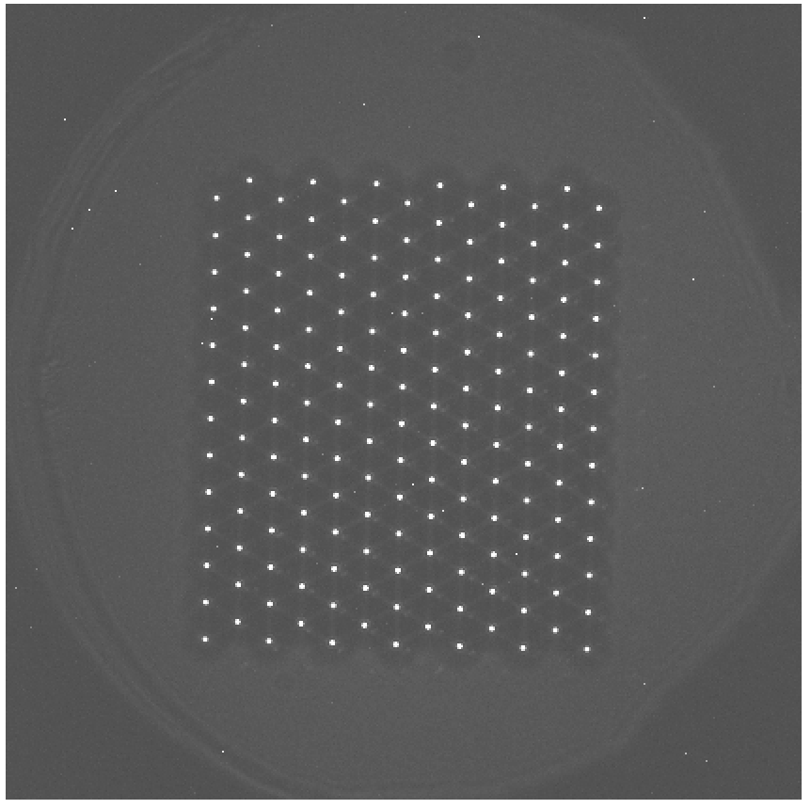

Figure - LED reference image for the f/9 WFS with the new SBIG ST-8300 camera

The new camera has a significantly different pixel scale than the old one, 5.4 microns/pixel vs 20. Therefore, the camera is configured to use 3x3 binning for normal WFS operations to provide improved sensitivity and reduced readout time while still providing more than sufficient resolution of the spot images.

An attempt was made to use the new camera with the old WFS software. In principle, it should be possible if the relevant configuration parameters (e.g. pixel scale, pixel size, image size) are changed, but in practice the old system’s algorithms for finding spots and associating them with lenslet apertures are too fragile to deal with the new WFS image format. The new, fully refactored WFS software works fine with this data, however. A preliminary version of a web interface to the new WFS software was deployed and was successfully used during the May and June f/9 campaigns.

**Natural Guide Star (NGS) Topbox**

**Laser Guide Star (LGS) Topbox**

**Wavefront Sensor Software**

Development of the new WFS software continued over the course of the quarter. Deploying a version of it on-sky to support the new f/9 WFS camera provided some useful new test cases. These data helped in the testing and development of improved methods for background subtraction and aperture alignment which has made the core code much more robust. These have been further validated against archived WFS data. The new core routines can now reliably handle a much wider range of aberrations than the old system and can reliably centroid spots with seeing as bad as 2.5”. There remains some work to be done to fully validate on-sky the corrections used to recenter the WFS image using the hexapod. However, the rest of the corrections (e.g. focus, coma, and primary mirror forces) have been validated and successfully used with the f/9 configuration. Given that, they should also work as well for the other WFS modes.

The main thrust now is to complete building the new interface. An initial version has been deployed to support the f/9 WFS which can also be used for the other modes, if desired. However, it currently only supports manual interaction. Work is on-going to integrate and automate image acquisition so that the new system can support automated and continuous operation. The plan is to commission and deploy the new WFS software for all modes after the end of summer shutdown.

The development of this project is hosted at <https://github.com/MMTObservatory/mmtwfs/>.

Some screenshots of the current web interface are shown in the following figures:

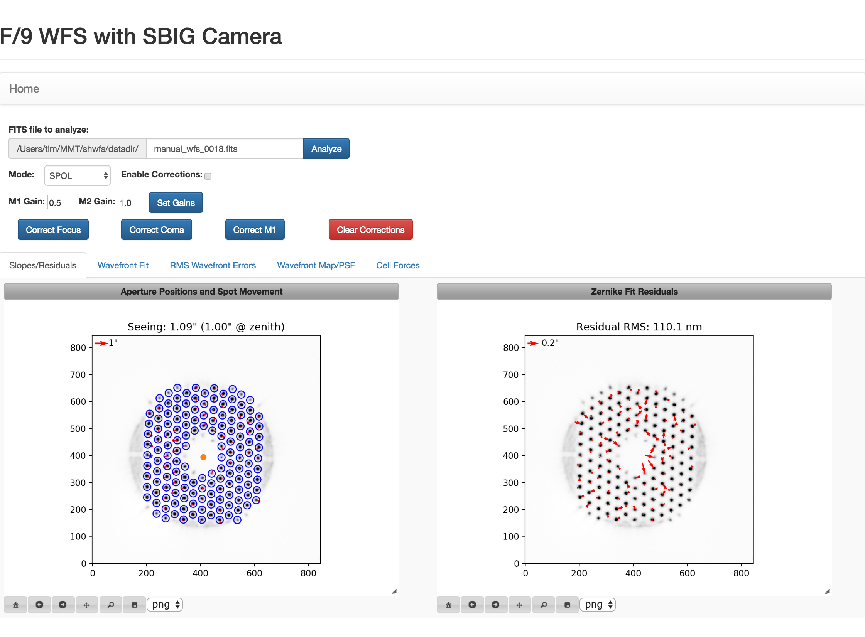

Figure - Default WFS page showing the spot positions and motions on the left and the the residuals of the wavefront fit on the right. The residuals are the difference between the measured spot motion and the motion predicted by the wavefront fit. The residual RMS provides a measure of the “goodness” of the wavefront fit, i.e. how well the fit describes the overall motion of the spot images.

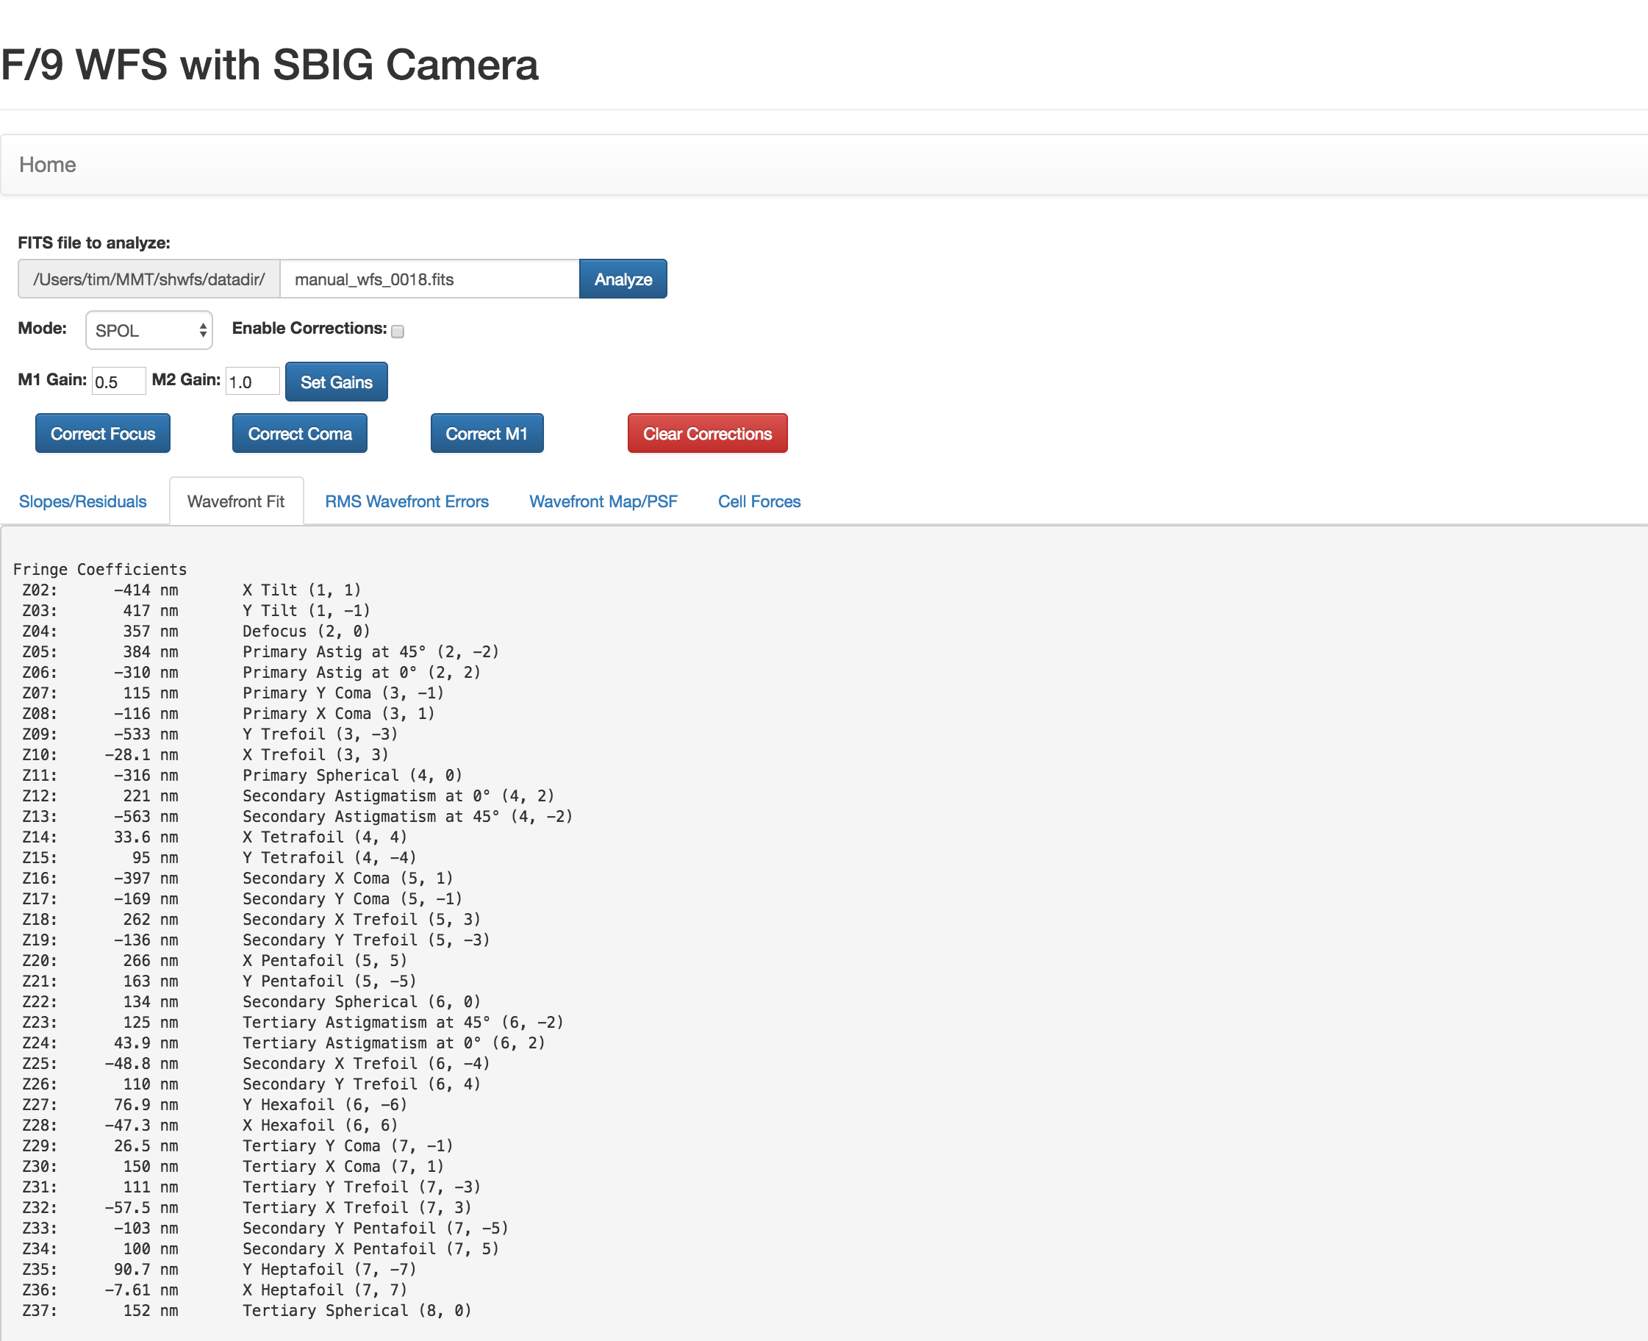

Figure - The new system uses 36 Zernike modes in its fits so that the first three spherically-symmetric terms are included. The ordering has been changed from the old system and now conforms to the Noll standard used elsewhere in the optical sciences. The “fringe coefficient” amplitudes match the units and scaling used in the old system.

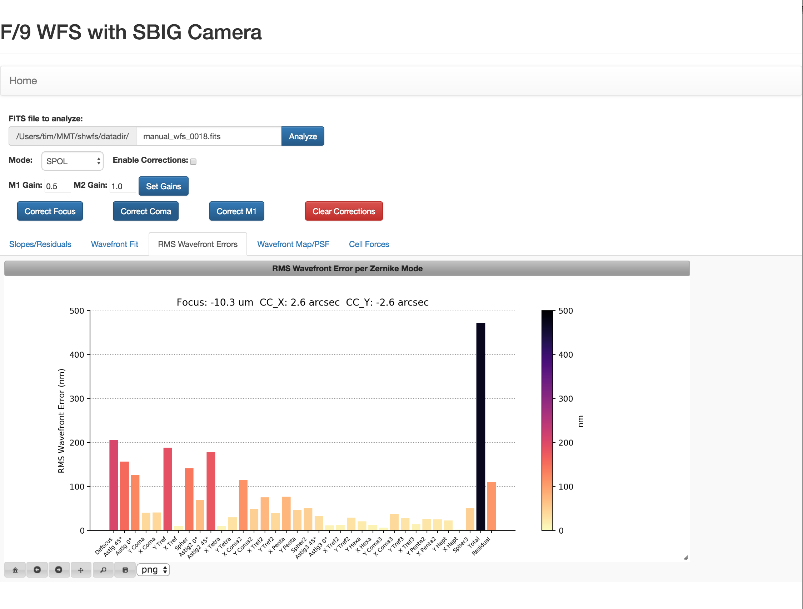

Figure - Bar chart showing the RMS wavefront error due to each mode of the wavefront fit along with the total and residual RMS.

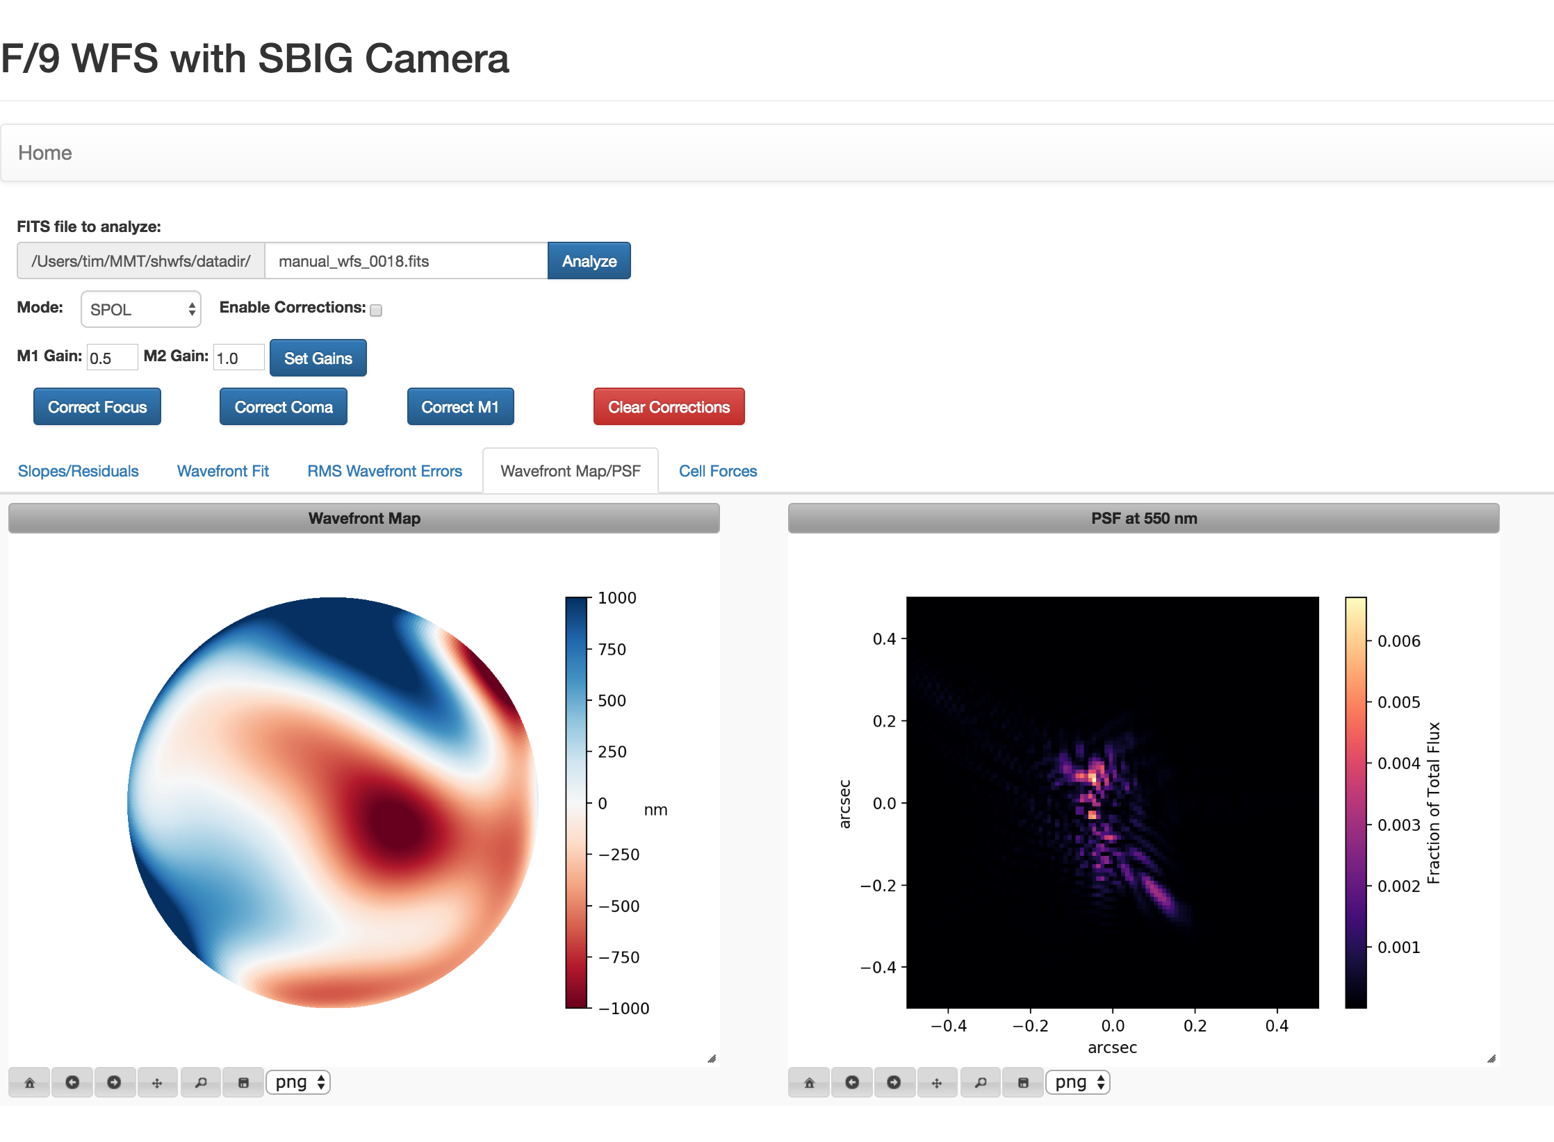

Figure - 2D map of the wavefront aberrations and resulting diffraction-limited PSF.

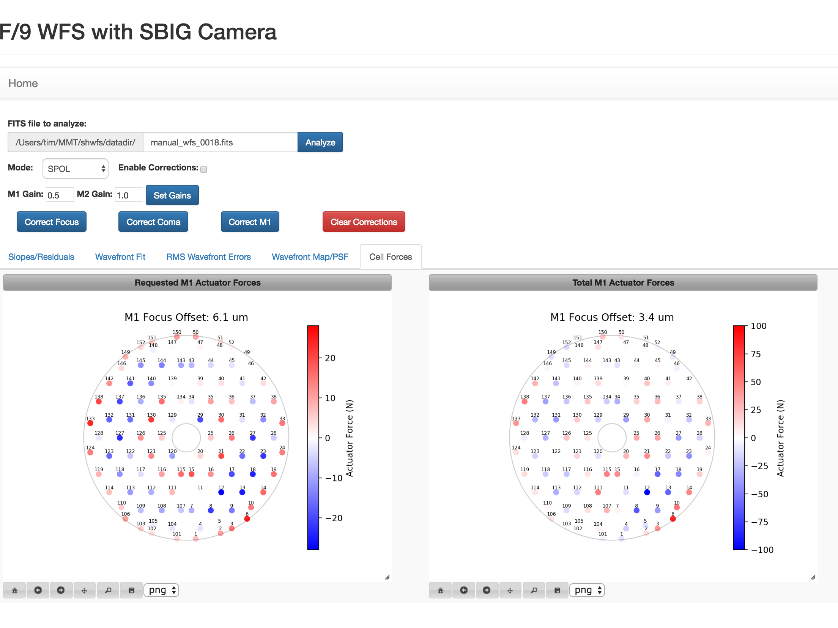

Figure - Plots showing forces required for requested corrections and total forces that have been applied by the WFS.

**Facilities**

**Main Enclosure**

**Instrument Repair Facility (IRF)**

**Common Building**

**Bowl Dorm**

**General Infrastructure**

##### **Computers and Information Technology**

**Computers and Storage**

**Network**

**Hardware/Software Interfaces**

**Telemetry, Logging, and Database Management**

**Annunciator**

**Weather and Environmental Monitoring**

**Weather Stations**

**All Sky Camera and Web Cameras**

**Seeing**

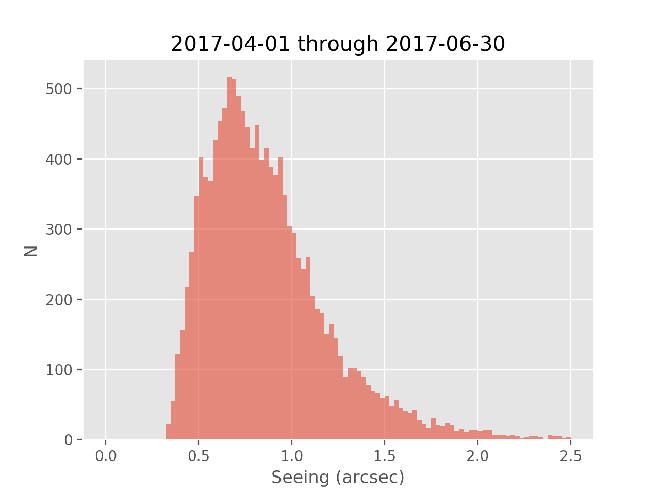

Figure - Histogram of seeing measurements taken with the MMTO wavefront sensors during 2017 Q2.

A total of 13329 valid seeing measurements were collected by the MMTO wavefront sensor (WFS) systems over the course of 2017 Q2 (Figure 7). The overall statistics are well-described by a log-normal probability distribution. Figure 8 shows a normalized histogram and a best-fit log-normal probability density function (PDF). The best-fit PDF gives a median seeing of 0.80” and a mode (i.e. the most probable value) of 0.67”. The best-fit median agrees well with the value of 0.81” calculated directly from the data. These numbers are fairly consistent with the long-term statistics for the site.

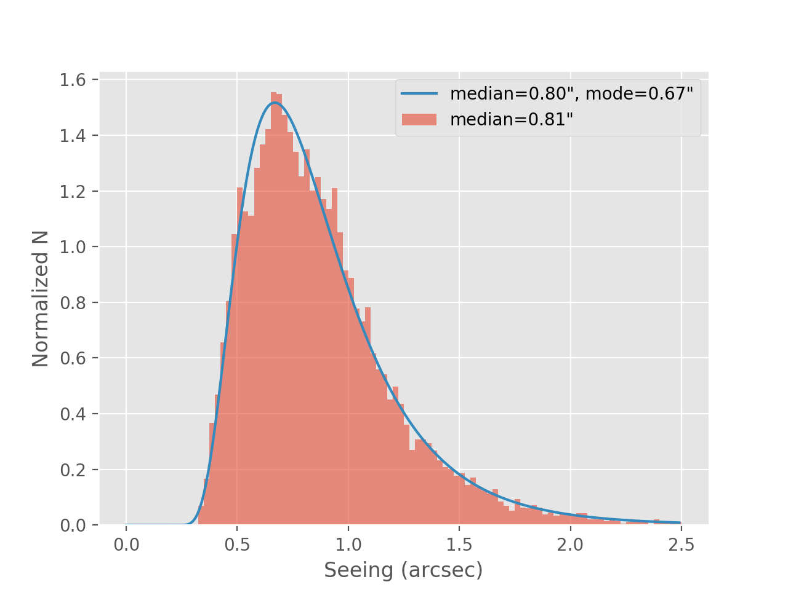

Figure 8 - Normalized histogram of seeing measurements and best-fit log-normal probability distribution function. The plot legend shows the best-fit median and mode as well as the median calculated directly from the data.

However, the statistics are somewhat skewed by the large amount of WFS data taken during the April MMIRS campaign which had some stretches of excellent weather. That campaign alone accounted for almost half (6541) of the total number of seeing measurements. Figure 9 bears this out by showing histograms of the data broken down per month. April had a median seeing of 0.71” while it was significantly worse in May and June (0.93” and 0.92”, respectively). This isn’t just due to MMIRS vs. the other WFS systems since the May and June MMIRS campaigns contributed 4603 of the 6125 seeing measurements during that time.

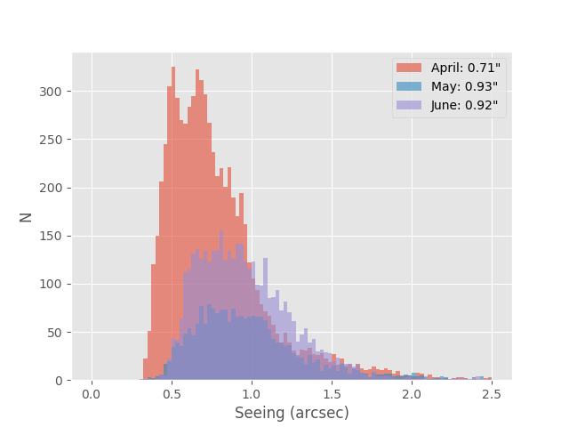

Figure - Seeing data broken down by month. The plot legend lists the median seeing for each month.

To help show this trend a bit better, Figure 10 shows the minimum, maximum, and median seeing for each night that had valid data. The nearly two straight weeks of sub-arcsecond median seeing in April is clearly visible. After that there are no clear trends, but a lot of night-to-night as well as intra-night variability is evident.

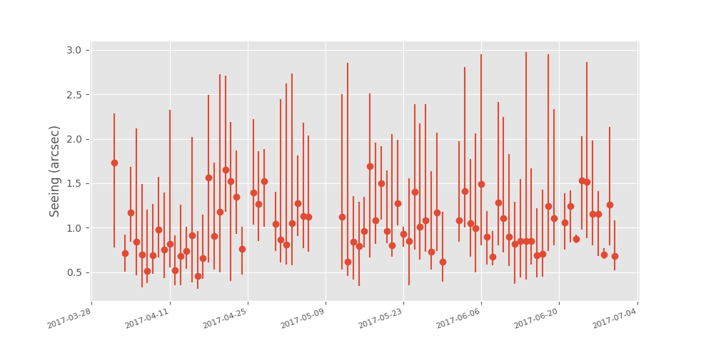

Figure - Seeing data broken down by night showing the median, minimum, and maximum for each night.

One interesting trend that was uncovered is that there is a significant difference between the statistics of the seeing data taken before and after midnight (Figure 11). The median seeing for the first half of the night is 0.86”, but it drops to 0.73” for the second half. This doesn’t appear to be an issue of sampling bias. The amount of data is split 55%/45% between the first and second halves and the ratio of MMIRS data to other WFS data is 82% in the first half and 86% in the second. There could be a meteorological component to this (e.g. inversion layer dropping below the summit as the night progresses), but this could also be an indication of dome seeing that subsides as temperatures equilibrate. It may be possible to analyze the WFS spot shapes in greater detail to get some indication of dome seeing (e.g. changes in width/shape as a function of pupil location). However, truly discriminating between site seeing and dome seeing requires an external seeing monitor and we are assessing options for setting one up.

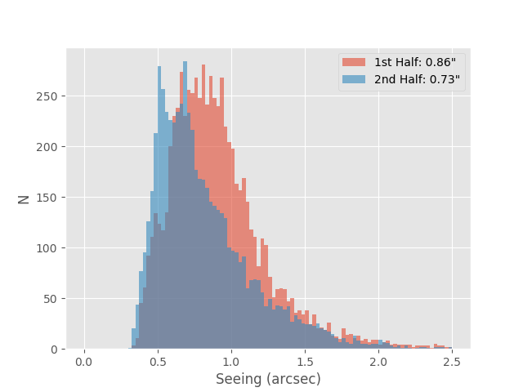

Figure - Histograms of seeing measurements taken during the first and second halves of the night.

The data and Jupyter notebook used in this analysis are hosted at <https://github.com/MMTObservatory/seeing_analysis>.

**User Support**

**Web Pages**

**Remote Observing**

**Data Quality Assessment**

**Data Archive**

**Reduction Procedures**

Documentation

**Document Database**

**Procedures**

**Public Relations and Outreach**

**Visitors and Tours**

**Public Presentations**

#### MMTO in the Media

**Site Protection**

#### Appendix I - Publications

#### MMT Related Scientific Publications

*(An online publication list can be found in the MMTO ADS library at* [*http://www.mmto.org/node/244*](http://www.mmto.org/node/244)*)*

**MMT Technical Memoranda / Reports**

#### Non-MMT Related Staff Publications

**Appendix II - Service Request (SR) and Response Summary: April - June, 2017**

**Appendix III - Observing Statistics**

The MMTO maintains a database containing relevant information pertaining to the operation of the telescope, facility instruments, and the weather. Details are given in the June 1985 monthly summary. The data attached to the back of this report are taken from that database.