S m i t h s o n i a n A s t r o p h y s i c a l O b s e r v a t o r y & S t e w a r d O b s e r v a t o r y , T h e U n i v e r s i t y o f A r i z o n a

Quarterly Summary



**July - September 2017**

MMT Observatory Activities

Our Quarterly Summary Reports are organized using the same work breakdown structure (WBS) as used in the annual Program Plan. This WBS includes a major category with several subcategories listed under it. In general, many specific activities might fall a tier or two below that. The WBS will be modified as needed in future reports.

**Administrative**

**Program Management**

**Staffing**

**Scheduling**

**Quarterly Reports**

**Strategic Planning**

**Reports and Publications**

**Presentations and Conferences**

Safety

**Training**

**Safety Inspections**

**Procedures and Protocols**

**Personal Protective Equipment**

**Interlock System**

Primary Mirror

**Coating & Aluminization**

**Ventilation and Thermal Systems**

**Hardpoints**

**Actuators**

**Secondary Mirrors**

**f/9**

**f/5**

**f/15**

**Baffling**

**Hexapods**

**f/5 hexapod**

**f/9 and f/15 hexapod**

**Optics Support Structure**

**Truss**

**Secondary Hub**

**Spider Arms**

**Neutral Members**

**Pointing and Tracking**

**Azimuth**

**Elevation**

**Rotator**

**Mount Alignment Telescope**

Final tweaks were made to the Mount Alignment Telescope (MAT) during summer shutdown and a new web interface was created for it (Figure 1). The interface is built around the JS9 (<https://js9.si.edu/)> widget that allows you to display, analyze, and manipulate FITS images directly within a web browser. The rest of the interface interacts with a backend server that controls the camera and exposes the camera’s capabilities to the user (e.g. cooling, set-point temperature, filter, etc.). As images are acquired, the JS9 widget is updated to display them. The display can be manipulated in a way very similar to the DS9 viewer that has been in use at the MMTO for many years.

Figure 1 also shows that the MAT is well-aligned with the main telescope. The star in the image was placed at the center-of-rotation in the VideoScope display and is within a few arcsec of the center of the MATcam image. More on-sky engineering is required to fully verify/quantify the quality of the MAT’s alignment.

The JS9/backend server model used here can easily be applied to building new web-based interfaces for other MMTO imaging systems. The software is available at <https://github.com/MMTObservatory/camsrv>.

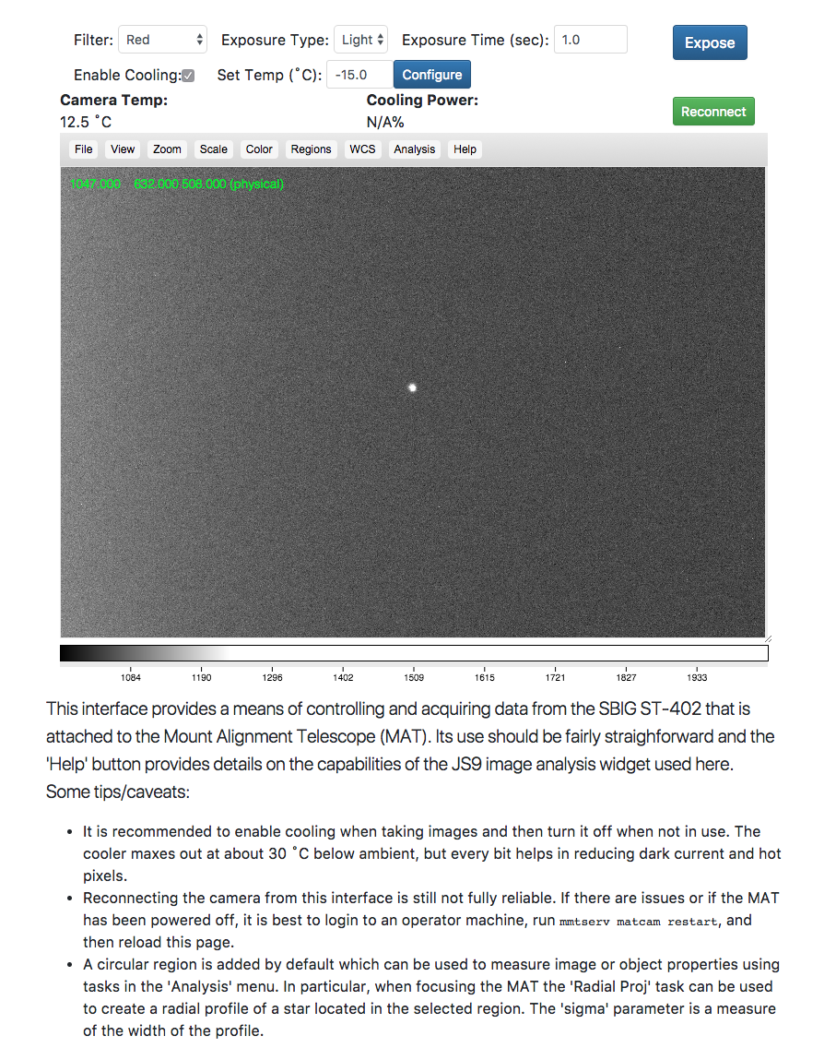

Figure - Web interface to the Mount Alignment Telescope

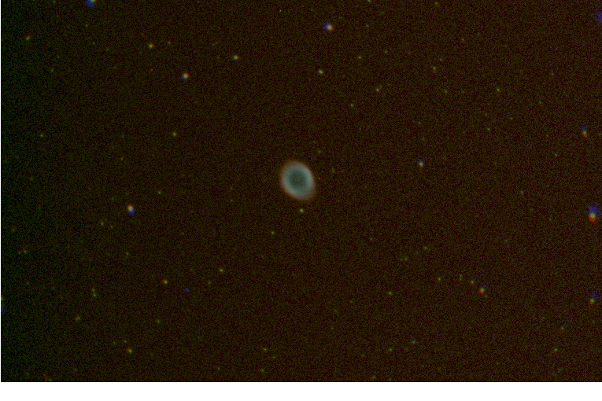

Figure - Three-color composite image of the Ring Nebula (M57) taken with the MAT at the end of summer shutdown. Note the effects of field rotation at the edges of the field of view.

**Science Instruments**

**f/9 Instrumentation**

**f/5 Instrumentation**

**f/15 Instrumentation**

**Instrument Handling**

**Topboxes and Wavefront Sensors (WFS)**

**f/5 WFS**

**f/9 Topbox**

**Natural Guide Star (NGS) Topbox**

**Laser Guide Star (LGS) Topbox**

**Wavefront Sensor Software**

Work has continued on the refactored wavefront sensor software. Some specific accomplishments include:

* Improved the reliability of the initial association between reference aperture and spot positions. The scale of grid of aperture positions is set by the reference focus of a WFS configuration and a best-fit center position is found by maximizing the number of associated apertures and minimizing the distances between the reference and measured positions. The fitting scheme that was developed can also allow the scale (i.e. focus) and X/Y coma to vary. However, that proved to be unreliable when too many spots were missing or parts of the pupil were obscured (common with MMIRS). Only allowing the center to vary may in principle reduce the ability to handle very large amounts of focus or coma, but in practice the current scheme can easily handle +/- 200 um of focus and +/- 3 um of X/Y coma. This is more than sufficient the vast majority of the time.
* Minor improvements were made to the WFS web interface. Most notably an “Analyze Latest” button that automatically picks the most recent image and analyzes it. Initial support for continuous operation was added as well. Most significantly, the web interface and backend server code were moved to their own repository, <https://github.com/MMTObservatory/WFSsrv>.
* Initial support for the Binospec WFS was added using the MMIRS mode as a template. The configuration parameters are based on the published specifications plus some reference images that were taken in the lab. Final configuration of the Binospec mode will require on-sky testing during commissioning.

**Facilities**

**Main Enclosure**

**Instrument Repair Facility (IRF)**

**Common Building**

**Bowl Dorm**

**General Infrastructure**

##### **Computers and Information Technology**

**Computers and Storage**

**Network**

**Hardware/Software Interfaces**

**Telemetry, Logging, and Database Management**

**Annunciator**

**Weather and Environmental Monitoring**

**Weather Stations**

**All Sky Camera and Web Cameras**

**Seeing**

Thanks to a healthy monsoon season and summer shutdown, there is wavefront sensor data available for only 5 nights in July and 6 nights in August. Figure 3 shows a histogram of all of the seeing data that was collected along with a best-fit log-normal probability density function. The median seeing calculated directly from the data agrees almost exactly with the best-fit median, 0.81”. The most probable seeing, the “mode”, is 0.74”. These numbers are consistent with historic averages.

Figure 4 shows the histograms for each individual month. While we were open for only a few nights in July, MMIRS was the instrument that was used so a lot of wavefront sensor data was taken (777 usable images). And the seeing for those nights was excellent at times with extended periods < 0.5”. Relatively little data was acquired in August because F/9 was mounted for those nights. September had a more representative mix with data acquired on 27 of the 30 nights. Figure 5 shows the median, minimum, and maximum seeing for each night. It shows that the very best seeing specifically happened during the first two nights of July. The night-to-night and intra-night variability of the seeing is also consistent with what we normally see. Figure 6 shows the seeing data split into first half (before midnight) and second half of the night. The median seeing follows the trend we’ve been finding in historical data that seeing is systematically better in the second half of the night. However, the best seeing of the quarter occurred during the first half so there are obviously exceptions to that trend.

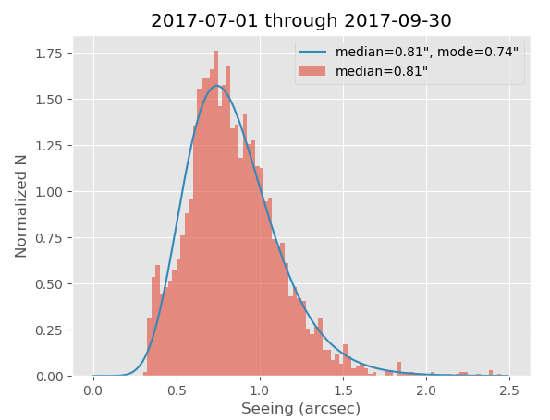

Figure - Histogram of all seeing data collected between July 1 and September 30, 2017. The blue line is the best-fit log-normal probability density function.

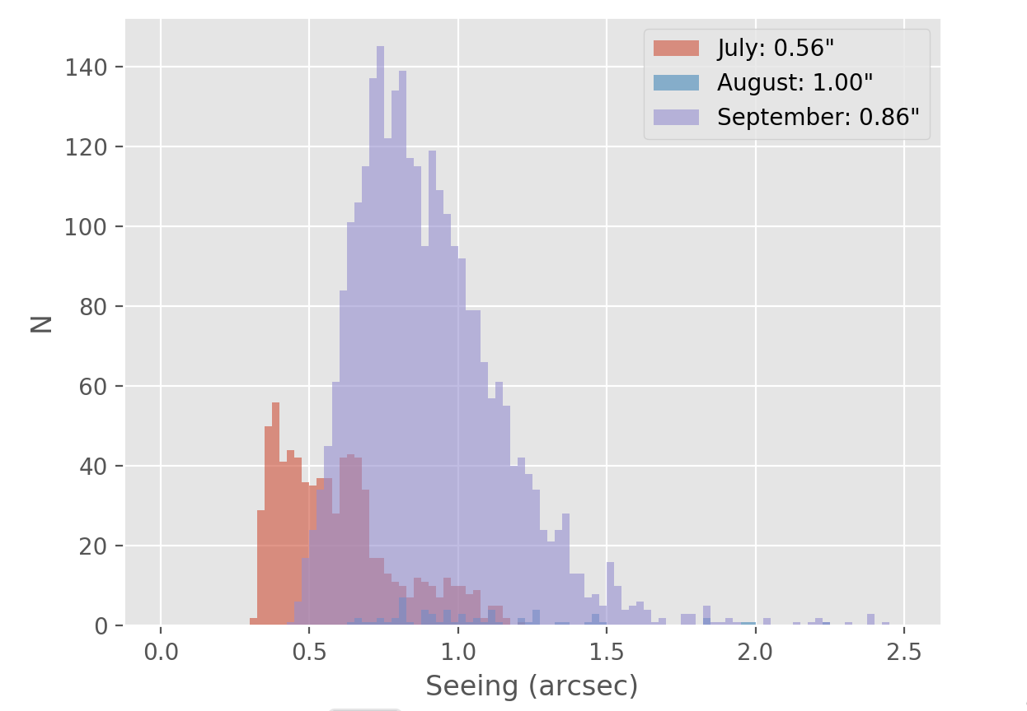

Figure - Seeing histograms for each month

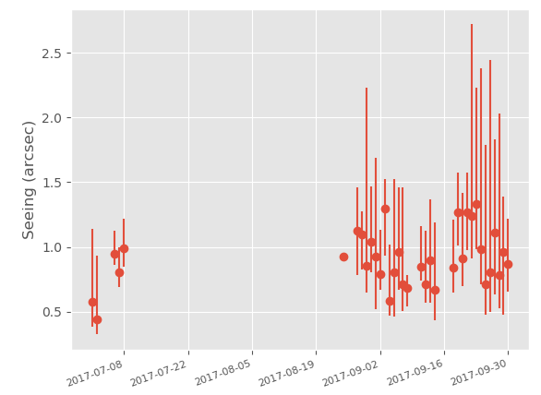

Figure - Median seeing for each night of the quarter with error bars indicating the min and max recorded seeing values

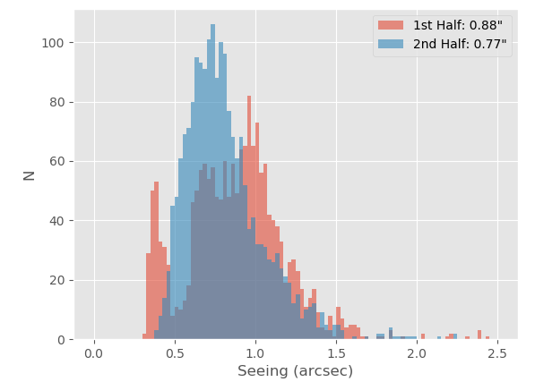

Figure - Seeing histograms split between the first and second halves of the night

**User Support**

**Web Pages**

**Remote Observing**

**Data Quality Assessment**

**Data Archive**

**Reduction Procedures**

Documentation

**Document Database**

**Procedures**

**Public Relations and Outreach**

**Visitors and Tours**

**Public Presentations**

#### MMTO in the Media

**Site Protection**

#### Appendix I - Publications

#### MMT Related Scientific Publications

*(An online publication list can be found in the MMTO ADS library at* [*http://www.mmto.org/node/244*](http://www.mmto.org/node/244)*)*

**MMT Technical Memoranda / Reports**

#### Non-MMT Related Staff Publications

**Appendix II - Service Request (SR) and Response Summary: July - September, 2017**

**Appendix III - Observing Statistics**

The MMTO maintains a database containing relevant information pertaining to the operation of the telescope, facility instruments, and the weather. Details are given in the June 1985 monthly summary. The data attached to the back of this report are taken from that database.