S m i t h s o n i a n A s t r o p h y s i c a l O b s e r v a t o r y & S t e w a r d O b s e r v a t o r y , T h e U n i v e r s i t y o f A r i z o n a

Quarterly Summary



**October - December 2017**

MMT Observatory Activities

Our Quarterly Summary Reports are organized using the same work breakdown structure (WBS) as used in the annual Program Plan. This WBS includes a major category with several subcategories listed under it. In general, many specific activities might fall a tier or two below that. The WBS will be modified as needed in future reports.

**Administrative**

**Program Management**

**Staffing**

**Scheduling**

**Quarterly Reports**

**Strategic Planning**

**Reports and Publications**

**Presentations and Conferences**

T. E. Pickering attended the 27th annual Astronomical Data Analysis Software and Systems (ADASS) conference in Santiago, Chile. This year’s meeting had a much larger emphasis on operations and data pipeline software than previous meetings. T. E. Pickering also attended the following tutorials at ADASS:

* Using Docker “containerization” to simplify deployment and management of observatory computing systems.
* Asynchronous programming in Python.

T. E. Pickering was invited to and attended the 9th annual .astronomy conference hosted by SAAO in Cape Town, South Africa.

Safety

**Training**

**Safety Inspections**

**Procedures and Protocols**

**Personal Protective Equipment**

**Interlock System**

Primary Mirror

**Coating & Aluminization**

**Ventilation and Thermal Systems**

**Hardpoints**

**Actuators**

**Secondary Mirrors**

**f/9**

**f/5**

**f/15**

**Baffling**

**Hexapods**

**f/5 hexapod**

**f/9 and f/15 hexapod**

**Optics Support Structure**

**Truss**

**Secondary Hub**

**Spider Arms**

**Neutral Members**

**Pointing and Tracking**

**Azimuth**

**Elevation**

**Rotator**

**Science Instruments**

**f/9 Instrumentation**

**f/5 Instrumentation**

**f/15 Instrumentation**

**Instrument Handling**

**Topboxes and Wavefront Sensors (WFS)**

**Wavefront Sensor Software**

All wavefront sensor (WFS) systems are now using the updated software for wavefront analysis. Work has been ongoing to improve the new analysis software to optimize performance and robustness. Support for the Binospec WFS was fully implemented and demonstrated. Some improvements have been made to the web interface including support for continuous wavefront sensing.

**Binospec WFS**

Binospec has its own built-in WFS that patrols an off-axis region of sky to allow for continuous operation during science observations. The hardware is very similar to the WFSs on MMIRS, though Binospec only has a single unit. Early in the November commissioning run it became clear that the aberrations measured by Binospec’s WFS were quite wrong. One didn’t even need analysis software to see this. The WFS images were obviously aberrated in ways that on-axis images taken with the single-object guider were obviously not.

During the course of the two commissioning runs, a large amount of data was taken with the Binospec WFS to try and characterize the problem. The current theory is that the WFS’s pick-off mirror is attached at the wrong angle. This then causes the light to enter the WFS at an angle which leads to aberrations due to the internal optics as well as some magnification of the off-axis aberrations inherent to the MMT’s optics.

As a workaround to at least enable periodic wavefront sensing, we developed a scheme that uses the single-object guide camera to perform on-axis curvature wavefront sensing (CWFS). This scheme involves taking a pair of images with the telescope focus changed by the same amount inside and outside of focus. We use +/- 1000 um of M2 focus change which provides a good balance of signal-to-noise, pupil sampling, and calculation time for our needs. The pair of images is then analyzed using the LSST’s CWFS analysis software (<https://github.com/bxin/cwfs>). The only modification that was required to make this software work for the MMTO was to add a configuration file containing the MMT’s optical specifications.

Once demonstrated to work, the LSST CWFS outputs were integrated with the new MMTO WFS software to calculate and apply corrections. A web interface was developed to simplify carrying out CWFS analysis (Figure 1).

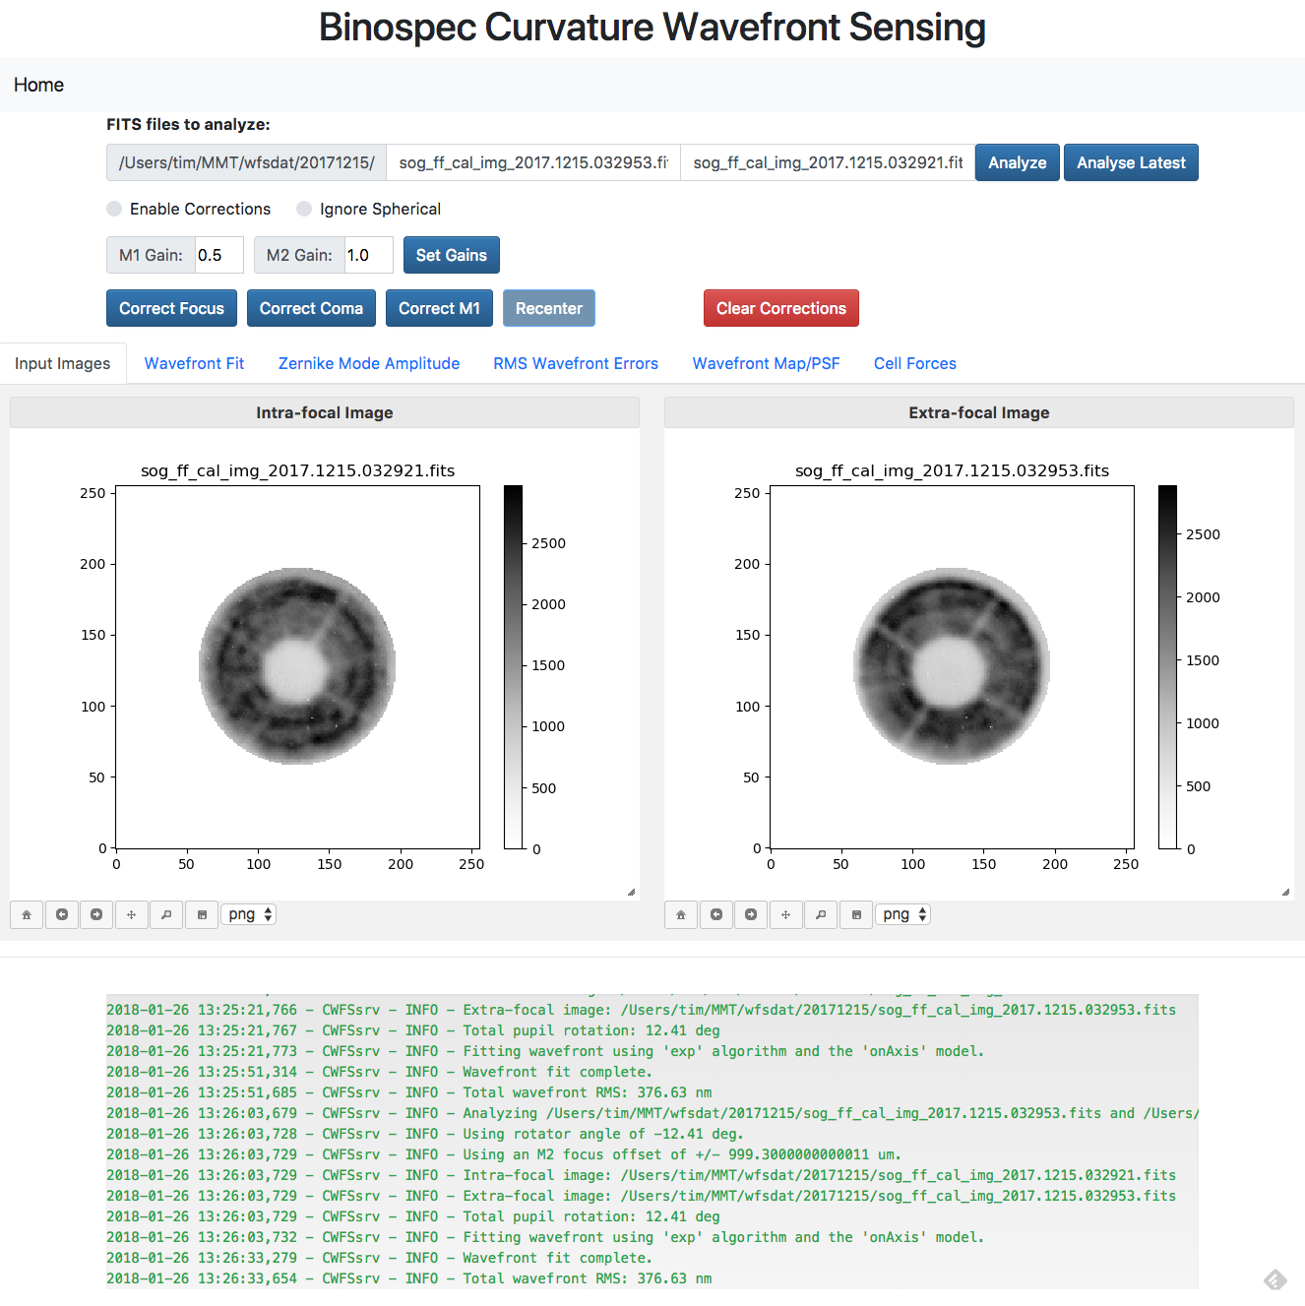

Figure - Screenshot of web interface for Binospec CWFS

**MMIRS WFS**

The patrol regions for the MMIRS guide/WFS cameras are complicated “banana”-like shapes that bracket the field of view of the instrument. Due of the narrowness of some parts of these regions, it is not uncommon for parts of a WFS spot pattern to be missing because part of the star’s pupil falls outside of the patrol region. Because the pickoff mirrors that define the patrol regions are angled, the size of the pupil on the mirror is a function of position of the star. The WFS analysis software can handle missing sections of the pupil up to a point, but becomes more unreliable if a significant portion is missing.

B. McLeod worked out a way to predict pupil vignetting of MMIRS guide stars as a function of field position. Figure 2 shows some examples of predicted guide star pupil images. The areas in green are reflected into the guide/WFS camera while the areas in red are not and would yield missing WFS spots. Figure 3 shows how the predicted missing spots matches up with actual WFS data. It matches very well! Work is ongoing to implement these predictions into the WFS analysis software.

Another issue we discovered with MMIRS WFS data is that there are systematic outward spot displacements in apertures near the outer edges of the pickoff mirrors. This is likely due to the outer edges of those mirrors being slightly turned down. In addition to predicting missing spots, the analysis code will also need to flag and mask out apertures affected by the turned edges to avoid systematic errors in the wavefront measurements.

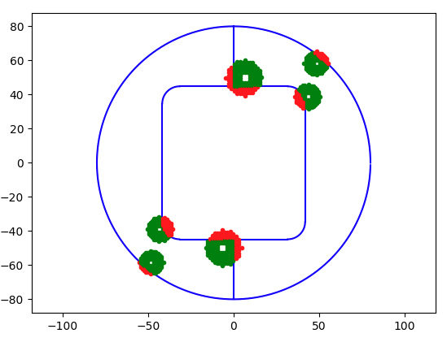

Figure - Pupil images of MMIRS guide stars at different field positions

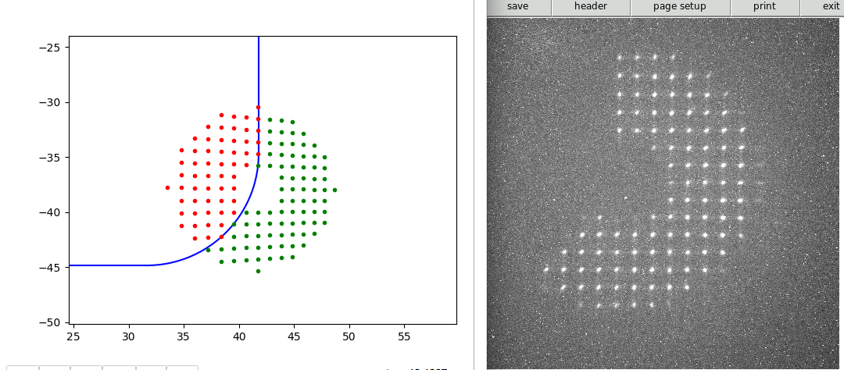

Figure - Predicted missing spots along with actual MMIRS WFS data taken at the same position

**f/5 WFS**

**f/9 Topbox**

A new web-based interface to the F/9 WFS camera was developed and deployed. It is based off the design of the MATcam interface and uses the same JS9 widget for image display and manipulated. A screenshot is shown in Figure 4.

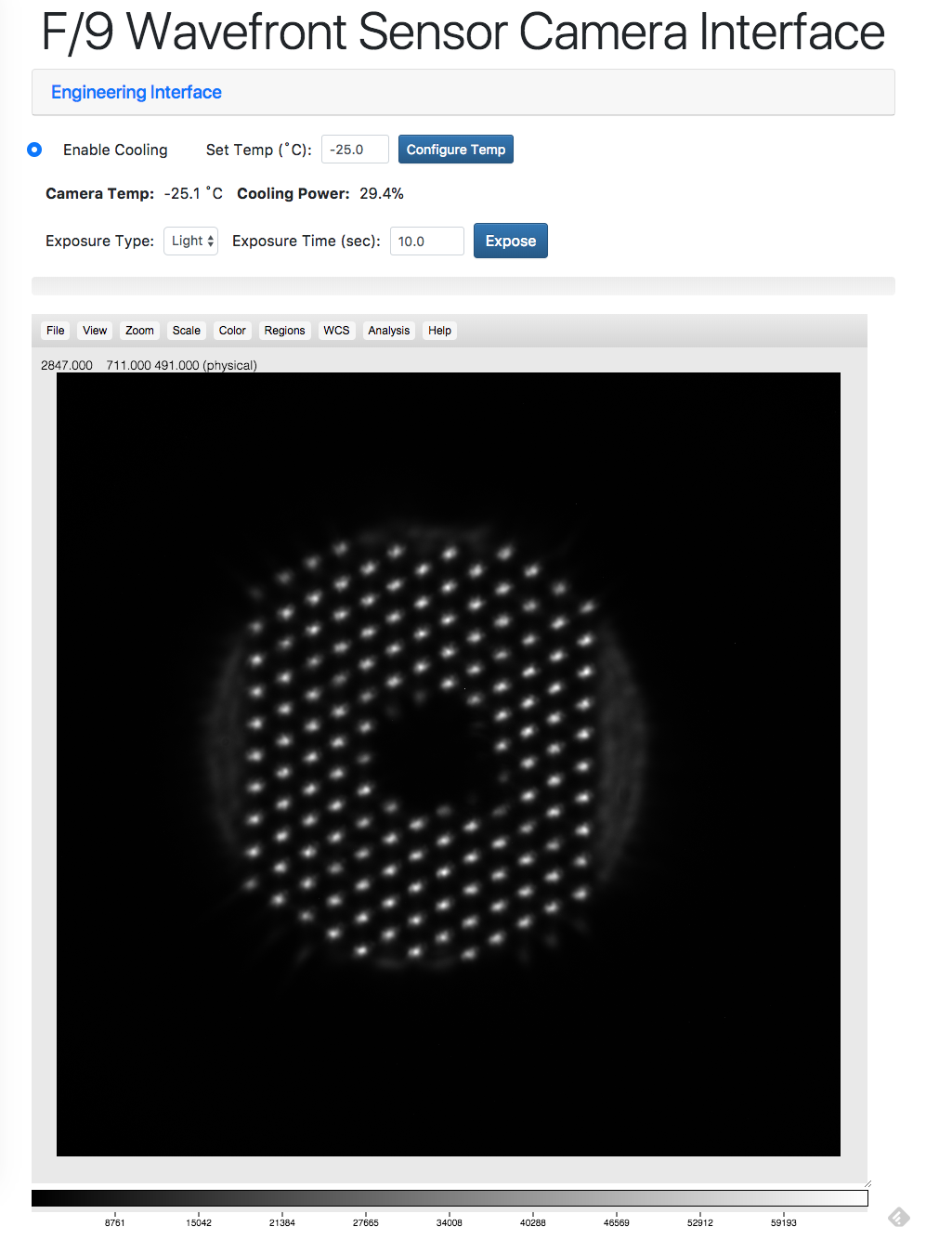

Figure - Web interface for F/9 WFS camera

**Natural Guide Star (NGS) Topbox**

**Laser Guide Star (LGS) Topbox**

**Facilities**

**Main Enclosure**

**Instrument Repair Facility (IRF)**

**Common Building**

**Bowl Dorm**

**General Infrastructure**

##### **Computers and Information Technology**

**Computers and Storage**

**Network**

**Hardware/Software Interfaces**

**Telemetry, Logging, and Database Management**

**Annunciator**

**Weather and Environmental Monitoring**

**Weather Stations**

**All Sky Camera and Web Cameras**

The numerous hot pixels on the MMTO all-sky camera have long been a source of confusion for some users. T. Pickering used a set of images from a cloudy night to construct a bad pixel mask. An example of the results is shown in Figure 5. This bad pixel mask is now implemented in the pipeline for the all-sky camera and is applied to every image it acquires. It makes a significant improvement overall. There are still a few sporadic hot pixels that flash on and off at times, but they are mostly unobtrusive and easy to pick out in the all-sky animations. The mask is implemented as a FITS image so updating the bad pixel mask only requires replacing that one file.

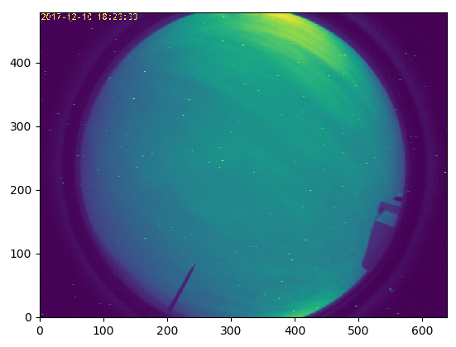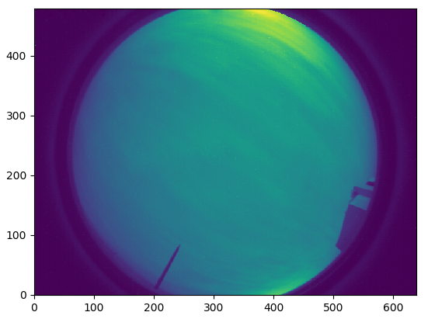

Figure - Sky camera images before and after applying bad pixel mask

**Seeing**

The overall seeing histogram for the 4th quarter of 2017 is shown in Figure 6. There is a strong peak at 0.73”, but also a long tail so the overall median seeing as-measured is 0.84”. The shape of the histogram is not as well-described by a log-normal distribution as it has been in previous quarters. There are two possible reasons why: 1) The new analysis software works much better in very bad seeing and thus can actually measure seeing values >2.5”. Therefore, it’s measuring more of the long tail of the spectrum of bad seeing. 2) The overall statistics are dominated by the number of measurements taken during the Binospec (11099) and MMIRS (4136) runs. The November Binospec run had generally pretty good to great seeing while the December run was characterized by poor weather and strong easterly winds.



Figure - Histogram of seeing data for the 4th quarter of 2017

The monthly trends were pretty stark overall as seen in Figure 7. October had very good conditions with a median of 0.71” and many instances of sub-0.5” seeing. November was somewhat worse with the numbers dominated by the week and a half of Binospec data, but was still sub-1.0” the majority of the time. December was quite bad overall, however, and was dominated by persistent easterly winds from very strong high pressure over the Great Plains. This is even more clearly shown in the nightly seeing statistics (Figure 8) where the seeing obviously blows up in mid-December, but settles back down by the end of the month.



Figure - Monthly seeing histograms for the 4th quarter of 2017



Figure - Median, minimum, and maximum seeing for each night of the 4th quarter of 2017

Interestingly, the dichotomy between seeing measured in the first and second halves of the nights is not evident in this quarter as it had been previously (Figure 9). This time, the seeing is formally slightly worse in the second half, a reverse of the previous trend.



Figure - Histograms of seeing measured in the first and second halves of the night

However, given the large amount of Binospec seeing measurements collected during bad weather and easterly winds in December, it’s worth breaking this out per month.

As seen in Figure 10 it’s actually November where the second half seeing is worse than the first half. For the other two months the second half seeing is clearly better as we’ve seen in previous data. The difference in December is pretty stark with a median of almost 2” in the first half and improving to 1.4” in the second half.



Figure - First/second half seeing histograms for October (left), November (middle), and December (right)

**User Support**

**Web Pages**

**Remote Observing**

**Data Quality Assessment**

**Data Archive**

**Reduction Procedures**

Documentation

**Document Database**

**Procedures**

**Public Relations and Outreach**

**Visitors and Tours**

**Public Presentations**

#### MMTO in the Media

**Site Protection**

#### Appendix I - Publications

#### MMT Related Scientific Publications

*(An online publication list can be found in the MMTO ADS library at* [*http://www.mmto.org/node/244*](http://www.mmto.org/node/244)*)*

**MMT Technical Memoranda / Reports**

#### Non-MMT Related Staff Publications

**Appendix II - Service Request (SR) and Response Summary: October - December, 2017**

**Appendix III - Observing Statistics**

The MMTO maintains a database containing relevant information pertaining to the operation of the telescope, facility instruments, and the weather. Details are given in the June 1985 monthly summary. The data attached to the back of this report are taken from that database.