Pizza House Menu **Feb 2012**

*Appetizers 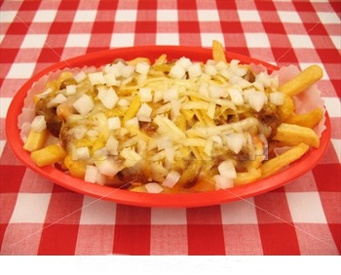*

*Pictured*

***\*Bacon n Cheddar Fry***

***One of our favorite appetizers***

*Garlic Bread Styx w/Cheese..5.50 Ch & Bacon..5.95 Br Style..6.25*

*Family Style Garlic Bread..8.50 w/Cheese and Bacon..9.50*

***\*****Bacon & Chedd Fry..5.99 Cheddar Fry..5.25 Ched & Jalo Fry..5.25*

*Chic Tend & Fry..5.99 Fam Style 10pc and Fry..11.95 5 pc CT..5.99*

*10 Pc Chic Tend..9.99 Bomb Chic Tend & Fry..7.50 Fried Zucc..4.95*

*Zuccini & Fry..5.99 Mozzarella Stix..5.50 Cheddar Poppers 4.50*

*Potato Skins w/Bac & Cheddar or Cheddar & Broc .. 5.99 Pepperoni Bread...4.95 New Spirit Tenders...5.99 Chick Nuggets.4.99*

Pizza Toppings **1 Topping 2 Topping 3 Topping Signature or 4 Topping**

Small **10in** 6.99 7.50 7.99 8.50

Medium **12 in** 9.99 10.99 11.99 12.99

Large **16 in** 11.99 13.99 15.99 16.99

Partyhouse **18 x 13** 14.99 17.99 19.99 21.99

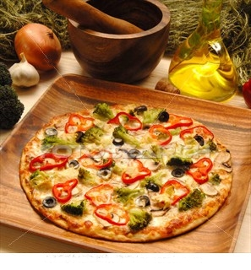

**Signature Pizzas**

**Toppings-pepperoni, spicy Ham, grd beef, Ital sausage, crumble sausage, meatball, bacon, smoked ham, grill chic**

**broccoli, dice tomato, white onion, red onion, ban pepper**

**fresh spinach, mushrooms, pineapple, jalo peppers, gr pepp**

**green olive, kalamata olive, feta cheese, cheddar cheese**

**\* All pizzas are made with dough made fresh everyday. Dough is pan height, unless requested thin. Signature products basted with our garlic butter are indicated as white pan. Provolone cheese is standard on all pizzas.**

*Arizona- Diced tomato, chicken, feta, red onion*

*Artist- White pan w/artichoke, feta, black olive and onion*

*BR Special- White pan featuring, crumbled bacon, feta cheese and special sauce*

*Bomb- Pepperoni, spicy ham, onion, green pepper, crumble sausage, extra cheese !*

*Cain Park- Spinach, tomato, onion, feta cheese*

*California Vegetable- None like it ! mushroom, onion, gr pepper, tomato ,blk olive, broccoli, feta*

*Cheeseburger- Ground Beef, tomato, onion, cheddar cheese*

*Chicken Club- White pan w/ grill chicken, tomato, bacon*

*Chicken BBQ- dough is basted with bbq sauce, add grill chicken, red onion and feta cheese*

*Chicken & Broccoli- White pan w/ grill chicken and broccoli, cheese is placed over top*

*Chicken & Broccoli Alfredo- Same as above, add our signature alfredo sauce*

*Hawaiian Maui- Smoked ham, bacon and pineapple*

*House Deluxe- Pepperoni, mushroom, onion, green pepper, Italian sausage*

*LoPresti- Meatballs, onion, green pepper*

*Super Deluxe- Same as house deluxe, add black olive*

*Meat Supreme- Pepperoni, spicy ham, bacon, and Italian sausage*

*Onassis- A Greek delight! white pan w/onion, black olive, tomato and feta cheese*

*Ranch Steak- white pan w/our Philly steak sauteé and topped with ranch !*

*Seafood Deluxe- White pan with onion, garlic seasoning, shrimp and crabmeat, WOW !*

*Shaw Special- Lots of xtra pepperoni and Italian sausage*

*Sicilian Masterpiece- Thin Italian white pan w/ spicy ham, pepperoni, ban peppers and feta ch*

*White House- White pan, w/ onion, green pepper, black olive & Italian sausage*

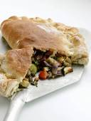

Voted Best Calzone in Cleveland!

All calzones start with creamy ricotta cheese and provolone cheese. Choose a signature product or build your own..up to 4 toppings. Basted with garlic butter and served with marinara sauce.

8.99

*Beta Zone- chicken, broccoli and cheddar cheese*

*Buffalo Zone- chicken tenders dipped in 1 alarm sauce w/onion, green pepper and feta cheese*

*California Veg Zone- mushroom, onion, gr pepper, tomato, broccoli, black olive, feta ch*

*Cain Park Zone- Spinach, tomato, onion, feta cheese*

*Chicken and Spinach Zone-Pesto sauce, w/ spinach, chicken, red onion and feta cheese*

*Chicken Philly Zone- grill chicken, onion, green pepper, dash of pepper and ranch*

*Chicken Tender Zone- Deep fried tenders, pizza sauce, onion and green pepper*

*ER Zone- Our delicious Philly steak saute wrapped in a zone*

*House Deluxe Zone- pepperoni, mushroom, green pepper, onion, crumble sausage*

*Italian Zone- Spicy ham, salami, pepperoni & banana peppers*

*LoPresti Zone- meatball, onion and green pepper*

*Maui Zone- smoked ham, bacon, onion and pineapple*

*Meat Supreme Zone- pepperoni, bacon, spicy ham, and crumble sausage*

*Motorcar Zone- lots of pepperoni and crumble sausage*

*PMS Zone- pepperoni, mushroom and crumble sausage*

*Rob Zone- chicken, bacon, onion and tomato*

*Seafood Zone- Our delicious seafood saute (shrimp and crabmeat), seasoned w/ red onion*

Subs and Hoagies 8.50

All of our subs and hoagies are served on fresh Orlando rolls, with your choice of chips and a pickle spear. Add fries, onion rings or pasta salad for 1.50.

Order a Sub Platter for Meetings

Just 35.00 feeds 15 guests

**\* Cold * Hot**

Our delicious

Turkey Sub !

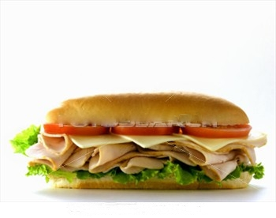

*\* BBQ Chicken Sub- Deep fried chic patties w/ bbq sauce, red onion, feta and provolone cheese*

*\* Burger Sub- Two 6 oz burgers w/mayo, tomato, lettuce and American cheese*

*\* Cal Veggie Sub- Sauteed mushroom ,onion ,gr pepper, tomato, broccoli, blk olive and feta ch*

*\* Chicken Finger Sub- Deep fried tenders with mayo, tomato and lettuce*

*\*Chicken Salad Melt- Homemade with red onion, tomato and cheese*

*\* Chick Parmesan Sub- Deep fried chicken patty with marinara and provolone cheese*

*\* Chicken Philly- One of our best sellers with sauteed chicken, onion ,green pepper, and ranch*

*\* Danny Boy- All beef sausage, with bbq sauce, topped w/fries and cheese*

*\* Hot Italian Sub- Spicy ham, salami, pepperoni, ban pepper and provolone cheese*

*\* Little Italy Sub- Ital sausage with gr pepper & onion marinade, topped with provolone cheese*

*\* Meatball Sub- Italian meatballs with pasta sauce, topped with provolone cheese*

*\* Pepperoni Sub- a pepperoni pizza on an Italian roll*

*\* Philly Steak Sub- Our famous Philly Steak sautee, mushroom ,onion, gr pepper and cheese*

*\* Tuna Buna Sub- Our homemade tuna, with mayo, tomato, lettuce & American cheese*

*\* Tuna Melt- Our homemade tuna, toasted open face with mayo, onion, tomato and cheese*

*\* Turkey Melt-Turkey, cooked open face with red onion, mayo, tomato, and cheese*

*\* You Little Turkey Sub- Smoked turkey, with red onion, tomato, lettuce, mayo & cheese*

Best Salads in the Heights !

Start with either, our fresh spinach, or mixed greens, add daily prep tomato, red onion, mushrooms, green peppers, cucumbers, baby carrots, bacon topping, grill chicken, broccoli, or cubed deli meats and top it off with provolone cheese and some of our fresh baked croutons !! You'll see why the hospitals rank us #1 on salads,

HANDS DOWN !!

Our Caesar salad with our

famous croutons !

fresh baked croutons

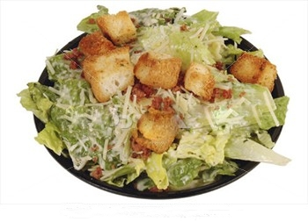

*Antipasto- mixed greens, salami, pepperoni, gr olive, kala olive, cheese and hot peppers 7.95*

*BLT Club- tomato, bacon, and gr chicken, does not come w/cheese 7.50*

*Caesar- mix greens with gr chicken, baked croutons and Romano cheese 7.75*

*Caesar Supreme- Add egg and bacon to our Caesar salad 8.50*

*California Vegetable- Mushroom, red onion, cuc, tomato, broccoli, blk olive , feta ch 7.75*

*Chicken Tender- House salad fixins topped with chicken tenders 7.75*

*Cobb Salad- Rows of egg, bacon, smoked ham and tomato 7.75*

*Deluxe Chef- tomato, red onion, cube turkey and ham, egg and cheese 8.25*

*Greenwald Salad- mixed greens, our homemade tuna and choice of toppings 8.50*

*Grill Chicken- house salad topped with grilled chicken 7.75*

*Grill Chicken and Spinach- bed of spinach w/red onion, feta ch, egg & almonds 7.95*

*House Salad- mix greens with tomato, mushroom, red onion, cuc, carrot and cheese 6.95*

*House Side- Smaller version of house salad 4.50*

*New Spirit Salad- Chic tenders dip in our 1 alrm sauce, with tomato, red onion and cheese 7.50*

*Onassis- mix greens with tomato, greek olive and feta cheese 7.25*

*Ran Steak Salad- Our philly steak fixins with croutons with tomato and red onion 7.95*

*Spinach Salad- spinach, egg, bacon topping and feta cheese 6.95*

*Seafood Salad- Saute Shrimp and crabmeat with croutons, tomato and red onion 8.99*

*Seafood Bomb- Seafood toppings with Cheese, bacon and egg 9.99 No Discounts*

*Specialty Side - choice of any salads above in smaller version, Except Seafoods 5.25*

*Surf n Turf- Our seafood and ran steak ingedients, unbelievable! 8.25*

*Terriyaki Salad- Bed of spinach with terri chicken, red onion, croutons, egg, feta cheese 8.25*

Dressing choices

Ranch Italian Blue Cheese Honey Mustard California French

Creamy Parmesan Caesar Poppyseed Lite Italian 1000 Island

Add croutons .99 Xtra dressing .50

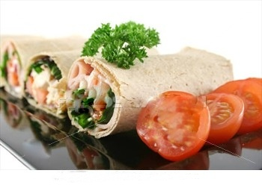

Ultimate Wraps

A great low calorie alternative, served with choice of chips or add pasta salad for 1.50.

7.25

*Cain Park Wrap- spinach, tomato, red onion, chicken, feta cheese, and oil & vin dressing*

*Chef Wrap- tomato, lettuce, red onion, ham, turkey, and egg with mayo*

*Chicken Caesar- mix greens, Caesar dressing, chicken, parmesan cheese, tomato, red onion*

*Chicken Finger- Fried chicken tenders with tomato, lettuce, cheese and ranch*

*Chic Philly- Saute chicken, onion, green pepper, with lettuce, tomato and ranch*

*Hawaii Wrap- Bacon, ham, pineapple, lettuce, tomato, american ch and french dressing*

*Italian Wrap- Spicy ham, salami, pepperoni, ban peppers, onion, and Ital dressing (Toasted)*

*Ranch Caesar- Chick Tenders with lettuce, red onion, parmesan ch, Caesar & ranch dressing*

*Ranch Steak- Our Philly steak saute with Tomato, lettuce, cheese and ranch*

*Rob Wrap- Chicken, bacon, lettuce, tomato, cheese and ranch*

*Tuna Wrap- Homemade tuna, tomato ,onion, cheese ,lettuce and mayo*

*Turkey Wrap- Smoked turkey, bacon, red onion, lettuce, tomato, cheese and mayo*

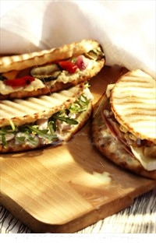

Flat Bread Melts

A New Taste Sensation !

Start with Greek Pita Bread, basted with garlic butter and then toasted open face with our great ingredients ! Served with choice of Chips.

6.99

*BLT flatbread- chicken, tomato, bacon and cheese*

*Bomb Flatbread- pepp, spicy ham, bacon, onion ,gr pepper, sausage and cheese*

*Chic Philly Flatbread- chicken, onion, green pepper, ranch and cheese*

*Chicken Salad Flatbread- homemade, with red onion, tomato and cheese*

*Chic Tender flatbread- deep fried tenders with red onion, tomato and cheese and ranch*

*Ran Steak Flatbread- philly steak fixins, with tomato, cheese*

*Turkey Flatbread- smoked turkey, red onion, tomato, cheese*

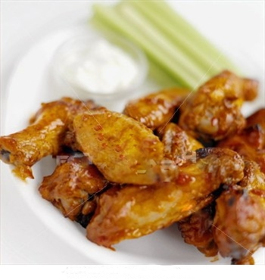

Award Winning Wings

Floured and deep fried to seal the natural juices. Sauces are honey mustard..mild bbq...garlic butter...hickory bbq....1 alarm.

*1/2 dozen 5.50 dozen 9.50 two dozen 16.99*

*50 wing platter 32.95 100 wing platter 63.00*

*celery and blue cheese or ranch 2.00*

*Ask about our New Southern Crispy Wings. A little smaller, but a lot more crispier! Ask for a dozen and get 2 extra !*

*(while supplies last)*

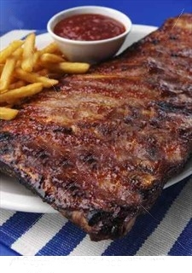

Try our New Rib Dinner

Comes with french fries,bread bites, and pasta salad all for 11.95

or Shrimp and Rib dinner

comes with all the above, plus 5 pc of deep fried shrimp all for 13.95

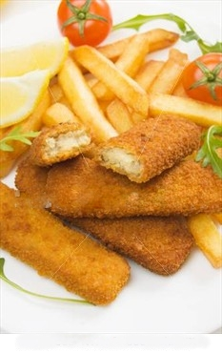

Fish n Chips

We feature deep fried pub battered fish, with fries, tartar sauce, bread bites and pasta salad 8.95

*Fish Sandwich- Deep fried cod with lettuce ,onion ,tartar sauce and french fries 8.50*

*Fish Dinner- 2 pc deep fried cod, served with french fries, bread bites, pasta salad 9.95*

*Ask about our Perch dinners for 2.00 more*

*Shrimp Dinner- 7 pc fried shrimp, fries, cocktail sauce, bread bites, pasta salad 11.95*

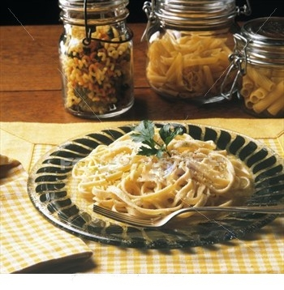

PASTA PASTA !!

Our Alfredo bar...Simply put...as good as the fine dining restaurants..at 1/2 the price!

* Chicken Alfredo

* Chicken and Broccoli

* Chicken and Spinach

* Shrimp Alfredo

* Steak Alfredo

* comes with salad and bread bites

all for 11.95

*Spaghetti, Rigatoni plain 9.50 w/ meatball 9.95*

*Chicken Parmesan- deep fried chic patty, served with spaghetti 9.95*

*Baked Ziti- made famous by the "Sopranos" start with our penne pasta, add ricotta and*

*pasta sauce, a dash of pepper and vegetables or meats 10.95*

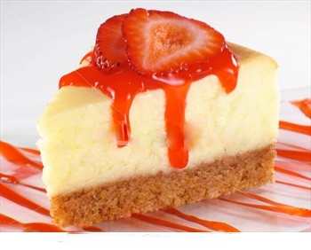

Our Signature Cheesecake 2.99 slice

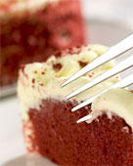

Red Velvet Cake

2.99 slice

Hours of Operation

Tues -Thurs 11-8

Fri-Sat 11-9

Closed Sun-Mond