

**Arab Academy for Science, Technology and Maritime Transport**

**College of Computing and Information Technology**

**Computer Science Department**

B. Sc. Final Year Project

**Vision-based vehicle speed estimation**

Presented By:

|  |  |
| --- | --- |
| *Mohammed Reda* | *Ahmed Sayed* |
| *Yousef Fadel* | *Salma Nasser* |
| *Mohammed Ramadan* | |

Supervised By:

*Mostafa Mohammed*

JULY – 2022

DEclaration

I hereby certify that this report, which I now submit for assessment on the programme of study leading to the award of Bachelor of Science in Computer Science, is all my own work and contains no Plagiarism. By submitting this report, I agree to the following terms:

*Any text, diagrams or other material copied from other sources (including, but not limited to, books, journals, and the internet) have been clearly acknowledged and cited followed by the reference number used; either in the text or in a footnote/endnote. The details of the used references that are listed at the end of the report are confirming to the referencing style dictated by the final year project template and are, to my knowledge, accurate and complete.*

I have read the sections on referencing and plagiarism in the final year project template. I understand that plagiarism can lead to a reduced or fail grade, in serious cases, for the Graduation Project course.

|  |  |
| --- | --- |
| Student Name: Ahmed Sayed  Registration Number: 18108518  Signed: ________________________  Date: 01 – Jul – 2022 | Student Name: Mohammed Reda  Registration Number: 18108564  Signed: ________________________  Date: 01 – Jul – 2022 |
| Student Name: Yousef Fadel  Registration Number: 18108569  Signed: ________________________  Date: 01 – Jul – 2022 | Student Name: Mohammed Ramadan  Registration Number:  Signed: ________________________  Date: 01 – Jul – 2022 |
| Student Name: Salma Nasser  Registration Number:  Signed: ________________________  Date: 01 – Jul – 2022 |  |

**STUDENTS CONTRIBUTION**

<PROJECT TITLE>

By:

<Student (A)>

<Student (B)>

<Student (C)>

<Student (D)>

|  |  |  |
| --- | --- | --- |
| Chapter | Title | Contributors |
| 1 | Introduction | Student (A)  Student (B) |
| 2 | Literature Review | Student (C)  Student (D) |
| 3 | Modeling | Student (A) |
| 4 | Results and Discussion | Student (A)  Student (B)  Student (C)  Student (D) |
| 5 | Conclusions | Student (C) |
| 6 | Future Work and Suggestions | Student (D) |
| 7 | Conclusions and discussions | Student (A)  Student (B)  Student (C)  Student (D) |

Acknowledgment

We would like to acknowledge and give our warmest thank to Professor *Mostafa Mohammed* who made this work possible by guiding us through the different processes of the project and shared his knowledge and expertise with us.

We would also like all the great professors who have taught us during our journey pursuing this degree. Without them we could have never reached such milestone and we wish to them all the best teaching and raising new generations of developers, engineers and scientists.

Abstract

Table of Contents

**LIST OF FIGURES………………………………………………………………………………………..III**

list of tables iv

LIST OF ACRONYMS/ABBREVIATIONS v

1 Introduction 6

1.1 RADAR DISADVANTAGES…………………………………………………………………………...6  
 1.1.1 6  
1.2 BUT WHAT COULD WORK AS AN ALTERNATIVE FOR A RADAR?........................................7  
1.3 WHAT IS COMPUTER VISION………………………………………………………………………7

2 formatting description 7

2.1 Title Page 12

2.2 General Project Layout 13

2.3 Page and Text Setting 13

2.3.1 Sub-Heading Level 1 .13

2.4 Figures and Tables 14

2.4.1 Figure Captions and Table Titles .14

2.4.2 Numbering of Figures and Tables .

2.4.3 Referring to Figures and Tables in Text 15.

2.5 General Recommendations 16

2.5.1 Units .16

2.5.2 Abbreviations and Acronyms 16

2.5.3 Equations 16

2.5.4 Other Recommendations 16

3 Answers to Frequently Asked Questions .17

3.1 What is the final year project? .18

3.2 Why is it important to you? .19

3.3 Why is it important to the college? .20

3.4 How do i get allocated to a project? .21

3.5 May I suggest a project? .22

3.6 How do I get started? .

4 Plagiarism .23

4.1 Definition of Plagiarism .24

4.2 Dealing with Plagiarism .25

4.2.1 Plagiarism Levels .26

4.2.2 Academic Sanctions .27

4.2.3 Identifying Plagiarism .28

5 citation and referencing 30

5.1 References Format………………………………………………………………….….30

5.2 References to Electronic Sources 31

References 32

Appendices 33

List of figures

Figure ‎2‑1: . 9

Figure ‎2‑2: . 11

Figure ‎2‑3: . 15

Figure ‎2‑4: .17

list of tables

Table ‎2‑1:. 14

LIST OF ACRONYMS/ABBREVIATIONS

|  |  |
| --- | --- |
| YOLO | You look only once which is an object detection algorithm |
|  |  |
|  |  |
|  |  |
|  |  |
|  |  |
|  |  |
|  |  |

Chapter One

# Introduction

We have been depending on using radar in Egyptian traffic for a long time which does its job properly but comes at its own costs and disadvantages. We thrive to create a more efficient way to be able to estimate vehicles speed with lower cost and an ability to easily implement and integrate it with new technologies.

## radar disadvantages

* + 1. **it must be setup in certain places**

Usually, we find radar being setup away from the road usually in a high place this due to many to name a few of them 1. RADAR takes time to lock on objects 2. Large objects that are close to the Transmitter can saturate the receiver 3. Large objects that are close to the Transmitter can saturate the receiver.

* + 1. **It can only determine an objects speed.**

Important aspects of a vehicle like it’s color, make, model, license plate and type of vehicles cannot be determined using regular RADAR it must have a camera that works along with it in order to achieve such ability.

* + 1. **RADAR signal can be jammed**

Many RADAR jammers are being sold illegally and tutorials online teaching how to make a one.

|  |  |
| --- | --- |
| British Driver Jailed for Running Laser Jammers - YouTube | **Figure 1-1: car equipped with a RADAR Jammer** |

## but what could work as an alternative for a radar?

As we mentioned previously radar comes with its own costs this being price and how hard it’s to implement and integrate it with new systems and technologies.

That’s why we considered using computer vision in combination with regular cameras which helps 1. cutting the cost of production as it’s not as expensive as using radars 2. Makes it way easier to extend its functionalities and add new features and help automate the process of capturing vehicle violations and reporting them to authorities. Let us just think about the current speed ticking systems how many time have we had fines that we couldn’t find on the government website it simply doesn’t work efficiently because of how hard it’s to extract data from radar and input it into a backend system but now lets imagine implementing this using computer vision this will just be a matter of sending an http request to an API with the vehicle information and its speed.

But This brings a new question what is computer vision?

## What is computer vision

Computer vision is a field of AI that thrives to give computers a high level understanding of footage trying to mimic the way human brain works in processing information coming from sight.

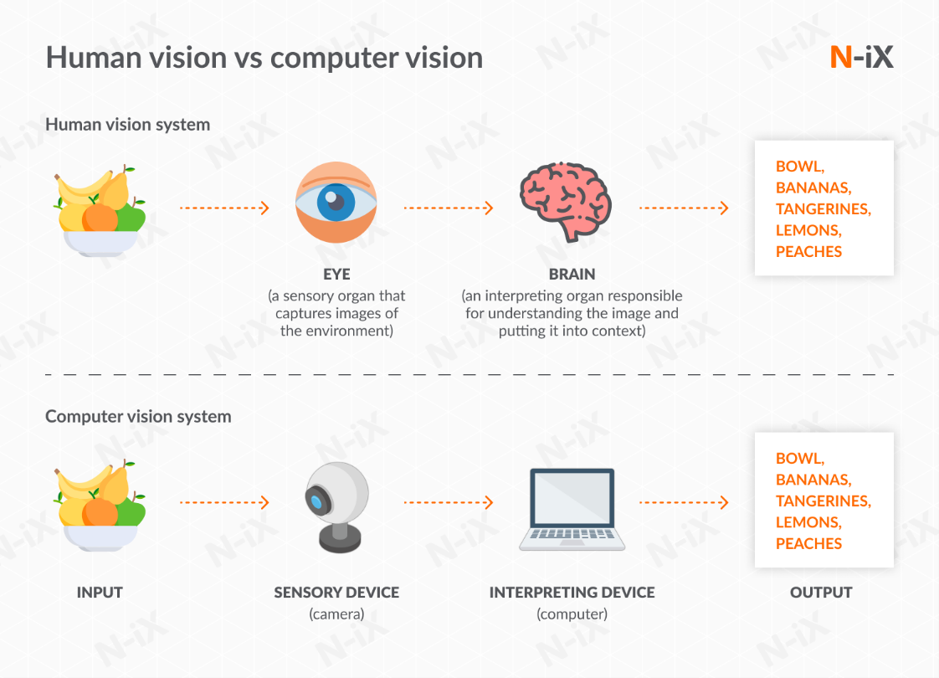

**Figure 1-2: human vision vs computer vision.**

With these point discussed earlier now we know why we’re going to work on this project and which computer science field it’s related to but this brings out a lot of questions like how are we going to use computer vision to achieve our desired goals and this comes with a lot of challenges to like how are we going to deal with vehicles with different dimensions and body types (i.e. trucks, sedans, SUV’s, pickup trucks) and a lot of more questions that we’ll further discuss and answer in the following chapters.

Chapter Two

# BACKGROUND AND Literature REVIEW

**2.1 CHAPTER INTRODUCTION**

As we mentioned in chapter 1 this project will emphasize on the use of **Computer Vision** which is a field of **Artificial Intelligence** so before jumping into that we’re going to discuss how the computer can determine that the object (in **figure 2-1)** on the left is a car and the object on the right isn’t here comes the use of **deep learning**.

|  |  |
| --- | --- |
| 2010 Kia Forte Ratings, Pricing, Reviews and Awards | J.D. Power | Flying Plane transparent PNG - StickPNG |
| Car | Not a Car |

**Figure 2-1: how computer tells the difference between a car and an airplane**

**2.2 INTRODUCTION TO DEEP LEARNING**

Deep learning subfield of machine learning concerned with algorithms inspired by the structure and function of the brain called artificial neural networks.

**2.2.1 Difference between deep learning and machine learning**

First of all lets define what’s machine learning? Machine learning **performs a function with the data given to it and gets progressively better over time** while deep learning continually analyze data with a logical structure similar to how a human would draw conclusions. To complete this analysis, deep learning applications use a layered structure of algorithms called an artificial neural network. While basic machine learning models do become progressively better at performing their specific functions as they take in new data, they still need some human intervention. If an AI algorithm returns an inaccurate prediction, then an engineer has to step in and make adjustments. With a deep learning model, an algorithm can determine whether or not a prediction is accurate through its own neural network—no human help is required.

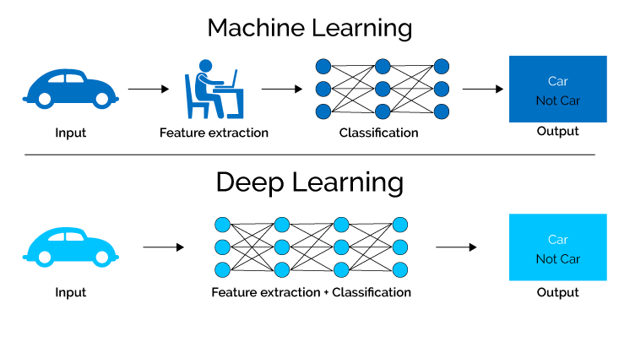

**­Figure 2-2: Difference between machine learning and deep learning**

**2.2.2 How deep learning works and adjusts itself**

Deep learning is about **neural networks** Let’s look inside the brain of our AI. Like animals, our estimator AI’s brain has neurons. They are represented by circles. These neurons are inter-connected. The neurons are grouped into three different types of layers: 1. Input Layer 2. Hidden Layer(s) 3. Output Layer The input layer receives input data. In our case, we have four neurons in the input layer: Origin Airport, Destination Airport, Departure Date, and Airline. The input layer passes the inputs to the first hidden layer. The hidden layers perform mathematical computations on our inputs. One of the challenges in creating neural networks is deciding the number of hidden layers, as well as the number of neurons for each layer. The “Deep” in Deep Learning refers to having more than one hidden layer. The output layer returns the output data. In our case, it gives us the price prediction.

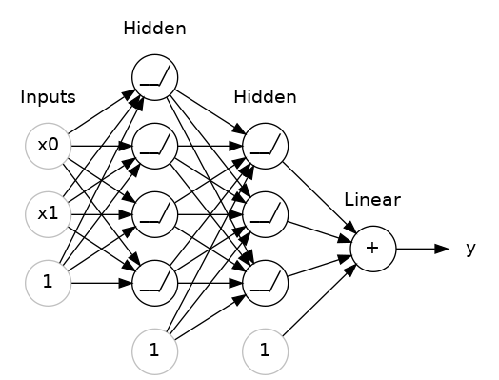

**Figure 2-3: example neural network**

**2.3 HOW WE DETECT CARS USING COMPUTER VISION AND MACHINE LEARNING**

**2.3.1 Feature extraction**

In order to detect a car on the image, we need to identify feature(s) which uniquely represent a car. We could try using simple template matching or relaying on color features but these methods are not robust enough when it comes to changing perspectives and shapes of the object.

In order to have a robust feature set and increase our accuracy rate we will be using Histogram of Oriented Gradients (HOG). This feature descriptor is much more resilient to the dynamics of the traffic. In essence, you should think of features as thumbprints of the objects you are interested in.

**figure 2-4: extracting vehicle HOG features**

**2.3.2 Model Training**

In order to detect the car based on our feature set, we would need a prediction model. For this particular case we will be using Linear Support Vector Machines (Linear SVMs). It is a supervised learning model which will be able to classify whether something is a car or not after we train it. HOG features have been scaled to zero mean and unit variance using Standard Scaler.

**2.3.3 Sliding windows**

Once we have the prediction model, it’s time to use it on our test images. Prediction model will be applied in a special technique called Sliding Windows. With this technique we will be running prediction model on sub-regions of the images which is divided into a grid.

In order to increase the robustness of this approach we will be adding multiple grids which will be traversed by the prediction model. We are doing this since cars can appear on the image in various sizes depending on its location on the road.A picture containing chart

**Figure 2-5: sliding window example**

**2.3.4 Eliminating false positives**

In order to improve the accuracy of the final output we will be trying to find multiple hits for the object of interest in the similar area. This approach is equivalent to creating a heat map. The next step is introducing threshold which needs to be met in order for a specific hit count from the heat map to be accepted as a detected car. In our case threshold has a value of 2.

Figure 2-6 shows an example of applying the heat map and thresholding it to a specific value.

**Figure 2-6: eliminating false positives by applying heat map and thresholding**

But the previous method discusses how we can perform this using machine learning what about deep learning? Here comes the use of **YOLO**

**2.4 USING YOLO TO DETECT A CAR SPEED IN REAL TIME**

YOLO stands for You look only once which is a real-time object detection algorithm that identifies specific objects in videos, live feeds, or images. YOLO uses features learned by a deep convolutional neural network to detect an object.

# What's new in YOLO v3?. A review of the YOLO v3 object… | by Ayoosh Kathuria | Towards Data Science

**Figure 2-7: Yolov3 Network architecture**

**2.4.1 Dataset and system structure**

This section introduces the vehicle dataset from the perspective of the highway surveillance video we produced. The dataset has been published in: http://drive.google.com/open?id=1li858elZvUgss8rC_yDsb5bDfiRyhdrX. The dataset picture is from the highway monitoring video of Hangzhou, China (Fig. 1). The highway monitoring camera was installed on the roadside and erected at 12 meters; it had an adjustable field of view and no pre-set position. The images from this perspective cover the far distance of the highway and contains vehicles with dramatic changes in scale. The dataset images were captured from 23 surveillance cameras for different scenes, different times, and different lighting conditions. This dataset divides the vehicles into three categories: cars, buses, and trucks (Fig. 2). The label file is stored in a text document that contains the numeric code of the object category and the normalized coordinate value of the bounding box.

# figure 2

**Figure 2-8: dataset vehicles category**

### 2.4.2 SEGMENTATION

We implemented surface extraction and segmentation using image processing methods, such as Gaussian mixture modelling, which enables better vehicle detection results when using the deep learning object detection method. The highway surveillance video image has a large field of view. The vehicle is the focus of attention in this study, and the region of interest in the image is thus the highway road surface area. At the same time, according to the camera’s shooting angle, the road surface area is concentrated in a specific range of the image. With this feature, we could extract the highway road surface areas in the video. The process of road surface extraction is shown in Figure 2-9

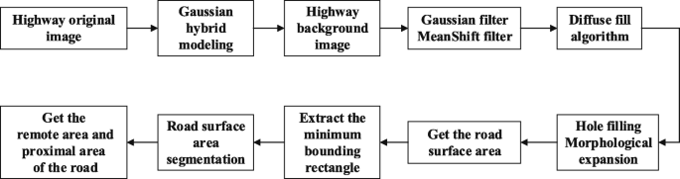

**Figure 2-9: Overall flow of road surface extraction**

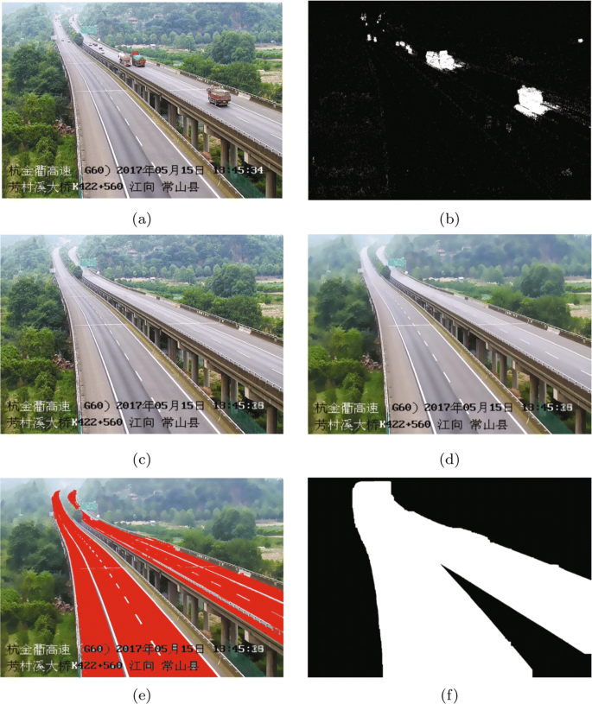As shown in the figure above (2-9), to eliminate the influence of vehicles on the road area segmentation, we used the Gaussian mixture modelling method to extract the background in the first 500 frames of the video. The value of the pixel in the image is Gaussian around a certain central value in a certain time range, and each pixel in each frame of the image is counted. If the pixel is far from the centre, the pixel belongs to the foreground. If the value of the pixel points deviates from the centre value within a certain variance, the pixel point is considered to belong to the background. The mixed Gaussian model is especially useful in images where background pixels have multi-peak characteristics such as the highway surveillance images used in this study.

**Figure 2-10: traffic road segmentation**

### 2.4.3 Vehicle detection using YOLOv3

This section describes the object detection methods used in this study. The implementation of the highway vehicle detection framework used the YOLOv3 network. The YOLOv3 algorithm continues the basic idea of the first two generations of YOLO algorithms. The convolutional neural network is used to extract the features of the input image. According to the size of the feature map, such as 13*13, the input image is divided into 13*13 grids. The center of the object label box is in a grid unit, and the grid unit is responsible for predicting the object. The network structure adopted by YOLOv3 is called Darknet-53. This structure adopts the full convolution method and replaces the previous version of the direct-connected convolutional neural network with the residual structure. The branch is used to directly connect the input to the deep layer of the network. Direct learning of residuals ensures the integrity of image feature information, simplifies the complexity of training, and improves the overall detection accuracy of the network. In YOLOv3, each grid unit will have three bounding boxes of different scales for one object. The candidate box that has the largest overlapping area with the annotated box will be the final prediction result. Additionally, the YOLOv3 network has three output scales, and the three scale branches are eventually merged. Shallow features are used to detect small objects, and deep features are used to detect large objects; the network can thus detect objects with scale changes. The detection speed is fast, and the detection accuracy is high. Traffic scenes taken by highway surveillance video have good adaptability to the YOLOv3 network. The network will finally output the coordinates, confidence, and category of the object.

When using YOLO detection, images are resized to the same size, such as 416*416, when they are sent to the network. Since the image is segmented, the size of the remote road surface becomes deformed and larger. Therefore, more feature points of a small vehicle object can be acquired to avoid the loss of some object features due to the vehicle object being too small. The dataset presented in “[Vehicle dataset](https://etrr.springeropen.com/articles/10.1186/s12544-019-0390-4#Sec5)” section is placed into the YOLOv3 network for training, and the vehicle object detection model is obtained. The vehicle object detection model can detect three types of vehicles: cars, buses, and trucks Because there are few motorcycles on the highway, they were not included in our detection. The remote area and proximal area of the road surface are sent to the network for detection. The detected vehicle box positions of the two areas are mapped back to the original image, and the correct object position is obtained in the original image. Using the vehicle object detection method for obtaining the category and location of the vehicle can provide necessary data for object tracking. The above information is sufficient for vehicle counting, and the vehicle detection method thus does not detect the specific characteristics of the vehicle or the condition of the vehicle.

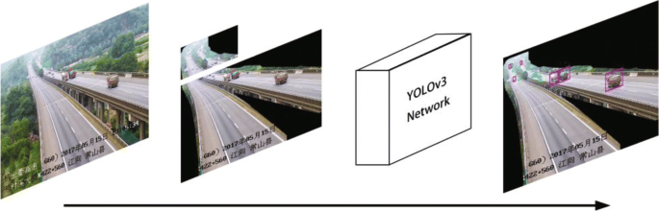

**Figure 2-10: using yolo3 to detect vehicles in traffic**

Now that we discussed detecting cars in traffic using two different methodologies lets raise the biggest question **How are we going to estimate the vehicle speed?** Here comes the use of **Optical Flow**

**2.5 OPTICAL FLOW**

Optical flow is the motion of objects between consecutive frames of sequence, caused by the relative movement between the object and camera.

**2.5.1 Sparse vs Dense Optical Flow**

Sparse optical flow gives the flow vectors of some "interesting features" (say few pixels depicting the edges or corners of an object) within the frame while Dense optical flow, which gives the flow vectors of the entire frame (all pixels) - up to one flow vector per pixel. As you would've guessed, Dense optical flow has higher accuracy at the cost of being slow/computationally expensive.

**2.5.2 Tracking specific objects**

There may be scenarios where you want to only track a specific object of interest (say tracking a certain person) or one category of objects (like all 2-wheeler-vehicles in traffic). You can easily modify the code to track the pixels of the object(s) you want by changing the previous variable.

You can also combine Object Detection with this method to only estimate the flow of pixels within the detected bounding boxes. This way you can track all objects of a particular type/category in the video.

**2.5.3 Lucas-Kanade: Sparse Optical Flow**

Lucas and Kanade proposed an effective technique to estimate the motion of interesting features by comparing two consecutive frames in their paper An Iterative Image Registration Technique with an Application to Stereo Vision. The Lucas-Kanade method works under the following assumptions: Two consecutive frames are separated by a small-time increment *(d****t****)* such that objects are not displaced significantly (in other words, the method work best with slow-moving objects). A frame portrays a “natural” scene with textured objects exhibiting shades of gray that change smoothly.

First, under these assumptions, we can take a small 3x3 window (neighborhood) around the features detected by Shi-Tomasi and assume that all nine points have the same motion.

**figure 2-11: Lucas-kanade**

Chapter There

# mathematical MODEL

# 3.1 project model

Our project structure consists of 5 main phases (video acquisitions, Region of interest and masking, Contour Detection and object detection, speed estimation, save vehicle data)

# Diagram Description automatically generatedFigure 3-1: project model

# 3.1.1 video acquisition

The video used in this project is a street view in Abu Dhabi. We have chosen this video because it has a big road with good amount of cars passing by that are not overlapping on each other. The number plates of the vehicle in the video are however not clearly visible.

# 3.1.2 region of interest and masking

Region of Interest (ROI) takes a smaller portion of the original video. On this ROI, Image subtraction is performed to detect a moving vehicle. (Image Subtraction helps find the difference between two frames). Masking is performed to make the moving vehicles appear white and the rest of the image black.

**Figure 3-2: ROI**

**3.1.3 Contour Detection and Object Tracking**

We’ve tried first using YOLOv3 to detect object but **the problem with using YOLO** When we attempted to use different versions of YOLO, we found it requires a lot of GPU and CPU usage which is not suitable for out project that should be able to run on a low cost and not require too many resources.

**Figure 3-3: Car detection using YOLO**

Based on the area threshold of number of pixels, the contours are detected. The threshold is used to avoid detecting contours of smaller moving objects that are not vehicles. The object is tracked based on the distance between two contours between frames. An ID is assigned to each contour.

**Figure 3-4: object tracking**

**3.1.4 Speed Estimation**

Time difference between the position of a vehicle is calculated and the speed is estimated based on a formula. The timer starts when the vehicle crosses the first line, and the timer ends when the vehicle crosses the second line. The speed is displayed on top of the bounding box only when the vehicle crosses both the lines.

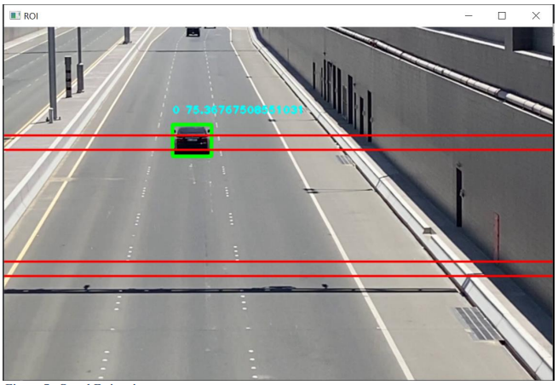

**Figure 3-5: car speed estimation**

**3.1.5 Save Vehicle Data**

The picture of the bounding box (the vehicle) is saved into a file along with the speed. Vehicles crossing the speed limit is segregated into a separate folder.

**Figure 3-6: detected vehicles data folder**

# 3.2 Implementation

**3.2.1 loading the video**

We use the VideoCapture method from OpenCV library to read from a video with mp4 format.

cap = cv2.VideoCapture("resources/traffic4.mp4")

**3.2.2 background segmentation and defining kernels**

Then we want to create our threshold background subtractor by creating a new background subtractor object also from the OpenCV python library.

object_detector = cv2.createBackgroundSubtractorMOG2(history=None,varThreshold=None)

#KERNELS

kernalOp = np.ones((3,3),np.uint8)

kernalOp2 = np.ones((5,5),np.uint8)

kernalCl = np.ones((11,11),np.uint8)

fgbg=cv2.createBackgroundSubtractorMOG2(detectShadows=True)

kernal_e = np.ones((5,5),np.uint8)

**3.2.3**

Chapter Four

# RESULTS AND DISCUSSION

Chapter Five

# conclusion

# References

## References Format

Sample correct formats for various types of references are as follows.

***Books:***

1. G. O. Young, “Synthetic structure of industrial plastics,” in *Plastics*, 2nd ed., vol. 3, J. Peters, Ed. New York: McGraw-Hill, 1964, pp. 15–64.
2. W.-K. Chen, *Linear Networks and Systems*. Belmont, CA: Wadsworth, 1993, pp. 123–135.

***Periodicals:***

1. J. U. Duncombe, “Infrared navigation—Part I: An assess­ment of feasibility,” *IEEE Trans. Electron Devices*, vol. ED-11, pp. 34–39, Jan. 1959.
2. E. P. Wigner, “Theory of travelling-wave optical laser,” *Phys. Rev.*, vol. 134, pp. A635–A646, Dec. 1965.
3. E. H. Miller, “A note on reflector arrays,” *IEEE Trans. Antennas Propagat.*, tobe published.

***Articles from Conference Proceedings (published):***

1. D. B. Payne and J. R. Stern, “Wavelength-switched pas­sively coupled single-mode optical network,” in *Proc. IOOC-ECOC*, 1985, pp. 585–590.

***Papers Presented at Conferences (unpublished):***

1. D. Ebehard and E. Voges, “Digital single sideband detec­tion for interferometric sensors,” presented at the 2nd Int. Conf. Optical Fibre Sensors, Stuttgart, Germany, 1984.

***Standards:***

1. G. Brandli and M. Dick, “Alternating current fed power supply,” U.S. Patent 4 084 217, Nov. 4, 1978.

***Technical Reports:***

1. E. E. Reber, R. L. Mitchell, and C. J. Carter, “Oxygen absorption in the Earth’s atmosphere,” Aerospace Corp., Los Angeles, CA, Tech. Rep. TR-0200 (4230-46)-3, Nov. 1968.

## References to Electronic Sources

***Books:***

1. J. Jones. (1991, May 10). *Networks*. (2nd ed.) [Online]. Available: [http://www.atm.com](http://www.atm.com/)

***Journals:***

1. R. J. Vidmar. (1992, Aug.). On the use of atmospheric plasmas as electromagnetic reﬂectors. *IEEE Trans. Plasma Sci.* [Online]. *21(3)*, pp. 876–880. Available: <http://www.halcyon.com/pub/journals/21ps03-vidmar>

***Papers Presented at Conferences:***

1. PROCESS Corp., MA. Intranets: Internet technologies deployed behind the firewall for corporate productivity. Presented at INET96 Annu. Meeting. [Online]. Available: <http://home.process.com/Intranets/wp2.htp>

***Computer Programs and Electronic Documents:***

1. A. Harriman. (1993, June). Compendium of genealog­ical software. *Humanist*. [Online]. Available e-mail: HUMANIST@NYVM Message: get GENEALOGY REPORT

# Appendices