Login and Generate Token

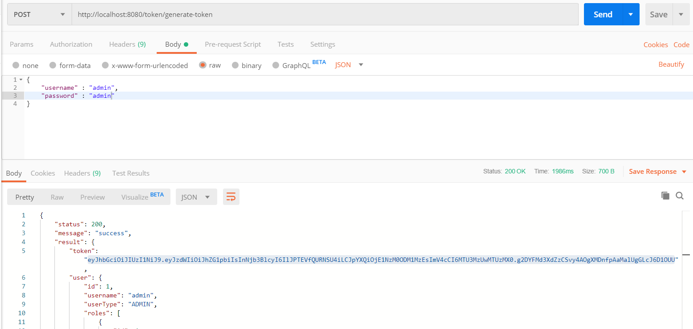

API Call

Set Headers > Authorization > Bearer <generated token>

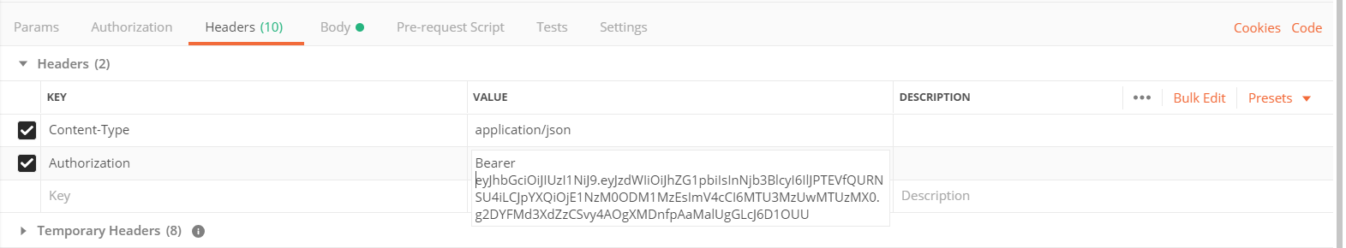

Project Plan

Name: Project 1

Save

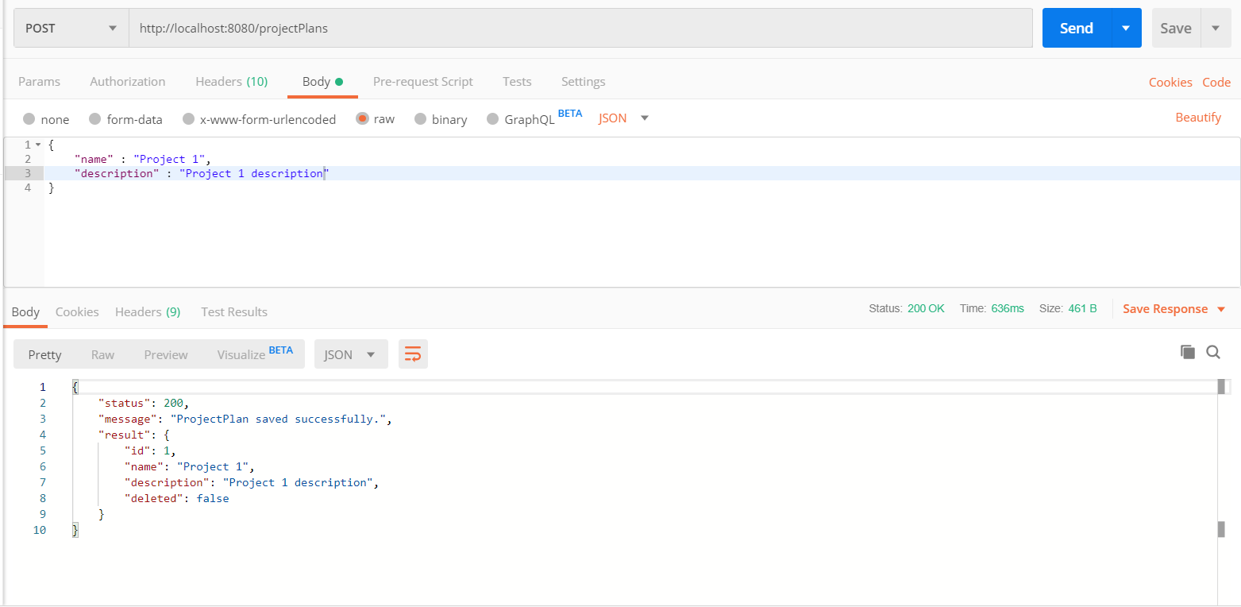

Update

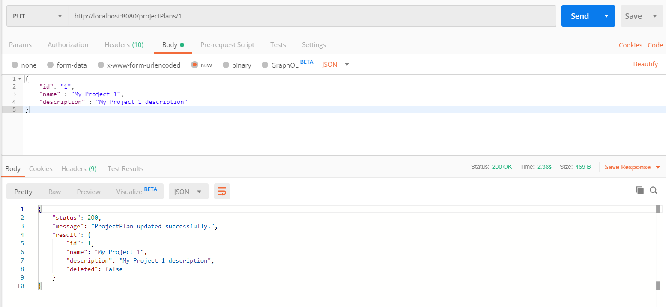

List

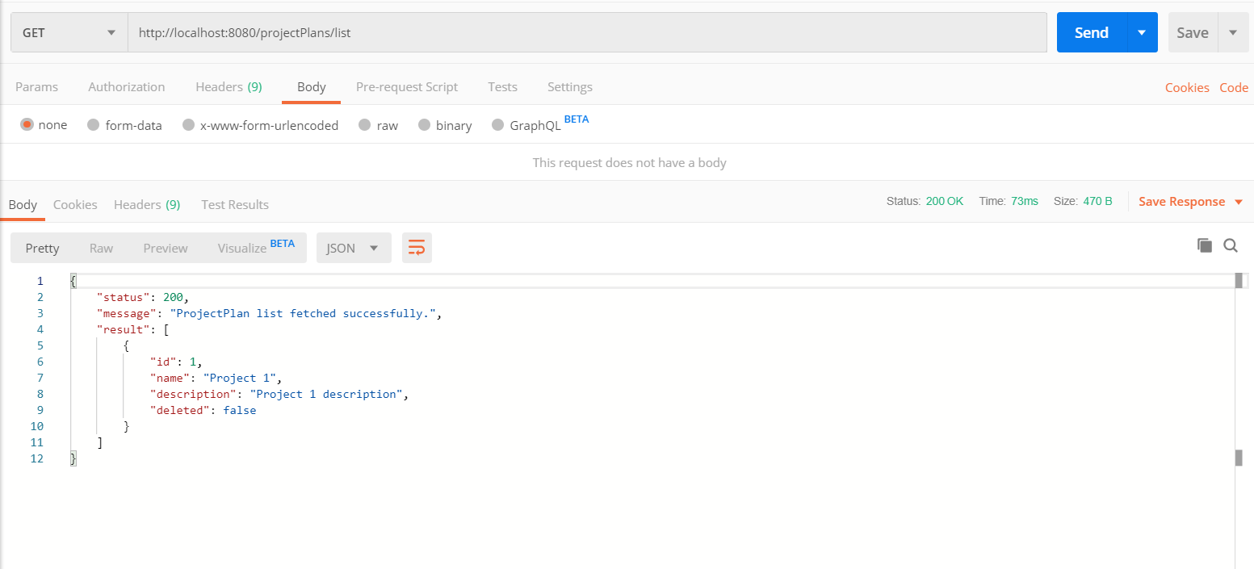

Task

Save Task 1 (no dependency)

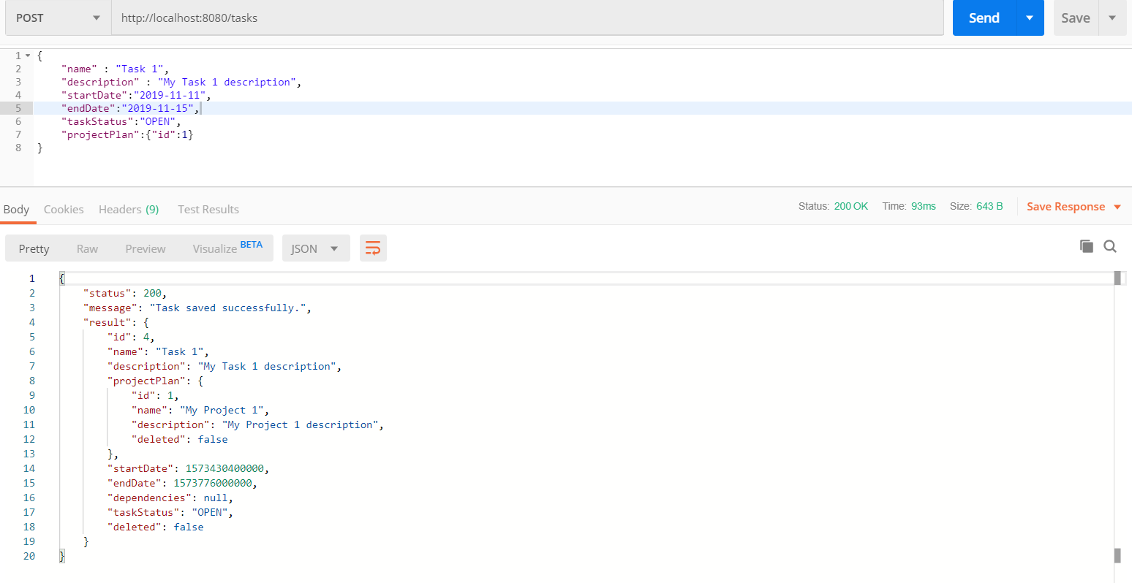

Update Task 1 (no dependency)

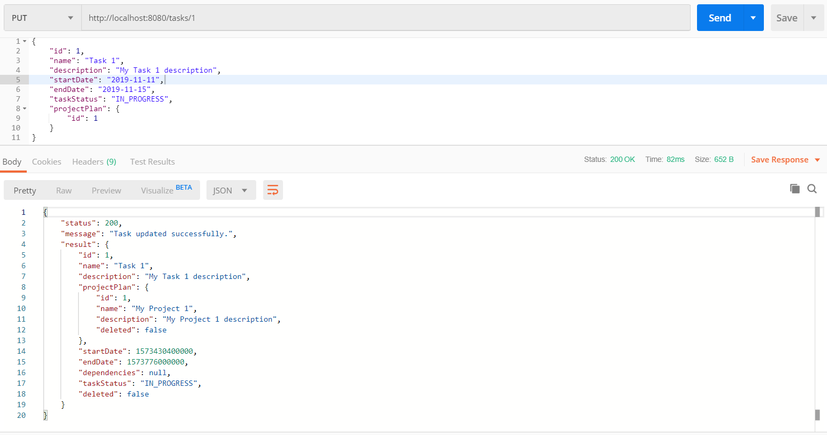

Save Task 2 (no dependency)

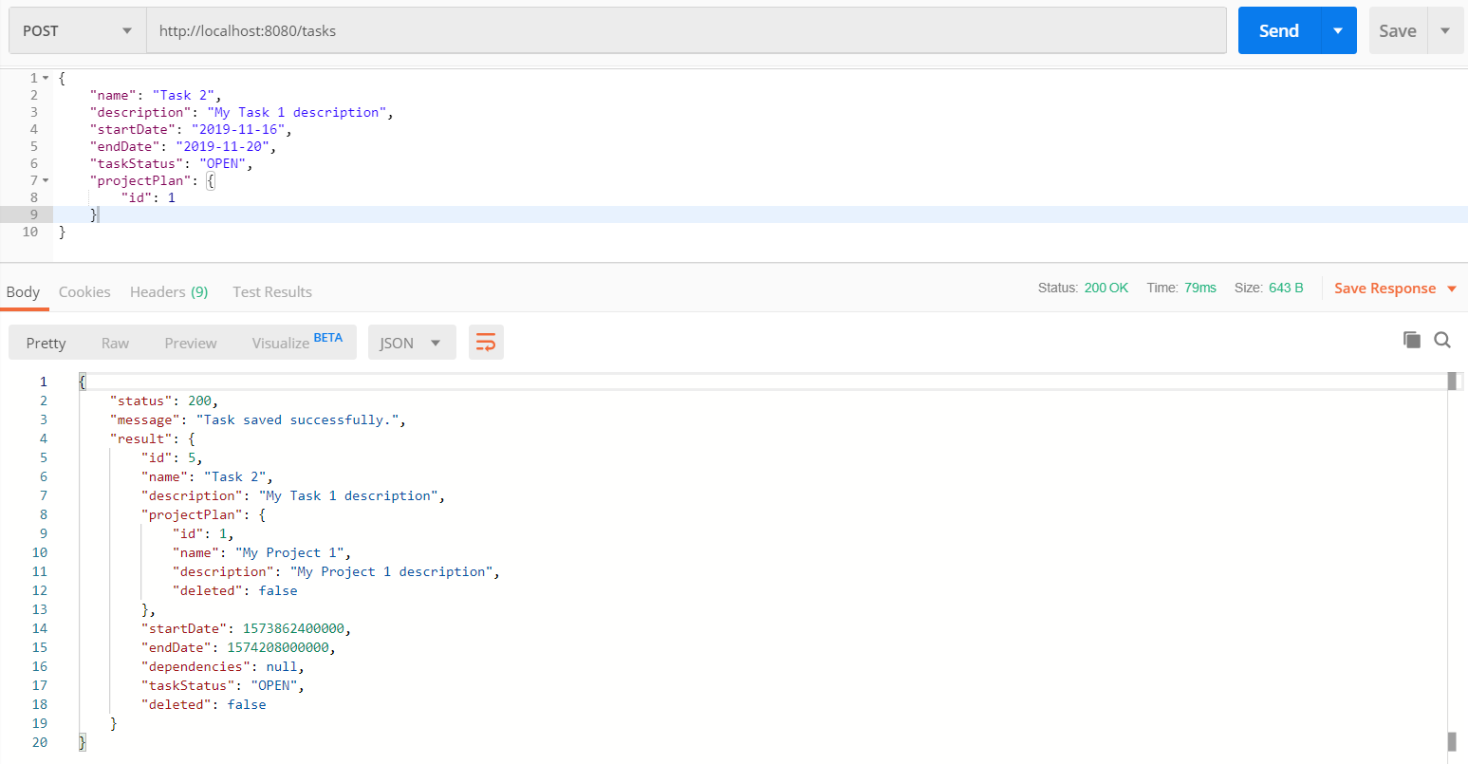

Update

Task 2

Status : OPEN

Dependency :

Task 1

Status : IN_PROGRESS

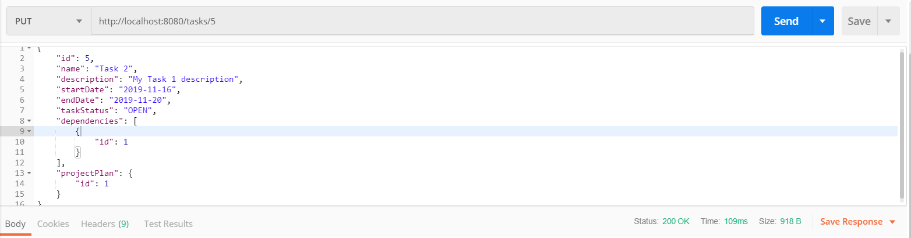

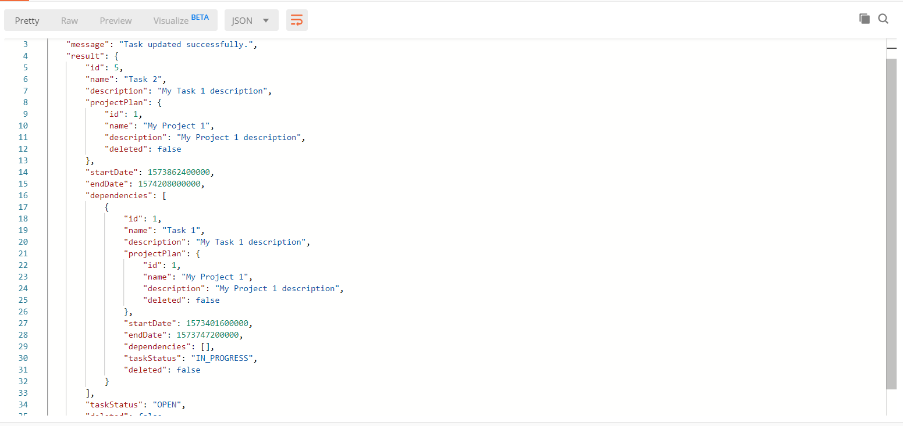

Update

Task 2

Status : IN_PROGRESS

Dependency :

Task 1

Status : IN_PROGRESS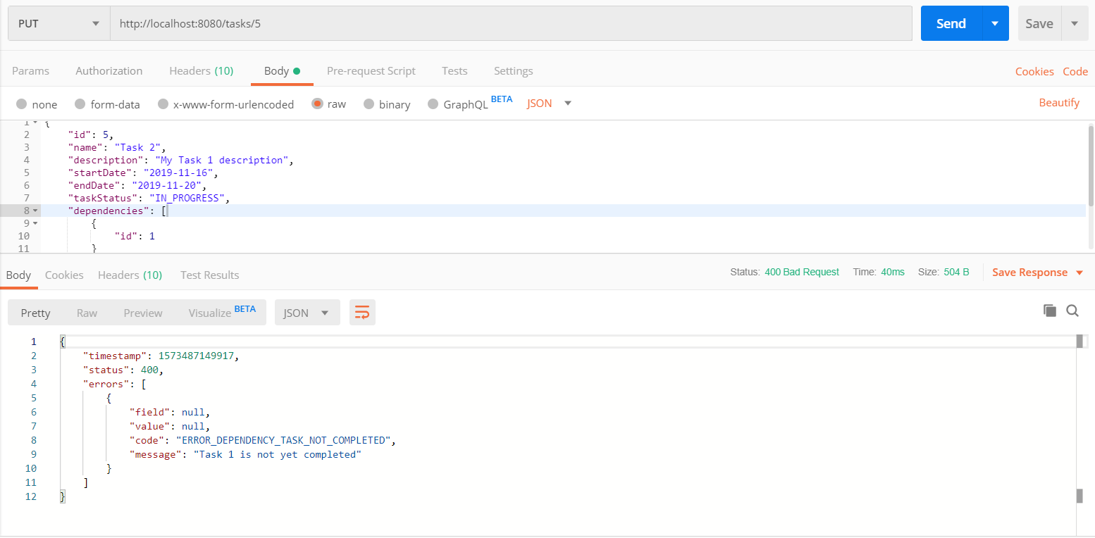

Update Task 1

Status:COMPLETED

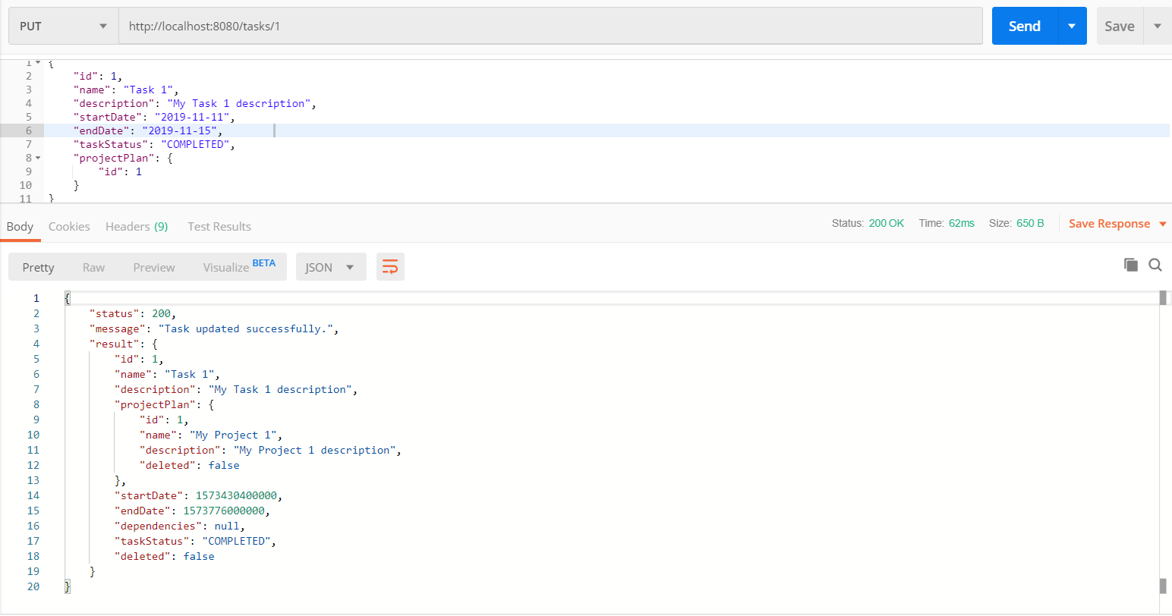

Update

Task 2

Status : IN_PROGRESS

Dependency :

Task 1

Status : COMPLETED

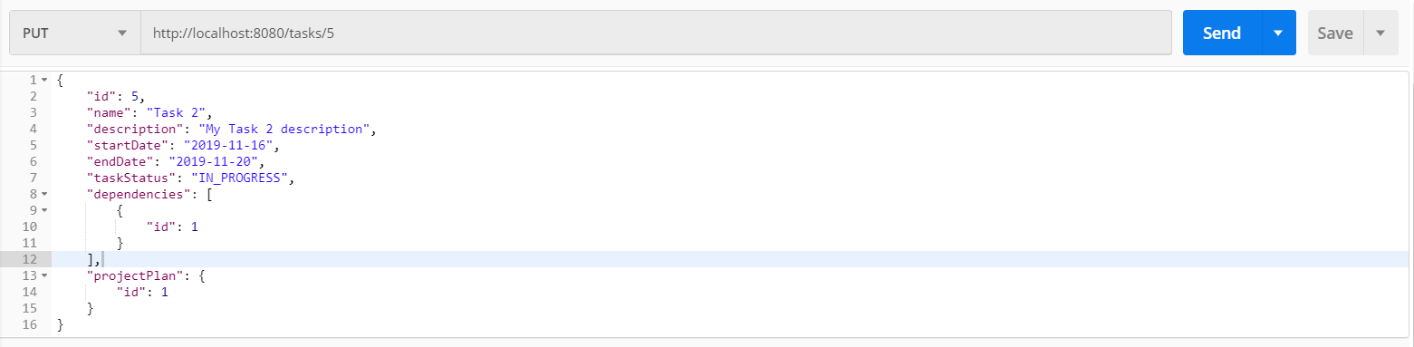

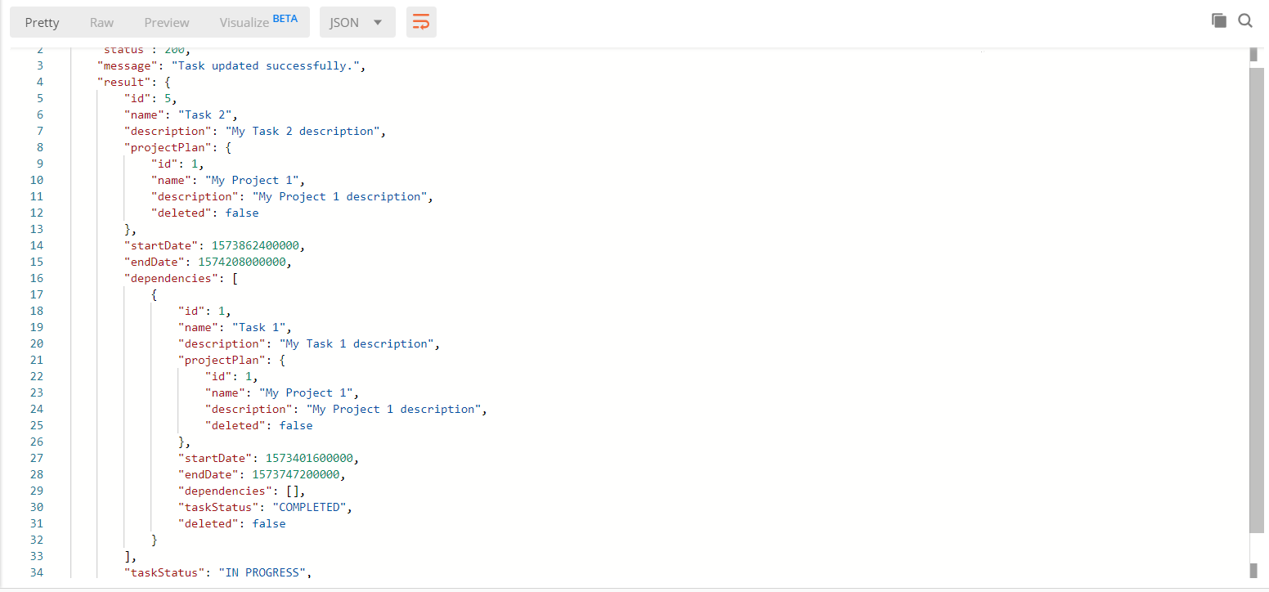

Create/Update Task 3

Status:IN_PROGRESS

Dependencies :

Task 1

Status:COMPLETED

Task 2

Status:COMPLETED

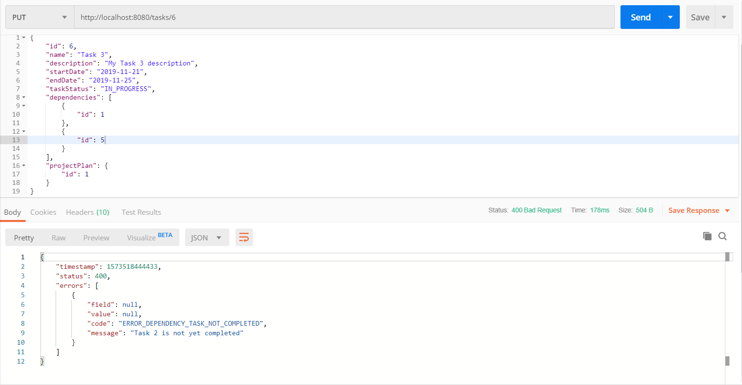

Update Task 3

Status:IN_PROGRESS

Dependencies :

Task 1

Status:COMPLETED

Task 2

Status:COMPLETED

