Michael Young (myoung10)

**XSS 1**

*Private Snippet* in *Profile*

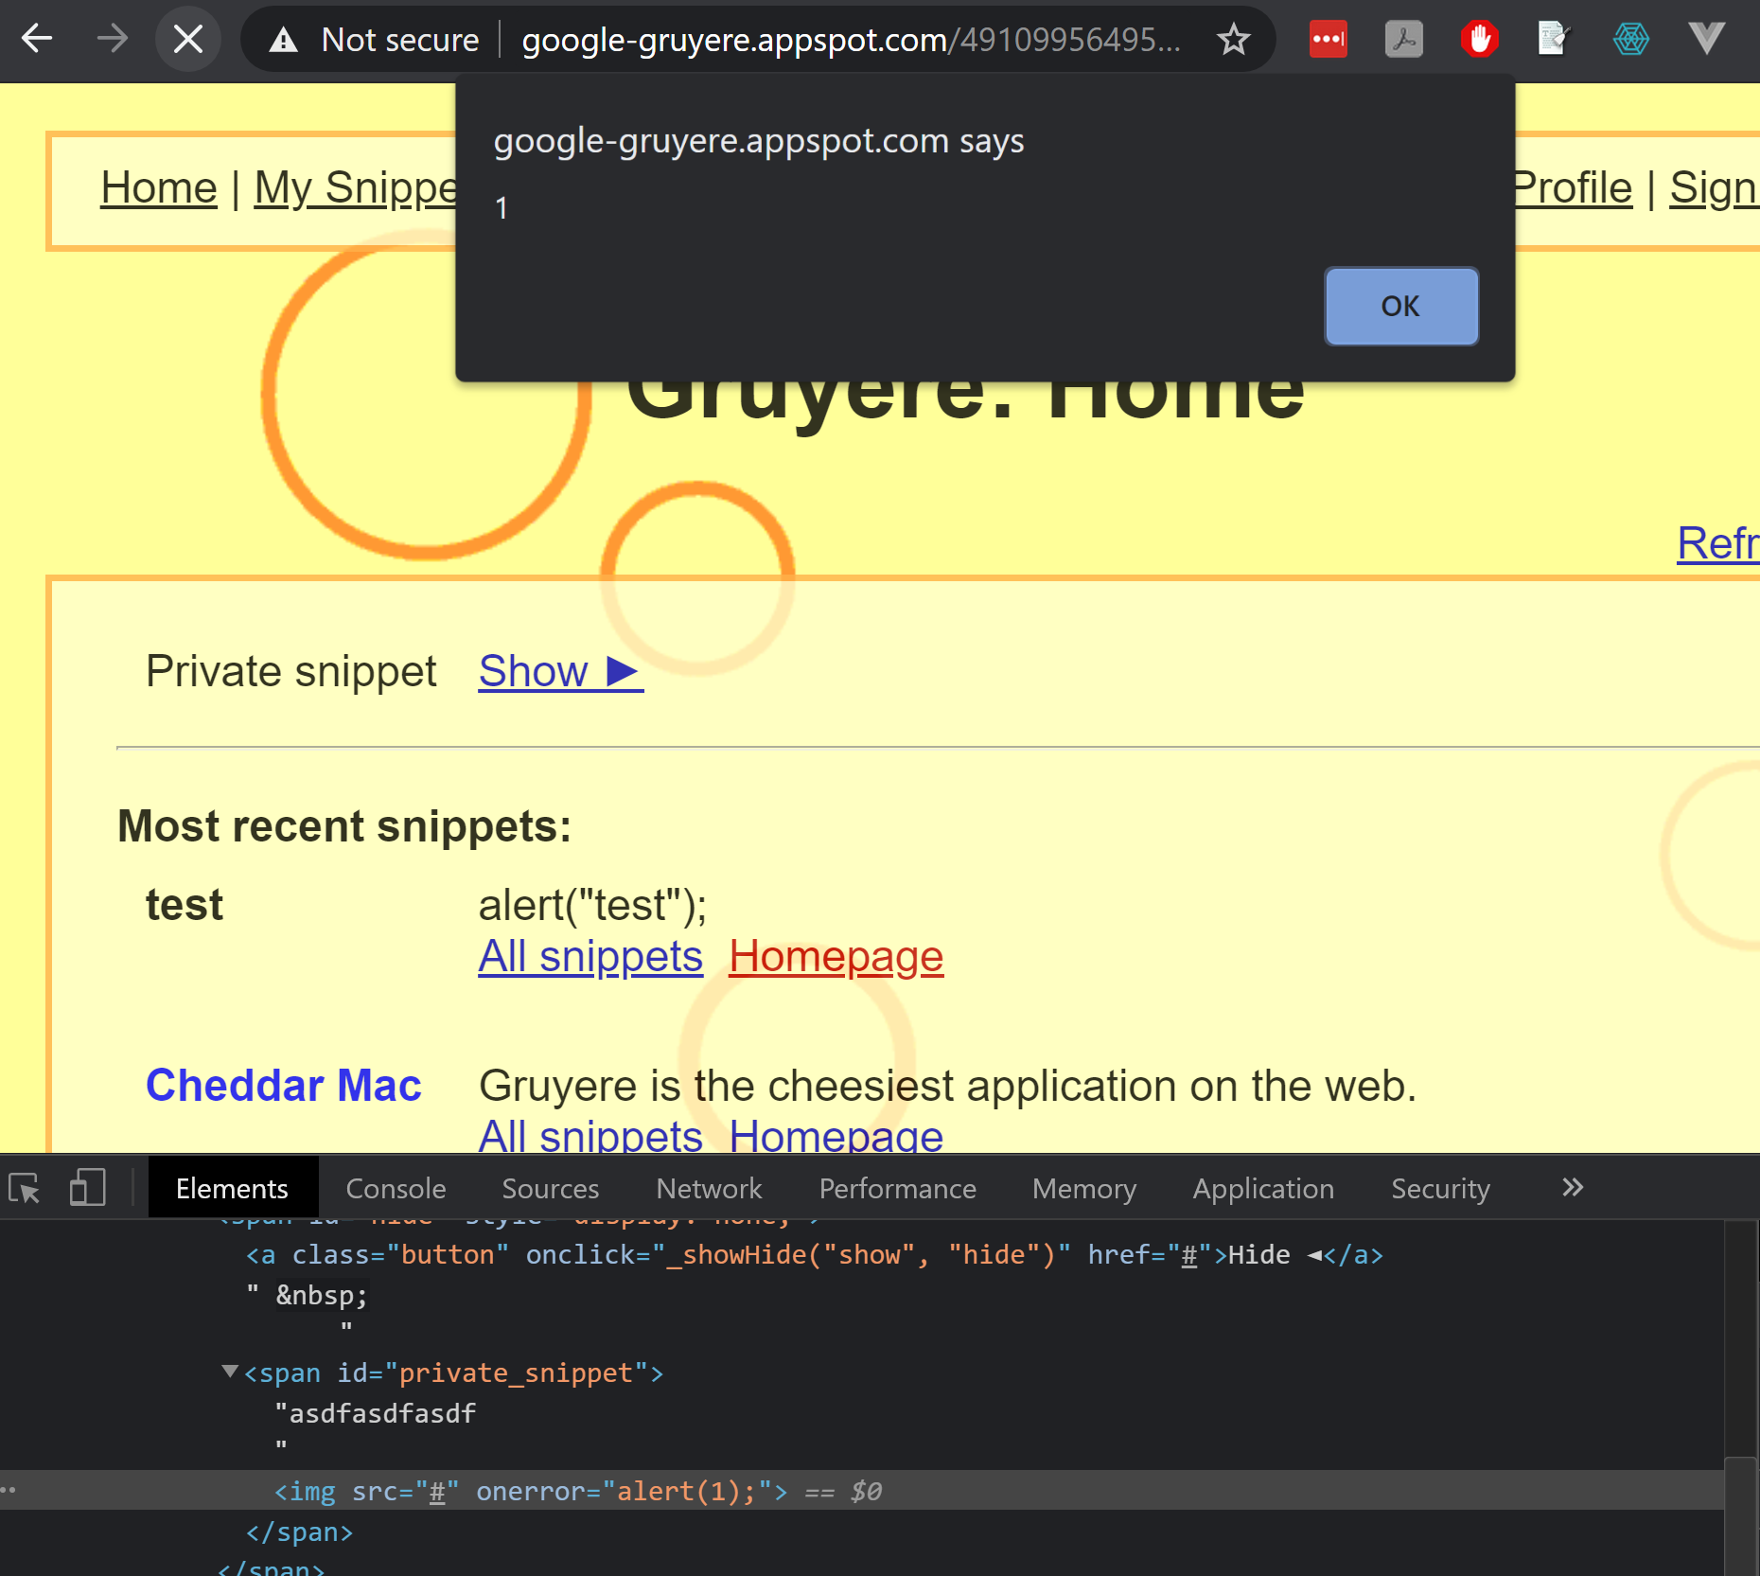

**XSS 2**

New Snippet

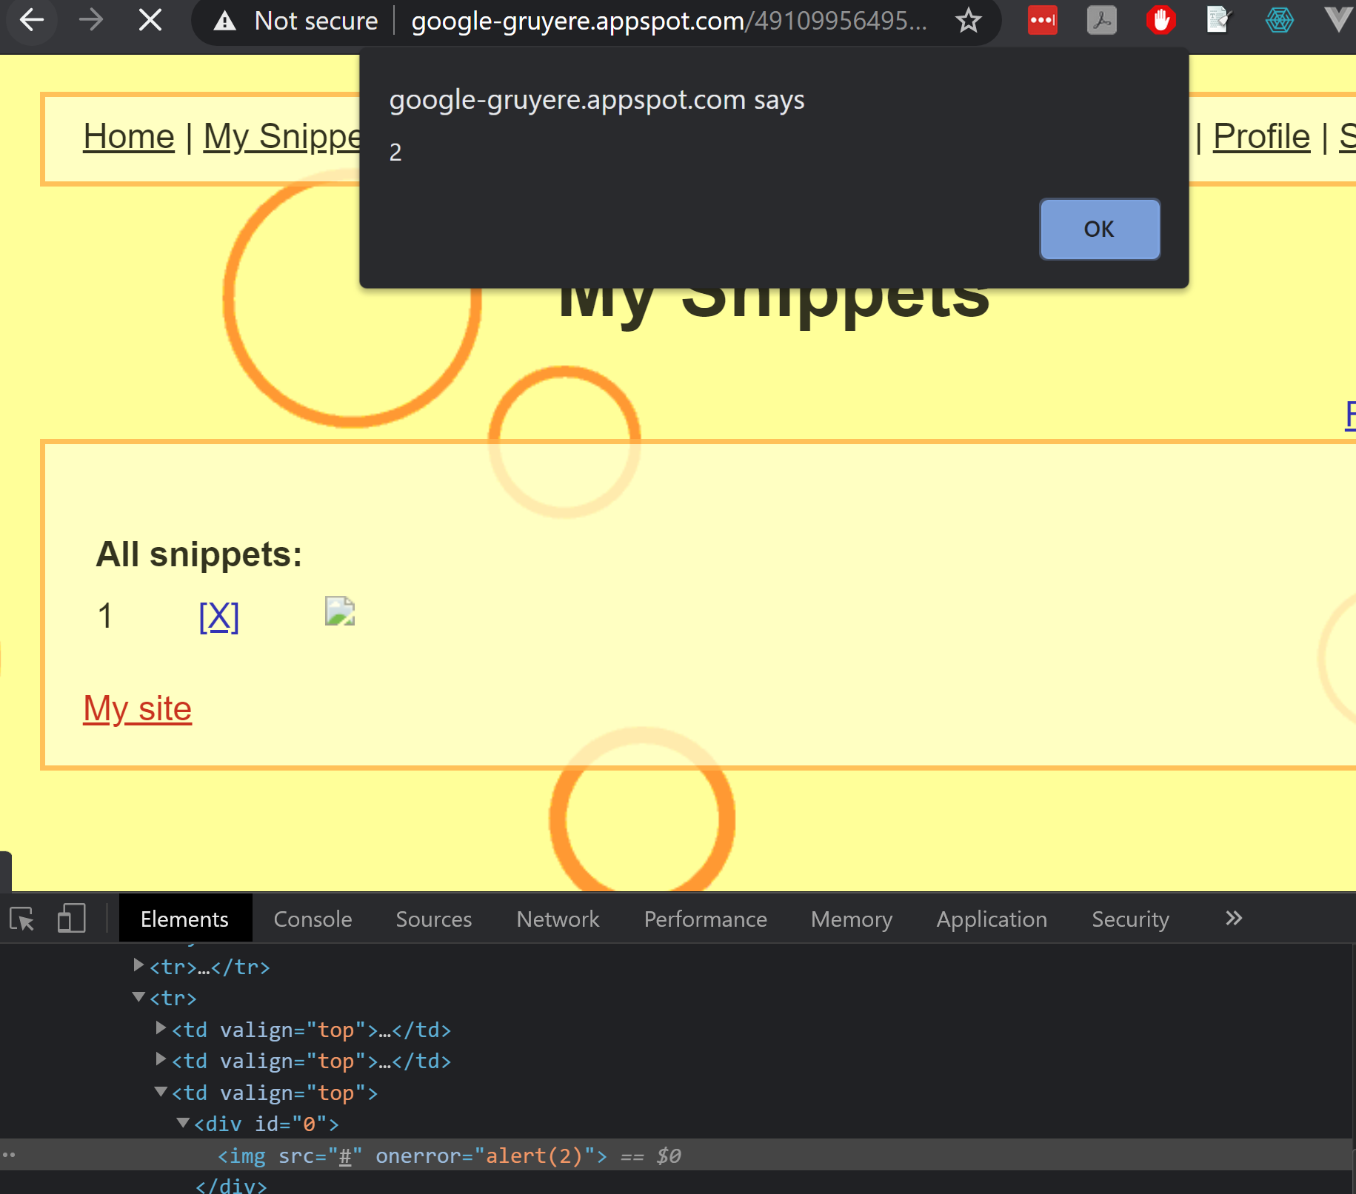

**XSS 3**

Modifying query string that pulls a username and displays it

