Name: Michael Young (myoung10)

Assignment 3-1 Ethical Hacking (Advanced)

4) **take a screenshot of what folders are available and turn in the screenshot**  
note mentally that the "etc" folder is not available

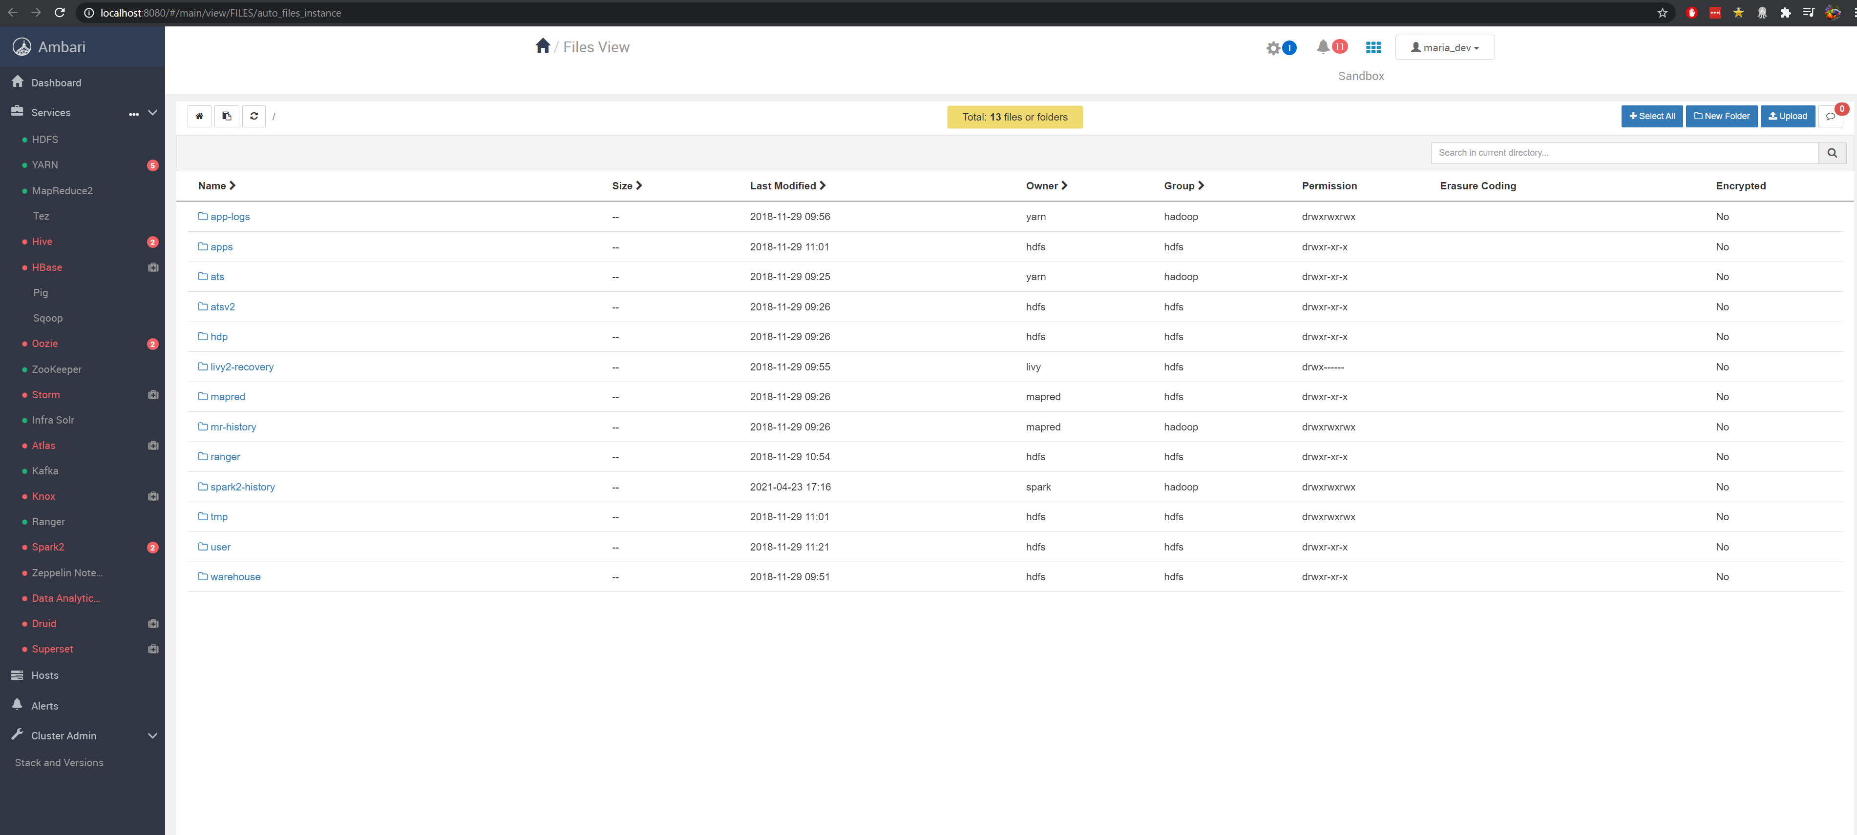

**take a screenshot of the result returned to you, turn in this screenshot. Congratulations you just stole the**[**password file (Links to an external site.)**](https://access.redhat.com/documentation/en-US/Red_Hat_Enterprise_Linux/4/html/Introduction_To_System_Administration/s2-acctsgrps-files.html)**from the machine.**

***Note: I had to change the table format, because the suggested way was not ingesting the data properly.***

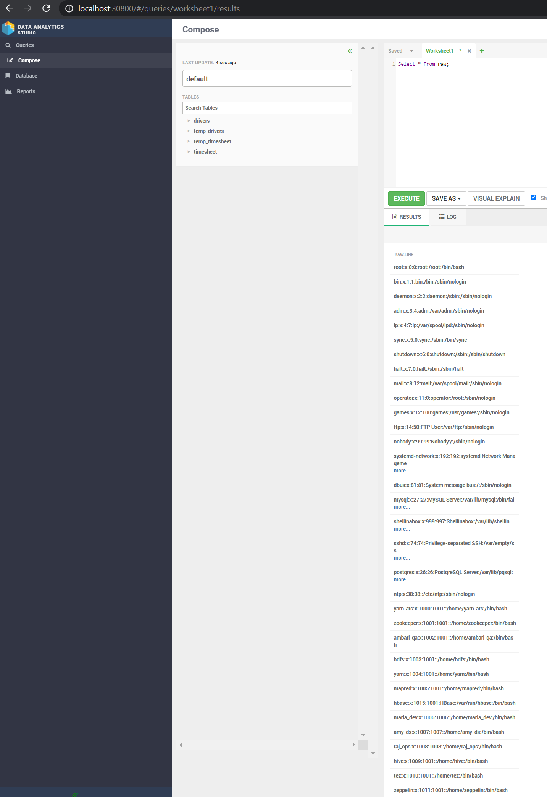

**8) the final step is to repeat steps 6 & 7 but for a different file of your choosing. Choose a file which through the HDFS view you are not normally able to see.**

Here I selected to view the /etc/php.ini file which provides the configuration details for PHP.

