Client Intake
1.
Our intended client is the Ghana Stock Exchange. We communicate with their Head of IT, Mr. Eric Edifor.
Email: eedifor@gse.com.gh

2.
1. Investors Do Not Know the Method of Engagement with the GSE
Many first-time investors lack access to simple, Ghana-specific resources explaining how the GSE works, what stocks are, and how returns are generated. As a result, potential investors struggle to evaluate opportunities and often keep their savings in lower-yield investments. A software solution can address this through an Education Hub containing beginner-friendly lessons, a GSE glossary, and company profiles integrated into the investment journey.
2. No Safe Practice Environment
Current GSE investment channels require real money from the start, with no simulation platform for beginners. Fear of financial loss, reinforced by experiences such as the 2017–2019 banking crisis, discourages participation. A Paper Trading Simulator using live GSE prices would allow users to practise investing without risk and build confidence.
3. Opaque Transaction Costs
Brokerage fees, SEC levies, and taxes are often not clearly visible before a trade is made. This reduces transparency and can make small investments less attractive. A Pre-Trade Cost Calculator can display all charges upfront, helping investors make informed decisions.
4. Limited Access to Brokerage Services
Many potential investors do not know how to find, contact, or begin investing through licensed brokers. The onboarding process is often perceived as complex, requiring multiple steps, paperwork, and direct interaction with brokerage firms. This lack of accessibility discourages new and digitally oriented investors from participating in the stock market. A software platform can simplify the process by integrating broker services, digital KYC using the Ghana Card, and Mobile Money funding into a single user-friendly interface.

3
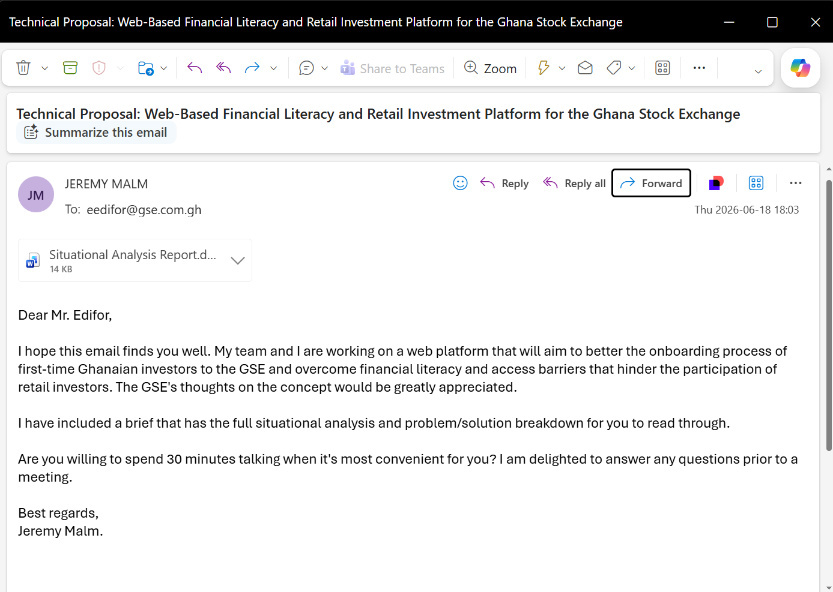
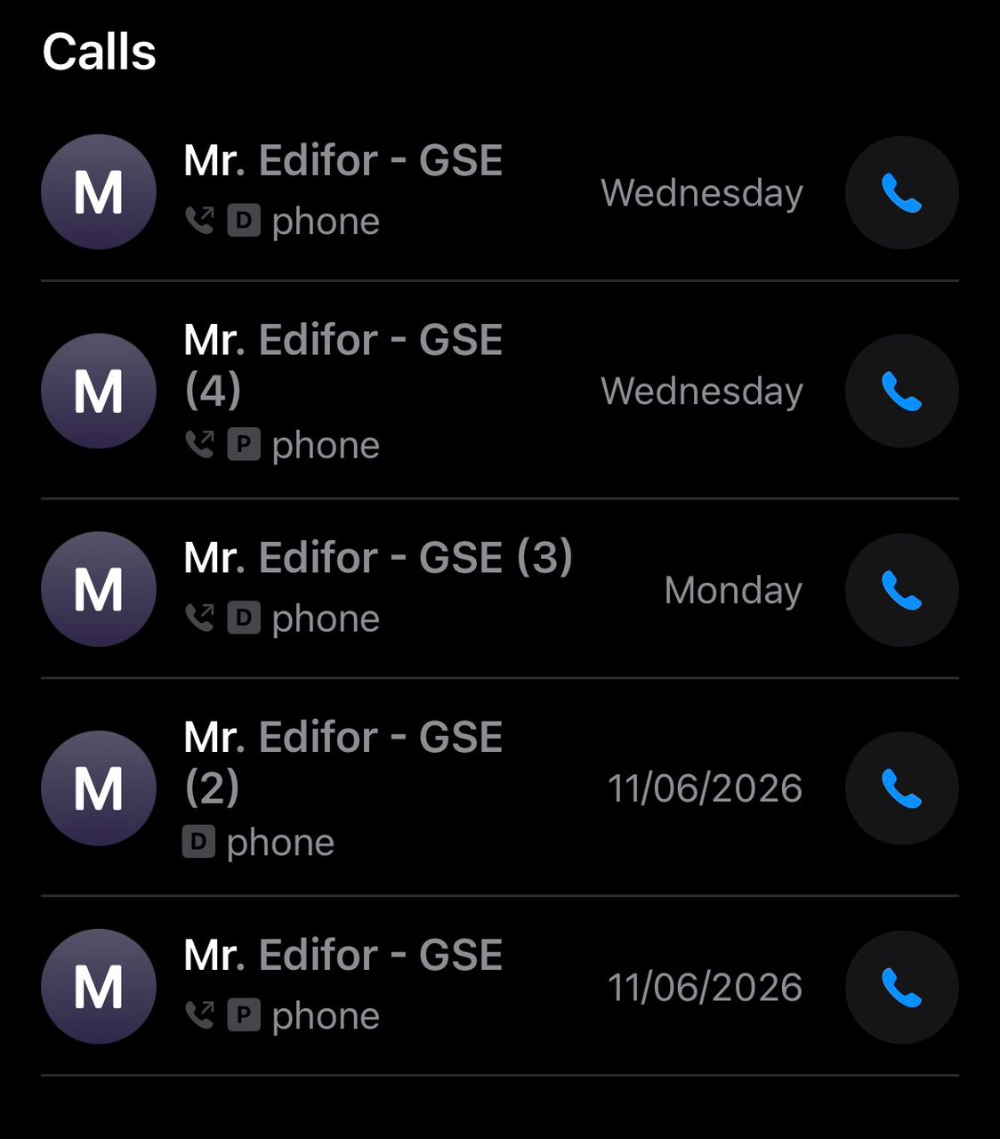
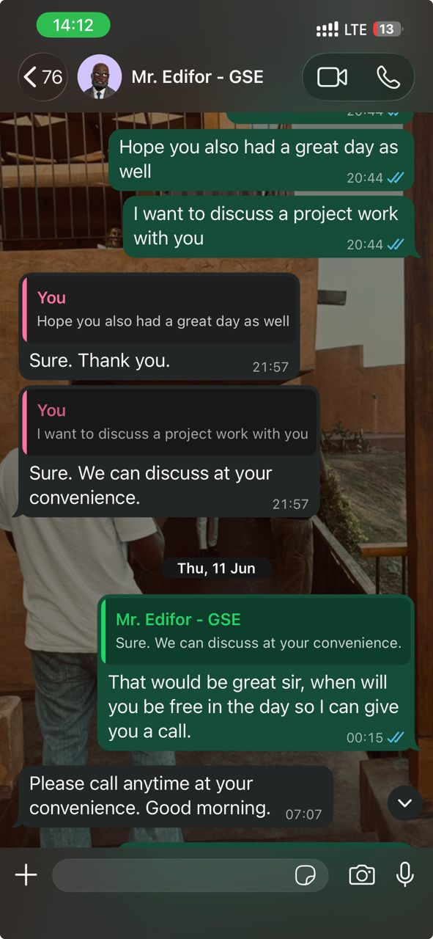

4
The possible users for the web app are students, first time investors, brokers and seasoned investors.
5
If the client fails to meet a deadline, the project team should:
- Identify the critical deliverables needed to keep the project moving.
- A reasonable grace period can be provided while clearly communicating the impact of the delay on the project schedule.
- The team should continue working on tasks that do not depend on the client's input and, where appropriate, proceed based on documented assumptions.
- Project timelines and milestones should be updated to reflect the delay and shared with all team members.

