UNIVERSITY OF GHANA.
DCIT 208: SOFTWARE ENGINEERING
WEEK 3 DELIVERABLE

TEAM CHARTER.
Prepared by: [CodeNova]
Submitted to: Mark Atta Mensah.
Date: June 18, 2026

SECTION A: TEAM IDENTITY.
1. Team Information
Team Name:
[CodeNova]
Project Title:
[SmartOps System]
Tagline:
[A new explosion of innovative software ideas]
Primary Team Contact:
- Name: Terrence Aseda Ogo.
- Phone Number: +233 50 030 6530
- Email Address: taogo@st.ug.edu.gh
Deputy Team Contact:
- Name: Jeremy Malm.
- Phone Number: +233 50 856 1509
- Email Address: jmalm003@st.ug.edu.gh

1.1. Team Members.
Member 1.
- Full Name: Terrence Aseda Ogo
- Student ID: 22330566
- Email address: taogo@st.ug.edu.gh
- Phone Number: +233 50 030 6530
- GitHub Username: ter1rry
Professional Biography.
Terrence Aseda Ogo is a Level 200 Computer Science student at the University of Ghana with a strong interest in software development, problem-solving, and technology-driven innovation. He is currently studying Software Engineering and actively participates in team-based projects that apply software development principles to real-world challenges. Terrence is committed to continuous learning and enjoys developing his skills in programming, system analysis, and project management. He values teamwork, effective communication, and professionalism in achieving project goals. As Project Manager for his software engineering project team, he aims to coordinate efforts efficiently and ensure the successful delivery of quality solutions.

Member 2.
- Full Name: Jeremy Malm
- Student ID: 22310005
- Email Address: jmalm003@st.ug.edu.gh
- Phone Number: +233 50 856 1509
- GitHub Username: Jerryzmm1
Professional Biography:
Jeremy Malm is a Computer Science student at the University of Ghana with a growing expertise in software development and artificial intelligence. He has earned two IBM certifications in AI Literacy and AI Fundamentals, demonstrating a strong commitment to staying at the forefront of emerging technologies. Jeremy has applied his skills through hands-on Django projects, including a chat web application and a weather web app, showcasing his ability to build functional, real-world solutions. Passionate about technology and innovation, he continues to expand his technical capabilities with the goal of making a meaningful impact on the global tech industry.

Member 3.
- Full Name: Nathan Jojo Timothy Mensah.
- Student ID: 22385716
- Email Address: ntjmensah@st.ug.edu.gh
- Phone Number: +233 59 155 8868
- GitHub Username: NathanJMensah
Professional Biography:
Mensah Nathan Jojo Timothy is a 2nd Year Computer Science and Software Engineering Student, who has a good mastery of the Python programming language, and has a passion for producing practical and applicable real-world applications. His technical portfolio features a fully functional college management portal, an Uber Eats clone, and a fully functional e-commerce platform, showcasing his expertise in designing and developing end-to-end software solutions. Nathan's desire to continually learn and grow and his overall objective is to become a proficient software engineer. He continues to believe in and work towards the use of technology for meaningful and impactful solutions in different areas.

Member 4.
- Full Name: Kimathi Christian Osafo
- Student ID: 22308781
- Email Address: kcosafo@st.ug.edu.gh
- Phone Number: +233 55 756 2501
- GitHub Username: kimathiosafo
Professional Biography.
Kimathi Osafo is a Computer Science student at the University of Ghana with a strong passion for mathematics, technology, and problem-solving. He is currently developing expertise in computer systems, hardware fundamentals, circuit design, and digital logic. Known for his analytical mindset and dedication to learning, Kimathi enjoys applying mathematical concepts to real-world computing challenges. Beyond academics, he is an enthusiastic football fan who values teamwork, discipline, and continuous improvement. With aspirations of becoming a data analyst and pilot, he combines technical knowledge, determination, and curiosity to pursue excellence in aviation and technology, preparing for a successful and impactful career.

Member 5.
- Full Name: Prince Mashood Mahama Sugri
- Student ID: 22359192
- Email Address: psmmashood@st.ug.edu.gh
- Phone Number: +233 54 790 7968
- GitHub Username: Sugri007
Professional Biography.
My name is Prince Mashood Mahama Sugri, and I am a Computer Science student at the University of Ghana, Legon. I have a genuine passion for technology and a strong drive to excel in everything I do. I take my academics seriously and put in the work consistently, whether it is understanding complex concepts or completing challenging coursework. My studies have built a solid foundation in both the theory and practical side of computing. I am hardworking, dependable, and deeply committed to my personal and professional development. My goal is to become a well-rounded technology professional who creates meaningful solutions and makes a real impact.

Member 6.
- Full Name: Bilal El Masri El Chaarani
- Student ID: 22369794
- Email Address: bel_masri_el-chaarani@st.ug.edu.gh
- Phone Number: +233 55 054 5831
- GitHub Username: bilalch8
Professional Biography.
I am Bilal El Masri El Chaarani, a Computer Science student at the University of Ghana, Legon, with a genuine interest in how technology solves everyday problems. I am currently developing my understanding of software development, algorithms, and systems thinking, and I take my academic work seriously. I am detail-oriented and committed to producing work I can stand behind, whether independently or as part of a team. I am exploring a future in software engineering and hope to build useful, well-made products that create real impact. I am eager to learn, open to feedback, and ready to grow professionally.

Member 7.
- Full Name: Lord Dziedzom Yao Fianu
- Student ID: 22374358
- Email Address: ldyfianu@st.ug.edu.gh
- Phone Number: +233 25 693 1807
- GitHub Username: LordFianu
Professional Biography.
Lord Dziedzom Yao Fianu is a Computer Science student at University of Ghana with a strong interest in artificial intelligence and software development. He specializes in backend development using Python, with experience in Django Rest Framework and FastAPI.
He has developed scalable APIs and backend systems through academic projects, demonstrating strong problem-solving and system design skills. His technical strengths include building efficient, secure, and maintainable web services.
Aspiring to become an AI engineer, lord Dziedzom Yao Fianu is committed to continuous learning and applying intelligent solutions to real-world problems. He is known for his dedication, adaptability, and passion for innovation in technology.

1.2. Team Meeting Evidence.
First Zoom Meeting Screenshot.
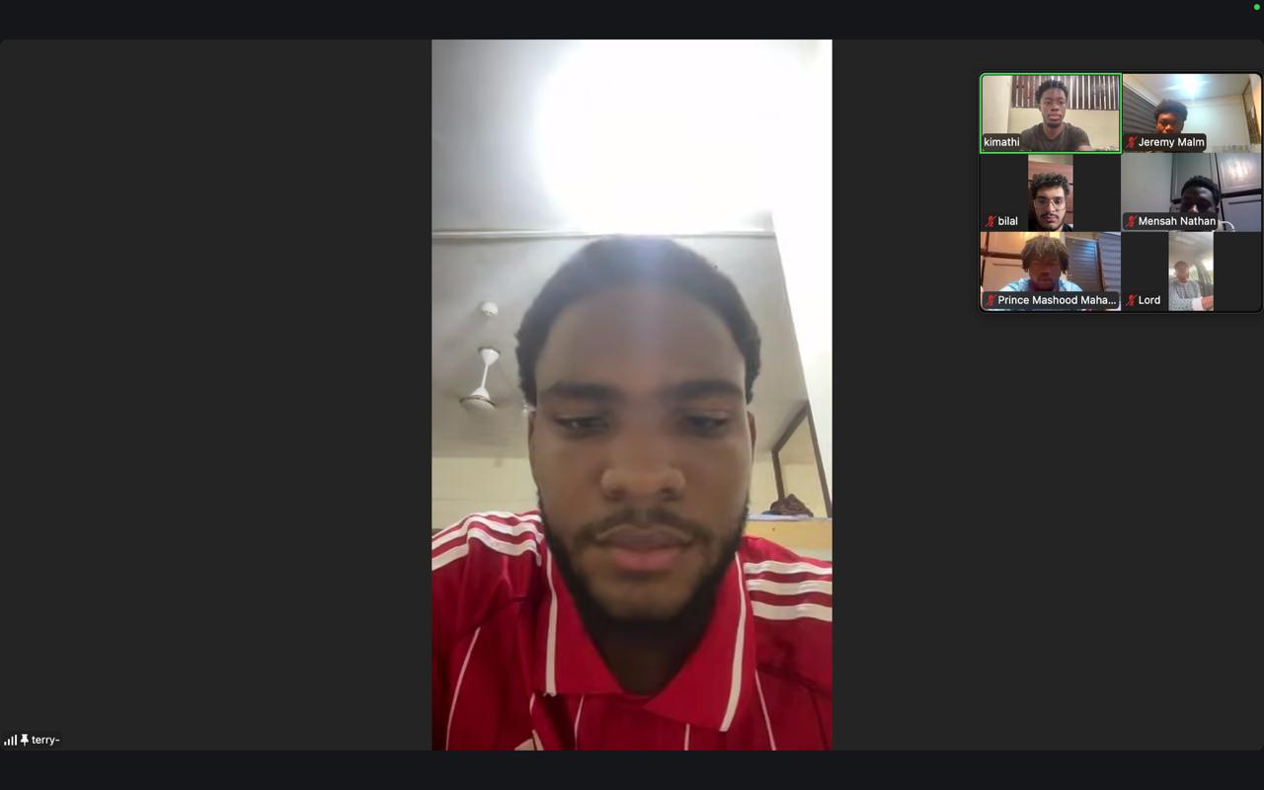

First Team Meeting Photo.
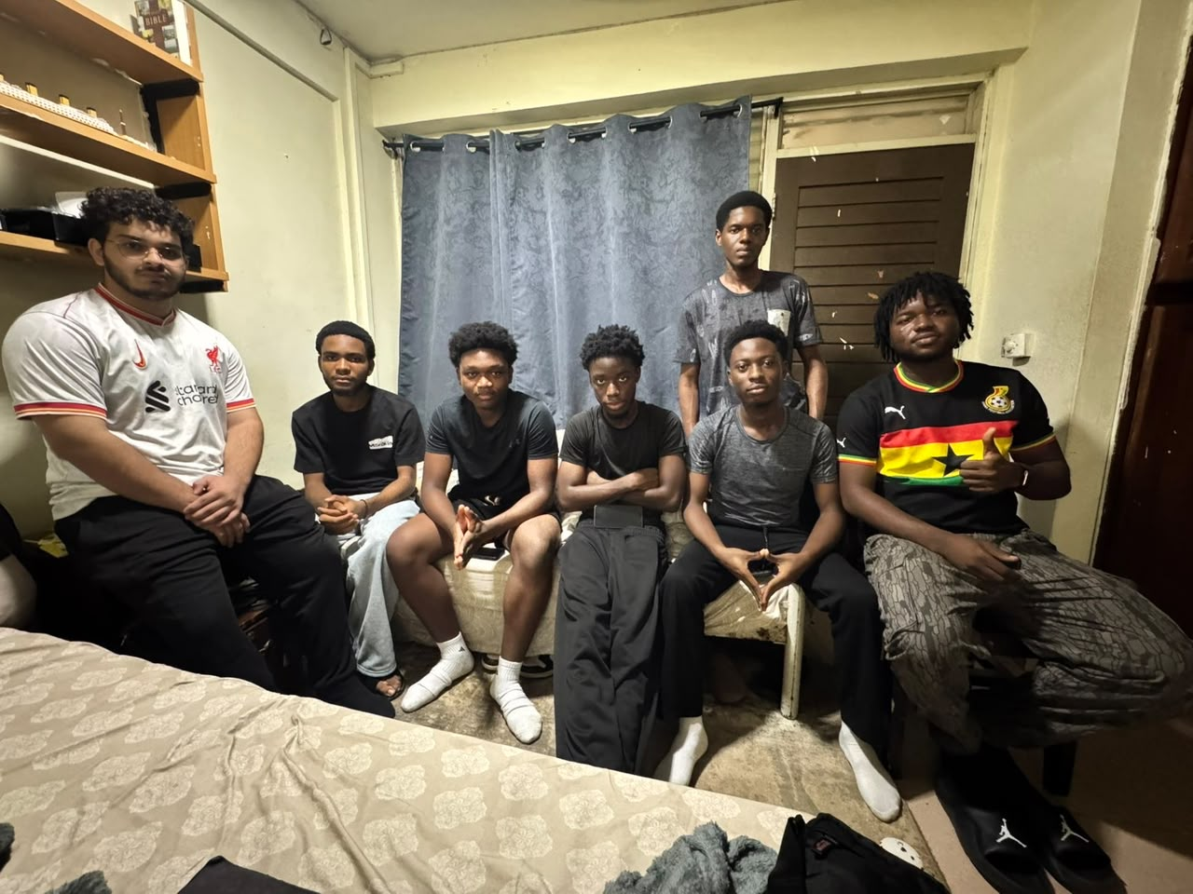

2. Team Operating Management.

2.1. Communication Tools and Expected Response Time.
The team will use the following communication platforms:
- WhatsApp: Primary communication platform for quick updates, discussions, and announcements.
- Zoom: Used for formal meetings, project discussions, and progress reviews.
- GitHub: Used for code collaboration, version control, issue tracking, and project documentation.

Team members are expected to respond to important messages within 8 hours during active project periods. Members should notify the team in advance if they are unavailable.

2.2. Meeting Schedule, Attendance Rules, Minute-Taking Responsibility, and Decision Recording Process.
The team will hold regular project meetings every Friday to discuss project progress, challenges, assigned tasks, and upcoming activities.
Attendance Rules
- All team members are expected to attend scheduled meetings.
- Members who are unable to attend must inform the Project Manager before the meeting.
- Repeated absence without valid reasons will be addressed by the team.
Minute-Taking Responsibility.
- A designated team member will record meeting minutes during each meeting.
- Meeting minutes will include:
- Date and time of the meeting
- Members’ present
- Topics discussed
- Decisions made
- Assigned tasks and deadlines
Decision Recording Process
- Important decisions made during meetings will be documented and shared with all team members
- Decisions will be reviewed by the Project Manager to ensure alignment with project goals
2.3. Work Division Process and Task Management.
Project tasks will be assigned based on each team member's role, skills, and responsibilities. The Project Manager will coordinate task distribution and ensure that assigned tasks align with project objectives.
Task Assignment Process.
- Tasks will be created and assigned through GitHub Issues or the agreed team communication platform.
- Each task will have a clear description, responsible team member, and expected deadline.
- Team members are expected to update their progress regularly.
Task Review Process.
- Completed tasks will be reviewed by relevant team members before being considered complete.
- Code-related tasks will be reviewed through pull requests before merging with the main branch
- Documentation tasks will be reviewed for accuracy and completeness.
Task Acceptance Process.
- A task will be considered completed when:
- The assigned member has finished the required work.
- The work has been reviewed and approved.
- Any identified issues have been resolved.
- The changes have been properly documented when necessary.
2.4. Version Control Rules.
The team will use GitHub as the primary platform for version control, code collaboration, and project tracking, all members are expected to follow the agreed Git workflow.
Branch Naming Rules.
Team members should create separate branches when working on tasks. Branch names should clearly describe the purpose of the work
Example:
- feature/login-system
- feature/user-dashboard
The main branch will contain stable and reviewed work
Commit Message Rules.
Commit messages should be clear and describe the changes made.
Example:
- feat: add user login functionality
- fix: resolve database connection issue

Pull Request (PR) Rules.
- Members must create a pull request before merging changes into the main branch.
- Pull requests should include a clear description of the changes made.
- Another team member should review the changes before approval.
Merge Rules.
- Only reviewed and approved changes should be merged into the main branch.
- Members should avoid pushing incomplete or untested work directly to the main branch.
- Conflicts should be resolved before merging.
2.5. Conflict Resolution Rules and Consequences.
Conflict Resolution Process.
The team will handle conflicts through open communication and professional discussion. Members are encouraged to address issues early to prevent delays in project progress.
The conflict resolution process will follow these steps:
- Team members involved will discuss the issues and attempt to reach an agreement.
- If the issues remain unresolved, the Project Manager will assist in finding a solution.
- If necessary, the issue will be escalated to the appropriate authority
Non-Participation and Grading.
All team members are expected to actively contribute to the project. A member who is unavailable must communicate with the team.
Repeated cases of:
- Ignoring team communication
- Failing to complete assigned tasks
- Being absent without notice
will be discussed and addressed by the team.
Late Work.
Members are expected to complete assigned tasks within agreed timeframes. If a delay is expected, the member should inform the team early and provide a reason.
Academic Dishonesty.
All team members must maintain academic integrity. Any form of plagiarism, unauthorized copying, or misinterpretation of another person’s work will not be accepted.
The team will follow the university’s academic integrity guidelines when handling such cases.
2.6. Submission Process.
The team will follow a structured submission process to ensure that all deliverables are complete and submitted on time.
Preparation and Review.
- The Documentation Lead will compile and organize the required project documents.
- Team members responsible for each section will review their contributions before final submission
- The Project Manager will perform the final review to ensure that all requirements have been met.
Sakai Submission.
- The Project Manager will be responsible for the final upload of deliverables to Sakai.
- The final submission file will be checked before uploading to confirm that the correct documents and formats are included.
Internal Submission Freeze.
- All team contributors must be completed and submitted for review before the official deadline.
- The team will set an internal deadline before the 5:00 PM submission deadline to allow time for final checks and corrections.
Final Approval.
The Project Manager will confirm that the submission is complete after receiving approval from the relevant team members.

