SoftDevReport-v27
ver: 2 -Modified: 25 Jul 2020, 19:39
Table of Contents
Revision History 2
About 3
1. Styles examples are provided below. 3
02_Title 4
1. 03_Chapter 4
1.1. 04_Section 4
1.1.1. 05_SubSection 4
1.1.1.1. 06_Paragraph 4
2. LISTS 5
3. Frames 6
4. Shortcuts and styles application 6

Issues Index
Issue 1: A demo issue 6

Figures Index
Figure 1: Shortcut example 6

Tables Index
Table 1: Table example 7

Revision History

Revision | Date | Author(s) | Description
1 | 25 Jul 2020 | VP | Initial document

About

How to use this template:
- Import the template into LibreOffice via the template manager.
- To update Title, Author, Author initials and Company, go File→Properties and …
  - In the tab “Description” provide your title.
  - In the tab “Custom Properties” update the corresponding properties.
- On the section Revision History change description.
- On the section About select everything from “How to use this template” up to the end of this document and press DEL. The document will clear for you to start writing.
- Updating of Table of Contents, Figures Index and Tables Index in the start of the document, should be done manually, by right clicking on it and selecting the Update Index option, every time you change the basic headings of the document or insert/remove Tables and Figures.
------------------------------------------------------------------------------------

  - Styles examples are provided below.
00-00 Default
00-01 Bold
00-02 Italic
00-03 Bold Italic
00-04 Bold Underline
00-05 Underline
00-06 Gray
00-07 Orange Letters
00-08 Reference Link

01-01 Note Important - Title
01-02 Note
01-03 Note Red
01-04 Note Green
01-05 Comment Italic Green
01-06 Yellow Comment
01-07 Idea
01-08 Repository Path
01-09 Repository Branch
01-10 Version number
01-11 Test Name

02-01 Project
02-02 Filename
02-03 Filepath
02-04 Function
02-05 Class
02-06 Namespace

02-07 Code Parts
02-08 Type
02-09 Code Line Indexing
02-10 Special Variable
02-11 Special Number
02-12 Quote
02-13 Quote Important
02-14 Quote Note
02-15 Quote Variable
02-16 Person Name

03-01 Code Font
03-02 Code Font 4pt
03-03 Code Font 6pt
03-04 Code Font 10pt

Hyperlink

01_BookTitle

02_Title
  - 03_Chapter
    - 04_Section
      - 05_SubSection
        - 06_Paragraph

07_SubParagraph

08_Deprecated text
08_Errors
09_Notes
10_CODE
11_CODE_Setup
12_CODE_TextRun
13_CODE_Text
14_IMPORTANT
15_Conclusions
16_Opinion_Note
17_Quotes

  - LISTS
- 00 - Default 1
  - 00 - Default 2
    - 00 - Default 3
      - ...

- 00-Numbering Simple 1
  - 00-Numbering Simple 2
    - ...

- 01-[1]._Numbering 1
  - 01-[1]._Numbering 2
    - ...

- 02-Simple_Bullet 1
  - 02-Simple_Bullet 2
    - …

- 03-Simple_Arrow 1
  - 03-Simple_Arrow 2
    - …

- 04-Simple_Tick 1
  - 04-Simple_Tick 2
    - …

- 05-Simple_X 1
  - 05-Simple_X 2
    - …

- 06-Simple Filled Arrow 1
  - 06-Simple Filled Arrow 2
    - ...

- 07-Simple Rhombus 1
  - 07-Simple Rhombus 2
    - …

- 08-Simple Square 1
  - 08-Simple Square 2
    - …

  - Frames
00-Default
01-Border black
Issue 1: A demo issue
This is a demonstration issue
  - Shortcuts and styles application
In order not to mess with styles, select to view only the “Custom Styles” from the styles explorer (View → Styles).
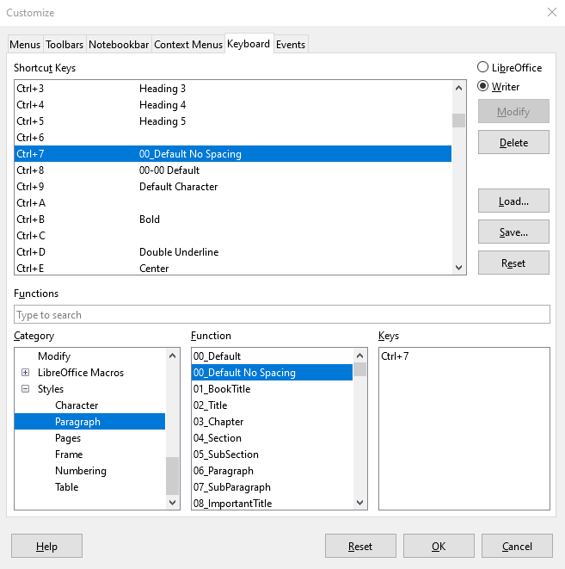Figure 1: Shortcut example

In order to easily reset and apply styles, user can set custom keyboard shortcuts. One proposal is the one that is depicted in the right figure.
- Ctrl+7 ► Styles/Paragraph::00_Default No Spacing
- Ctrl+8 ► Styles/Character::00-00 Default
- Ctrl+9 ► Styles/Character::Default Character

In this way, when using Paragraph styles except from the 00_Default No Spacing you have to select the text and press Ctrl+9, thus to remove any custom Character styles.

When writing any text, press Ctrl+7 and Ctrl+8 to reset style to default Paragraph and Character styles for this template.

Of course there is and the Ctrl+M default shortcut with removes 3rd level modifiers on a text (those ones that are neither Paragraph, neither Character styles, i.e. modified like bold letter when using Ctrl+B).

Table 1: Table example
0 | 1 | 2

------------------------------------------------- Template End -------------------------------------------------

