Introduction
I have always been fascinated by volcanoes and their remarkable destructive power. This power is so obscene, unless you've actually witnessed a volcanic eruption, it's almost impossible to grasp the magnitude of force exploding from the big scary earth cone. When a volcano erupts, they spew all sorts of gases into the atmosphere and magma to the earth. Most of the gases are toxic, yet contain chemicals that are a foundation for life. Magma after thousands of years turns into soil, which fills the ground with rich nutrients directly from our mantle. I can go on..
This analysis is a capstone project applied data science specialization I've been working on for the past two months.
Below you will find data, methodology and observations.

Data/Methodology
I will use a combination of geographic data from the United States volcanic eruptions in the Holocene period (past 11,700 years) provided by kaggle.com (an open source data platform) and foursquare.com. Foursquare is an intelligent location tracking software. I will use this platform to gather venue data from locations in the identified volcanic regions. From there, I will apply the k-means algorithm to analyze the clusters of venues around the different volcanoes. Upon doing so, I can analyze the distribution of clusters in relation to the volcano. If there is an observable difference, then it is possible that the activity from the volcanoes over the Holocene period has contributed to the differences in community centralization around those volcanoes.

Exploration
Here is just some cool exploratory data highlighting eruptions by country, tectonic elevation and number of eruptions by type. My personal favorite eruption is a pyroclastic explosion. I'll spare you the nightmares, but Vesuvius and Mount St. Helens were both super-pyro-clastic-expialidoucious explosions. As you can see, stratovolcano's hold the title for the most eruptions. Heres a link to more: Holocene Period Volcanic Eruptions data.

Analysis
This map divides out the US and Hawaii.
Most of the eruptions sit along the mountain ranges stretching from Canada to Mexico. This is because there is a massive subducting plate tectonic just beneath. The mantle and crust are constantly being forced up. The Sierra Nevada’s, Yosemite, all are a result of the perseverance of our rotating earth, and every so often the pressure releases.
All around the ring of fire, volcanoes are dotted some more active than others. Hawaii, compared to the Pacific America seaboard has much younger eruptions. This is known intuitively, and statistically. Out of the venues in Hawaii, 50% of the venues near eruption coordinates are volcanoes and 17% mountains. In Canada and US, only 33% of the venues near eruption coordinates are Mountains (volcanoes don't even appear).
Diving in as far as 10 segments, you begin to understand the economy around volcanic eruptions, how they are similar and different. (Queue k-means algorithm)
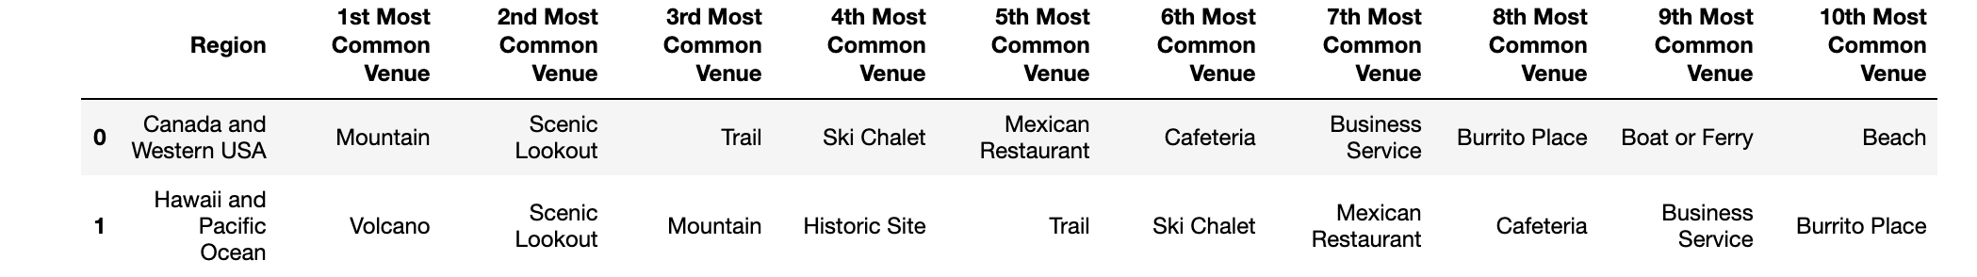
For example, the fourth most common venue for US/Canada is a Ski Chalet. For Hawaii, it's historical site, which makes sense because of their rich heritage. *Side bar for you data trolls: google Skiing in Hawaii.
Update: Upon further analysis I found "Burrito Place" didn't even make the comparison between Italy + Japan region segments. Can you guess what showed up?
There is an observable difference between Hawaii and the Canada / Western USA region in venue segments. It would be very intriguing next to understand how mineral deposits in these regions change, vs. areas with no volcanic eruptions. Age since last - eruption contributes to the amount of economic development a region can sustain as well as conservation.

Results
Unfortunately, given the nature of the data the correlation is very slight. While there are empirical differences, there will need to be more regions analyzed and compared to begin to paint a picture of cultural nuances by volcanic region.

Applications
As our earth is forever changing, understanding the relationship between volcanic activity and economic development could help us optimize commerce in a potentially toxic environment in the near future. Ultimately, this is all very inconclusive. More macro data and investigation is needed to truly dig into if/why/how volcanoes can help us prepare for climate change.

