KickMaker-v2

User's Manual
by Nik Reiman, nik@teragon.org

Installation and Registration | 2
Plugin Usage | 4
Effects | 5
Presets | 6
Support | 7

- Installation and Registration

After purchasing KickMaker, Teragon Audio will send you a confirmation email with your registration information. Using the username and password provided to you in this email, download the latest version of KickMaker for your platform from the following website:

http://www.teragon.org/downloads/KickMaker-v1/

All product updates will be posted to this address. You can be automatically notified of updates by subscribing to the Teragon Audio RSS feed:

http://www.teragon.org/rss/index.xml

After downloading the product zipfile, uncompress it and install the plugin. Under Windows, an installer has been provided for this task; simply run it as prompted. By default, the installer will copy the KickMaker DLL to C:\Program Files\Steinberg\VstPlugins, but this location may be changed within the installer. The installer will also copy the factory presets to your user preset location (see the "Presets" section for more details).

Under Mac OSX, the plugin must be placed under Library/Audio/Plug-Ins (either under the user domain or the root domain). Audio Units go under the "Components" subfolder, and VST's go under the "VST" folder. It is not necessary to install both versions of KickMaker for Mac unless desired. Some hosts are known to only support one of the two formats, so both have been provided for maximum compatibility. After plugin installation, it may be necessary to restart your sequencer host program.

The first time that KickMaker is launched, it will ask you for the registration codes provided to you in the confirmation email. Enter them in the registration screen:

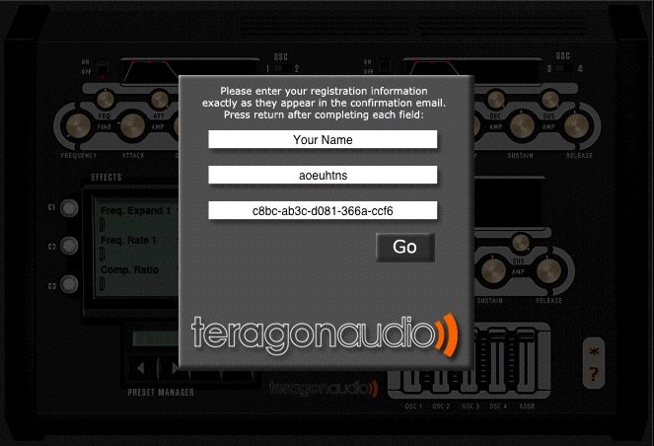

When you have finished entering data in each field, press return to confirm your entry. If you make a typo, you can go back and edit an individual field by clicking on it. When all fields have been completed, press the "Go" button to authorize the plugin.

Should you experience difficulties in authorizing KickMaker, please email info@teragon.org to receive product support.

- Plugin Usage

Please refer to the following schematic for KickMaker's user interface:

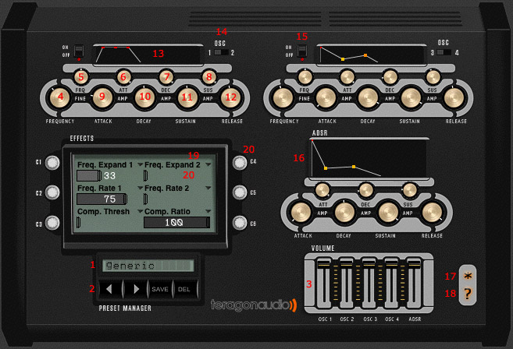

- Preset display
- Preset navigation controls
- Oscillator mixer
- Per-oscillator frequency control
- Per-oscillator frequency fine control
- Per-oscillator attack amplitude
- Per-oscillator decay amplitude
- Per-oscillator sustain amplitude
- Per-oscillator attack length
- Per-oscillator decay length
- Per-oscillator sustain length
- Per-oscillator release length
- Per-oscillator ADSR visual display
- Toggle oscillator display
- Per-oscillator enable switch
- Global ADSR controls
- About screen
- On-screen help
- Effect select
- Effect controls

To create kick sounds, KickMaker employs the use of four independent sinewave oscillators. Individual oscillators may be enabled or disabled with the oscillator enable switch (15). The user interface groups oscillators 1/2 and 3/4 together to save space. To switch between oscillator displays, simply toggle the respective switch to the target oscillator number. The display and controls will update automatically to show the settings for the oscillator.

The first step in creating good kick noises is to set up a primary oscillator. Using the frequency control (4), tune the oscillator to the desired "base" frequency. Each oscillator is capable of generating frequencies from 20Hz to 125Hz. The frequency fine control (5) can be used to adjust this value in 0.1Hz increments. Next, adjust the attack, decay, sustain, and release envelopes (henceforth referred to as "ADSR") to create an amplitude curve for the wave. The large ADSR knobs (9-12) all control the length of the curve segment, and the smaller knobs (6-8) determine how loud the signal should be at a given point in the curve. If the amplitude of these knobs is set to zero, then the oscillator will be muted until a non-zero value is reached in the curve.

Although KickMaker allows a zero-value to be set for the attack length, this may create "clicks", which are caused from sudden jumps in amplitudes. To correct these problems, simply raise the individual oscillator's attack length, or the global attack length. Alternately, one can adjust the signal's phase to mitigate such clicks (see section 3 for more information about this).

After tuning a first oscillator, other oscillators may be added to the kick. Using frequencies close to the base oscillator tends to generate more "conventional" sounding kicks. The strength of each of these signals may be controlled with the built-in mixer (3), which also controls the volume of the overall output.

Finally, a global ADSR curve (16) is applied to the sum of each individual oscillator before the signal is played. These controls will have more influence on the overall sound of the kick than the individual oscillator curves, since it is applied to the signal after mixing.

- Effects

Effects may also be added to kicks to give the sound a more distinctive tone. They are accessed in the effect panels above the preset display. The effect panel contains displays for six different effects, which may be toggled by clicking on the effect name (19). The corresponding effect value can either be adjusted by dragging the slider or knob for the effect control (20). Currently, the following effects are available in KickMaker:

- Phase adjustment
- White noise
- Frequency expander
- Compressor

Phase adjustment simply controls the wave's phase, which is the point at which the wave starts to play. This can be adjusted for each individual oscillator.

White noise will add a static-like hissing to the wave. In practice, it is best to have a single oscillator with a high amount of static, and then control the timing and volume of this static with the ADSR and volume controls. This effect can be adjusted for each individual oscillator.

The frequency expander allows each oscillator to act as a brief variable-frequency oscillator. The expander itself has two effect controls, the first being for the expansion amount, and the second being for the expansion rate. The expansion amount controls sets the original frequency which the oscillator should start at, and the rate determines how quickly the oscillator should drop to its base frequency. Used together, the frequency expander can create lifelike drum sounds which resemble a distinct hit and then a low-frequency fadeoff.

The compressor is the only effect within KickMaker which does not act upon the individual oscillators. Instead, it is applied to the entire signal after the global ADSR envelope. Technically, the compression unit is a variable gain enhancer and limiter; it does not have any concept attack and release rates like a regular compressor. Rather, it determines an exponential gain factor based on the wave amplitude, and then an inverse gain factor is applied for all points above the compressor's threshhold. Using the compressor may have drastic effects such as distortion and clipping at high attack and release levels, so be careful when adjusting these values.

- Presets

KickMaker has a simple preset system which can easily manage plugin settings. The current preset name is displayed in the LCD panel (1), which shows a pop-up menu of presets when clicked on. Likewise, one can quickly navigate through presets by using the "next" and "previous" buttons on the control panel (2).

To save the current plugin settings to a preset file for later use, simply click the "Save" button. The LCD panel will then turn into a text-entry box where the preset name may be entered. When finished typing, press 'return' to save the preset to disk. The new preset name should now be shown in the preset display.

To make changes to an existing preset, simply press the "Save" button, and when prompted for a name press "return" without changing the text. This will overwrite the data for the respective preset. If a new name is entered, then a new preset will be created and the original preset will be untouched.

Factory presets cannot be overwritten, if you attempt to save over them then a copy of the preset will be created in your local preset folder. They can, however, be deleted like normal presets. User presets are saved in the following locations:

- /Users/YourUsername/Library/Application Support/Teragon Audio/KickMaker (Mac OSX)
- C:\Documents and Settings\YourUsername\Application Data\Teragon Audio\KickMaker (Windows)

The presets themselves are stored as plain-text files, so they may easily be transferred between users. To install new presets, simply move them to the above directory and reload KickMaker.

To remove a preset, press the "Del" button. This button will not prompt you to remove the preset, it will automatically remove it from the preset list and also physically from your hard disk.

- Support

Should you have any additional questions or problems with KickMaker, please email Teragon Audio's support at info@teragon.org. To report a bug within KickMaker, please email bugs@teragon.org. Be sure to state your host sequencer program, operating system, and version of plugin used. Alternately, you may use the online bug reporting form:

http://www.teragon.org/contact.html

