WhatsApp Photo Report (04/08/2025 - 03/09/2025)

Generated on: September 03, 2025 at 01:07 PM

Period: August 04, 2025 to September 03, 2025

## Photo 1

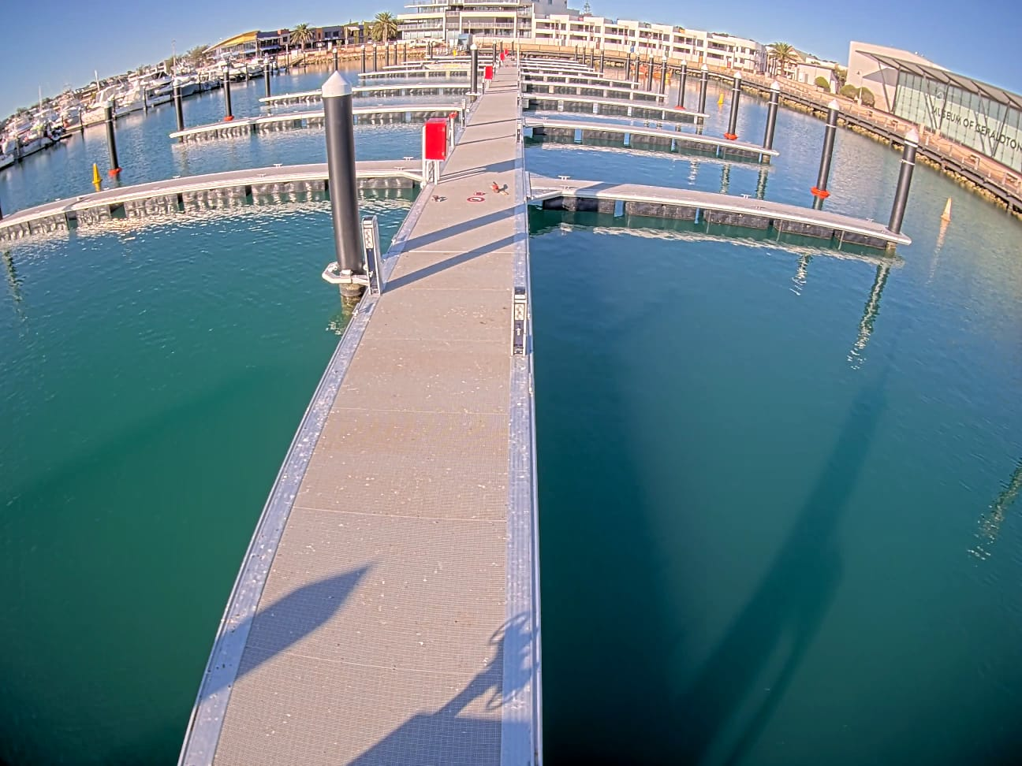

*From: Lindsay Bligh  
Date: 11/8/25 at 7:00 am  
Message: Couple of CCTV snaps from Geraldton Batavia Coast Marina which will get PC this week.*

## Photo 2

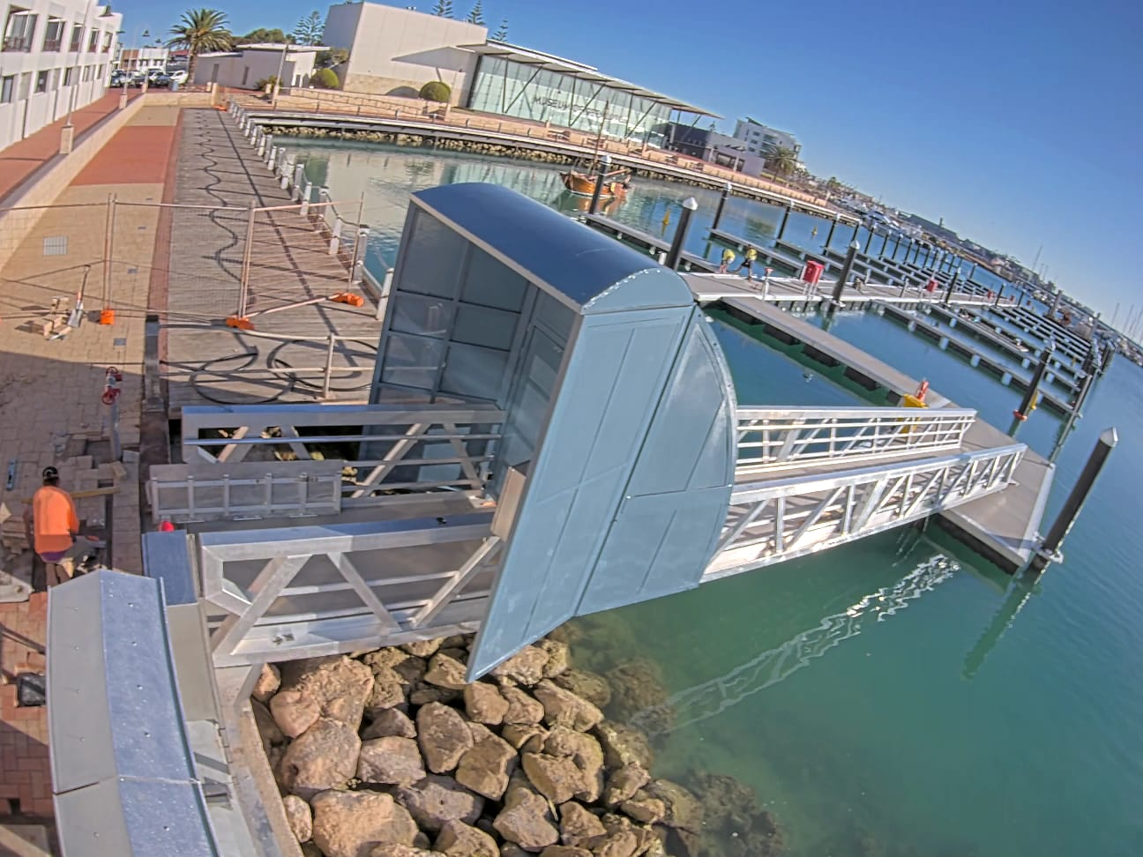

*From: Lindsay Bligh  
Date: 11/8/25 at 7:00 am*

## Photo 3

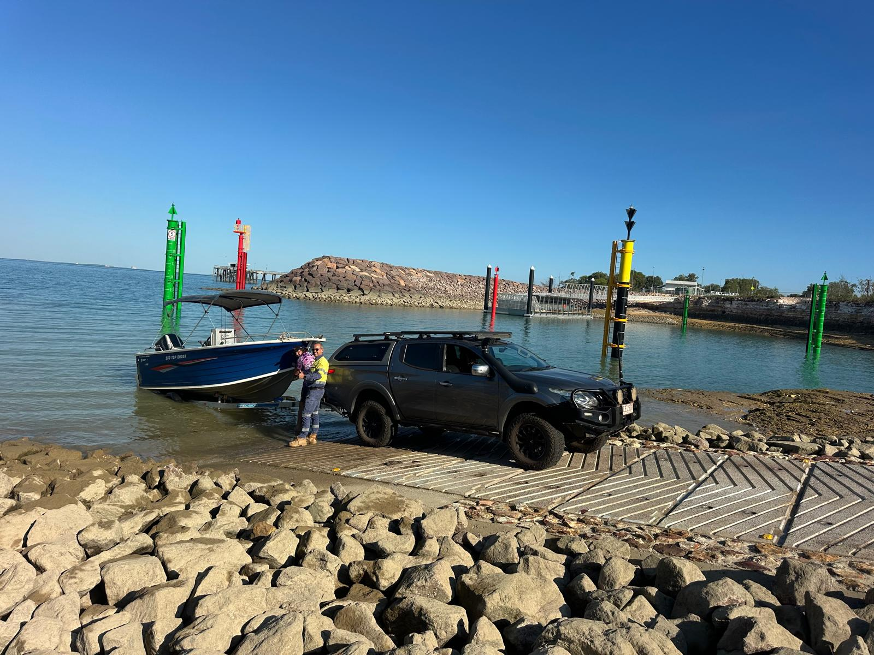

*From: Pete (m)  
Date: 18/8/25 at 6:48 pm  
Message: One of our first happy customers at Mandorah the facility looks amazing.*