Complexity of alorithms:

- O(1) - time required is constant, independent of the problem size.
e.g Hash Searching.
- O(log_{n} * log_{n}) - very slow growth of time required. e.g Interpolation.
- O(log_{n}) - logarithmic growth of time required - doubling the problem size only increase the time with constant. Basically means time goes up linear while elements goes up exponentially.
10 items takes at most some amount of time x, and 100 items takes at most, say 2x, and 10,000 items takes at most 4x.
e.g binary tree search, search.
- O(n) - linear time complexity. e.g Iterating over array

*** Heap - array represented as binary tree. In perticular heap provides simple way of implementing priority queues.
*** Priority queue - abstract data structure that keeps track of dynamically changing set of values. Most efficiently implemented with binary heap.
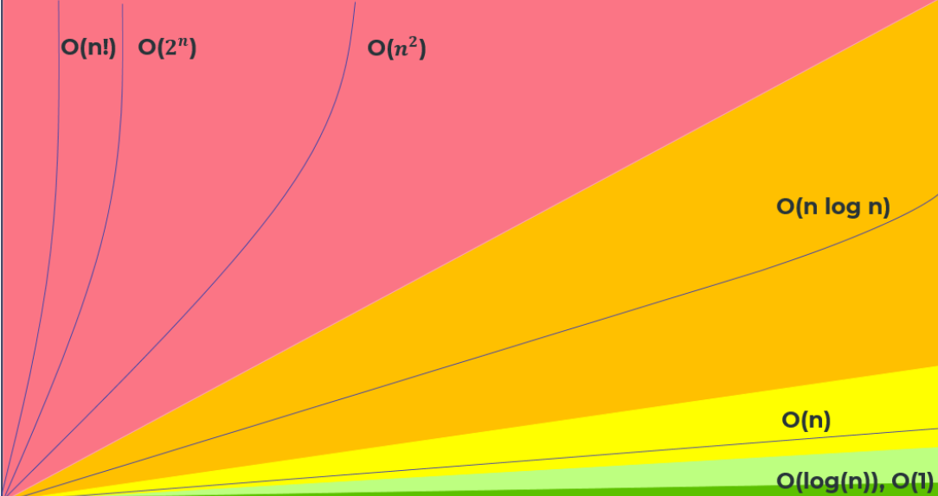

LinkedList vs Array
- accessing element in Array is O(1)
- deleting and inserting elements is slow
- accessing element in LinkedList takes O(n)
- deleting and inserting takes O(1)

