Това което подаваме на функцията наричаме аргументи.
Това което функцията приема наричаме параметри.

Най-важното oт фунции:

- using arguments object
- using rest operator ... function statement(...params)-> returns array - it should be placed always at the end
- undefined + number -> NAN
- return on few lines won't execute properly, return automaticly will set ; at the end of the line. Solution is to wrap the code in brackets
- void 0 === undefined - in old version of JS undefined can be set to different value a.k.a undefine = 5. void 0 is shorter than undefined therefore it is more optimal.
- undefined vs null -> undefined means that something is not defined, null should be defined explicitly to occure.
- executed length of function will return all parameters which are not default and not defined with rest operator -> sum(one, two = 0, ...params) => 0
- аrrow function (x, y) => { return x + y }; === (x, y) => x + y; || x => x + 1;

Най-важното от Exceptions:

- ReferenceError

Declaration vs Initialization

- let variable; - declaration, variable = 5; - initialization

Function declaration vs expression

const two = () => console.log('two') - value of variable two can't be mutated

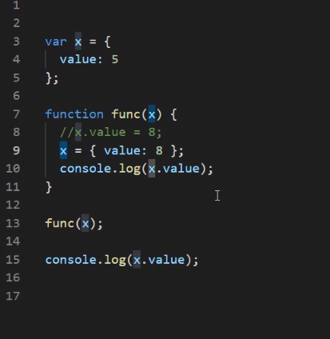
function one() { console.log('one') } - otherwise on variable one can be set value( one = 5; )

The result will be 8, 5

- x variable is only pointer to the objectl, not the object itself. Therefore if you mutate x as x = { value: 100 }, x will point to the other object, won't mutate the original one.
- !!! X is passed as of pointer copy !!!
- Strings are objects which behave as primitive types.

