let elemets = [ 'one', 'two', 'three', 'four' ];

- for(let element of elements) - abbreviated way to iterate over collection. It's not reccomended to use `for in` to iterate over array, particularly because it cannot be guaranteed that the iteration will happen in sequence.

- for(let property in object) - used to iterate over object own keys.
- elements.includes('one') -> true, elements.indexOf('one') -> 0

for-in - will iterate over object keys.
for-of - will iterate over the values on array

function which doesn't return anything will return undifined.

!!! Array.isArray(element) - проверява дали елемента е масив !!!
!!! let nums = gets().split(',').map( e => parseInt(e)); ===
let nums = gets().split(',').map(Number); !!!

!!! const array = Array.from('1234', (e) => parseInt(e)); - passed string should not have spaces e.g '1 23 4' !!!

!!! .filter( Boolean ) -> it will all values which are not falsy

!!! const array = [1, 2, 3]; -> array[-1] = 42; - array.length will return 3 !!!
!!! const array = [1, 2, 3]; -> array[21] = 90; - array.length will return 21 !!!

Ways to create array:

- const array = [1, 2, 3] - array literal
- Array.from( [ 1, 2, 3, 4 ] ); Array.from({ length: 4 }, () => 0 );
- Array.of( 1, 2, 3 );
- new Array(1, 2, 3, 4, 5) - if passed only one value to the constructor, it will be taken as length of the newly created array

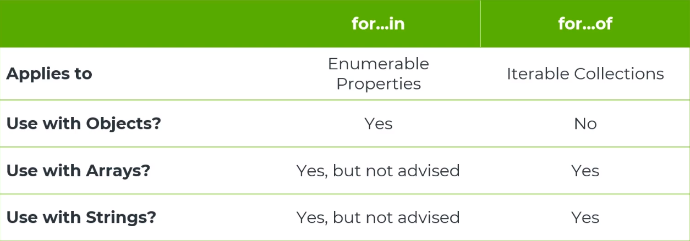

Functional Array methods

- [ 1, 2, 3, 4 ].findIndex( e => e > 3 ) - will return the index of first element which satisfies the arrow function condition

let sizeOne = gets(), sizeTwo = gets();
let arrayOne = Array.from({length: sizeOne }, () => { return gets() });
let arrayTwo = Array.from( gets().split(' ').map( e => { return parseInt( e ) }));

Array methods:

- mapFlat() === map().flat(1)
- reduce( ( acc, e ) {} ) - if it's not passed initial accumolater -> accumolater value will be the first element and e will be the second element.
- reduceRight() - starts from the end
- sort() - will not mutate the original array
  - a.name.localeCompare( b.name ) - comapre string
- splice(startIndex, deleteCount) - used to delete element/s from given position(startIndex). If startIndex is a negative number then the count will start from the end of the array. a.k.a array.length + startIndex. Mutate the original array.
- slice(start, end) - end index is not included in the new created array.

Other Methods:
- String.fromCharCode() - it will parse the given number to its character
- 'a'.charCodeAt() - it will parse the character to its number

