Hash table
  - a hash table is collection that holds a set of values. hash -> value
  - computes an index by hashing a key. Perfect hashing function doesn't exist.
  - a collisin is a situation when different keys have the same hash value. In this case one of the strategies to handle this is to store the colliding values in list, re-hashing is another good approach.

Set
  - Set is iterable object, therefore we can use spread and rest operator over it.
    - const set = new Set([1, 2, 3, 4]) => [ ...set ] - using set as array
    - const union = (first, second) => new Set([ ...first, ...second ]);
    - iteresection - common elements between two collection, in this case Set
  - Common operations:
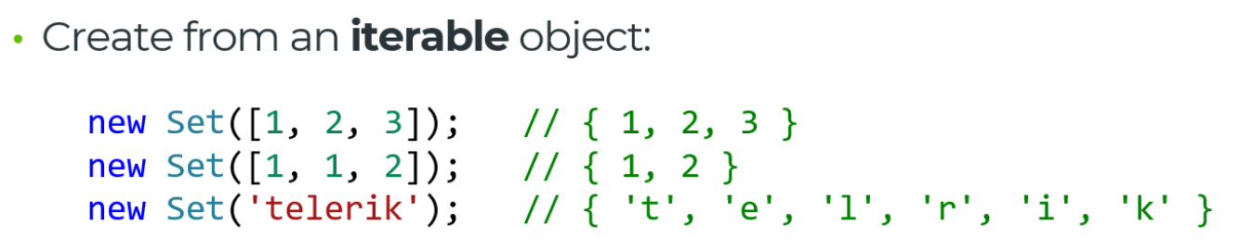
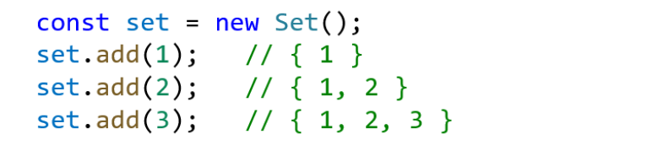
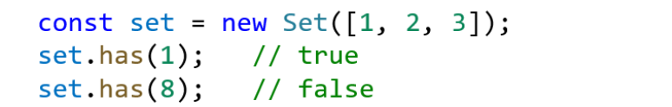
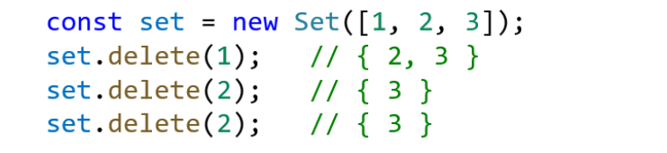

Map
  - maps are aslo known as dictionary. Usually they're implemented with a hashtable or a balanced tree.

