Objects

let - има block scope заразлика от var

Object.assign({}, object) -> creates copy of the passed object
Object.freez(object) -> will set all properties of the passed object to writable: false

!!! За да проверим дали дадено property съществува в обекта !!!

if('street' in person)

Object.keys() -> returns all properties key for the passed object.

const name = 'John', age = 20; //If we
const Person {
name, //if we have variable and property with the same naming we can skip name: name
age: age,
city: 'Edinburgh'
}

no primitive, reference values

* using destructuring on object won't mutate the destructed variables if there are not of reference type.
* destructering always creates copy of the property or value if there are not reference type

e.g

let object = { number: 20 };

function multiply({ number }) {

number += 10;
console.log( number );
}

multiply(object);
console.log(object.number); // 20

Copying Objects:

- { ...object } - creates shallow copy of the object
- Object.assign({}, object) - shallow copy too
- JSON.parse( JSON.stringify(object) ) - creates new object

this - gets its value when a function is invoked(it get bound). What it reference is determinated entirely by the call-site where the function is called. 4 rules are applied.

- Default biding - this refers to the global object. If name is declared in the global scope running sayName will print it. Using 'use strict' `this` inside the function below will be undefined.
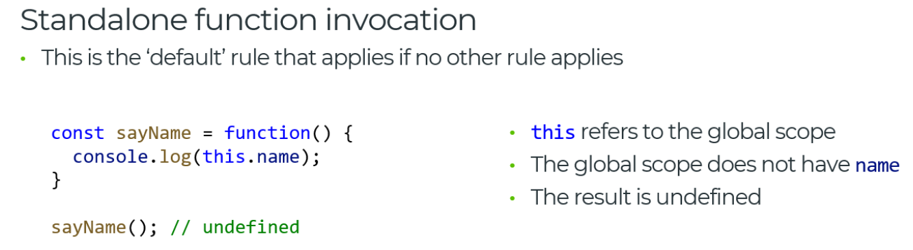
- Implicit biding - if the called function have context object wraping it up.
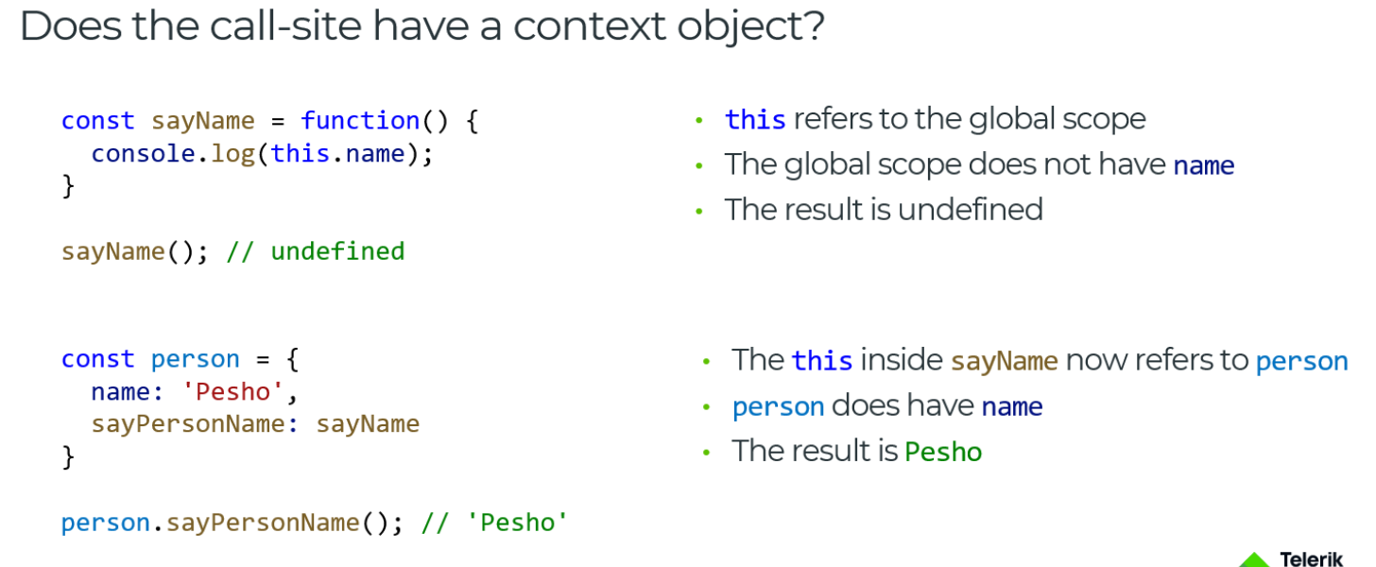
- Explicit biding - using function.call() and function.apply() we set the context in which the function to be executed. function.bind( context ) returns the function which executed will execute in the context of the passed argument(context)
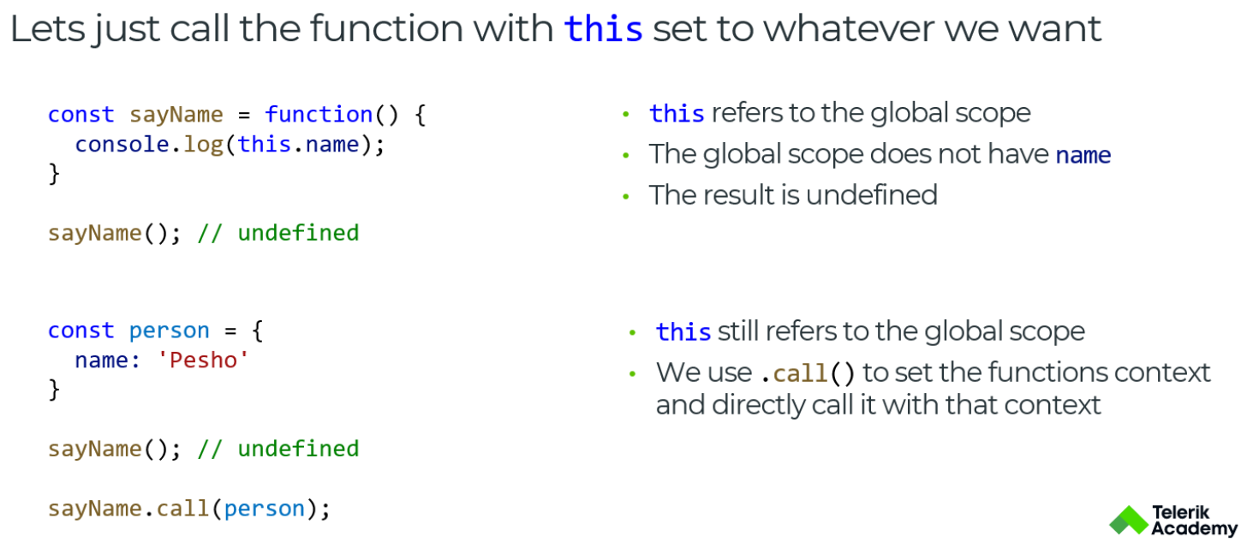

- new biding - using `this` inside of class. `this` points to the instance.

'this' in arrow functions - points to its parent scope.

Almost every object in javascript has toString() and valueOf()

- valueOf() - return number representation of the object
- toString() - return string representation of the object

