OOP

- Properties - methods used as fields. The import thing to remember is that when on property is assigned value a function is called.
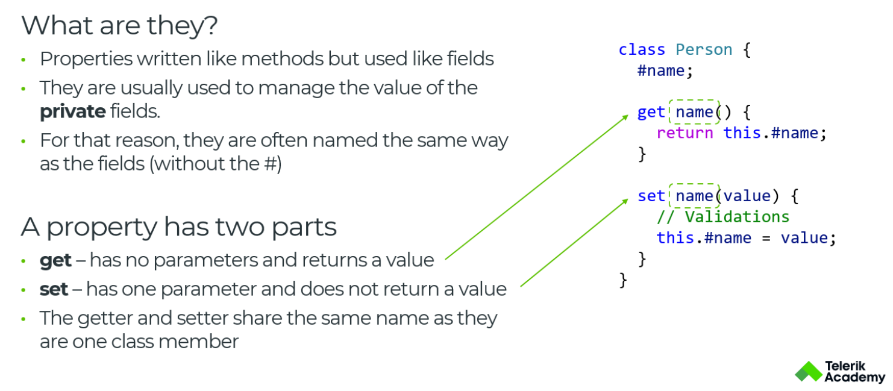

fields define internal object state
- Static members - the static keyword defines a static field or method for a class.
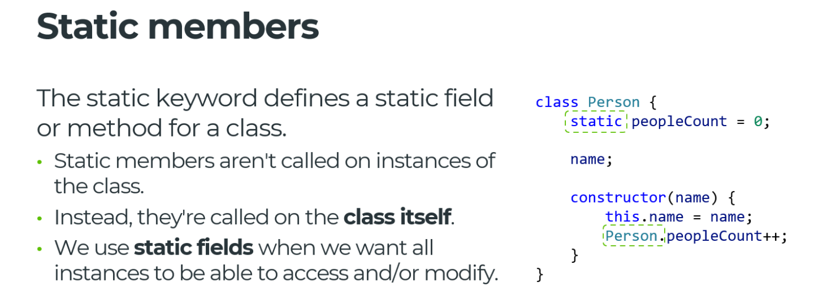

- encapsulation - is a concept where object state(class fields) and its behevior(methods) is wrapped together.Sometimes confused with 'information hiding'
- inheritance - it allows a class to inherit the state and behevior of another class, more general. Use inheritance for building 'is-a' type of relationships. We use the keyword super to access the parent's methods, constructor, properties and public fields. With this we can access parent's fields, if field or property is not found in the current class, it will search higher a.k.a its parent. Overriding property which is used internaly by parent's class, will result in parent class using that property, not its own.
- polymorphism
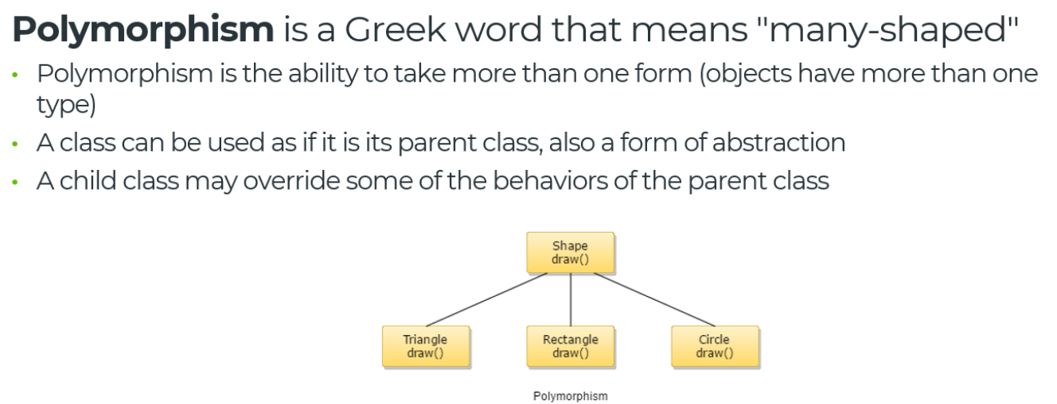
- abstraction

The way how abstract classes are represented in javascript.
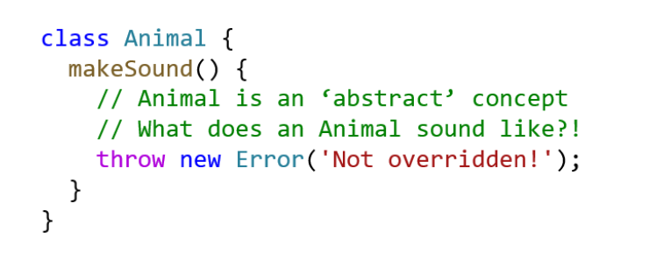

SOLID, KISS, DRY, YAGNI

KISS - keep it simple stupid
DRY - don't repeat yourself (don't over-engineer)
YAGNI - you aren't gonna need it

Composition vs Inheritance

composition - 'has-a' type of relationship.
inheritance - 'is-a' type of relationship.

Cohesion and Coupling (сближаване, свързване)

Testing npm run test:browser

