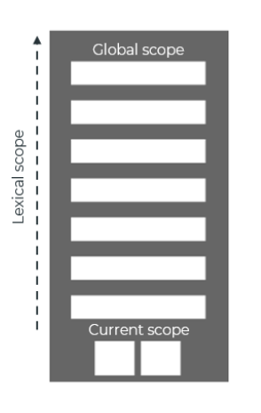
Type error:

- trying to execute a variable which is not a function as function.
- access a property of null object.

Reference error:

- when the variable is failed to be found nowhere in the scopes.

Scopes:

scope - способноста на функцията да запомни своя лексикален scope, дори като фунцията се изпълнява извън своя лексикален scope. (виж. Lexical scope отдолу)

javascript

When variable is not found in current scope the search goes up till global scope is not reached. e.g example 1
In the case of nested function: inner function have access to the variables of the outer.
e.g example 2

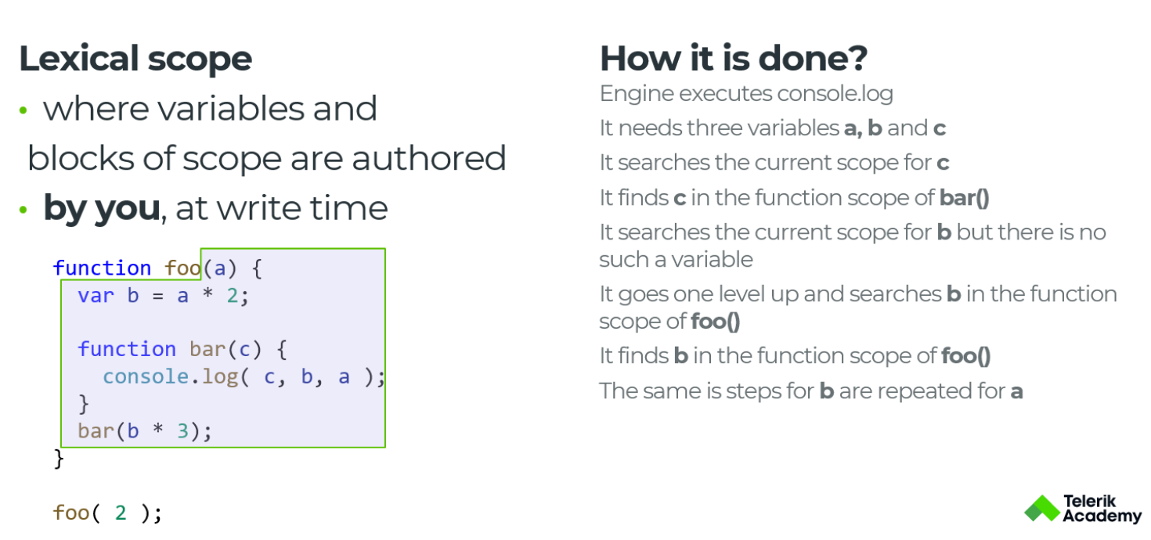
example 1 example 2

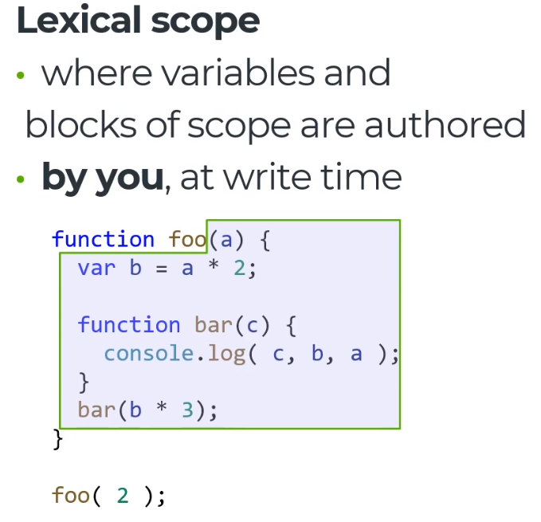

- Function scope means that nomatter of the nesting of given variable it can be access in the function.

- Block scope can be declared simply be {}.

- Lexical scope - е scope в който обгражда всички променливи, който са нужни на функцията. Lexical scope за function bar е всичко оградено в синьо, защото там се намират всички нужни променливи за функцията.

!!! var has function scope and global scope. !!!
!!! const and let are block scope and are only accessible
after declaration !!!

!!! globalThis -> reference to the global object !!!

two(); -> it will throw a reference error, because variable declared with let/const, can't be access before declaration/initialization;
let two() = function two(a, b) { return a + b };

(знае, кой scope е над него.)
scope chain - every scope knows which is scope is up him. It store reference to it.

Closure:

Фукция помни въшния си контекст.
!!! Вътрешна функция може да създаде closure на външна !!!
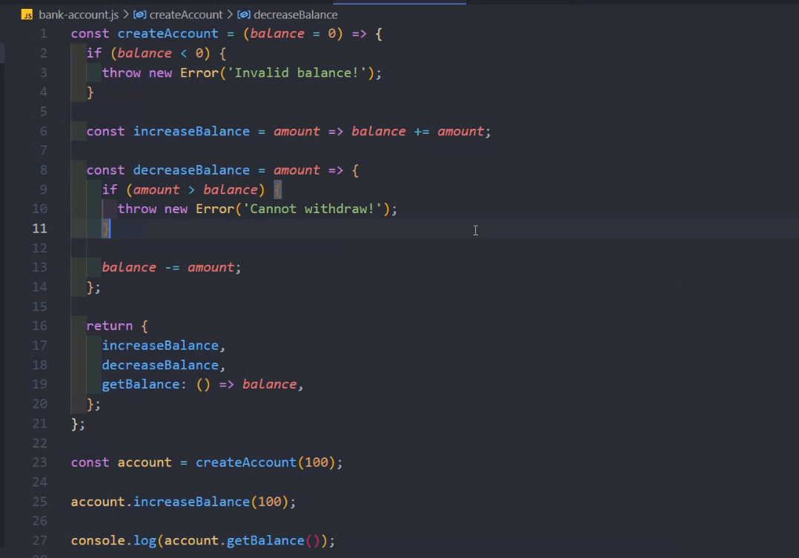

Hoisting:

Everything in Javascrip is hoisted even variable declared with let and const.
let and const variables cannot be accessed before declaration because there are in state of TMZ(temporal dead zone).

Function Hoisting:

Function declaration can be executed before initialization
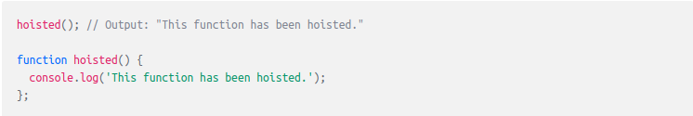
Function expression can't be executed before initialization
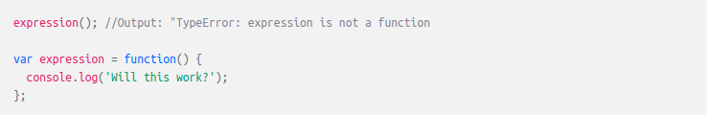
the same is applied to arrow function too

