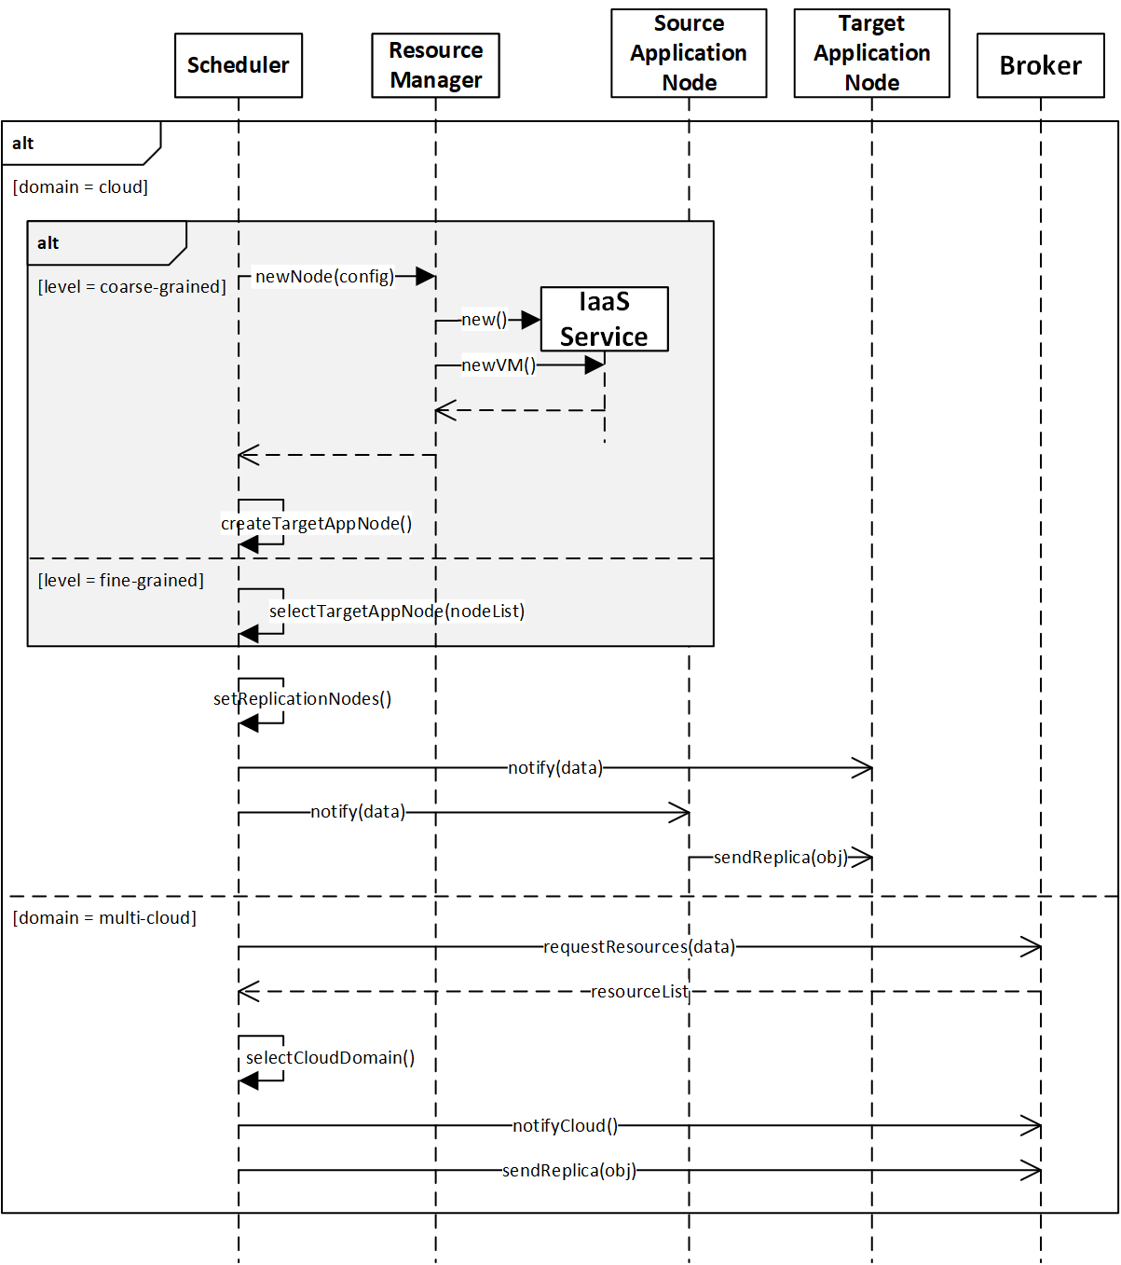
- Adapter decides which strategy to perform and calls Scheduler to execute the replication based on this strategy
- Depend on the strategy, the Scheduler:
  - if replication must be in cloud]
    - if it must be fine-grained:
From a list of elegible nodes (able nodes to support the demand), the Scheduller selects one to be the target node (criteria to be chosen) for replication process
    - else it must be coarse-grained:
Request to Resource Manager a new VM
Scheduller configure the new VM as a Application node and set it as the target node for replication process
    - Notifies source and target node about replication process
    - Request to source node to start replication
  - else replication must be out cloud
    - Requests resources to other cloud domains through the Broker
    - The Broker requests to the other ones in the multi-cloud domain
    - When the Broker passes along to Scheduler some received "offering".
    - The Scheduler selects the cloud domain with the best fit offering (target cloud domain)
    - The Scheduler notifies and sends the replica through the respective Brokers

